Supplementary Materials.
1. Lowest order mode of the rectangular ring nanogap structure.
Figure S 1 A. The lowest dipole mode of a coaxial rectangular waveguide, behaving effectively as two identical rectangular slot antennas. B. Polarization dependent transmission of the rectangular ring nanogaps.
The lowest dipole mode of a coaxial waveguide, TE11 mode, supports sinusoidal axial dependence on the tangential electric field distribution, similar to the lowest TE mode of a simple rectangular waveguide where the field distribution is also sinusoidal along the long axis. Being an intermediate structure of the above two, a coaxial rectangular waveguide also incorporates nearly sinusoidal field distribution along the perimeter of the rectangular ring. Such feature is revealed in a finite element method calculation using a commercial software (COMSOL Multiphysics 5.2) shown in Figure S1 A. The lowest energy mode will be excited when incident polarization is perpendicular to the long axis of the rectangle, leading to higher coupling efficiency and higher transmitted amplitude. And in this case the electric field at the long axis of the rectangular ring nanogap will solely contribute to the far field transmission because the short axis show antisymmetric field distribution, leading to zero net contribution to far field scattering. Incident polarization perpendicular to the short axis will also exhibit resonant transmission behavior but with much smaller transmission, as depicted in Figure S1 B. In terms of the waveguide’s fundamental mode, therefore, the rectangular ring will be treated as a couple of identical slot antennas with both end truncated by the amount of the length of the short axis.

2. Analytic calculation with modal expansion method for the terahertz nanogaps.
Most commonly used 3-dimensional electromagnetic simulation tools such as FDTD or FEM require computational load that scales with $\sim {\left(λ/a\right)}^{3}$, where a is the minimum pitch size of the structure. Such requirements make nanostructures working in terahertz frequencies $(λ \sim 300 μm)$ notoriously difficult to be simulated in conventional ways, calling for an alternative approach.
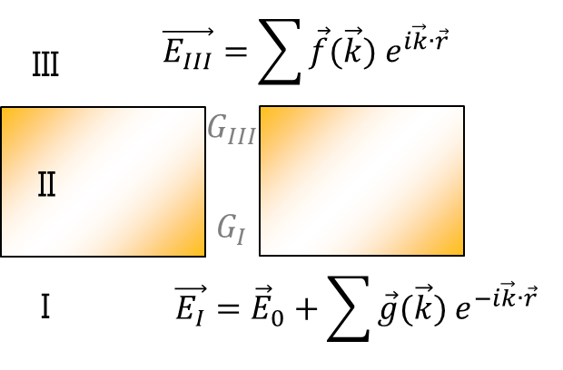
Figure S 2 Cross sectional schematics for modal expansion calculation.
Modal expansion calculation takes advantage of a known field profile inside the gap to reduce the computational load. For the above structure, the aforementioned TE waveguide mode inside the rectangular ring nanogap is boundary-matched with k-space-expanded electromagnetic fields outside the gap (Figure S2). Here we follow the formalism of Garcia-Vidal et al.¹, where perfect electric conductor is first assumed for the metal structures² and then the effect of finite permittivity is added by considering surface impedance boundary conditions and gap plasmon-induced effective index increase at the gap^{3, 4}. To briefly summarize, the electric field at the gap is determined in terms of gap-air, gap inlet-outlet, and gap-substrate coupling coefficients:
$$E_{gap}=\frac{I_{0}G_{V}}{\left(G_{I}-Σ\right)\left(G_{III}-Σ\right)-G_{V}^{2}}$$
Then fields outside the gap are determined from the field at the gap in terms of diffraction:
$$E_{I}=\frac{1}{\sqrt{ϵ_{I}}}e^{ikz}-\frac{1}{\sqrt{ϵ_{I}}}e^{-ikz}+\sum_{k_{x}, k_{y}}{J\left(k_{x},k_{y}\right)βE_{gap}e^{ik_{x}∙x+ik_{y}∙y}e^{-ik_{z}∙z}}$$
$$Z_{0}H_{I}= e^{ikz}+e^{-ikz}+\sum_{k_{x}, k_{y}}{J\left(k_{x},k_{y}\right)\frac{k_{x}^{2}+k_{Iz}^{2}}{k_{0}k_{Iz}} βE_{gap}e^{ik_{x}∙x+ik_{y}∙y}e^{-ik_{z}∙z}}$$
$$E_{III}=\sum_{k_{x}, k_{y}}{J\left(k_{x},k_{y}\right)βE_{gap}e^{i\vec{k}∙\vec{r}}}, Z_{0}H_{III}= \sum_{k_{x}, k_{y}}{J\left(k_{x},k_{y}\right)\frac{k_{x}^{2}+k_{Iz}^{2}}{k_{0}k_{Iz}} βE_{gap}e^{i\vec{k}∙\vec{r}}}$$
Here Z0 is vacuum impedance, J is transfer function of the gap into the free space, and β is gap coverage ratio.
The gap plasmon effect is then included, since our nanogap width is so small and metal-metal coupling occurs in the metal-insulator-metal geometry. This is done by considering a wavevector smearing into metal layer (which is zero in perfect electric conductor case) to relate the wavevectors and dielectric permittivities of the metal and the insulator:
$$\tanh{\frac{k_{d}w}{2}}=- \frac{k_{m}ϵ_{d}}{k_{d}ϵ_{m}}$$
Here w is width of the nanogap and subscripts d and m denotes dielectric and metal, respectively. The correspondingly calculated $k_{d}$ determines the propagation constant and therefore effective refractive index of the gap.
Zeroth order reflection is then calculated by taking curl of backward propagating components of $E_{I}$ and $H_{I}$ with $k_{x}=k_{y}=0$:
$$R={\frac{1}{2}Real(E_{I}×H_{I})}/{\frac{1}{2}Real(E_{0}×H_{0})}= 1-\frac{4}{π}n_{1}β×Re\left(E_{gap}\right)+\frac{4}{π^{2}} ϵ_{1}β^{2}×{\left|E_{gap}\right|}^{2}$$

3. Kirchhoff integral formalism for determination of near field enhancement from the observed far field transmittance
The far field transmitted amplitude is connected to near field at the gap via diffraction theory based on Kirchhoff integral formalism. Provided that direct transmission through metal layer is negligible (less than 0.1% in experiments) such that electric field only exists at the gap, the far field transmitted amplitude is expressed in terms of area integration of near field at the gap:
$$\vec{E}\left(\vec{r}\right)=\frac{ie^{ikr}}{2πr} \vec{k}×\int{\hat{n}×\vec{E}\left({\vec{r}}^{'}\right)e^{-i\vec{k}∙\vec{r}'}da'}$$
Therefore the detected transmitted field amplitude is proportional to the near field amplitude at the gap and the gap area. Note that even if this equation describes field amplitude at a certain point in space, the deep subwavelength periodicity of the nanogap arrays used in this experiment ensures high directivity of transmitted waves and therefore also correctly accounts for the area-averaged total transmitted power.

4. Nonlinear transmission measurements for a graphene gap
A graphene gap sample is fabricated on top of a quartz substrate, with copper used as a gap metal⁵. Quartz has a refractive index of 1.5 at 1THz, where the resonance of the graphene gap sample lies. As shown in Figure S3 the graphene gap shows huge nonlinear response of 80% decrease in transmission, with substrate side incidence (Figure S3(a)) showing slightly larger decrease in transmission compared to the air side counterpart (Figure S3(b)). In this case also the factor ${2n}/{(n+1)}$ is valid for the value of electric field required to produce the same relative transmission in substrate side incidence, with the value decreased to 1.2 according to change in the substrate. The index-matching effect of field enhancement inside nanogaps can therefore be considered universal, holding regardless of gap material, types of metal or substrate, etc.
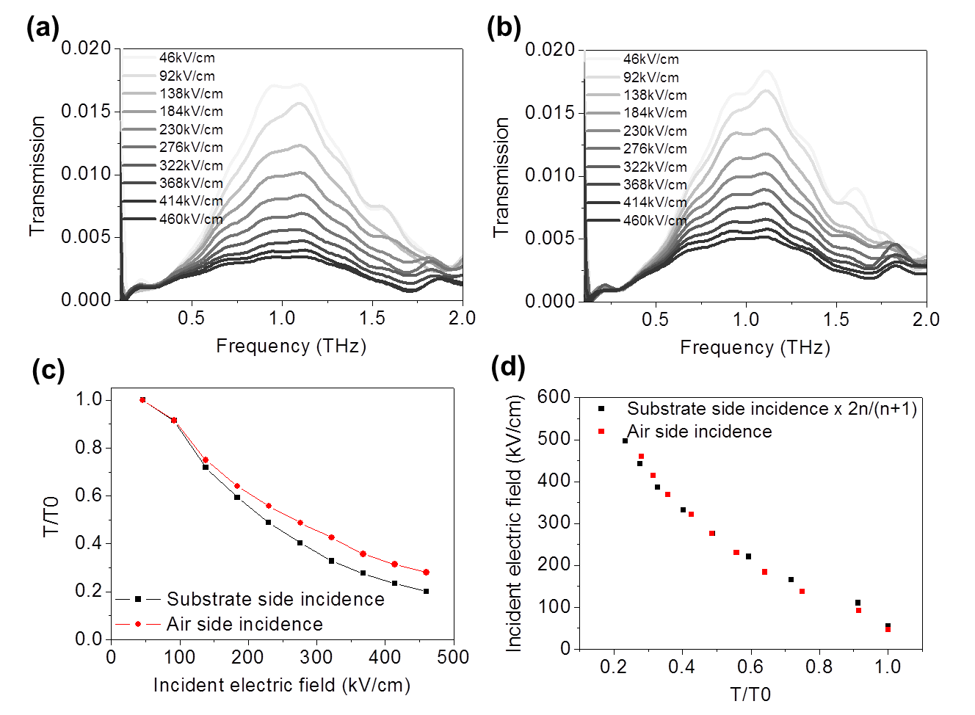
Figure S 3 Nonlinear transmission measurements for graphene gap sample, fabricated on top of a quartz substrate $(n=1.5)$. Transmission curves for (a) substrate side and (b) air side incidence. (c) Relative transmission curve for the same incident electric field. (d) Plot of electric fields required to obtain the same relative transmittance, with a factor ${2n}/{(n+1)}=1.2$ considered for substrate side incidence.

5. Other possible routes for the observed extinction
One of the other possible routes for the observed loss in energy is Ohmic heating of the metal film, which is determined by the electric field inside the metal according to the formula below,
$$P_{Abs}=\int{\vec{J}∙\vec{E} dV}=\int{σE^{2}dV}$$
where J is volume current density and σ is conductivity of the metal. In THz frequencies high metal refractive index of ~1000+1000i leads to extremely small electric field inside the metal, overwhelming the effect of high conductivity and leading to small overall absorption. Figure S4 shows the result of finite element method calculation with a commercial simulation tool (COMSOL Multiphysics 5.2), depicting the electric field profile inside the metal under 1 W excitation on a slit array structure. Electric field inside metal is 4 orders of magnitude smaller than the enhanced near field at the gap, resulting in Ohmic absorption of less than 0.01 W among the incident 1 W, negligible compared with the total observed extinction of over 50%. It is therefore more reasonable that scattering is the main contribution to the extinction, rather than absorption.
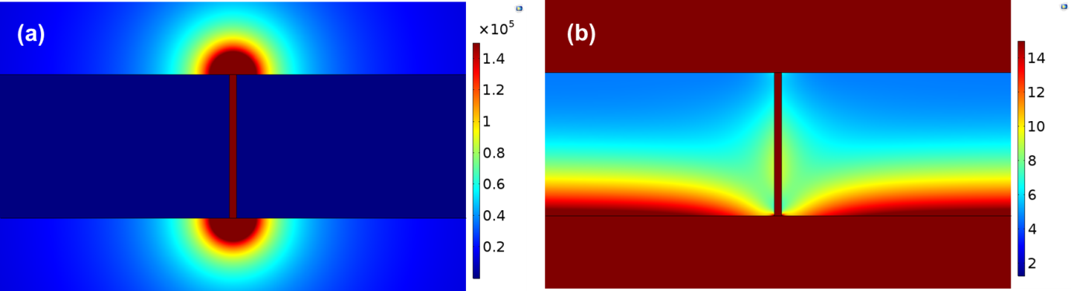
Figure S 4 Electric field distribution (a) outside and (b) inside a slit at 0.5 THz.

References
1. Garcia-Vidal, F. J.; Martin-Moreno, L.; Ebbesen, T. W.; Kuipers, L. Light passing through subwavelength apertures. Rev. Mod. Phys. 2010, 82, 729-787.
2. Garcia-Vidal, F. J.; Moreno, E.; Porto, J. A.; Martin-Moreno, L. Transmission of light through a single rectangular hole. Phys. Rev. Lett. 2005, 95 103901.
3. Garcia-Vidal, F. J.; Martin-Moreno, L.; Moreno, E.; Kumar, L. K. S.; Gordon, R. Transmission of light through a single rectangular hole in a real metal. Phys. Rev. B 2006, 74, 153411.
4. Gordon, R.; Choudhury, A. I. K.; Lu, T. Gap plasmon mode of eccentric coaxial metal waveguide. Opt. Express 2009, 17, 5311-5320.
5. Bahk, Y. M.; Kang, B. J.; Kim, Y. S.; Kim, J. Y.; Kim, W. T.; Kim, T. Y.; Kang, T.; Rhie, J.; Han, S.; Park, C. H.; Rotermund, F.; Kim, D. S. Electromagnetic Saturation of Angstrom-Sized Quantum Barriers at Terahertz Frequencies. Phys. Rev. Lett. 2015, 115, 125501.

