High efficiency/CRI/color stability warm white organic light-emitting diodes by incorporating ultrathin (< 0.1 nm) phosphorescence layers in a blue fluorescence layer
Yanqin Miao*,†, Kexiang Wang†, Bo Zhao†, Long Gao†, Peng Tao†, Xuguang Liu‡, Yuying Hao§, Hua Wang*,†, Bingshe Xu†, Furong Zhu*,∥
† Key Laboratory of Interface Science and Engineering in Advanced Materials of Ministry of Education, Research Center of Advanced Materials Science and Technology, Taiyuan University of Technology, Taiyuan, 030024, PR China
‡ College of Chemistry and Chemical Engineering, Taiyuan University of Technology, Taiyuan, 030024, PR China
§ Key Laboratory of Advanced Transducers and Intelligent Control System of Ministry of Education, College of Physics and Optoelectronics, Taiyuan University of Technology, Taiyuan 030024, PR China
∥ Department of Physics, Institute of Advanced Materials, and Institute of Research and Continuing Education (Shenzhen), Hong Kong Baptist University, Kowloon Tong, NT, Hong Kong, PR China
* Corresponding authors: E-mails: miaoyanqin@tyut.edu.cn (Yanqin Miao), wanghua001@tyut.edu.cn (Hua Wang), frzhu@hkbu.edu.hk(Furong Zhu).

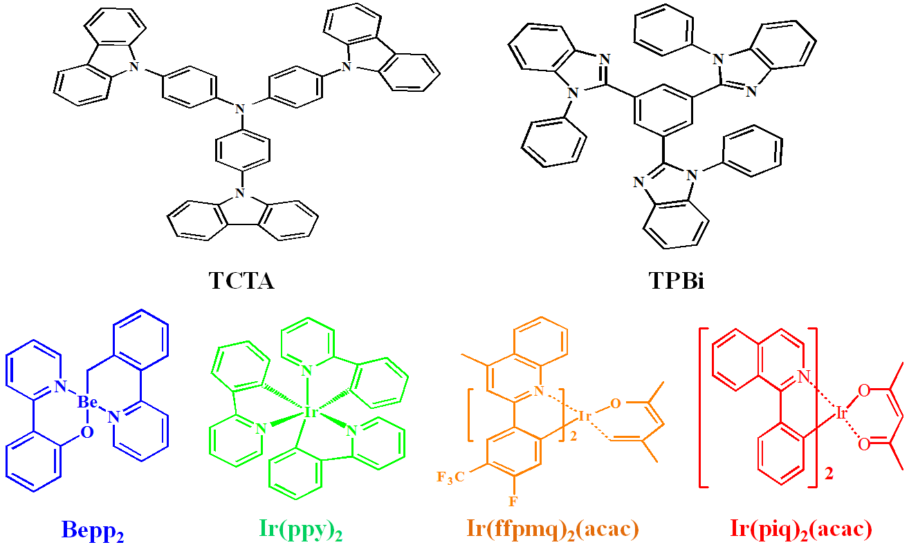
Figure S1. The molecular structures of organic materials used for white devices in this work.

