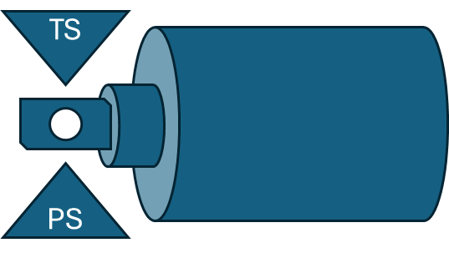
Supplementary figure 1: schematic representation of the temperature (TS) and pressure (PS) sensors placed above and below the sample. The sample is loaded vertically in the HPF chamber and the liquid nitrogen jets arrive orthogonally to the sample to deliver optimal pressure and temperature conditions.

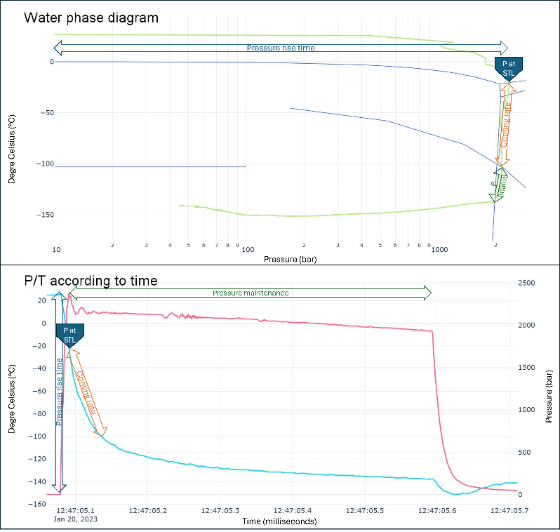
Supplementary figure 2: evaluation criteria for HPF quality assessment. Based on the water phase diagram, we evaluate the pressure rise time from atmospheric pressure to the pressure at solid to liquid transition (STL), from this time to the point of first order transition (TLL) we calculate the cooling rate, from TLL point to pressure drop, we measure the pressure maintenance.

