Synthesis, characterization and cytotoxic activity of triphenyltin complexes of N-(5-bromosalicylidene)-α-amino acids
Yanze Yao, Min Yang, Xiaoliang Zheng, Laijin Tian*

Supplementary data

1. The cell proliferation inhibition rates of the complexes

Supplementary Table 1 The cell proliferation inhibition rates against MCF-7.
1 | Dose (μg/ml) | 0.01 | 0.1 | 1 | 10
1 | Inh% | -19.2 ± 3.2 | 25.2 ± 2.4 | 80.4 ± 1.5 | 90.7 ± 2.4
2 | Dose (μg/ml) | 0.0625 | 0.125 | 0.25 | 0.5
2 | Inh% | 31.6 ± 4.0 | 68.0 ± 9.8 | 87.0 ± 6.2 | 93.3 ± 6.2
3 | Dose (μg/ml) | 0.0625 | 0.125 | 0.25 | 0.5
3 | Inh% | 19.9 ± 10.0 | 58.8 ± 20.3 | 81.3 ± 8.4 | 89.4 ± 4.8
5 | Dose (μg/ml) | 0.125 | 0.25 | 0.5 | 1.0
5 | Inh% | 7.4 ± 3.9 | 43.8 ± 3.6 | 90.8 ± 2.4 | 94.1 ± 1.2
cis-platin | Dose (μg/ml) | 2.5 | 5 | 10 | 20
cis-platin | Inh% | 38.8 ± 5.5 | 44.6 ± 0.5 | 62.2 ± 1.7 | 90.5 ± 2.4

Supplementary Table 2 The cell proliferation inhibition rates against CoLo205.
1 | Dose (μg/ml) | 0.01 | 0.1 | 1 | 10
1 | Inh% | - 6.9 ± 15.0 | - 13.1 ± 25.9 | 81.4 ± 1.6 | 79.3 ± 5.7
2 | Dose (μg/ml) | 0.0625 | 0.125 | 0.25 | 0.5
2 | Inh% | -17.3 ± 11.3 | 10.8 ± 9.9 | 92.3 ± 10.7 | 99.7 ± 4.5
3 | Dose (μg/ml) | 0.0625 | 0.125 | 0.25 | 0.5
3 | Inh% | -1.0 ± 1.2 | 12.4 ± 4.1 | 58.1 ± 12.5 | 96.6 ± 2.2
5 | Dose (μg/ml) | 0.125 | 0.25 | 0.5 | 1.0
5 | Inh% | -9.9 ± 6.4 | 8.1 ± | 83.0 ± | 92.8 ±
cis-platin | Dose (μg/ml) | 0.16 | 0.8 | 4 | 20
cis-platin | Inh% | 16.2 ± 7.0 | 32.7 ± 2.4 | 39.0 ± 1.4 | 70.9 ± 7.3

Supplementary Table 3 The cell proliferation inhibition rates against HeLa.
5 | Dose (μg/ml) | 0.01 | 0.05 | 0.25 | 1.25
5 | Inh% | -7.1 ± 0.8 | 3.1 ± 6.2 | 90.1 ± 2.4 | 94.5 ± 0.7
cis-platin | Dose (μg/ml) | 0.16 | 0.8 | 4 | 20
cis-platin | Inh% | 1.0 ± 3.6 | 40.3 ± 2.1 | 60.0 ± 3.5 | 92.6 ± 3.9

2. Stability of complexes
The 200 mg/L stock solutions were prepared by dissolving 20 mg of the test compounds in 2 mL ethanol and by diluting the resultant solutions with serum-free DMEM (Dulbecco’s Modified Eagle Medium) culture media under ultrasound. This solution was kept at 4°C in a refrigerator. After a week, the solution was extract with CHCl₃. The extraction solution was evaporated by a rotary evaporator. The resulting yellow solid was dissolved in CDCl₃ and the ¹¹⁹Sn NMR was recorded. The ¹¹⁹Sn NMR data of the complexes 1, 2, 3 and 5 showed that there is only a singlet and the shift does not change obviously compared with the original shift. The ¹¹⁹ NMR shifts of 1, 2, 3 and 5 are -96.0, -95.6, -97.6, and -100.1 ppm, respectively. This indicted that the complexes in this solution are stable and do not decompose.
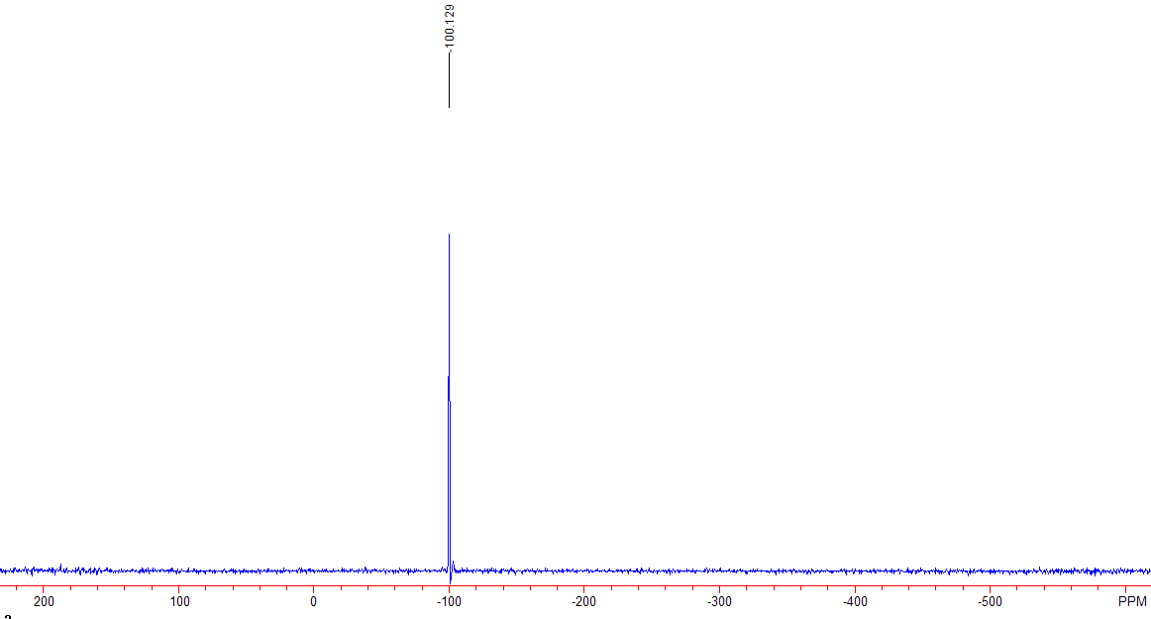

Supplementary Figure 1 ¹¹⁹Sn NMR of complex 5 after a week.

