Crystal structure of the triphenyltin(IV) chloride dimethyl N-cyanodithioiminocarbonate adduct

Mouhamadou Birame Diop, Yaya Sow, Libasse Diop,
Laurent Plasseraud and Hélène Cattey

Supplementary material

- Figure S1 Middle infrared spectra (ATR) of (a) L and (b) 1.
- Figure S2 Far infrared spectra (ATR) of (a) Ph₃SnCl, (b) 1 and (c) L.
- Figure S3 ¹H NMR spectrum of 1 (CDCl₃, 300 K).
- Figure S4 ¹³C{¹H} NMR spectrum of 1 (CDCl₃, 300 K).
- Figure S5 ¹¹⁹Sn{¹H} NMR spectrum of 1 (CDCl₃, 300 K).
- Figure S6 δ(¹¹⁹Sn{¹H}) versus concentration of 1 (CD₂Cl₂, 300 K): (a) 2 M, (b) 1 M and (c) 0.5 M.
- Figure S7 Middle Infrared spectra (transmission) of (a) L and (b) 1 in dichloromethane solution.

Figure S1. Middle infrared spectra (ATR) of (a) L and (b) 1.

Figure S2. Far Infrared spectra (ATR) of (a) Ph₃SnCl, (b) 1 and (c) L.

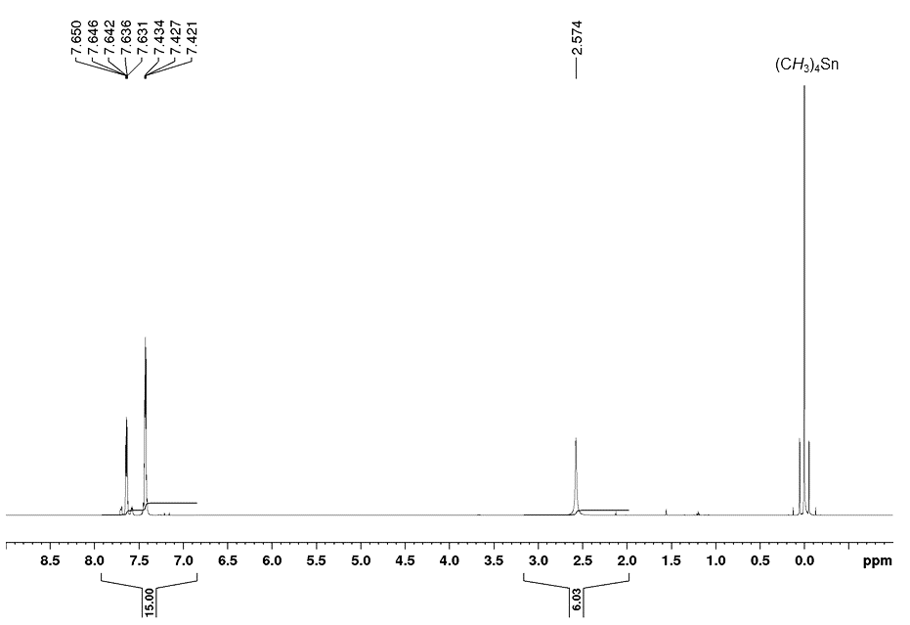
Figure S3. ¹H NMR spectrum of 1 (CDCl₃, 300 K).

Figure S4. ¹³C{¹H} NMR spectrum of 1 (CDCl₃, 300 K).

Figure S5. ¹¹⁹Sn{¹H} NMR spectrum of 1 (CDCl₃, 300 K).

Figure S6. δ(¹¹⁹Sn{¹H}) versus concentration of 1 (CD₂Cl₂, 300 K): (a) 2 M, (b) 1 M and (c) 0.5 M.

Figure S7. Middle Infrared spectra (transmission) of (a) L and (b) 1 in dichloromethane solution.

