Image 1: Generations and Multimodal Linguistic Humor Types

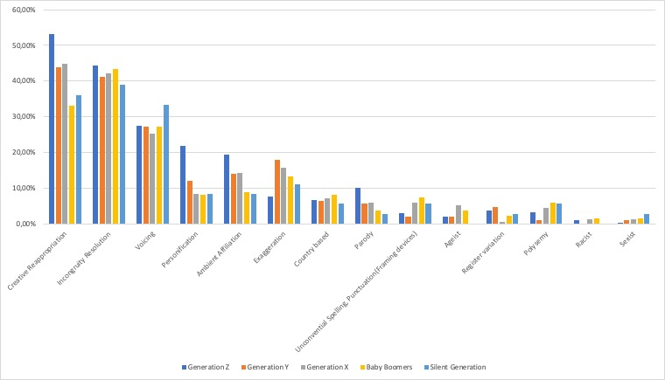

Supplementary material

Image 2: Generations

Image 3: Mosaic Plot: Humor Topics and Generations

Image 4 Languages of memes per generation

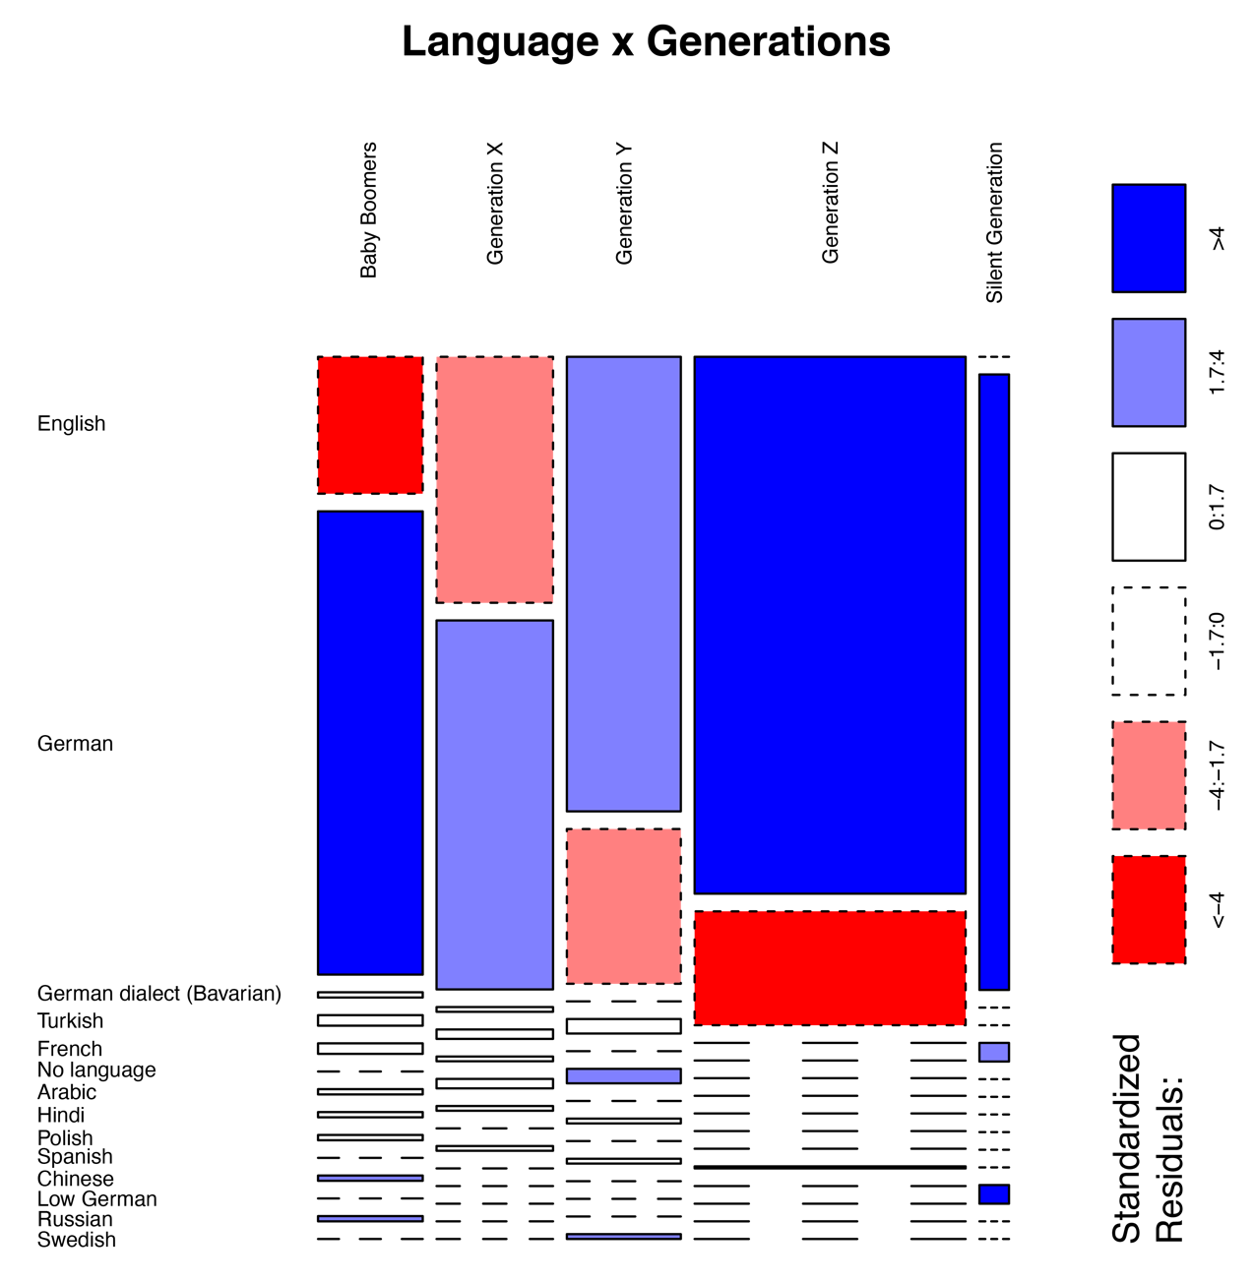

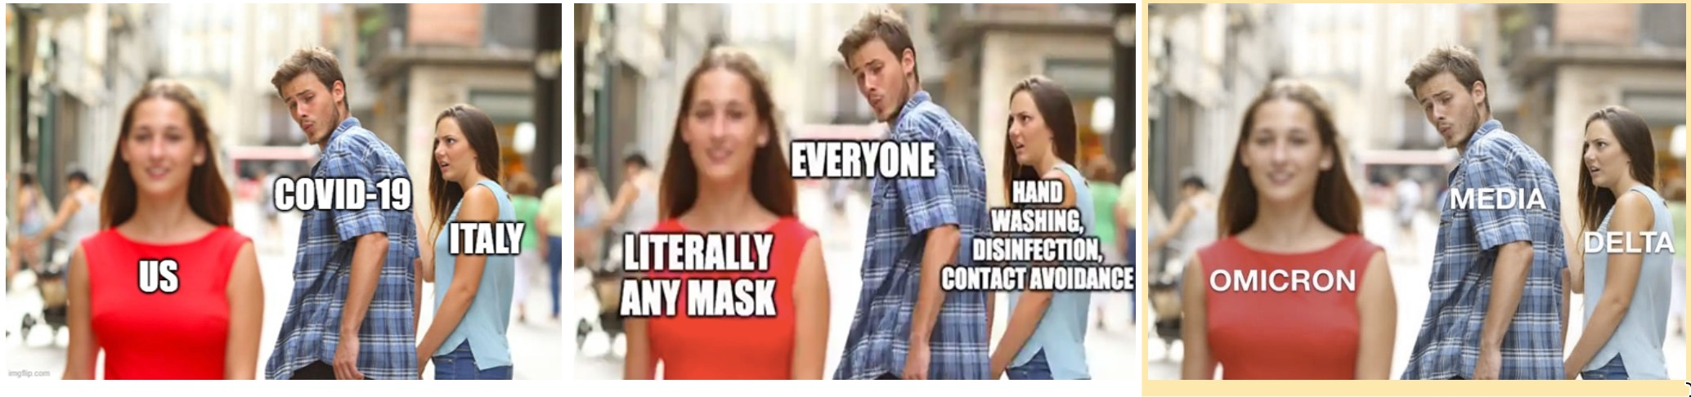

Panel 1: Variation of the distracted boyfriend meme

Source: https://knowyourmeme.com/memes/distracted-boyfriend

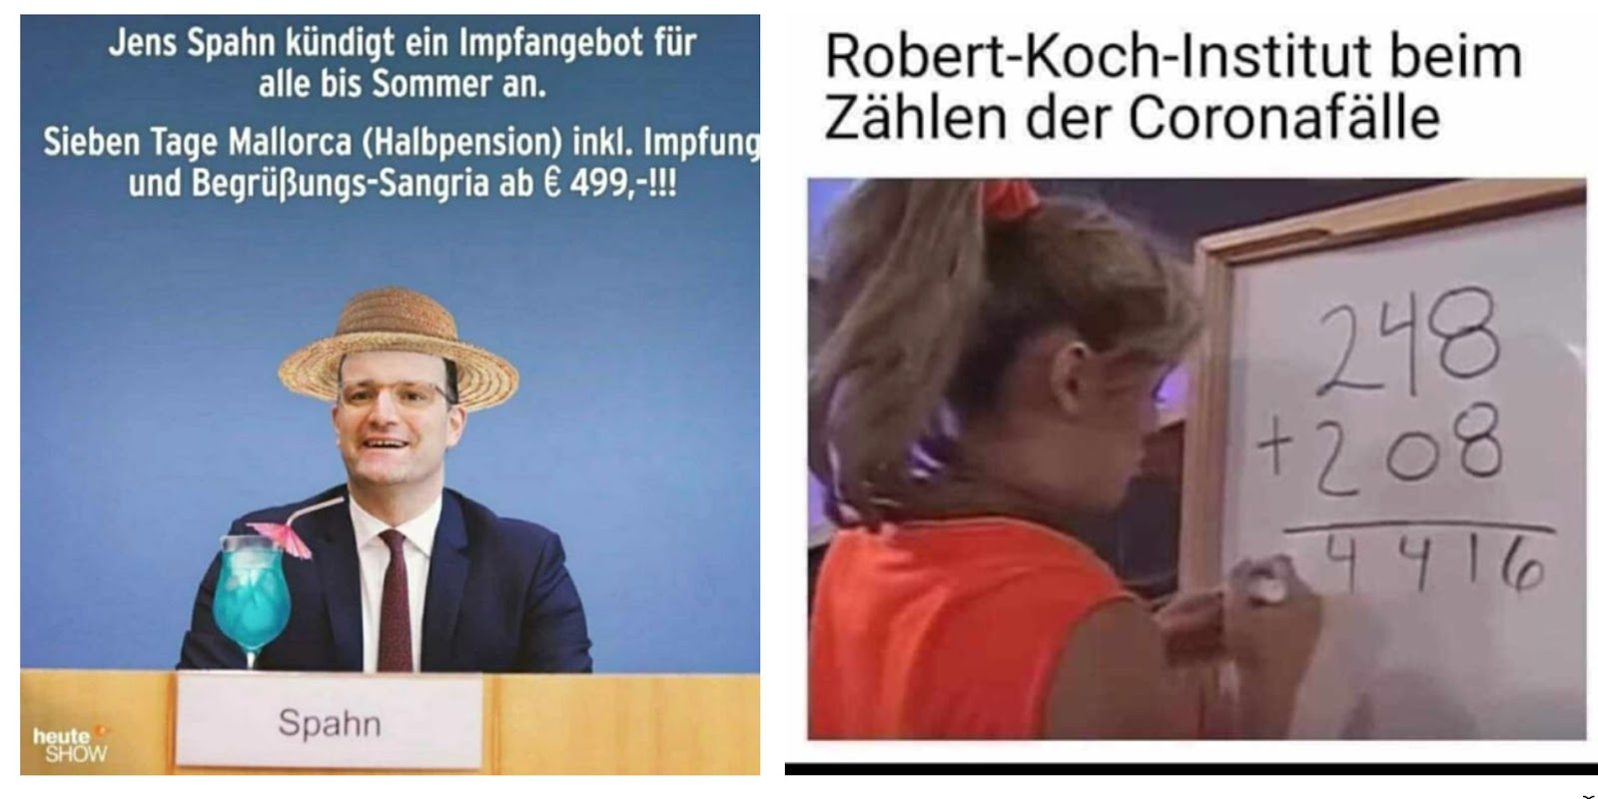

Panel 2

<https://www.facebook.com/Hessenschau/photos/?ref=page_internal>