**Supplementary Material**

**The karyotype along with molecular data of the Iranian lineage of the bicolored shrew *Crocidura leucodon* (Hermann, 1780) provides evidence of the species level of *C. persica* Thomas, 1907**

Hessamodin Zali et al.

DOI 10.1515/mammalia-2024-0111

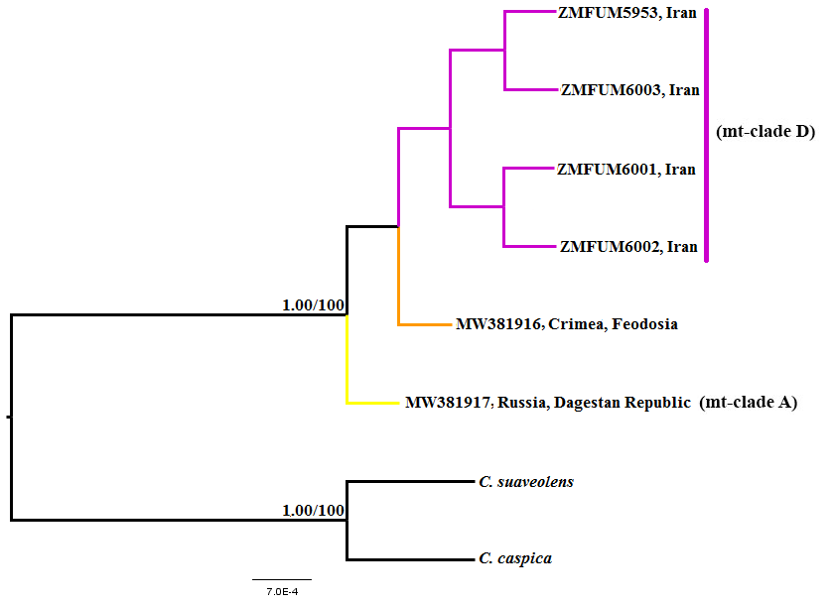

**Figure S1:** Phylogenetic relationships between the specimens of *Crocidura leucodon* produced by Bayesian inference (BI) analysis that was inferred from nuclear ApoB marker. Numbers on branches refer to posterior probability (PP) and bootstrap (BP) values in the BI and maximum likelihood (ML) analyses, respectively.

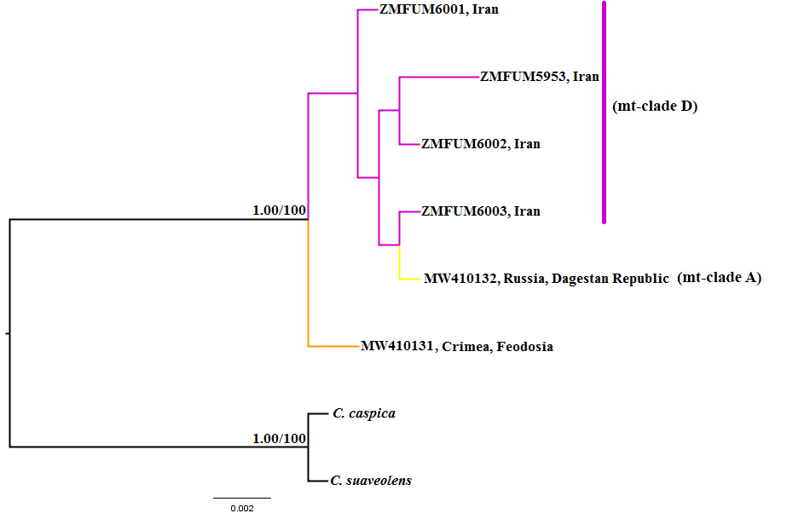

**Figure S2:** Phylogenetic relationships between the specimens of *Crocidura leucodon* produced by Bayesian Inference (BI) analysis that was inferred from nuclear BRCA1 marker. Numbers on branches refer to posterior probability (PP) and bootstrap (BP) values in the BI and maximum likelihood (ML) analyses, respectively.

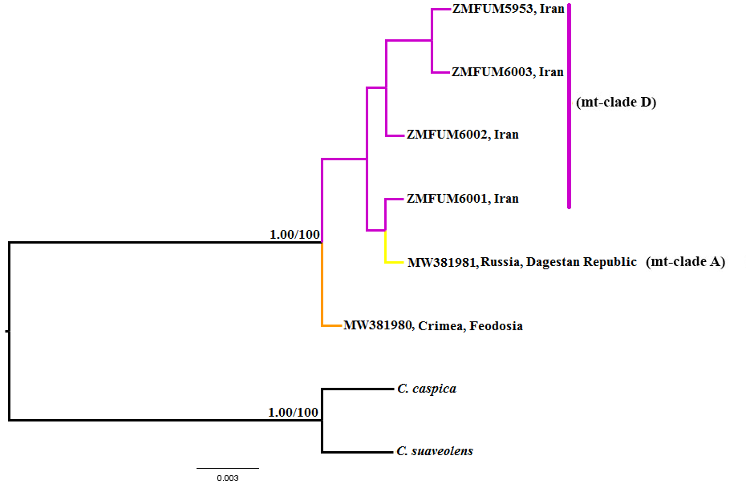

**Figure S3:** Phylogenetic relationships between the specimens of *Crocidura leucodon* produced by Bayesian Inference (BI) analysis that was inferred from nuclear vWF marker. Numbers on branches refer to posterior probability (PP) and bootstrap (BP) values in the BI and maximum likelihood (ML) analyses, respectively.

**Table S1:** Details of samples used in this study: species, locality, accession number or Museum registration number of cytb, and nuclear markers sequences. The exact location of the localities marked with * is not known.

|  |  |  |  |  |
| --- | --- | --- | --- | --- |
| **Reference** | **Number on the map** | **GenBank accession number or Museum registration number** | **Locality** | **Species** |
| Bannikova et al. 2021 | 1 | OP599556 (cytb) | Russia, Dagestan Republic | *C. leucodon* (clade A) |
| Dubey et al. 2007a | 2 | DQ994757 (cytb) | Georgia, Alazani | *C. leucodon* (clade A) |
| Dubey et al. 2007a | 2 | DQ994756 (cytb) | Georgia, Alazani | *C. leucodon* (clade A) |
| Dubey et al. 2007a | 2 | DQ994758 (cytb) | Georgia, Alazani | *C. leucodon* (clade A) |
| Dubey et al. 2007a | 3 | DQ994759 (cytb) | Turkey, Altindere | *C. leucodon* (clade A). |
| Dubey et al. 2007a | 4 | DQ994755 (cytb) | Turkey, Rize | *C. leucodon* (clade A) |
| Dubey et al. 2007a | 4 | DQ994754 (cytb) | Turkey, Rize | *C. leucodon* (clade A) |
| Dubey et al. 2007a | 4 | DQ994753 (cytb) | Turkey, Rize | *C. leucodon* (clade A) |
| Dubey et al. 2007a | 4 | DQ994752 (cytb) | Turkey, Rize | *C. leucodon* (clade A) |
| Dubey et al. 2007a | 5 | DQ994751 (cytb) | Turkey, Cakalli | *C. leucodon* (clade A) |
| Dubey et al. 2007a | 6 | DQ994787 (cytb) | Turkey, Yellibeli | *C. leucodon* (clade A) |
| Dubey et al. 2007a | 7 | DQ994786 (cytb) | Turkey, Çiğlikara | *C. leucodon* (clade A) |
| Dubey et al. 2007b | 3 | DQ065609 (cytb) | Turkey | *C. leucodon* (clade A) |
| Kalkan et al. Unpublished | - | OR148018 (cytb) | Turkey* | *C. leucodon* (clade A) |
| Kalkan et al. Unpublished | - | OR148017 (cytb) | Turkey* | *C. leucodon* (clade A) |
| Kalkan et al. Unpublished | - | OR148024 (cytb) | Turkey* | *C. leucodon* (clade A) |
| Kalkan et al. Unpublished | - | OR148023 (cytb) | Turkey* | *C. leucodon* (clade A) |
| Kalkan et al. Unpublished | - | OR148016 (cytb) | Turkey* | *C. leucodon* (clade A) |
| Kalkan et al. Unpublished | - | OR148020 (cytb) | Turkey* | *C. leucodon* (clade A) |
| Kalkan et al. Unpublished | - | OR148019 (cytb) | Turkey* | *C. leucodon* (clade A) |
| Kalkan et al. Unpublished | - | OR148008 (cytb) | Turkey* | *C. leucodon* (clade A) |
| Kalkan et al. Unpublished | - | OR148021 (cytb) | Turkey* | *C. leucodon* (clade A) |
| Kalkan et al. Unpublished | - | OR148009 (cytb) | Turkey* | *C. leucodon* (clade A) |
| Kalkan et al. Unpublished | - | OR148022 (cytb) | Turkey* | *C. leucodon* (clade A) |
| Kalkan et al. Unpublished | - | OR148011 (cytb) | Turkey* | *C. leucodon* (clade A) |
| Kalkan et al. Unpublished | - | OR148010 (cytb) | Turkey* | *C. leucodon* (clade A) |
| Kalkan et al. Unpublished | - | OR148015 (cytb) | Turkey* | *C. leucodon* (clade A) |
| Kalkan et al. Unpublished | - | OR148014 (cytb) | Turkey* | *C. leucodon* (clade A) |
| Kalkan et al. Unpublished | - | OR148013 (cytb) | Turkey* | *C. leucodon* (clade A) |
| Kalkan et al. Unpublished | - | OR148012 (cytb) | Turkey* | *C. leucodon* (clade A) |
| Dubey et al. 2007a | 8 | DQ994792 (cytb) | Romania, Slobozia | *C. leucodon* (clade A) |
| Dubey et al. 2007a | 9 | DQ994791 (cytb) | Romania, Cataloi | *C. leucodon* (clade A) |
| Dubey et al. 2007a | 10 | DQ994776 (cytb) | Bulgaria, Burgas | *C. leucodon* (clade A) |
| Dubey et al. 2007a | 10 | DQ994775 (cytb) | Bulgaria, Burgas | *C. leucodon* (clade A) |
| Dubey et al. 2007a | 10 | DQ994774 (cytb) | Bulgaria, Burgas | *C. leucodon* (clade A) |
| Shpirer et al. 2021 | 11 | LR536366 (cytb) | Israel | *C. leucodon* (clade B) |
| Shpirer et al. 2021 | 11 | LR536310 (cytb) | Israel | *C. leucodon* (clade B) |
| Shpirer et al. 2021 | 11 | LR536311 (cytb) | Israel | *C. leucodon* (clade B) |
| Shpirer et al. 2021 | 11 | LR536312 (cytb) | Israel | *C. leucodon* (clade B) |
| Shpirer et al. 2021 | 11 | LR536313 (cytb) | Israel | *C. leucodon* (clade B) |
| Shpirer et al. 2021 | 11 | LR536314 (cytb) | Israel | *C. leucodon* (clade B) |
| Shpirer et al. 2021 | 11 | LR536315 (cytb) | Israel | *C. leucodon* (clade B) |
| Shpirer et al. 2021 | 11 | LR536316 (cytb) | Israel | *C. leucodon* (clade B) |
| Dubey et al. 2007a | 12 | DQ994773 (cytb) | Italy, Piacenza | *C. leucodon* (clade C) |
| Dubey et al. 2007a | 13 | DQ994772 (cytb) | Italy, Serramazoni | *C. leucodon* (clade C) |
| Dubey et al. 2007a | 13 | DQ994771 (cytb) | Italy, Serramazoni | *C. leucodon* (clade C) |
| Dubey et al. 2007a | 13 | DQ994770 (cytb) | Italy, Serramazoni | *C. leucodon* (clade C) |
| Dubey et al. 2007a | 14 | DQ994769 (cytb) | Italy, Vercelli | *C. leucodon* (clade C) |
| Dubey et al. 2007a | 14 | DQ994768 (cytb) | Italy, Vercelli | *C. leucodon* (clade C) |
| Dubey et al. 2007a | 14 | DQ994767 (cytb) | Italy, Vercelli | *C. leucodon* (clade C) |
| Dubey et al. 2007a | 15 | EF417543 (cytb) | Turkey, Katrancı | *C. leucodon* (clade C) |
| Dubey et al. 2007a | 16 | EF417544 (cytb) | Turkey, Özbek | *C. leucodon* (clade C) |
| Dubey et al. 2007a | 17 | EF417545 (cytb) | Turkey, Terzialan | *C. leucodon* (clade C) |
| Dubey et al. 2007a | 18 | DQ994778 (cytb) | Greece, Lesbos | *C. leucodon* (clade C) |
| Dubey et al. 2007a | 18 | DQ994777 (cytb) | Greece, Lesbos | *C. leucodon* (clade C) |
| Dubey et al. 2007a | 19 | DQ994749 (cytb) | Switzerland, Gordevio | *C. leucodon* (clade C) |
| Dubey et al. 2007a | 19 | DQ994748 (cytb) | Switzerland, Gordevio | *C. leucodon* (clade C) |
| Dubey et al. 2007a | 20 | DQ994785 (cytb) | Switzerland, Grison | *C. leucodon* (clade C) |
| Dubey et al. 2007a | 21 | DQ994747 (cytb) | Switzerland, Brigerbad | *C. leucodon* (clade C) |
| Dubey et al. 2007a | 21 | DQ994746 (cytb) | Switzerland, Raron | *C. leucodon* (clade C) |
| Dubey et al. 2007a | 21 | DQ994745 (cytb) | Switzerland, Rechy | *C. leucodon* (clade C) |
| Dubey et al. 2007a | 21 | DQ994744 (cytb) | Switzerland, Visp | *C. leucodon* (clade C) |
| Dubey et al. 2007a | 19 | DQ994750 (cytb) | Switzerland, Quartino | *C. leucodon* (clade C) |
| Ruedi et al. 2023 | 22 | OQ885426 (cytb) | Switzerland | *C. leucodon* (clade C) |
| Dubey et al. 2007a | 23 | DQ994780 (cytb) | France, Mignouillard | *C. leucodon* (clade C) |
| Dubey et al. 2007a | 24 | DQ994779 (cytb) | France, Chapelle | *C. leucodon* (clade C) |
| Dubey et al. 2007a | 25 | DQ994784 (cytb) | France, St-Etienne | *C. leucodon* (clade C) |
| Dubey et al. 2007a | 26 | DQ994783 (cytb) | France, St-Martin | *C. leucodon* (clade C) |
| Dubey et al. 2007a | 24 | DQ994782 (cytb) | France, Chapelle | *C. leucodon* (clade C) |
| Dubey et al. 2007a | 23 | DQ994781 (cytb) | France, Mignouillard | *C. leucodon* (clade C) |
| Dubey et al. 2007a | 27 | DQ994766 (cytb) | Slovak Republic, Bratislava | *C. leucodon* (clade C) |
| Dubey et al. 2007a | 27 | DQ994765 (cytb) | Slovak Republic, Bratislava | *C. leucodon* (clade C) |
| Dubey et al. 2007a | 28 | DQ994764 (cytb) | Germany, Rendsburg | *C. leucodon* (clade C) |
| Dubey et al. 2007a | 28 | DQ994763 (cytb) | Germany, Rendsburg | *C. leucodon* (clade C) |
| Dubey et al. 2007a | 28 | DQ994762 (cytb) | Germany, Rendsburg | *C. leucodon* (clade C) |
| Dubey et al. 2007a | 28 | DQ994761 (cytb) | Germany, Rendsburg | *C. leucodon* (clade C) |
| Dubey et al. 2007a | 29 | DQ994789 (cytb) | Czech Republic, Karlovy Vary | *C. leucodon* (clade C) |
| Dubey et al. 2007a | 29 | DQ994788 (cytb) | Czech Republic, Karlovy Vary | *C. leucodon* (clade C) |
| De Bellocq et al. 2023 | 35 | OQ929010 (cytb) | Czech Republic | *C. leucodon* (clade C) |
| De Bellocq et al. 2023 | 35 | OQ929024 (cytb) | Czech Republic | *C. leucodon* (clade C) |
| De Bellocq et al. 2023 | 35 | OQ929019 (cytb) | Czech Republic | *C. leucodon* (clade C) |
| De Bellocq et al. 2023 | 35 | OQ929012 (cytb) | Czech Republic | *C. leucodon* (clade C) |
| De Bellocq et al. 2023 | 35 | OQ929016 (cytb) | Czech Republic | *C. leucodon* (clade C) |
| De Bellocq et al. 2023 | 35 | OQ929017 (cytb) | Czech Republic | *C. leucodon* (clade C) |
| De Bellocq et al. 2023 | 35 | OQ928972 (cytb) | Czech Republic | *C. leucodon* (clade C) |
| De Bellocq et al. 2023 | 35 | OQ928977 (cytb) | Czech Republic | *C. leucodon* (clade C) |
| De Bellocq et al. 2023 | 35 | OQ928978 (cytb) | Czech Republic | *C. leucodon* (clade C) |
| De Bellocq et al. 2023 | 35 | OQ929009 (cytb) | Czech Republic | *C. leucodon* (clade C) |
| De Bellocq et al. 2023 | 35 | OQ979322 (cytb) | Czech Republic | *C. leucodon* (clade C) |
| De Bellocq et al. 2023 | 35 | OQ928986 (cytb) | Czech Republic | *C. leucodon* (clade C) |
| De Bellocq et al. 2023 | 35 | OQ928979 (cytb) | Czech Republic | *C. leucodon* (clade C) |
| De Bellocq et al. 2023 | 35 | OQ929026 (cytb) | Czech Republic | *C. leucodon* (clade C) |
| De Bellocq et al. 2023 | 35 | OQ929025 (cytb) | Czech Republic | *C. leucodon* (clade C) |
| De Bellocq et al. 2023 | 35 | OQ928975 (cytb) | Czech Republic | *C. leucodon* (clade C) |
| De Bellocq et al. 2023 | 35 | OQ929014 (cytb) | Czech Republic | *C. leucodon* (clade C) |
| De Bellocq et al. 2023 | 35 | OQ929027 (cytb) | Czech Republic | *C. leucodon* (clade C) |
| De Bellocq et al. 2023 | 35 | OQ928962 (cytb) | Czech Republic | *C. leucodon* (clade C) |
| Mahmoudi et al. 2019 | 30 | MH602279 (cytb) | Iran, Zanjan, Soltanieh | *C. leucodon* (clade D) |
| Mahmoudi et al. 2019 | 31 | MH602278 (cytb) | Iran, Semnan, Jashlobar | *C. leucodon* (clade D) |
| Mahmoudi et al. 2019 | 33 | MH602277 (cytb) | Iran, North Khorasan, Darkesh | *C. leucodon* (clade D) |
| Mahmoudi et al. 2019 | 33 | MH602276 (cytb) | Iran, North Khorasan, Darkesh | *C. leucodon* (clade D) |
| Mahmoudi et al. 2019 | 33 | MH602275 (cytb) | Iran, North Khorasan, Darkesh | *C. leucodon* (clade D) |
| Mahmoudi et al. 2019 | 33 | MH602274 (cytb) | Iran, North Khorasan, Darkesh | *C. leucodon* (clade D) |
| Mahmoudi et al. 2019 | 33 | MH602273 (cytb) | Iran, North Khorasan, Darkesh | *C. leucodon* (clade D) |
| Mahmoudi et al. 2019 | 33 | MH602272 (cytb) | Iran, North Khorasan, Darkesh | *C. leucodon* (clade D) |
| Mahmoudi et al. 2019 | 33 | MH602271 (cytb) | Iran, North Khorasan, Darkesh | *C. leucodon* (clade D) |
| This study | 32 | ZMFUM5953 (cytb, ApoB, BRCA1, vWF) | Iran, North Khorasan, Chenaranshahr | *C. leucodon* (clade D) |
| This study | 33 | ZMFUM6001 (cytb, ApoB, BRCA1, vWF) | Iran, North Khorasan, Darkesh | *C. leucodon* (clade D) |
| This study | 33 | ZMFUM6002 (cytb, ApoB, BRCA1, vWF) | Iran, North Khorasan, Darkesh | *C. leucodon* (clade D) |
| This study | 33 | ZMFUM6003 (cytb, ApoB, BRCA1, vWF) | Iran, North Khorasan, Darkesh | *C. leucodon* (clade D) |
| Bannikova et al. 2021 | 34 | MW381916 (ApoB) | Crimea, Feodosia | *C. leucodon* |
| Bannikova et al. 2021 | 1 | MW381917 (ApoB) | Russia, Dagestan Republic | *C. leucodon* |
| Bannikova et al. 2021 | 34 | MW410131 (BRCA1) | Crimea, Feodosia | *C. leucodon* |
| Bannikova et al. 2021 | 1 | MW410132 (BRCA1) | Russia, Dagestan Republic | *C. leucodon* |
| Bannikova et al. 2021 | 34 | MW381980 (vWF) | Crimea, Feodosia | *C. leucodon* |
| Bannikova et al. 2021 | 1 | MW381981 (vWF) | Russia, Dagestan Republic | *C. leucodon* |
| Gritsyshin et al. 2022 | - | MW297785 (cytb) | Russia | *C. suaveolens* |
| Bannikova et al. 2006 | - | AY994370 (cytb) | Azerbaijan | *C. caspica* |
| Bannikova et al. 2021 | - | OP599610 (ApoB) | Crimea | *C. suaveolens* |
| Gritsyshin et al. 2023 | - | OQ375085 (ApoB) | Azerbaijan | *C. caspica* |
| Bannikova et al. 2021 | - | OOP599585 (BRCA1) | Crimea | *C. suaveolens* |
| Gritsyshin et al. 2023 | - | OQ375844 | Azerbaijan | *C. caspica* |
| Gritsyshin et al. 2023 | - | OQ375592 | Crimea | *C. suaveolens* |
| Gritsyshin et al. 2023 | - | OQ375624 | Azerbaijan | *C. caspica* |

**Table S2:** Mean pairwise K2P cytb distances between the main clades of *Crocidura leucodon* with in-group distances (bold numbers).

|  |  |  |  |  |  |
| --- | --- | --- | --- | --- | --- |
|  | **A** | **B** | **C** | **D** | **Zanjan specimen** |
| Clade A | **0.6** |  |  |  |  |
| Clade B | 1.8 | **0.1** |  |  |  |
| Clade C | 3.4 | 3.0 | **0.5** |  |  |
| Clade D (except Zanjan specimen) | 6.2 | 5.6 | 7.0 | **0.2** |  |
| Zanjan specimen | 8.0 | 7.5 | 8.7 | 2.9 | **-** |

**Supplementary References**

Bannikova, A.A., Lebedev, V.S., Kramerov, D.A. and Zaitsev, M.V. (2006). Phylogeny and systematics of the Crocidura suaveolens species group: corroboration and controversy between nuclear and mitochondrial DNA markers/Phylogénie et systématique du groupe d'espèces *Crocidura suaveolens*: coordination et contradiction des marqueurs nucléaire et mitochondriaux de l'ADN. *Mammalia* 70(1-2): 106-119.

Bannikova, A.A., Zemlemerova, E.D., Lebedev, V.S. and Lavrenchenko, L.A. (2021). The phylogenetic relationships within the Eastern Afromontane clade of *Crocidura* based on mitochondrial and nuclear da*ta. Mammalian Biology* 101: 1005-1018.

De Bellocq, J.G., Fornůsková, A., Ďureje, Ľ., Bartákova, V., Daniszová, K., Dianat, M., Janča, M., Šabata, P., Šeneklová, N., Stodůlka, T., et al. (2023). First record of the greater white-toothed shrew, Crocidura russula, in the Czech Republic. *Journal of Vertebrate Biology* 72(23047): 23047.1-9.

Dubey, S., Cosson, J.F., Vohralik, V., Krystufek, B., Diker, E., and Vogel, P. (2007a). Molecular evidence of Pleistocene bidirectional faunal exchange between Europe and the Near East: the case of the bicoloured shrew (*Crocidura leucodon*, Soricidae). *Journal of Evolutionary Biology* 20(5): 1799-1808.

Dubey, S., Nová, P., Vogel, P., and Vohralík, V. (2007b). Cytogenetic and molecular relationships between Zarudny's rock shrew (*Crocidura zarudnyi*; Mammalia: Soricomorpha) and Eurasian taxa. *Journal of Mammalogy* 88(3): 706-711.

Gritsyshin, V.A., Lisenkova, A.A., Speranskaya, A.S., Artyushin, I.V., Sheftel, B.I., Lebedev, V.S. and Bannikova, A.A. (2023). Multilocus analysis of phylogenetic relationships in the *Crocidura suaveolens* *sensu lato* species complex: a comparison with mitochondrial data. *Doklady Biological Sciences* 509(1): 128-134.

Mahmoudi, A., Darvish, J., Siahsarvie, R., Dubey, S., and Kryštufek, B. (2019). Mitochondrial sequences retrieve an ancient lineage of bicolored shrew in the Hyrcanian refugium. *Mammalian Biology* 95: 160-163.

Ruedi, M., Manzinalli, J., Dietrich, A. and Vinciguerra, L. (2023). Shortcomings of DNA barcodes: a perspective from the mammal fauna of Switzerland. *Hystrix, the Italian Journal of Mammalogy* 34(1): 54-61.

Shpirer, E., Haddas-Sasson, M., Spivak-Glater, M., Feldstein, T., Meiri, S., and Huchon, D. (2021). Molecular relationships of the Israeli shrews (Eulipotyphla: Soricidae) based on cytochrome b sequences. *Mammalia* 85(1): 79-89.