Supplementary Material
New records and potential distribution of the Barbary ground squirrel (Atlantoxerus getulus) in arid ecosystems of Western Algeria
Moussouni Abdenour et al.
DOI 10.1515/mammalia-2024-0076

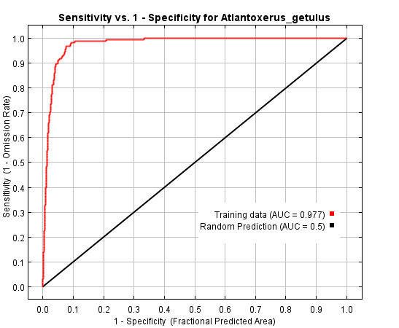

Supplementary Figure S1: Receiver operating characteristic (ROC) curve for evaluating the distribution of Barbary ground squirrel based on the MaxEnt model area under the curve (AUC) used to assess model prediction effectiveness. The AUC values vary from 0 to 1; values < 0.5 indicate that the model performance is worse than random, 0.5 indicates performance that is not better than random, 0.5–0.7 indicates poor performance, 0.7–0.9 indicates reasonable or moderate performance, and >0.9 indicates high performance. The model predicted Barbary ground squirrel distribution with high confidence (AUC for training data = 0.977).

