Supplementary Material
Variation in mammal ecological patterns in response to seasonality in a Brazilian tropical dry forest
Maria Luísa Falcão et al.
DOI 10.1515/mammalia-2024-0066

Supplementary Figure S1: Climograph with total precipitation (mm) and mean temperature (ºC) for Mossoró in the sampling year, 2018, obtained from INMET data (https://portal.inmet.gov.br/). The y-axis on the left shows precipitation (mm) and the temperature (ºC) on the right.
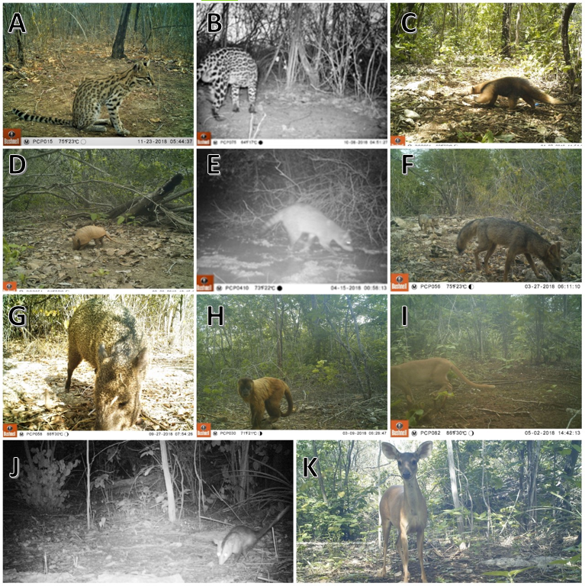
Supplementary Figure S2: Mammals recorded in the Furna Feia National Park, Caatinga of Northeastern Brazil: (A) Leopardus tigrinus, (B) Leopardus pardalis, (C) Tamandua tetradactyla, (D) Euphractus sexcinctus, (E) Procyon cancrivorus, (F) Cerdocyon thous, (G) Dicotyles tajacu, (H) Sapajus libidinosus, (I) Herpailurus yagouaroundi, (J) Didelphis albiventris, (K) Subulo gouazoubira.

Supplementary Table S1: Indication of the effect (sum of weights) of the season and effort variables on the occupancy (psi) and detection (p) of mammals recorded in Furna Feia National Park, Caatinga, Northeast Brazil.
Species | Variable | Weight
S. gouazoubira | p(season) | 0.65
S. gouazoubira | psi(season) | 0.55
S. gouazoubira | p(effort) | 0.28
E. sexcinctus | p(season) | 0.83
E. sexcinctus | psi(season) | 0.29
E. sexcinctus | p(effort) | 0.29
S. libidinosus | p(season) | 0.45
S. libidinosus | psi(season)* | 0.49
S. libidinosus | p(effort) | 0.46
C. thous | p(season) | 0.34
C. thous | psi(season) | 0.28
C. thous | p(effort) | 0.42
D. albiventris | p(season)* | 0.49
D. albiventris | psi(season) | 0.54
D. albiventris | p(effort) | 0.29
L. tigrinus | p(season) | 0.86
L. tigrinus | psi(season) | 0.35
L. tigrinus | p(effort) | 0.35
*Values which, although lower than the cut-off score of 0.5, should be highlighted.

Supplementary Table S2: Medium and large mammals recorded in Furna Feia National Park, Caatinga in northeastern Brazil, with the best models (with ΔAIC < 2) obtained in the Mark Program, ranked by AICc, ΔAIC, AICc weights and the number of parameters.
Species | Model | AICc | Delta AICc | AICc weights | No. of parameters
S. gouazoubira | p(.)+psi(.)+p(season) | 427.20 | 0 | 0.28 | 3
S. gouazoubira | p(.)+psi(.)+psi(season) | 427.61 | 0.42 | 0.23 | 3
S. gouazoubira | p(.)+psi(.)+p(season)+psi(season) | 428.17 | 0.98 | 0.17 | 4
S. gouazoubira | p(.)+psi(.)+p(season)+p(effort) | 428.86 | 1.67 | 0.12 | 4
E. sexcinctus | p(.)+psi(.)+p(season) | 400.35 | 0 | 0.45 | 3
E. sexcinctus | p(.)+psi(.)+p(season)+psi(season) | 402.21 | 1.86 | 0.18 | 4
S. libidinosus | p(.)+psi(.)+p(season)+psi(season) | 378.96 | 0 | 0.21 | 4
S. libidinosus | p(.)+psi(.)+p(effort) | 379.18 | 0.23 | 0.19 | 3
S. libidinosus | p(.)+psi(.) | 379.52 | 0.57 | 0.16 | 2
S. libidinosus | p(.)+psi(.)+psi(season)+p(effort) | 379.88 | 0.93 | 0.13 | 4
S. libidinosus | p(.)+psi(.)+p(season) | 380.39 | 1.43 | 0.10 | 3
S. libidinosus | p(.)+psi(.)+p(season)+psi(season)+p(effort) | 380.86 | 1.90 | 0.08 | 5
C. thous | p(.)+psi(.) | 275.72 | 0 | 0.31 | 2
C. thous | p(.)+psi(.)+p(effort) | 276.82 | 1.10 | 0.18 | 3
C. thous | p(.)+psi(.)+p(season)+p(effort) | 277.67 | 1.95 | 0.12 | 4
D. albiventris | p(.)+psi(.)+psi(season) | 267.11 | 0 | 0.25 | 3
D. albiventris | p(.)+psi(.)+p(season) | 267.64 | 0.53 | 0.20 | 3
D. albiventris | p(.)+psi(.)+p(season)+psi(season) | 268.26 | 1.15 | 0.14 | 4
D. albiventris | p(.)+psi(.) | 268.72 | 1.60 | 0.11 | 2
D. albiventris | p(.)+psi(.)+p(season)+p(effort) | 269.06 | 1.96 | 0.10 | 4
L. tigrinus | p(.)+psi(.)+p(season) | 257.16 | 0 | 0.39 | 3
L. tigrinus | p(.)+psi(.)+p(season)+p(effort) | 258.55 | 1.39 | 0.19 | 4
L. tigrinus | p(.)+psi(.)+p(season)+psi(season) | 258.84 | 1.68 | 0.17 | 4
Models generated with station variable for occupancy and detection and individual covariate of effort for detection.

