Supplementary Material
Spatiotemporal overlap between Siberian roe deer (Capreolus pygargus tianschanicus) and sympatric mammalian species on Jeju Island, South Korea
Maniram Banjade et al.
DOI 10.1515/mammalia-2022-0059

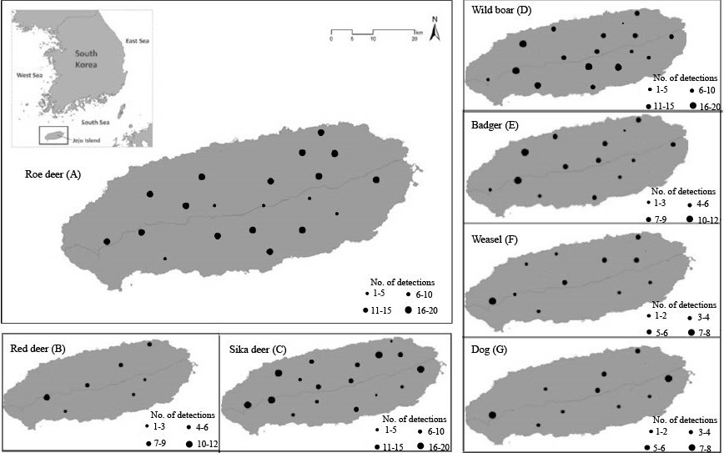

Supplementary Figure S1: Spatial patterns of detection frequency for animal species in the camera-trapping study area from October 2017 to September 2020. Black points on each map represent species detection sites and their size indicates detection frequency.

