**Supplementary material**

**Taxonomic status and phylogenetic position of *Oxymycterus juliacae* Allen 1900 (Rodentia: Cricetidae)**

Dennisse Ruelas and Víctor Pacheco

DOI 10.1515/mammalia-2021-0028

**Supplementary Table S1:** Difference between groups (diff), lower limit of the confidence interval (lwr), upper limit of the confidence interval (upr), and p-values (P) in the Tukey-Kramer Test along PC1.

|  |  |  |  |  |
| --- | --- | --- | --- | --- |
| **Comparisons** | **diff** | **lwr** | **upr** | **P** |
| *hiska - inca* | 1.040 | 0.752 | 1.327 | 0.00 |
| *hiska - juliacae* | 0.705 | 0.377 | 1.033 | 0.00 |
| *hiska - nigrifrons* | 0.107 | -0.229 | 0.443 | 0.87* |
| *hiska - paramensis* | 0.392 | 0.045 | 0.739 | 0.00 |
| *hiska - willkaurco* | 0.224 | -0.078 | 0.527 | 0.11* |
| *inca - juliacae* | -0.335 | -0.534 | -0.136 | 0.00 |
| *inca - nigrifrons* | -0.933 | -1.145 | -0.721 | 0.00 |
| *inca - paramensis* | -0.647 | -0.877 | -0.418 | 0.00 |
| *inca - willkaurco* | -0.815 | -0.969 | -0.662 | 0.00 |
| *juliacae - nigrifrons* | -0.598 | -0.862 | -0.333 | 0.00 |
| *juliacae - paramensis* | -0.312 | -0.591 | -0.034 | 0.00 |
| *juliacae - willkaurco* | -0.480 | -0.700 | -0.260 | 0.00 |
| *nigrifrons - paramensis* | 0.285 | -0.002 | 0.573 | 0.01 |
| *nigrifrons - willkaurco* | 0.117 | -0.115 | 0.349 | 0.48* |
| *paramensis - willkaurco* | -0.168 | -0.416 | 0.080 | 0.18* |

Asterisks show non-significant p-values (P > 0.05).

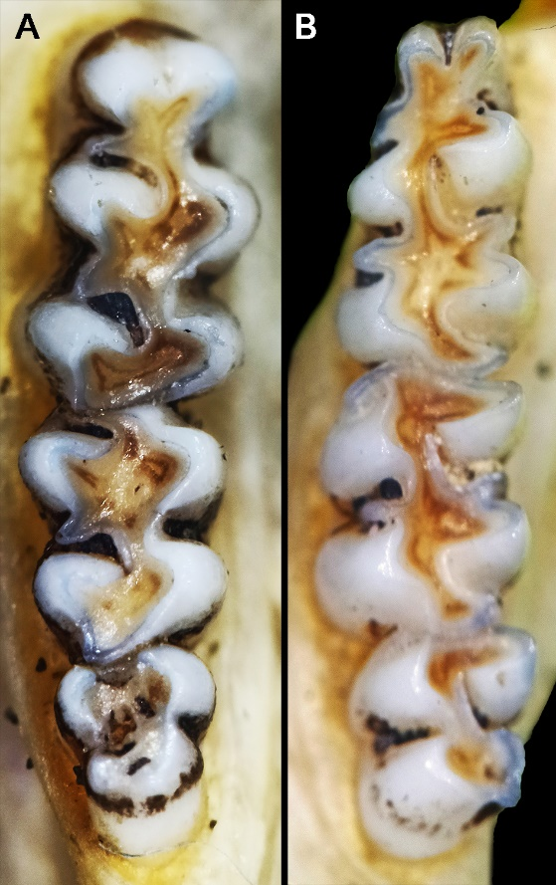

**Supplementary Figure S1:** Occlusal views of the molar series of *Oxymycterus juliacae*. Occlusal views of the upper right (A) and lower right (B) molar series of *Oxymycterus juliacae* (MUSM 35094, age class 2).