**Supplementary material**

**DNA barcoding for bats from northern region Colombia**

Álvaro J. Benítez et al.

DOI 10.1515/mammalia-2020-0138

**Supplement S3:** ASAP analysis of bat sequences from Córdoba (Colombia).

(A) Table of the 10 best partitions found by ASAP, the best partition with a score of one.

|  |  |  |  |  |  |  |  |  |  |  |  |  |  |  |  |  |  |  |  |  |  |  |  |  |  |  |  |  |  |  |  |  |  |  |  |  |  |  |  |  |  |  |  |  |  |  |  |  |  |  |  |  |  |  |  |  |  |  |  |  |  |  |  |  |  |  |
| --- | --- | --- | --- | --- | --- | --- | --- | --- | --- | --- | --- | --- | --- | --- | --- | --- | --- | --- | --- | --- | --- | --- | --- | --- | --- | --- | --- | --- | --- | --- | --- | --- | --- | --- | --- | --- | --- | --- | --- | --- | --- | --- | --- | --- | --- | --- | --- | --- | --- | --- | --- | --- | --- | --- | --- | --- | --- | --- | --- | --- | --- | --- | --- | --- | --- | --- |
| |  |  |  |  |  |  | | --- | --- | --- | --- | --- | --- | | Nb of species | asap-score | P-val (rank) | | W (rank) | Treshold dist. | | 8 | 1.00 | https://bioinfo.mnhn.fr/abi/public/asap/noir.png | 1.00e-05 (1) | 2.60e-03 (1) | 0.105793 | | * 9 | 3.50 | https://bioinfo.mnhn.fr/abi/public/asap/noir.png | 6.00e-05 (2) | 1.53e-04 (5) | 0.033061 | | 9 | 3.50 | https://bioinfo.mnhn.fr/abi/public/asap/jaune.png | 1.50e-01 (5) | 2.58e-03 (2) | 0.060084 | | 8 | 4.00 | https://bioinfo.mnhn.fr/abi/public/asap/rouge.png | 4.26e-02 (4) | 5.81e-04 (4) | 0.147264 | | * 10 | 6.00 | https://bioinfo.mnhn.fr/abi/public/asap/jaune.png | 5.67e-01 (9) | 1.47e-03 (3) | 0.015922 | | * 11 | 6.50 | https://bioinfo.mnhn.fr/abi/public/asap/jaune.png | 4.87e-01 (7) | 7.99e-05 (6) | 0.009817 | | * 19 | 9.00 | https://bioinfo.mnhn.fr/abi/public/asap/jaune.png | 2.99e-01 (6) | 4.38e-05 (12) | 0.006782 | | 24 | 10.00 | https://bioinfo.mnhn.fr/abi/public/asap/jaune.png | 7.90e-01 (12) | 5.15e-05 (8) | 0.004518 | | 7 | 10.50 | https://bioinfo.mnhn.fr/abi/public/asap/jaune.png | 8.38e-01 (14) | 6.23e-05 (7) | 0.165923 | | 28 | 11.00 | https://bioinfo.mnhn.fr/abi/public/asap/jaune.png | 5.09e-01 (8) | 2.97e-05 (14) | 0.003763 | |

(B) Histogram of distances.

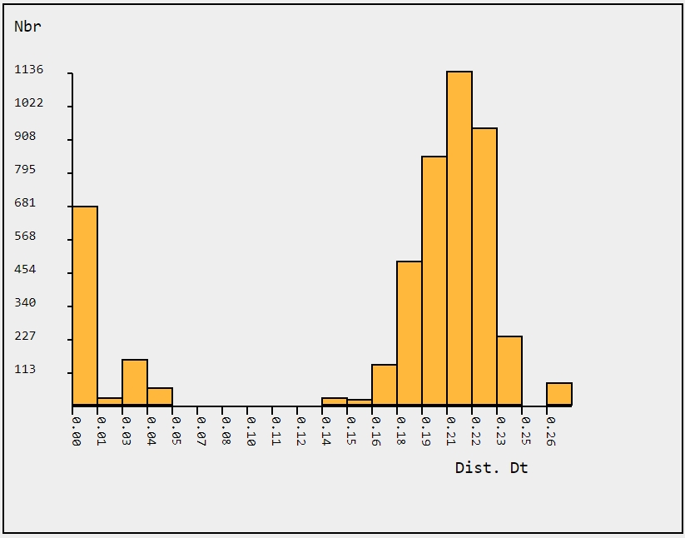

(C) Ranked distances.

