Supplementary figures
Molecular relationships of the Israeli shrews (Eulipotyphla: Soricidae) based on cytochrome-b sequences
Erez Shpirer, Michal Haddas-Sasson, Maya Spivak-Glater, Tamar Feldstein, Shai Meiri, Dorothée Huchon

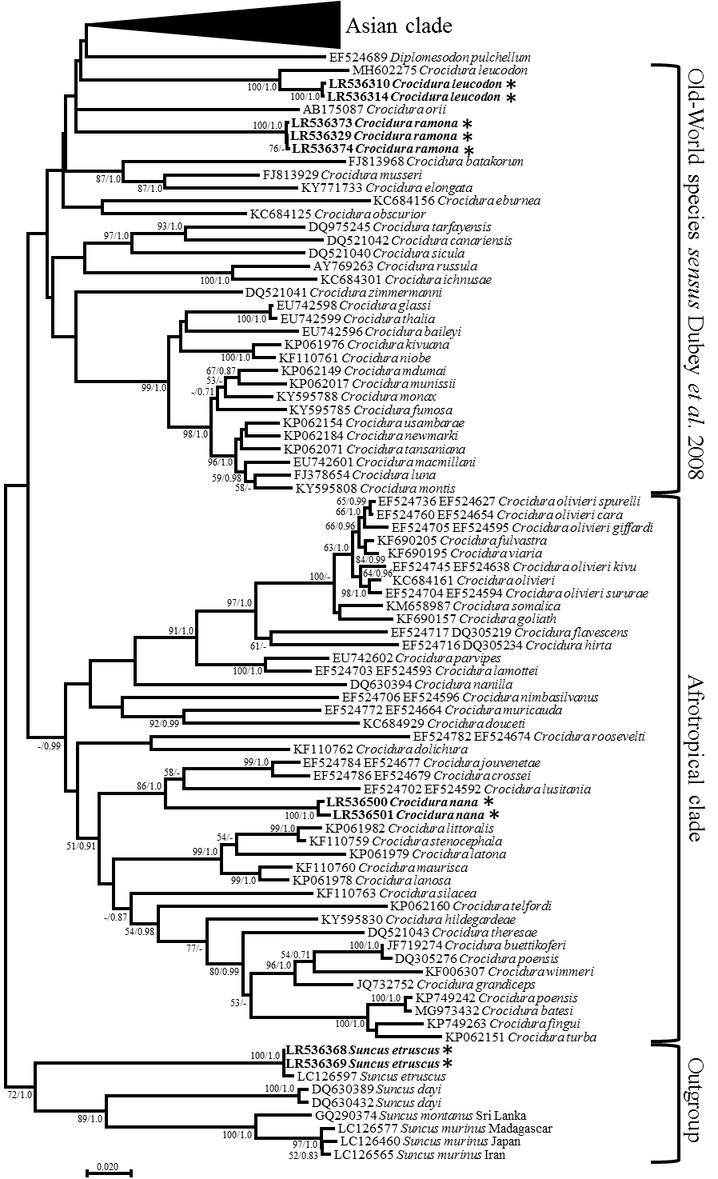
Supplementary Figure S1. Legend on next page.

Supplementary Figure S1. Maximum likelihood tree of Crocidura cytb sequences with emphasis on the Afrotropical clade. Phylogenetic relationships inferred from a matrix of 1,128 nucleotide positions for 131 individuals. Maximum likelihood bootstrap supports above 50% and Bayesian posterior probabilities above 0.70 are indicated near the corresponding node separated with a slash. Sequences obtained in this work are indicated in bold. Clade names follow Dubey et al. (2008).

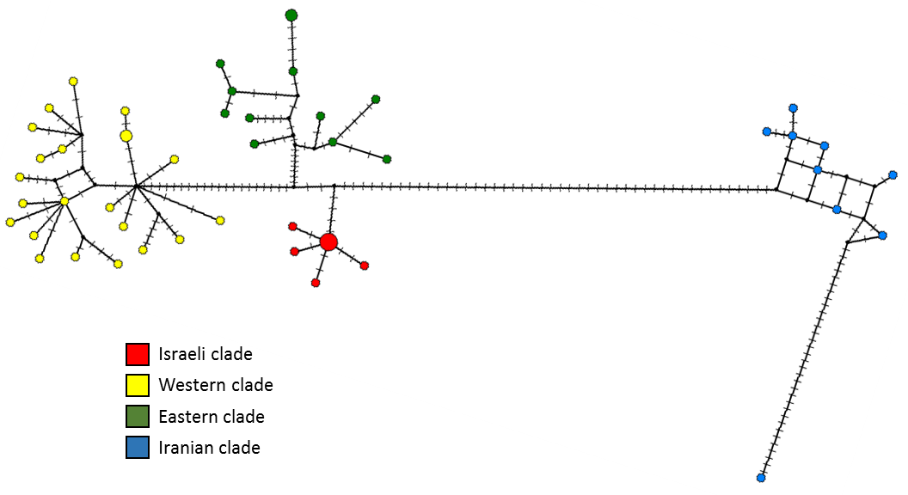

Supplementary Figure S2. Crocidura leucodon median joining network of Cytochome b haplotypes. Each circle corresponds to a different haplotype, and its size is proportional to the corresponding haplotype frequency. The smaller circles correspond to a single haplotype. Missing intermediates are indicated by small solid circles. Tick marks along each branch designate the number of base differences among haplotypes.

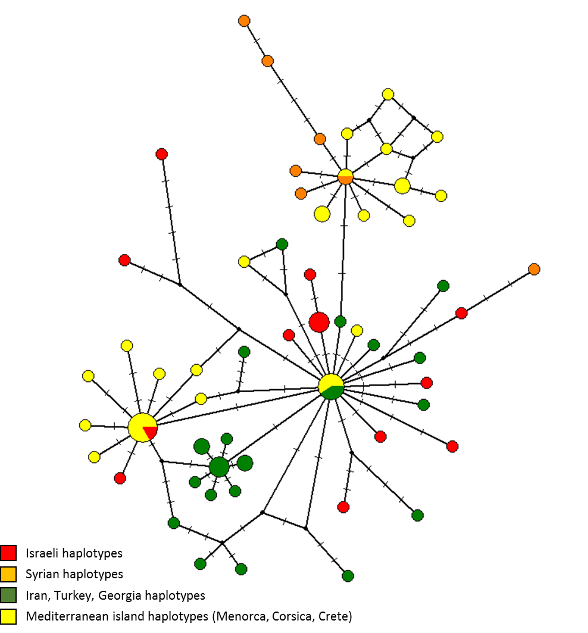

Supplementary Figure S3. Crocidura gueldenstaedtii median joining network of Cytochome b haplotypes. Each circle corresponds to a different haplotype, and its size is proportional to the corresponding haplotype frequency. The smaller circles correspond to a single haplotype. Missing intermediates are indicated by small solid circles. Tick marks along each branch designate the number of base differences among haplotypes.

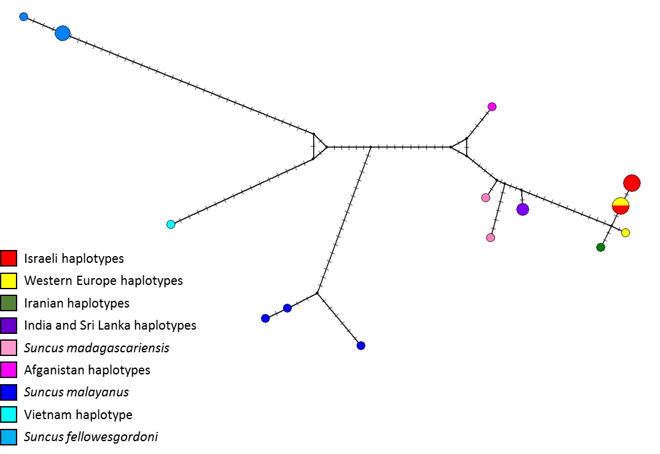

Supplementary Figure S4. Suncus etruscus median joining network of Cytochome b haplotypes. Each circle corresponds to a different haplotype, and its size is proportional to the corresponding haplotype frequency. The smaller circles correspond to a single haplotype. Missing intermediates are indicated by small solid circles. Tick marks along each branch designate the number of base differences among haplotypes.

References

Dubey, S., Salamin, N., Ruedi, M., Barriere, P., Colyn, M. & Vogel, P. 2008. Biogeographic origin and radiation of the Old World crocidurine shrews (Mammalia: Soricidae) inferred from mitochondrial and nuclear genes. Mol. Phylogenet. Evol. 48(3): 953-963.

