Supplementary materials

1 Sample spectrogram
The next image presents a Praat view of a recording with nasal and oral channels (channel 1 and channel 2, respectively). Tier 1 labels (orthographically) the target word and Tier 2 marks the word- internal coda nasal and the tautosyllabic vowel. An increase energy in the nasal channel (channel 1) can be seen in the vowel preceding the nasal consonant and then again, during the nasal consonant. Crucially, energy decreases in the oral channel (channel 2) during the nasal consonant, which can be linked to the constriction in the oral cavity during the articulation the nasal consonant.
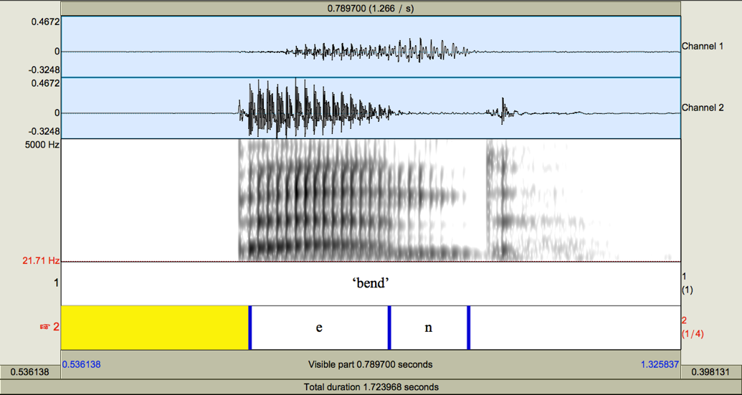
Figure S1 – Waveform and spectrogram of the word ‘bend’, produced by a native speaker of English.

2 Control items
For comparison purposes, the protocol also included words with word-final oral consonants (ie. CVC syllables). CVC syllables are not expected to present evidence of nasality, neither in the consonant nor in the tautosyllabic vowel. Figure S2 compares nasal energy traces for 250 randomly selected tokens. Time point zero corresponds to the onset of the nasal or oral consonant, represented in the figure as a dotted line. Thus, negative integers correspond to the vowel, whereas positive time points during the nasal or oral consonant.
Some oral consonants may exhibit nasal leakage, but arguably, not a pre-planned velic gesture (e.g., specified in the phonology). Figure S2 shows that pre-oral consonant vowels present overwhelmingly floor-level readings, whereas tokens with pre-nasal vowels exhibit increasing nasal energy. By comparison, I consider oral word-final consonants to be oral. For this reason, CVC data is not processed like word-final data. Calculating a range and establishing a 15% would be possible but not informative. As a whole, these data confirm the proper functioning of the nasometer and will not be discussed further. The nasometric signal is a reliable indicator of velum lowering.
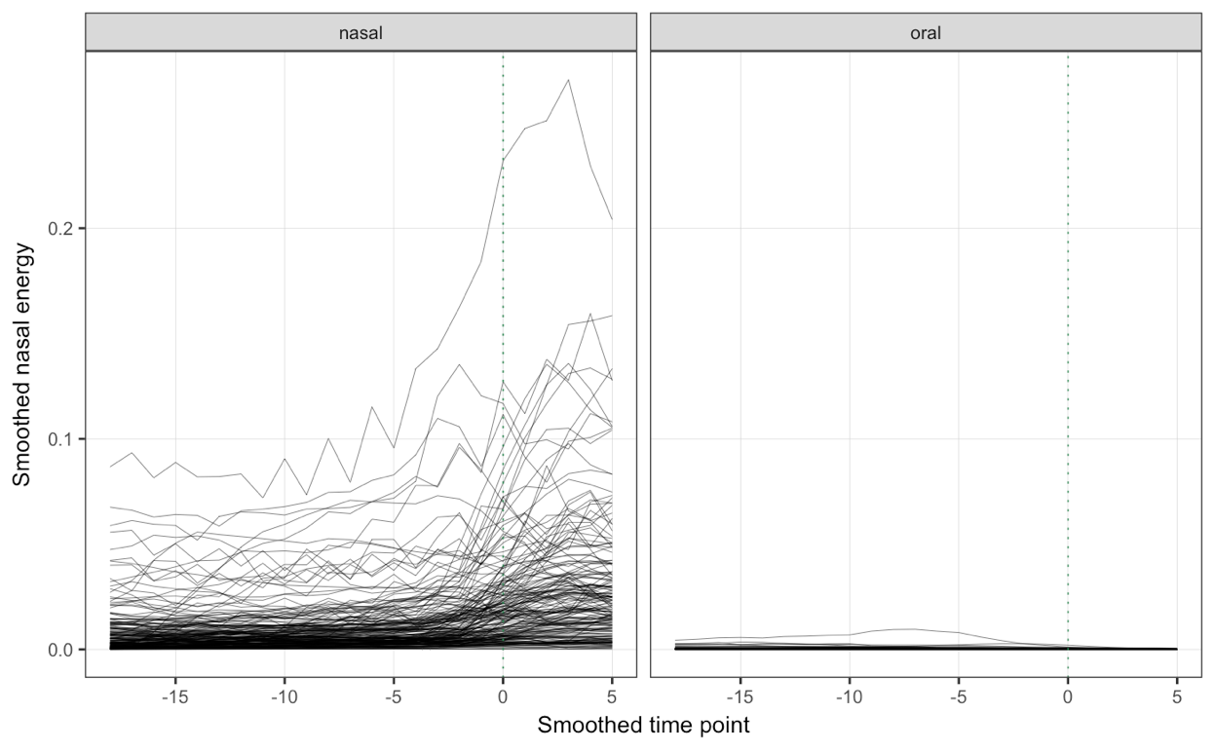
Figure S2 – Time-course of nasal energy for pre-nasal and pre-oral vowels of 250 randomly selected tokens from the corpus.

4 Energy traces NVN syllable
A comparison of CVN and NVN shows that the degree of nasalization (i.e. how much) in pre-nasal NVN vowels is higher than for pre-nasal CVN syllables, as Figure S3 shows. This study, however, exclusively focuses on the time-course of nasalization, and thus, degree of nasalization falls outside of the scope of inquiry.
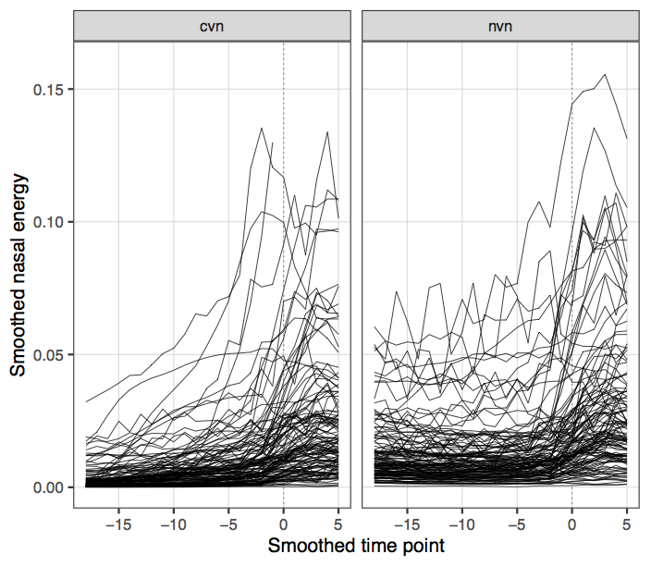
Figure S3 – Time-course of nasal energy in 250 randomly selected tokens in the corpus, per syllable type.
As operationalized here (the first time point that surpasses a noise band of 15% of the range between), onset of velum lowering does not allow to tease apart cases in which the velum lowers for the first nasal consonant and remains lowered throughout the vowel from cases in which the velum is raised again for the vowel (i.e. minimum and maximum values could be identified, the range between them calculated and a 15% threshold established), raw traces of nasal energy were explored we well. Figure S3 plots randomly selected 100 tokens of NVN syllables, per dialect. The right panel shows that, at the vowel-nasal boundary (time-point zero) nasal energy increases, thus confirming velum lowering.
Figure S4 – Time-course of nasal energy for NVN in 100 randomly selected tokens in the corpus, per dialect. The red line represents the mean.

