Supplementary Material

Table of Contents
Supplementary Figure 1: Schematic Overview of Simulated Contamination 2
Supplementary Figure 2: Fluid Compositions Used for the Simulation of IV Fluid Contamination. 3
Supplementary Table 1: Total Allowable Error and Reference Change Values 4
Supplementary Table 2: Reference Intervals, Delta and Feasibility Limits 5
Supplementary Figure 3: Significant Mixtures for All Ten Fluids by TEa. 6
Supplementary Figure 4: Significant Mixtures for All Ten Fluids by RCV. 7

Supplementary Figure 1: Schematic Overview of Simulated Contamination

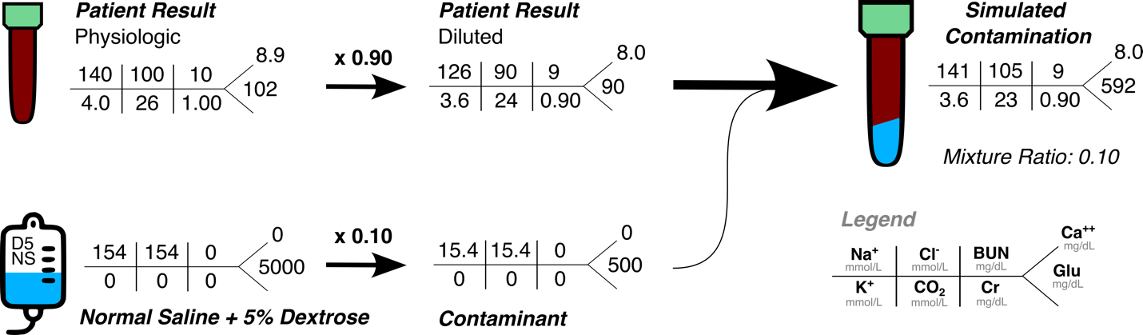

An overview of the in silico mixture approach to simulate IV fluid contamination.

Supplementary Figure 2: Fluid Compositions Used for the Simulation of IV Fluid Contamination.
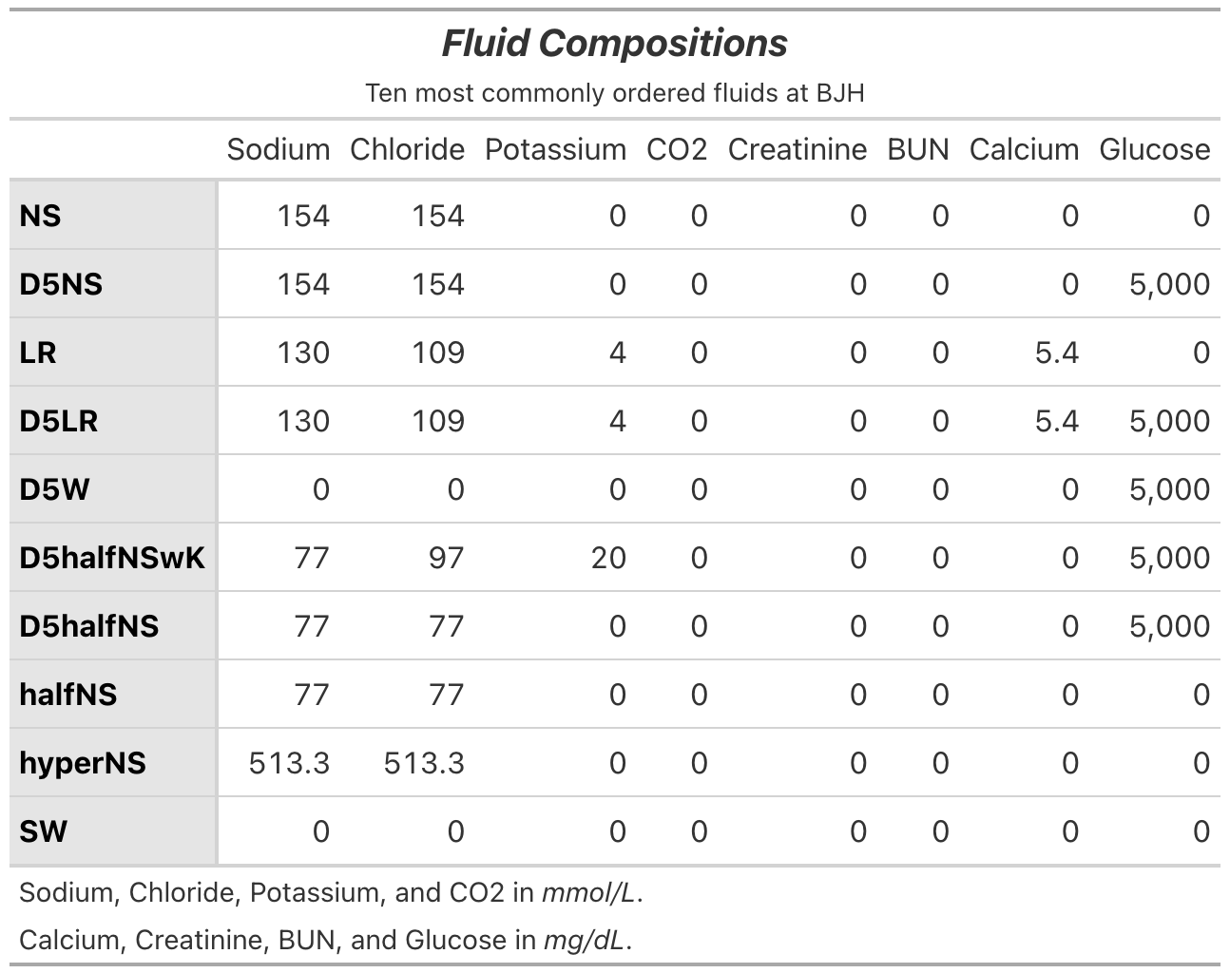

Supplementary Table 1: Total Allowable Error and Reference Change Values

 | Sodium | Chloride | Potassium | CO2 | Creatinine | BUN | Calcium | Glucose
TEa . | 4 mmol/L | 3 mmol/L | 0.5 mmol/L | 2 mmol/L | 0.3 mg/dL | 2 mg/dL | 1 mg/dL | 6 mg/dL
RCV_{Decrease .} | 3.1% | 5.5% | 9.9% | 23.2% | 13.4% | 29.5% | 5.9% | 12.6%
RCV_{Increase .} | 3.2% | 5.8% | 11% | 20.8% | 15.5% | 41.8% | 6.2% | 14.5%

TEa thresholds were adopted from the CLIA ‘88 requirements for analytical quality. For analytes without CLIA-defined, absolute TEa thresholds (chloride and CO2), the absolute thresholds from the Royal College of Pathologists of Australasia (RCPA) were used. Reference change values (RCV) were calculated using the European Federation of Clinical Chemistry and Laboratory Medicine Biological Variation Database (25), which applies the asymmetric approach. As such, contamination that caused an increase in the analyte-of-interest was compared to the appropriate RCV_{Increase}, while those that caused a decrease were compared with the RCV_{Decrease}. The mean of the high and low-level analytical coefficients of variation from our hospital laboratory’s most recent 30 days of quality control analysis were used as the CV_{a} for the calculation.

Supplementary Table 2: Reference Intervals, Delta and Feasibility Limits

 | Sodium | Chloride | Potassium | CO2 | Creatinine | BUN | Calcium | Glucose
Units | mmol/L | mmol/L | mmol/L | mmol/L | mg/dL | mg/dL | mg/dL | mg/dL
Reference Range | 135-145 | 97-110 | 3.3-4.9 | 22-32 | Varied | 6-25 | 8.5-10.3 | 70-199
Critical  Range | 120-160 | 75-130 | 2.5-6.2 | 10-45 | - | - | 6.5-14.0 | 54-450
Delta Magnitude | 9 | 9 | 100% change | 75% change | 200% change | 400% change | 2 | 200% change
Feasible | - | - | - | - | - | - | <5 | -

Supplementary Table 2 presents the reference ranges, critical limits, delta check thresholds, and feasibility check limits used in the analysis.

Supplementary Figure 3: Significant Mixtures for All Ten Fluids by TEa.
The mixture ratio at which a majority of contaminated results would exceed the TEa for each analyte on the BMP for each of the ten most common fluids at our institution. An ad hoc cut-off of 50% was chosen for the sake of simplicity.

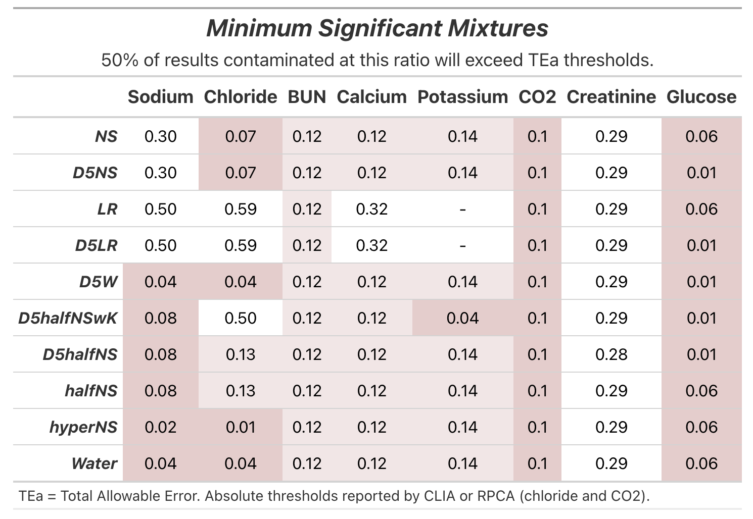

Supplementary Figure 4: Significant Mixtures for All Ten Fluids by RCV.
The mixture ratio at which a majority of contaminated results would exceed the RCV for each analyte on the BMP for each of the ten most common fluids at our institution.

