A new machine-learning-based prediction of survival in patients with end-stage liver disease

Supplement

Sebastian Gibb[1], Thomas Berg, Adam Herber, Berend Isermann, and Thorsten Kaiser

# 1 Survival plot



Survival plot. Kaplan-Meier survival estimate for the first 90 days of the analyzed population.

# 2 Benchmark results of machine-learning algorithms

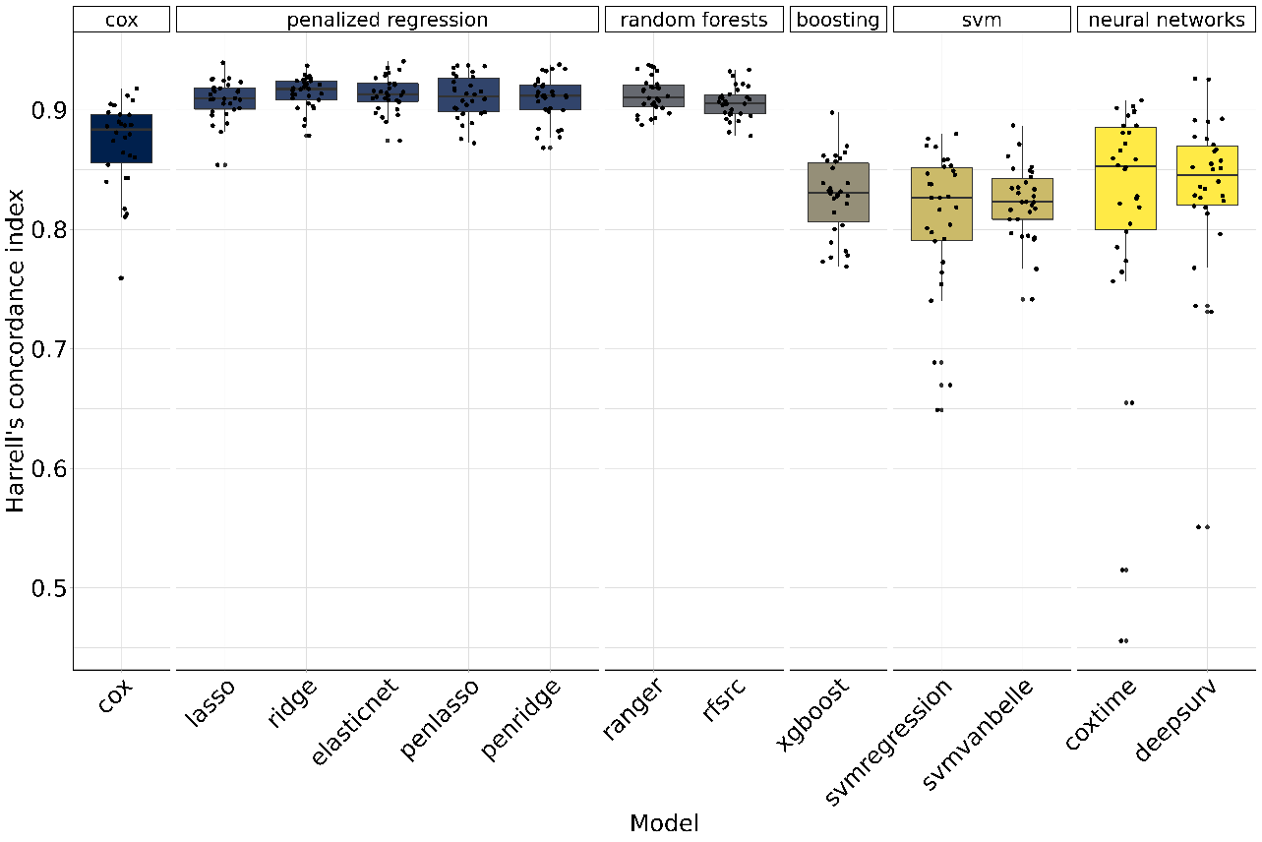

Figure 2.1: Benchmark results of machine-learning algorithms.

Table 2.1: Benchmark results. Ranking of the 13 tested machine-learning algorithms.

| Model | Harrell’s concordance index |
| --- | --- |
| ridge | 0.915 |
| elasticnet | 0.913 |
| ranger | 0.913 |
| penlasso | 0.911 |
| penridge | 0.909 |
| lasso | 0.909 |
| rfsrc | 0.906 |
| cox | 0.872 |
| deepsurv | 0.833 |
| xgboost | 0.828 |
| svmvanbelle | 0.823 |
| coxtime | 0.819 |
| svmregression | 0.809 |

# 3 Observed versus MELD-Na-expected 90-day mortality

Table 3.1: Observed vs. MELD-Na-expected 90-day mortality. MELD-Na mortality values are taken from [1] and the mean value was calculated for each MELD-Na category.All patients censored before day 90 are ignored for the calculation of the MELD-Na-expected deaths. SMR, Standardized mortality ratio = observed deaths/expected deaths.

| MELD category | Observed deaths (n) | Expected deaths (n) | Standardized mortality ratio (SMR) | Observed mortality (%) | Expected mortality (%) |
| --- | --- | --- | --- | --- | --- |
| [6,9] | 1 | 5.8 | 0.2 | 0.5 | 2.8 |
| [10,15) | 4 | 2.9 | 1.4 | 3.0 | 2.3 |
| [15,20) | 5 | 3.1 | 1.6 | 7.5 | 5.1 |
| [20,25) | 15 | 5.7 | 2.6 | 27.1 | 13.0 |
| [25,30) | 22 | 10.2 | 2.1 | 62.5 | 31.1 |
| [30,35) | 14 | 8.1 | 1.7 | 88.0 | 54.2 |
| [35,40) | 9 | 7.5 | 1.2 | 90.0 | 75.1 |
| [40,52) | 6 | 5.1 | 1.2 | 100.0 | 84.4 |

# 

# 4 ROC curves

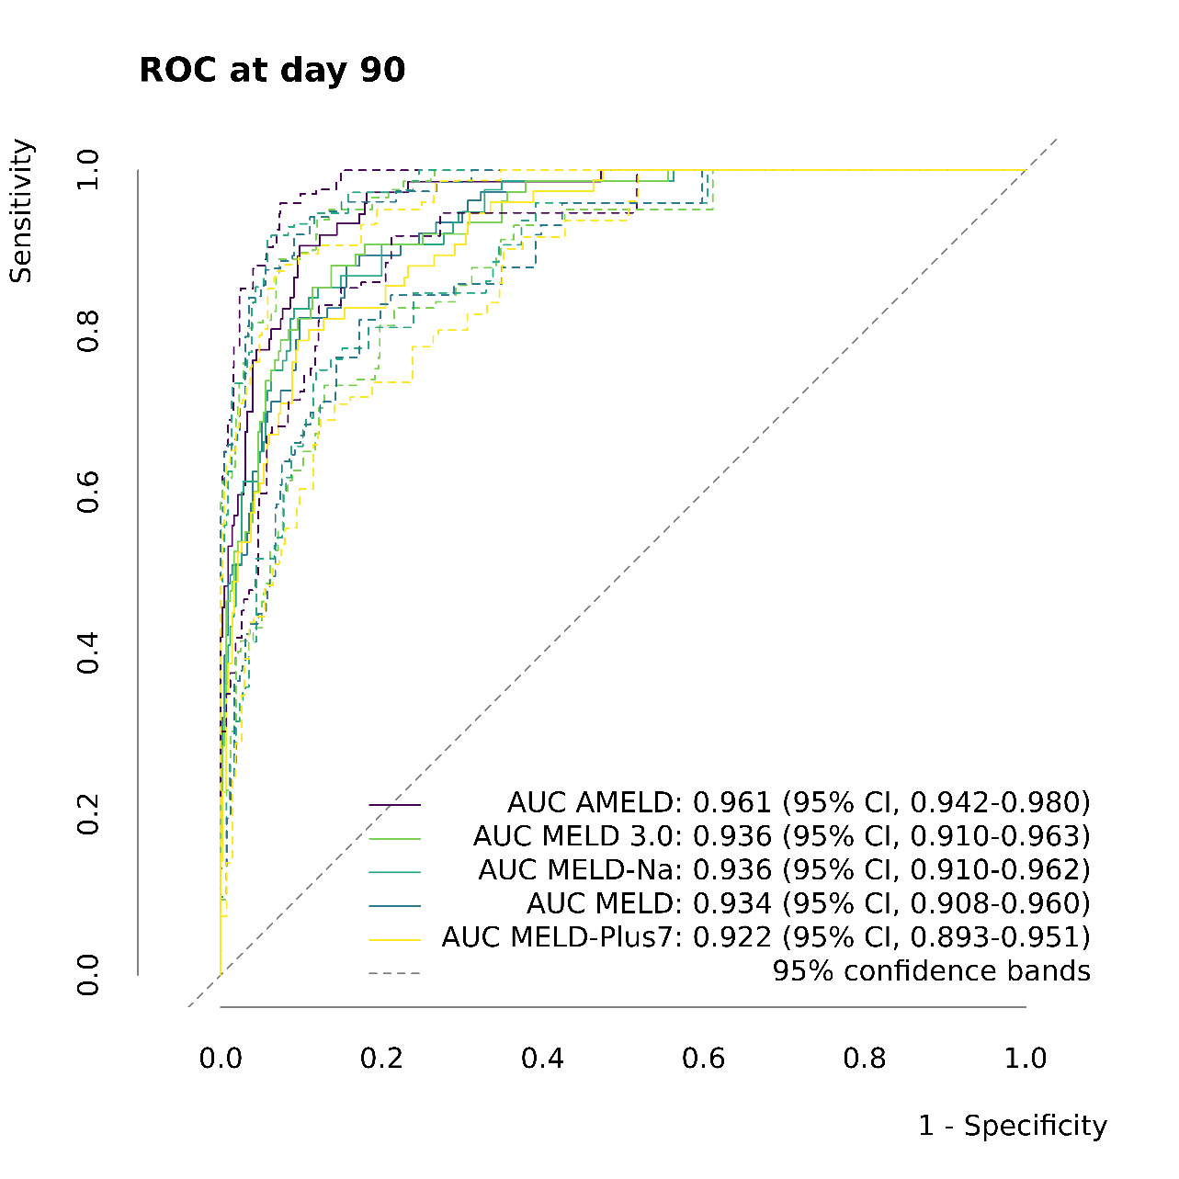

Figure 4.1: Receiver operating characteristic (ROC) curve. Area under the time-dependent ROC curve (AUC) based on the nonparametric inverse probability of censoring weighting estimate (IPCW) for AMELD, MELD, MELD-Na, MELD 3.0, MELD-Plus7, as described in [2]. The dashed lines depict the corresponding 95% confidence bands calculated by threshold averaging as described in [3].

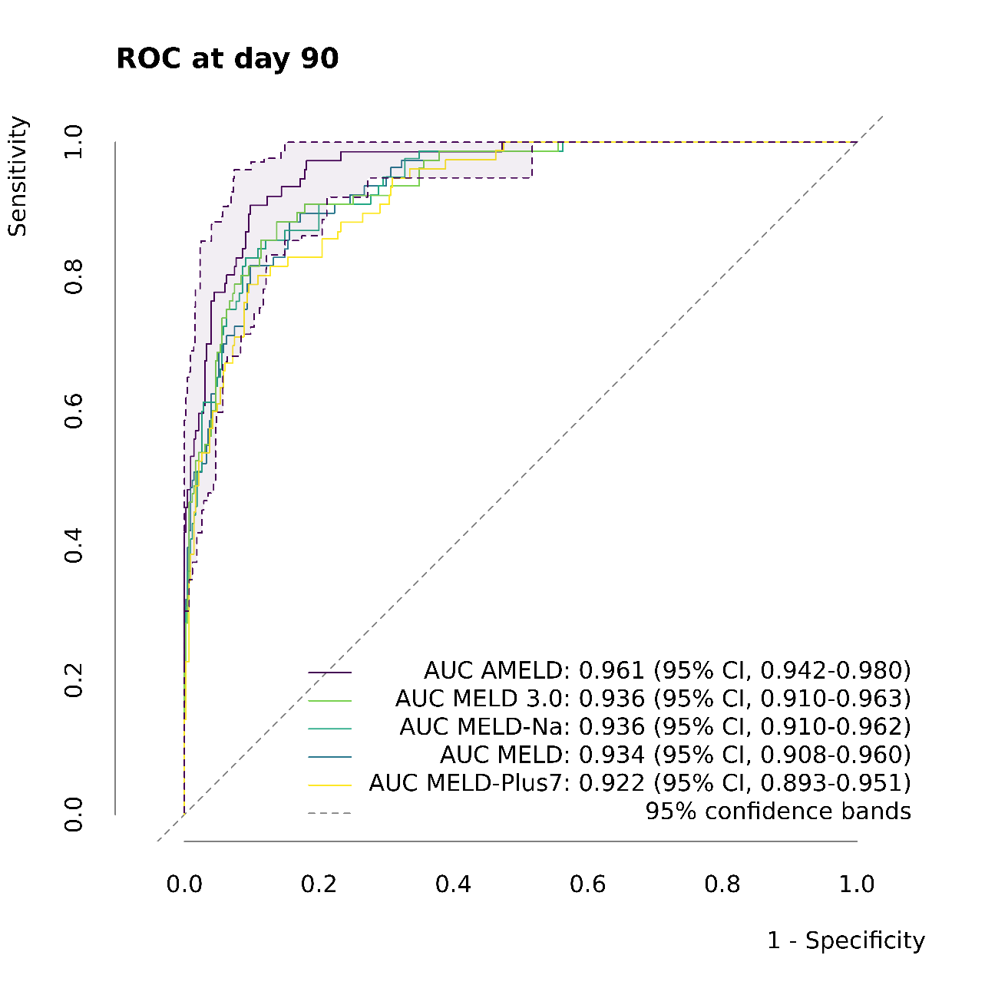

Figure 4.2: Receiver operating characteristic (ROC) curve. Area under the time-dependent ROC curve (AUC) based on the nonparametric inverse probability of censoring weighting estimate (IPCW) for AMELD, MELD, MELD-Na, MELD 3.0, MELD-Plus7, as described in [2]. The dashed lines depict the corresponding 95% confidence bands for AMELD calculated by threshold averaging as described in [3]. Identical to the figure 4.1 above but the other confidence bands are hidden for easier readability.

# 5 AUROC trend

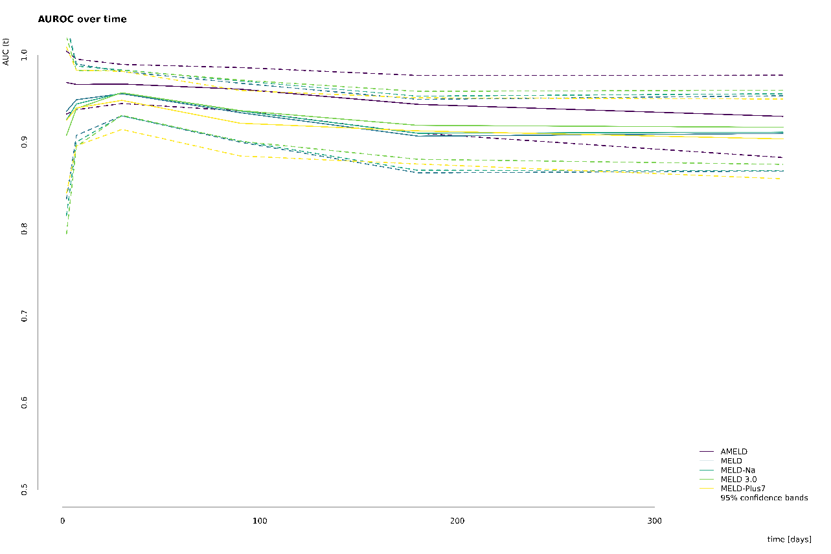

Figure 5.1: Trend in the area under the time-dependent receiver operating characteristic curve (AUROC) based on the nonparametric inverse probability of censoring weighting estimate (IPCW) for AMELD, MELD, MELD-Na, MELD 3.0, and MELD-Plus7, as described in [2].

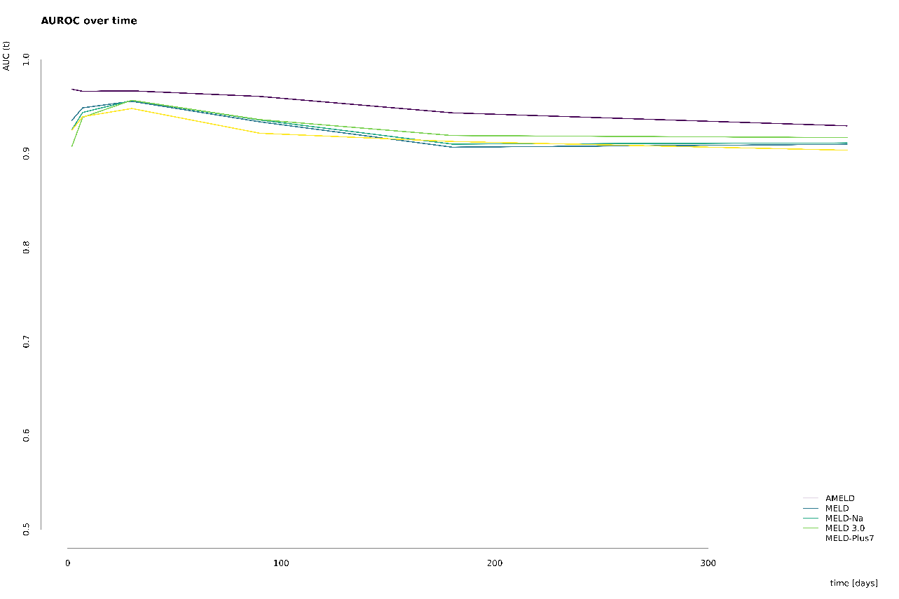

Figure 5.2: Trend in the area under the time-dependent receiver operating characteristic curve (AUROC) based on the nonparametric inverse probability of censoring weighting estimate (IPCW) for AMELD, MELD, MELD-Na, MELD 3.0 and MELD-Plus7, as described in [2]. Identical to figure 5.1 above but without confidence bands.

# 6 Variable importance



Figure 6.1: Variable importance by frequency of bootstrap selections.



Figure 6.2: Variable importance by logrank in random forest.

# References

1. VanDerwerken DN, Wood NL, Segev DL, Gentry SE. The Precise Relationship Between Model for End-Stage Liver Disease and Survival Without a Liver Transplant. Hepatology. 2021;74(2):950–60.
2. Blanche P, Dartigues J-F, Jacqmin-Gadda H. Estimating and comparing time-dependent areas under receiver operating characteristic curves for censored event times with competing risks. Stat Med. 2013 Sep;32(30):5381–97.
3. Fawcett T. ROC graphs: Notes and practical considerations for researchers. Machine learning. 2004;31(1):1–38.

1. [mail@sebastiangibb.de](mailto:mail@sebastiangibb.de)