Supplement to ʺPercentiler and Flagger – Low-cost, on-line monitoring of laboratory and manufacturer data and significant surplus to current external quality assessmentʺ
Linda M Thienpont, Dietmar Stöckl

Figure 1S. Geographical distribution of the Percentiler and Flagger participants in Belgium (where the development of the Percentiler/Flagger applications was initiated).
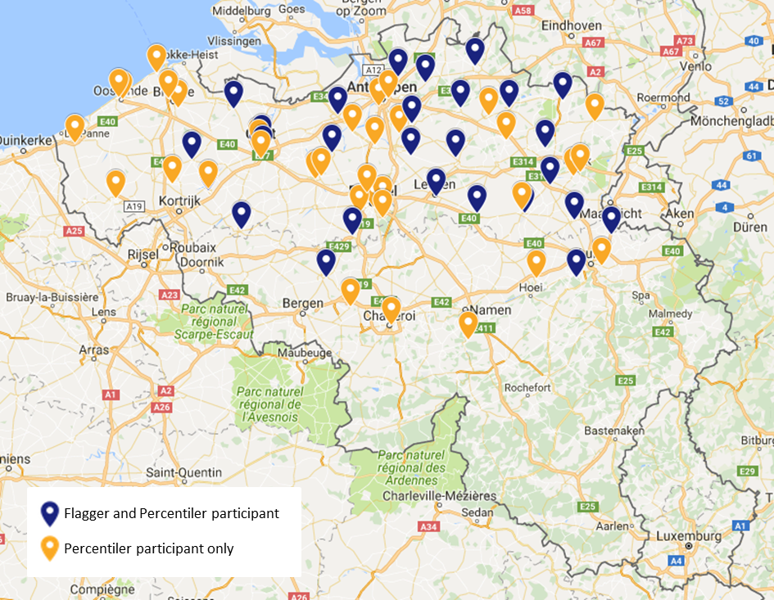

Figure 2S. Worldwide geographical distribution of the Percentiler and Flagger participants.
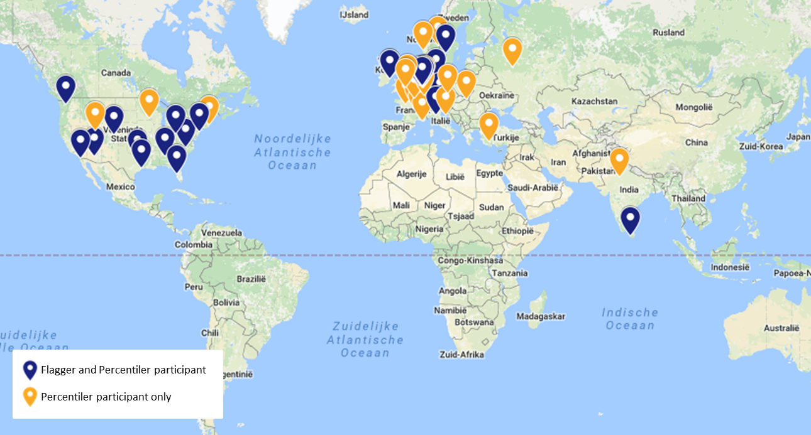

Figure 3S. The Flagger charts show (i) the moving median of daily hypo- and hyper-percentage of the selected medical devices over the selected period (full colored lines); (ii) the long-term median (long-broken grey line) and the stability limits proposed for the respective analyte (short-broken grey lines; the area in-between is shaded); (iii) the all or peer group moving median (black broken line).
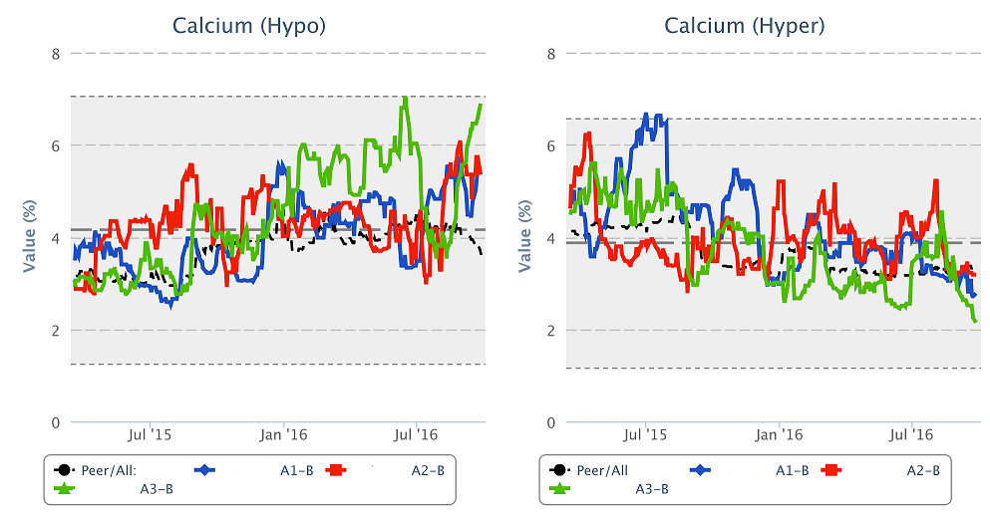

Figure 4S. The figure shows a drift of albumin values from ~ 39 g/L to ~35 g/L, followed by a shift back to ~38 g/L. The hypo flagging rate increases from ~20% to ~42% and falls back to ~20%. This laboratory has, like most laboratories, no hyper flagging for albumin. Note, the Percentiler limit is 1 g/L (= 2.3%; “desirable” = 1.4%) and the Flagger limit is 50% of the long-term flagging median observed in the concerned laboratory.

Figure 5S. ALP assays are among the most stable assays across laboratories and manufacturers. The figure here shows several moderate shifts of the alkaline phosphatase values, first the values drop from ~73U/L to ~68 U/L, second they go up to ~76 U/L, third they fall to ~70 U/L and fourth return to ~73U/L. The hypo flagging rate is very low, as mostly is the case. The hyper flagging rate varies concordantly with the analytical shifts between ~3 % to ~5%. Note, the Percentiler limit is 5 U/L (= 6.8%; “desirable” = 6.7%) and the Flagger limit is 30% of the long-term flagging median observed in the concerned laboratory.

Figure 6S. The figure shows a drift of the ALT values from ~24 U/L to ~18 U/L and a sharp shift to ~30 U/L. The hypo flagging rate increases from ~10% to ~28% and drops to 0%. The hyper flagging rate drops from ~7% to nearly 0% and increases, again, to ~8%. Note, the Percentiler limit is 2 U/L (= 9.5%; “desirable” = 11.5%) and the Flagger limit is 30% of the long-term flagging median observed in the concerned laboratory.
Figure 7S. The figure shows AST values varying from ~20 U/L to ~24 U/L and back to ~20 U/L. The hypo flagging rate decreases concordantly with the analytical variation from ~13% to ~4% and increases again to ~22%. The hyper flagging rate slightly drops from ~8% to ~6%. Note, the Percentiler limit is 1.5 U/L (= 6.5%; “desirable” = 6.5%) and the Flagger limit is 30% of the long-term flagging median observed in the concerned laboratory.

Figure 8S. The total-bilirubin assay is among the most stable assays across manufacturers and laboratories; typically, the limits are never violated. The figure shows total bilirubin values shifting from ~6.8 µmol/L up to ~7.5 µmol/L; then they decrease to ~7.0 µmol/L followed by an increase to ~7.6 µmol/L. The hyper flagging rate is concordantly affected by both analytical shift as it goes from ~2.5% up to nearly 4% and comes back to ~3%. As expected, the hypo flagging rate is almost zero %. Note, the Percentiler limit is 1 µmol/L (= 10%; “desirable” = 9.0%) and the Flagger limit is 30% of the long-term flagging median observed in the concerned laboratory.

Figure 9S. The figure shows moderately varying calcium values, i.e. they first shift upwards from ~2.33 mmol/L to ~2.38 mmol/L then they fall back to 2.33 mmol/L, gradually increase a second time to ~2.42 mmol/L, to finally drop back to 2.30 mmol/L. The hypo flagging rate drops more strongly with the analytical shifts from ~13% to ~ 3%, then increases to ~9%, falls back to 4% to finally increase a second time to ~15%. The hyper flagging rate is very low so that no effects are observed. Note, the Percentiler limit is 0.04 mmol/L (= 1.7%; “desirable” = 0.8%) and the Flagger limit is 70% of the long-term flagging median observed in the concerned laboratory.

Figure 10S. The figure shows 2 shifts in the chloride values, i.e., from ~ 103 mmol/L to ~100.5 mmol/L, and to ~99 mmol/L. The hypo flagging rate is most influenced by both analytical shifts as it increases from ~5% to ~21%. The hyper flagging rate decreases by the first downward shift from ~2% to nearly 0%. Note, the Percentiler limit is 1 mmol/L (= 1.0%; “desirable” = 0.5%) and the Flagger limit is 50% of the long-term flagging median observed in the concerned laboratory.

Figure 11S. The figure shows a major shift in total cholesterol values from ~4.7 mmol/L to ~4.4 mmol/L. The hypo flagging rate is nearly unaffected and in the order of ~1%, while the hyper flagging rate decreases from ~36% to nearly 23%. Note, the Percentiler limit is 0.2 mmol/L (= 3.8%; “desirable” = 4.1%) and the Flagger limit is 20% of the long-term flagging median observed in the concerned laboratory.

Figure 12S. The figure shows 4 major shifts in the CRP values, i.e., from ~7.0 mg/L to ~ 9.9 mg/L, then down to ~5.8 mg/L, up to ~9.5 mg/Land down to ~5 mg/L. The hyper flagging rate is influenced by the analytical shifts as it first increases from ~35% to ~48%, then drops to ~28% to increase again to ~35-45%, and then decreases to ~15-20%. The hypo flagging rate is and remains zero as expected. Note, the Percentiler limit is 0.25 mg/L (= 9.6%; “desirable” = 21.8%) and the Flagger limit is 30% of the long-term flagging median observed in the concerned laboratory.

Figure 13S. The figure shows drifting creatinine values from ~84 µmol/L down to ~74 µmol/L, followed by a shift to~78 µmol/L. The hypo flagging increases concordantly with the drift from ~3% to ~7.5% to normalize again to ~3%. The hyper flagging rate gradually decreases from ~15% down to nearly 8% and then normalizes to ~11%. Note, the Percentiler limit is 3 µmol/L (= 3.9%; “desirable” = 4.0%) and the Flagger limit is 30% of the long-term flagging median observed in the concerned laboratory.

Figure 14S. The figure shows FT4 values drifting and shifting from 15.5 pmol/L up to 17 pmol/L. The hypo flagging rates decrease from ~10% to ~0%, while the opposite happens for the hyper flagging rate (increases from ~8% to nearly 16%). Note, the Percentiler limit is 0.5 pmol/L (= 3.3%; “desirable” = 3.3%) and the Flagger limit is 30% of the long-term flagging median observed in the concerned laboratory.

Figure 15S. The figure shows a downward shift in GGT values from ~28 U/L to ~24U/L. The hypo flagging rate increases concordantly with the analytical shift from ~ 3% to ~10%. The hyper flagging rate drops from ~22% to nearly 10%. Note, the Percentiler limit is 2 U/L (= 9.1%; “desirable” = 11.1%) and the Flagger limit is 30% of the long-term flagging median observed in the concerned laboratory.

Figure 16S. Figure 2 shows 3 shifts in glucose values, i.e., a first time from ~5.1 mmol/L to ~5.3 mmol/L, then a shortly lasting shift up to 5.5 mmol/L followed by a return to ~5.4 mmol/L, and finally a third shift up to ~5.6 mmol/L. The hypo flagging rate is little affected and is in the order of 1 to 2%, while the hyper flagging rate mainly increases due to the last upwards shift from ~35% to nearly 55%. Note, the Percentiler limit is 0.15 mmol/L (= 3.1%; “desirable” = 2.3%) and the Flagger limit is 20% of the long-term flagging median observed in the concerned laboratory.

Figure 17S. The figure shows drifting LDH values from ~200 U/L up to to ~230 U/L. The hyper flagging rate gradually increases from ~18% to nearly 33%. As is the case for other enzymes, the hypo flagging rate is nearly 0%. Note, the Percentiler limit is 8 U/L (= 4.6%; “desirable” = 4.3%) and the Flagger limit is 30% of the long-term flagging median observed in the concerned laboratory.

Figure 18S. The figure shows several shifts in the magnesium values, i.e., a first drop from ~0.83 mmol/L to ~0.79 mmol/L, followed by an increase to ~0.84 mmol/L, to drop back to ~0.81 mmol/L and finally increase to 0.835 mmol/L. The hypo flagging rate decreases from ~7.5% to ~2.5%, then returns to ~7.5-9.0%, comes down to ~2.5%, to normalize again to ~7.5%. The hyper flagging rate is nearly 0%. Note, the Percentiler limit is 0.02 mmol/L (= 3.0%; “desirable” = 1.8%) and the Flagger limit is 70% of the long-term flagging median observed in the concerned laboratory.

Figure 19S. The figure shows several shifts in the inorganic phosphor values, the major ones being from ~1.13 mmol/L to ~1.03 mmol/L and back to ~1.17 mmol/L. The hypo flagging rate concordantly increases from ~2% to ~12% and drops back to ~2%. The hyper flagging rate mainly decreases due to the downwards analytical shift from ~7% to nearly 2.5%. Note, the Percentiler limit is 0.05 mmol/L (= 4.4%; “desirable” = 3.4%) and the Flagger limit is 50% of the long-term flagging median observed in the concerned laboratory.

Figure 20S. The potassium assay is among the most stable assays across manufacturers and laboratories; typically, the limits are never violated. The figure shows potassium values going down from ~ 4.15 mmol/L to ~4.05 mmol/L. The hypo flagging rate increase concordantly from ~3% to ~5%, while the inverse happens for the hyper flagging rate decreasing from ~7% to nearly 4%. Note, the Percentiler limit is 0.1 mmol/L (= 2.4%; “desirable” = 1.8%) and the Flagger limit is 30% of the long-term flagging median observed in the concerned laboratory.

Figure 21S. The figure shows a major shift in the total protein values from ~67.5 g/L to ~70.5 g/L. The hypo flagging rate decreases concordantly from ~5% to ~2%. The hyper flagging rate triplicates (from ~0.2% to nearly 0.6%), however, is generally low. Note, the Percentiler limit is 1 g/L (= 1.4%; “desirable” = 1.4%) and the Flagger limit is 50% of the long-term flagging median observed in the concerned laboratory.

Figure 22S. The figure shows a drift in sodium values from ~140 mmol/L up to ~141.4 mmol/L, followed by a downwards shift to ~139 mmol/L, and a normalization back to 141.5 mmol/L. The hypo flagging rate is affected by the shift and changes from ~2% to ~5%, and normalizes back to ~2%. The hyper flagging rate is affected by the drift as it increases from ~3% up to ~12%; due to the downward shift it drops from ~12% to nearly 2% and then increases back to ~12%. Note, the Percentiler limit is 1 mmol/L (= 0.7%; “desirable” = 0.2%) and the Flagger limit is 70% of the long-term flagging median observed in the concerned laboratory.

Figure 23S. The figure shows variable TSH values ~1.8 mIU/L to ~1.55 mIU/L. The hypo flagging rate follows the trend grossly and varies between ~5% and 12%. The hyer flagging rate follows the analytical trend nicely and varies between ~7% and 13%. Note, the Percentiler limit is 0.12 mmol/L (= 7.7%; “desirable” = 7.8%) and the Flagger limit is 30% of the long-term flagging median observed in the concerned laboratory.

Figure 24S. The figure shows drifting urea values from ~5.2 mmol/L to ~4.6 mmol/L and, finally slightly increasing to ~4.8 mmol/L. The hypo flagging rate <1% gradually increases up to ~2.5% and levels off at ~1.5%, while the hyper flagging rate decreases from ~12% to nearly 7.5%. Note, the Percentiler limit is 0.3 mmol/L (= 6.0%; “desirable” = 5.6%) and the Flagger limit is 30% of the long-term flagging median observed in the concerned laboratory.

Figure 25S. The figure shows a downward and upward shift in the uric acid values from ~335 µmol/L to ~315 µmol/L and back to ~340 µmol/L. Due to the downward analytical shifts, the hyper flagging rate at ~7% falls to ~2.5%; it returns to nearly 7% after the upwards shift. As expected, the hypo flagging rate is very low and little affected by the variation and varies between 0 and 1%. Note, the Percentiler limit is 15 µmol/L (= 4.8%; “desirable” = 4.9%) and the Flagger limit is 50% of the long-term flagging median observed in the concerned laboratory.

