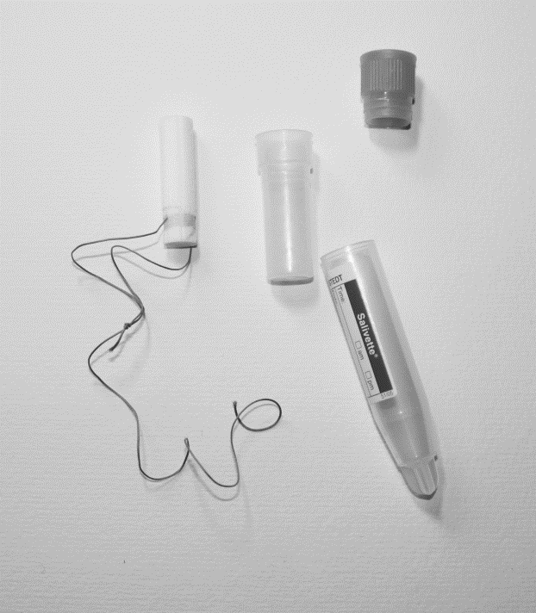
0 100mm
Supplemental Figure 1
Vaginal fluid sampling kit

