SUPPLEMENTARY FIGURES

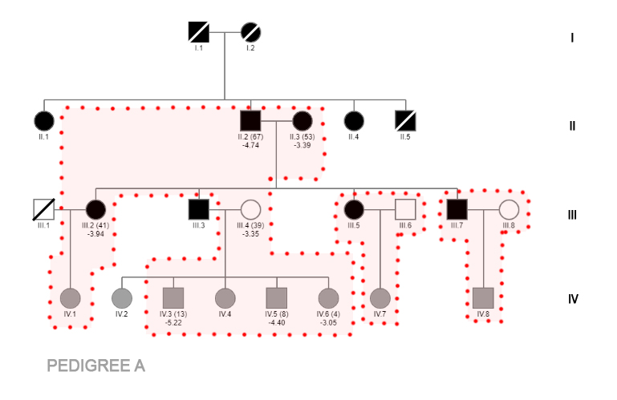
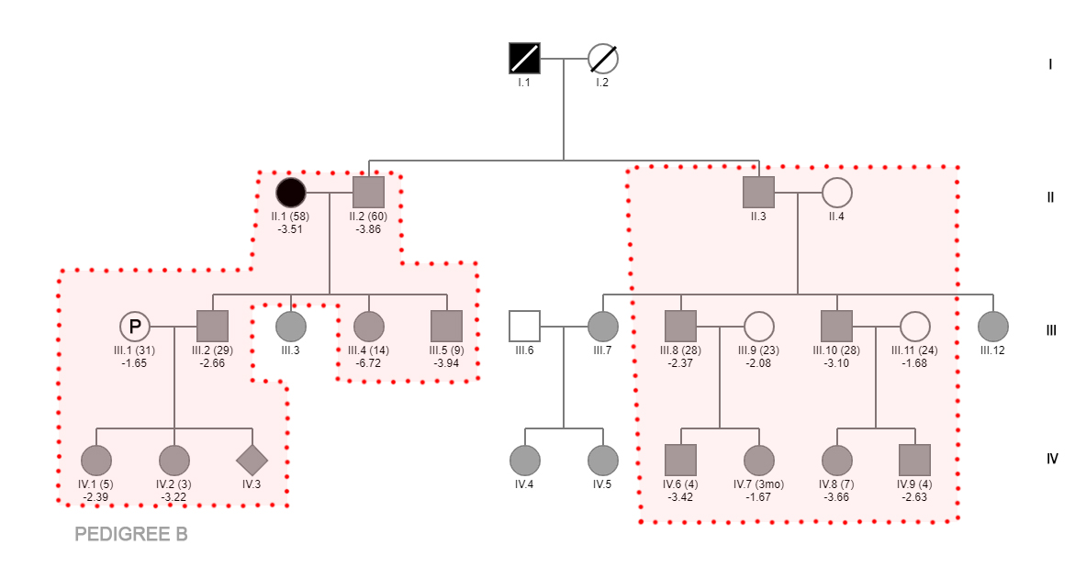
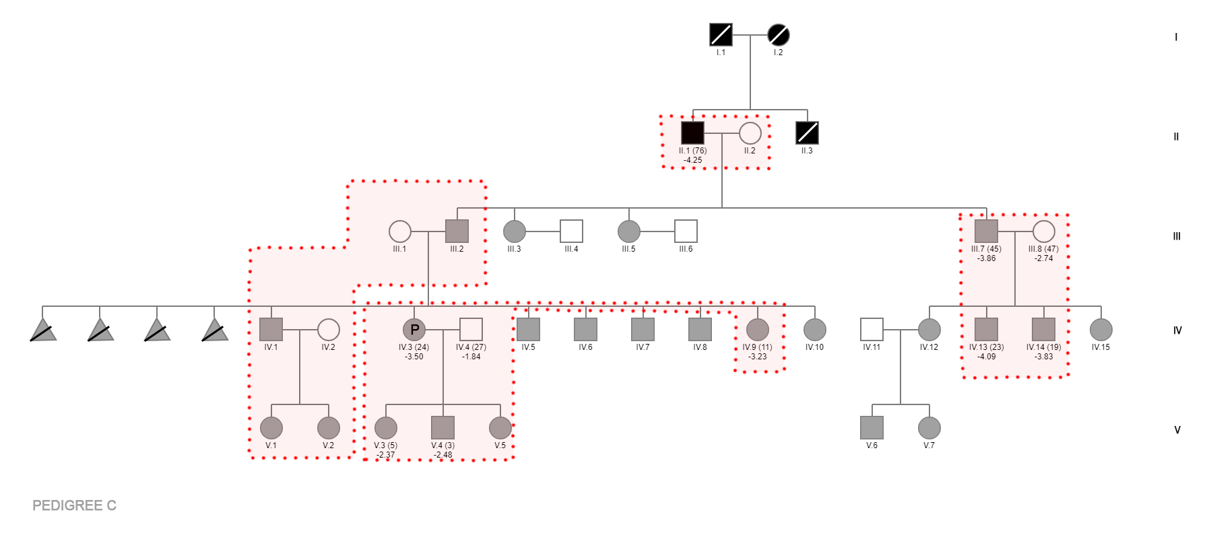
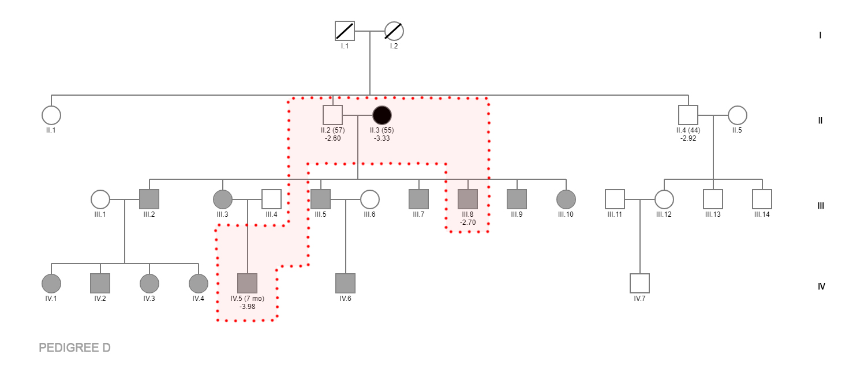
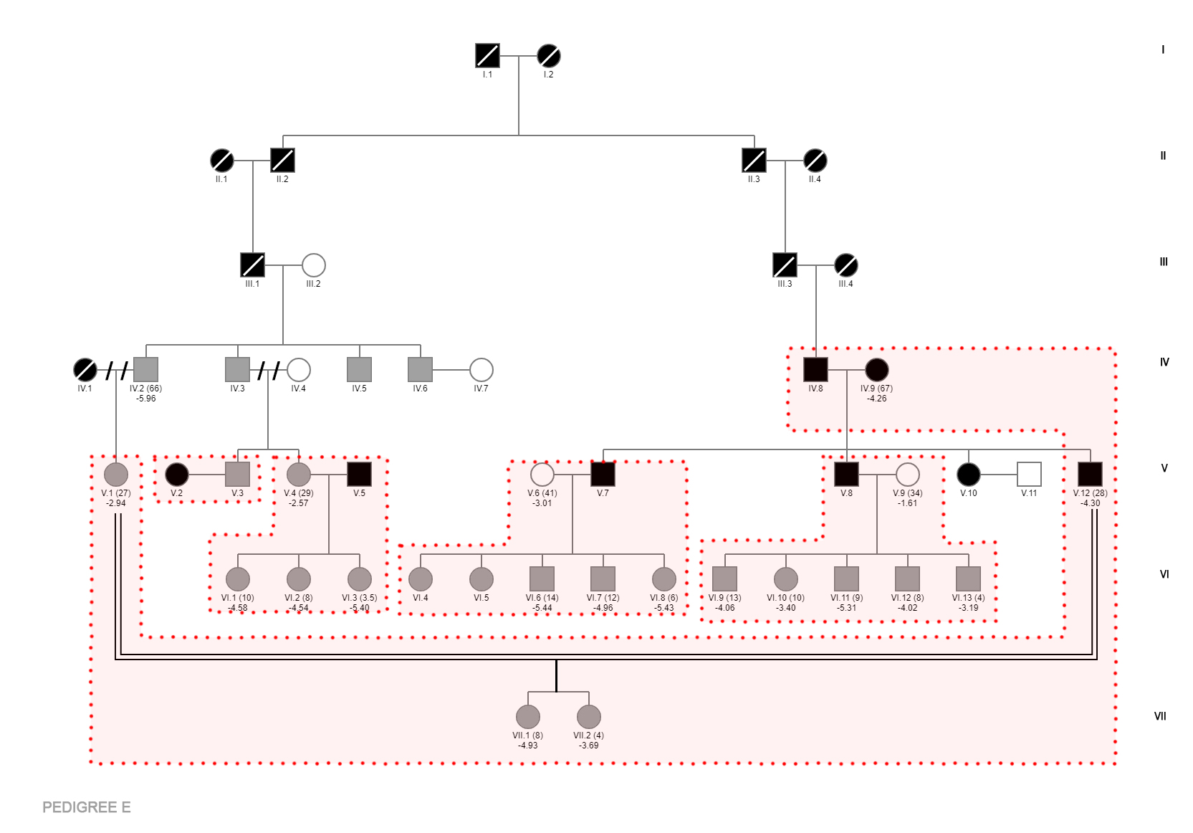
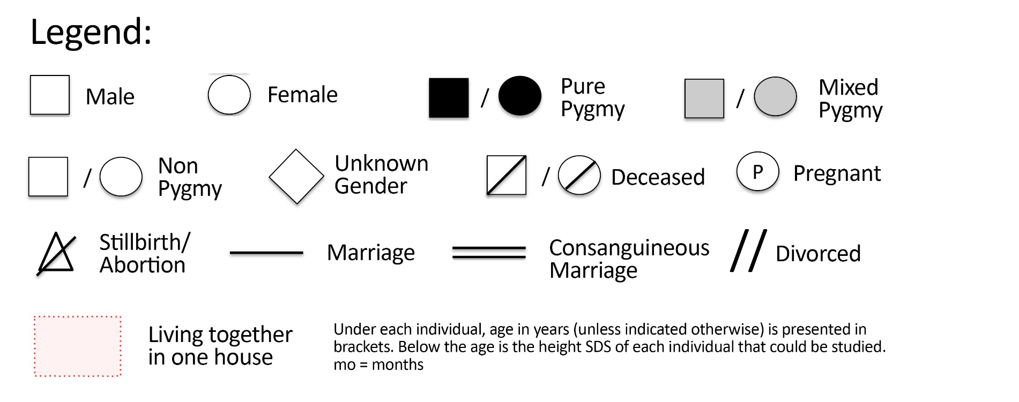

SUPPLEMENTARY TABLES

Supplementary Table 1. Laboratory results of case B-III-04 at 20.7 years of age

 | Result | Reference Range
Fasting glucose | 91 | <100 | mg/dL
Fasting insulin | 20.4 | 3.2-28.5 | uIU/mL
Creatinine | 0.5 | 0.5-0.9 | mg/dL
eGFR | 140 | >60 | mL/min/1.73 m²
FT4 | 1.44 | 0.93-1.71 | ng/dL
TSHs | 4.87 | 0.27-4.2 | uIU/mL
T3 (total) | 1.5 | 0.58-1.59 | ng/mL
T4 (total) | 10.76 | 4.87-11.72 | ug/dL
LH | 3.6 | Follicular phase: 1.80 – 11.78  Mid-cycle peak: 7.59 – 89.08  Luteal phase: 0.58 – 14.00 | mIU/mL
FSH | 5.28 | Follicular phase: 3.03 – 8.08  Mid-cycle peak: 2.55 – 16.69  Luteal phase: 1.38 – 5.47 | mIU/mL
Prolactin | 19.24 | 5.18-26.53 | ng/mL
Estradiol | 48 | Follicular phase: 21 – 251  Mid-cycle peak: 38 – 649  Luteal phase:  21 – 312 | pg/mL
Cortisol serum (morning) | 17.1 | 4.3-22.4 | ug/dL
IGF-I (SDS) | 249 (-0.09) | 105-346 | ng/mL
IGFBP-3 (SDS) | 4.8 (0.31) | 2.9-7.2 | mg/L
Growth hormone | 6.82 | <8 | ng/mL
ACTH (plasma) | 105 | 6-50 | pg/mL

Supplementary Table 2. Bone age, IGF-I, IGFBP-3 and IGF-I/IGFBP-3 ratio in children in Rampasasa (all P/N). IGF-I and IGFBP-3 data are presented in mass units, SDS for age and bone age, and for age (if age<9) or Tanner stage (if age≥9 years). IGF-I/IGFBP-3 is expressed as SDS for age and bone age.

Subjects' code | Age | Sex (Tanner Stage)¹ | Bone Age (y) | Bone Age Delay (y)² | IGF-1 (ng/ml) | IGF-1 SDS for CA | IGF-1 SDS for BA | IGF-1 SDS (CA, pub)³ | IGFBP-3 (ug/ml) | IGFBP-3 SDS for CA | IGFBP-3 SDS for BA | IGFBP-3 SDS (CA, pub)³ | IGF-1/IGFBP-3 Ratio | IGF-1/IGFBP-3 Ratio SDS for CA | IGF-1/IGFBP-3 Ratio SDS for BA
22 | 0.26 | F | n.a | n.a | <20 | <-2.26 | n.a | <-2.26 | 1.81 | 0.44 | n.a | 0.44 | <11.05 | <-2.89 | n.a
38 | 0.57 | M | n.a | n.a | <20 | <-3.25 | n.a | <-3.25 | 2.13 | 0.21 | n.a | 0.21 | <9.39 | <-4.89 | n.a
20 | 2.94 | F | 3 | 0.06 | <20 | <-3.79 | <-3.78 | <-3.79 | 1.35 | -0.75 | -0.93 | -0.75 | <14.81 | <-4.13 | <-4.13
35 | 3.29 | M | 3.5 | -0.21 | <20 | <-3.70 | <-3.68 | <-3.70 | 1.57 | -0.61 | -0.61 | -0.61 | <12.74 | <-4.14 | <-4.32
47 | 3.57 | F | 3 | 0.57 | <20 | <-3.72 | <-3.78 | <-3.72 | 1.07 | -1.58 | -1.58 | -1.58 | <18.69 | <-3.45 | <-3.45
60 | 4.09 | F | 3.5 | 0.6 | 45 | -2.29 | -2.31 | -2.29 | 2.62 | 0.42 | 0.69 | 0.42 | 17.18 | -3.39 | -3.62
8 | 4.3 | F | 3.5 | 0.8 | 41 | -2.21 | -2.47 | -2.45 | 2.29 | 0.09 | 0.32 | 0.09 | 17.90 | -3.30 | -3.54
24 | 4.34 | M | 4 | 0.34 | <20 | <-3.59 | <-3.63 | <-3.59 | 1.25 | -1.50 | -1.40 | -1.50 | <16.00 | <-3.55 | <-3.55
57 | 4.34 | M | 4 | 0.34 | <20 | <-3.59 | <-3.63 | <-3.59 | 1.3 | -1.40 | -1.50 | -1.40 | <15.38 | <-3.63 | <-3.63
21 | 4.39 | M | 4.5 | -0.11 | <20 | <-3.58 | <-3.57 | <-3.58 | 1.78 | -0.60 | -0.60 | -0.60 | <11.24 | <-4.17 | <-4.17
34 | 5.37 | F | 4.17 | 1.21 | 69 | -1.53 | -1.52 | -1.53 | 6.7 | 2.94 | 3.19 | 2.94 | 10.30 | -4.16 | -4.29
19 | 5.71 | F | 4.17 | 1.54* | 47 | -2.19 | -2.21 | -2.19 | 3.07 | 0.56 | 0.87 | 0.56 | 15.31 | -3.45 | -3.64
52 | 5.93 | F | 4.17 | 1.77* | 45 | -2.26 | -2.29 | -2.26 | 2.37 | -0.04 | 0.17 | -0.04 | 18.99 | -2.66 | -3.15
23 | 7.34 | F | 6.83 | 0.52 | 29 | -2.91 | -2.92 | -2.91 | 1.48 | -2.31 | -1.53 | -2.31 | 19.59 | -2.41 | -2.49
46 | 7.98 | F | 5.75 | 2.23* | 91 | -1.14 | -1.03 | -1.14 | 3.06 | -0.27 | 0.55 | -0.27 | 29.74 | -1.38 | -1.59
59 | 8.04 | F | 5.75 | 2.29* | 60 | -1.85 | -1.78 | -1.85 | 2.59 | -1.01 | 0.16 | -1.01 | 23.17 | -2.08 | -2.24
56 | 8.08 | M | 5 | 3.09* | 57 | -1.79 | -1.58 | -1.79 | 1.95 | -1.36 | -0.56 | -1.36 | 29.23 | -1.33 | -1.64
7 | 8.72 | M | 6 | 2.72* | 42 | -2.30 | -2.17 | -2.30 | 1.79 | -1.59 | -1.02 | -1.59 | 23.46 | -1.96 | -2.08
61 | 9.21 | M (I) | 5 | 4.22* | 31 | -2.66 | -2.73 | -2.76 | 1.97 | -1.66 | -0.54 | -1.48 | 15.74 | -3.17 | -3.39
14 | 9.68 | M (I) | 7 | 2.68* | 72 | -1.72 | -1.24 | -1.80 | 3 | -0.50 | 0.25 | -0.55 | 24.00 | -1.92 | -2.03
45 | 10.77 | F (I) | 6.83 | 3.95* | 62 | -2.59 | -1.74 | -1.76 | 2.51 | -1.74 | -0.21 | -0.91 | 24.70 | -2.28 | -1.95
55 | 10.88 | F (I) | 7.83 | 3.05* | 89 | -2.18 | -1.16 | -1.27 | 2.94 | -1.20 | -0.40 | -0.55 | 30.27 | -1.72 | -1.17
31 | 11.27 | F (I) | 7.83 | 3.45* | 118 | -1.93 | -0.64 | -0.75 | 3.65 | -0.79 | 0.27 | 0.04 | 32.33 | -1.86 | -0.95
51 | 12.1 | M (II) | 8 | 4.1* | 49 | -2.55 | -2.01 | -2.45 | 2.67 | -1.83 | -0.48 | -1.54 | 18.35 | -3.62 | -2.51
54 | 12.98 | M (?) | 9 | 3.99* | 89 | -2.35 | -1.24 | -1.76 | 2.56 | -2.34 | -0.94 | -1.68 | 34.77 | -2.25 | -0.81
5 | 13.54 | M (?) | 10 | 3.54* | 46 | -2.80 | -2.30 | -2.50 | 1.86 | -3.04 | -2.18 | -2.55 | 24.73 | -3.33 | -1.98
50 | 14.23 | F (II) | 10 | 4.23* | 195 | -1.97 | -0.34 | -0.96 | 3.4 | -2.00 | -0.73 | -1.29 | 57.35 | -1.02 | 0.36
13 | 14.34 | F (I) | 10.75 | 3.6* | 105 | -3.19 | -1.87 | -0.98 | 3.03 | -2.37 | -1.09 | -1.73 | 34.65 | -2.57 | -1.28
Mean | 7.98 |  | 5.89 | 0.63 | 69.10 | -2.57 | -2.22 | -2.33 | 2.46 | -0.92 | -0.38 | -0.74 | 21.82 | -2.88 | -2.59
SD | 3.67 |  | 2.33 | 0.30 | 38.57 | 0.74 | 1.01 | 0.92 | 1.12 | 1.22 | 1.06 | 1.11 | 10.17 | 1.01 | 1.25
Abbreviations: BA, bone age; CA, chronological age; F, female; M, male; n.a., not available; P/N, offspring of one parent from the pygmoid group and a parent from the non-pygmoid group; y, year;
¹ None of the included girls had had their menarche
²Delayed bone age as defined as >2 SD below the mean bone age for age is indicated by an asterisk
³IGF-I and IGFBP-3 SDS were calculated for age in children <9 years old and for Tanner stage in children ≥9 years
⁴For the calculation of mean (SD) IGF-I levels samples in which IGF-I was below the detection limit of 20 ng/mL, the value of was set at 20. Therefore the calculated means represent an overestimation of the real value
⁵Mean IGF-I SDS in children <9 years was -2.66 (0.86). Mean IGF-I in children ≥9 years adjusted for Tanner stage (assuming Tanner II in the boys with undocumented Tanner stage) was -1.70 (0.71).
⁶Mean IGFBP-3 SDS in children <9 years was -0.46 (1.19). Mean IGFBP-3 in children ≥9 years adjusted for Tanner stage (assuming Tanner II in the boys with undocumented Tanner stage) was -1.22(0.75).

