Supplementary table1: Primers for exons 2–6 of SHOX gene
Exon | Oligo sequences | Product size (base pairs) | Annealing temperature
SHOX 2F | ATAACAGCGCTGGTGATCCA | 492 | 67°C
SHOX 2R | AGACGGGAGCTGCAAATGT | 492 | 67°C
SHOX 3F | GTCAAAGCGCATTGGTTTTC | 495 | 65°C
SHOX 3R | CTCAGGCGTCTCCAAAAGTC | 495 | 65°C
SHOX 4,5F | CTCCCAGCTCCCAGAGGT | 485 | 65°C
SHOX 4,5R | GGCAGGGAGGGACTAGGAGT | 485 | 65°C
SHOX 6F | GCTCCCTAGGGGAGAAGAGG | 434 | 59.5°C
SHOX 6R | CGGGGTTGAGTGCAGGAC | 434 | 59.5°C

Supplementary table 2: Primers for exons 2–10 of GHR
Exon | Oligo sequences | Product size (bp) | Annealing temperature
GHR 2F | TGGTCTGCTTTTAATTGCTGG | 169 | 59°C
GHR 2R | CAAAACACTGAGGGTGGAAATGG | 169 | 59°C
GHR 3F | TACACAGGGTCATATCAGATTG | 240 | 56°C
GHR 3R | CTATTCCAGTTACTACCATCCC | 240 | 56°C
GHR 4F | ATATGACTCACCTGATTTCATGC | 225 | 58°C
GHR 4R | TAGGTACATCCATGGAGAGGAA | 225 | 58°C
GHR 5F | GCTACAACATGATTTTTGGAACAA | 276 | 57°C
GHR 5R | CATTTATTTAGTCTAAAACTATGTCA | 276 | 57°C
GHR 6F | AATATTAAATTGTGTCTGTCTGTGT | 268 | 60°C
GHR 6R | GAAAGAAAAGTCAAAGTGTAAGGT | 268 | 60°C
GHR 7F | TTGAGTTGTTGACTCTTTGGCC | 274 | 60°C
GHR 7R | AACTGTTATATTGACAAAAGCC | 274 | 60°C
GHR 8F | TAAACTGTGCTTCAACTATTC | 188 | 50°C
GHR 8R | AACTGGTACAAAATACCAA | 188 | 50°C
GHR 9F | GACAGGAGTCTTCAGGTGTTAA | 191 | 57 °C
GHR 9R | AGAATATGTAGCTTTTAAGATGTCA | 191 | 57 °C
GHR 10.1F | GAGTTTCTTTTCATAGATCTTC | 349 | 53°C
GHR 10.1R | TTAACCTCTGTGGCTGAG | 349 | 53°C
GHR 10.2 F | ACATGAGGGTACCTCAGA | 396 | 51°C
GHR 10.2 R | CAGAAGTAGGCATTGTCC | 396 | 51°C
GHR 10.3 F | GGAAATGGTCTCACTCTG | 375 | 62°C
GHR 10.3 R | CCAAAGAAAGGCTAAGGC | 375 | 62°C

Supplementary table 3: Primers for exons 1- 2 of IGFALS
Exon | Oligo sequences | Product size (bp) | Annealing temperature
IGFALS 1F | ACGAGGGGGTTAACAGAGC | 294 | 63°C
IGFALS 1R | GCAGACCCCCAGAGCTGA | 294 | 63°C
IGFALS 2.1F | ACCGGCTTCTTCGCATCT | 493 | 65°C
IGFALS 2.1R | CACAGGTTCTCTAGGCCCAG | 493 | 65°C
IGFALS 2.2F | CTTCCAGAACCTCTCCAGCC | 493 | 67°C
IGFALS 2.2R | CACGGCAGCGATGAGGTT | 493 | 67°C
IGFALS 2.3F | CCATCAAGGCAAACGTGTTC | 437 | 67°C
IGFALS 2.3R | AAGGTTCCGGAGACAGTTCC | 437 | 67°C
IGFALS 2.4F | TAGACCACAACCAGCTCCAG | 485 | 67°C
IGFALS 2.4R | CCCCAGTGGTGCCAAGAG | 485 | 67°C
IGFALS 2.5F | GAGTACCTGCTGCTCTCCC | 469 | 67°C
IGFALS 2.5R | CTGAGTCCGGGGCTTGAG | 469 | 67°C

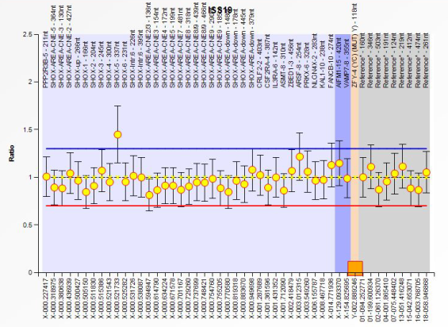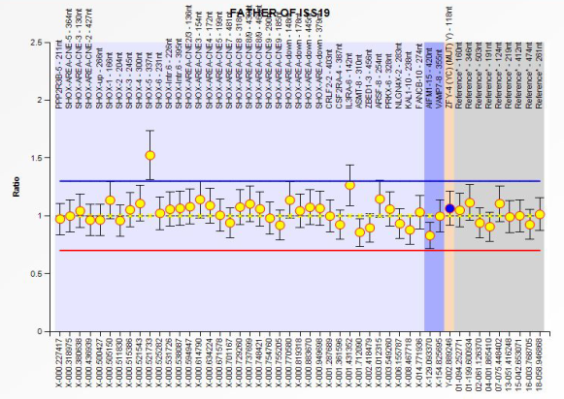
(1B)
(1A)

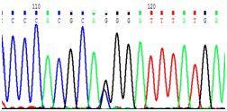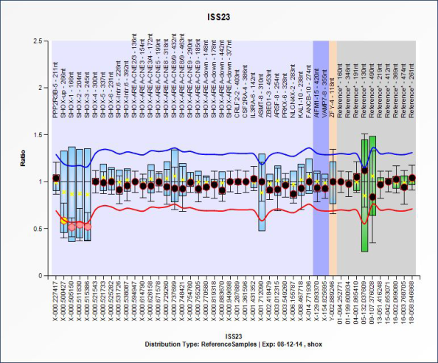
(1D)
(1C)

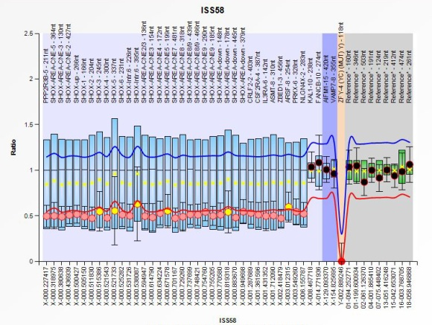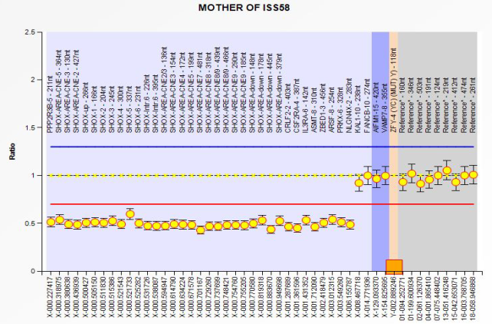
(1F)
(1E)

Supplementary figure1: MLPA analysis picture of (1A) ISS 19, and (1B) Father of ISS19, respectively showing duplication of exon 5 of SHOX gene; (1C) Sequence chromatogram for c.278-1G>C pathogenic variant of the SHOX gene of ISS 20; (1D) MLPA analysis picture of ISS 23 showing partial heterozygous deletion including the upstream SHOX region LOC159015 and exons 1, 2 and 3; (1E and 1F ) MLPA analysis picture of ISS 58, and her mother showing complete heterozygous deletion of SHOX gene which extended beyond pseudoautosomal region (PAR1) up to NLGN4X (Neuroligin 4X) gene

