Supplemental Material

**Figure 1**

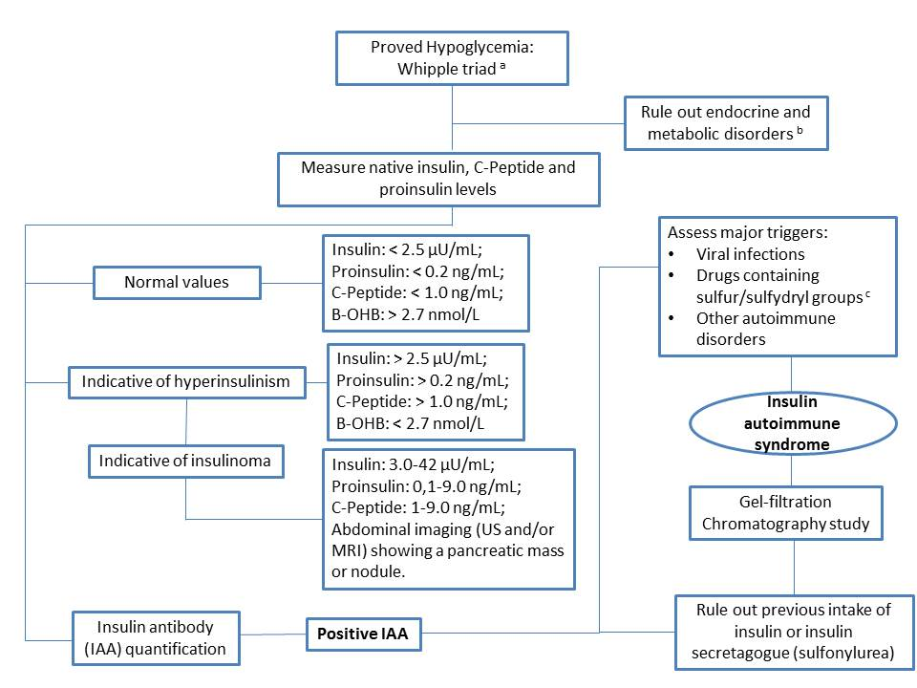

**Supplemental Material:**

**Legend:**

Figure 1: A flowchart approach to hypoglycemic in children (3,19)

a) Proved symptomatic hypoglycemia, glucose levels below 45 mg/dL (2.5 mmol/L), or a concentration low enough to elicit defensive neuroendocrine responses or to impair brain function.

b) Assessment of main lab tests: lactate, beta-hydroxybutyrate (B-OHB), free fat acid, ammonia, blood gas, carnitine and acylcarnitine, IGF-1 and cortisol.

c) methimazole, captopril, D-penicillamine, hydralazine, glutathione, methionine, mercaptans, clopidogrel, aurothioglucose, imipenem, penicillin G and diltiazem.

**Table 2:** Review of previous reported cases with regard of IAS by country among pediatric age

|  |  |  |  |  |  |  |  |  |  |
| --- | --- | --- | --- | --- | --- | --- | --- | --- | --- |
| Country  (Reference) | Year of publication | Ethnic background | Sex | Age of onset | Underlying disease | Insulin on plasma and method | Anti-Insulin antibody and method | HLA haplotype | Treatment and Evolution |
| Japan  (Nakagawa)  (Uchigata) | (1) 1973  (2) 1993 | (1) NR  (2) Japanese | (1) Female  (2) 2 cases were female and 1 were male | (1) 3 days  (2) Authors mention the range of age between 0-19 years, | (1) Hypoglycemia due to the presence of the antibody produced  in her mother's body against endogenous insulin and transferred to the patient transplacentally, despite no previous history of insulin injection of her or her mother  (2) No previous history of receiving methymazole nor alfa-mercapto-propionyl-glycine | (1) 4143 µu/mL (Free insulin: 3.7 µu/mL) by direct two antibody method: immuno-reactive insulin (IRI)  (2) serum immuno-reactive  insulin (IRI) (>1000 pmol/l) | (1) 1.82 BI/FI (Bound insulin/ Free insulin – normal value: 0.00) with Sephadex chromato-graphy  (2) High titer of antibody bound to human insulin (> 30% [1251] insulin binding). | (1) NR  (2) HLA-DRB1*0406/DQA1*0301/DQB1*0302 | (1) Multiple artificial feeding plus one-month course of prednisolone therapy.  (2) NR |
| Brazil | 2013 | NR | Female | 7 yo | Non-ketotic fasting hypoglycemia during treatment for pneumonia with ceftriaxone and oxacillin | 5.6 μIU/mL | 6.2% (normal, < 2.4%); | HLA-DRB1*1104 | Spontaneous resolution of the hypoglycemia, within 30 days, with normalization of serum anti-insulin titers, although therapy with hydrocortisone was started (bronchospasm and a severe urticarial allergic reaction). Patient died of multiple organ dysfunctions secondary to sepsis. |
| Turkey | 2014 | NR | Female | 16 yo | No history of chronic disease or medication use. | 379 mIU/ml  (direct chemiluminescent technology) | 41.8% (normal range: 0–7%) | NR | Controlled by a low-carbohydrate diet, but mildly symptomatic hypoglycemia occurred in the case of noncompliance with the diet. |
| Australia | 2016 | African | Male | 9 yo | Type 1 diabetes and  Kawasaki disease, treated with intravenous immunoglobulin | NR | high IA titer (>18 units, normal <0.7) by 125I-(A14)  human insulin immunoprecipitation assay.  Anti-insulin receptor antibody negative. | (HLA) DR4 status was negative | A combination of immune-suppressive therapies, including glucocorticoids, mycophenolate, high-dose immunoglobulin,and rituximab, besides regular use of therapeutic plasma exchange. |
| Argentina | 2013 | Caucasian | Male | 12 yo | Type 1 diabetes since 18 mo, with severe signs of lipodystrophy  in the insulin injection sites. | NR | Binding rate: 48.2% (cut off value = 3.28%) by Surface Plasmon Resonance (SPR) technology | NR | After 10 years of evolution, the patient continued with regular metabolic control and lipodystrophy. |
| USA  (Goldman)  (Gomez Cruz) | (9) 1979  (10) 2012 | (9) NR  (10) African-American | (9) Male  (10) Male | (9) first symptoms during the neonatal period; diagnosis at 25 months old  (10) 16 yo | (9) No evidence of exogenous insulin, though a differential diagnosis between factitious and autoimmune hypoglycemia remained.  (10) Graves’ disease and started on Methimazole four weeks later | (9) 254 µu/mL to >1,000 µu/mL  (10) 1184.5 pmol/L (reference range: 21.5–200.9 pmol/L). | (9) 3.46 BI/FI (Bound insulin/Free insulin – normal value: 0.00) with Sephadex chromatography  (10) at*>*50 unit/mL (reference range: *<*0.4 unit/mL | (9) NR  (10) NR | (9) Appropriate Glucagon response to hypoglycemia  (10) Persistent hypoglycemia was managed with prednisone and diazoxide during six months when antibodies levels decreased to normal levels (0.01 nmol/L) |
| South Korea (Lee) | 2013 | Korean | Female | 15 yo | Graves’ disease and was being treated with methimazole | 238.2 μU/mL | Anti-insulin antibody titer of ＞100 U/mL (normal,  ＜5 U/mL) | DRB1*04:06. | Treated with corticosteroid for 2 months. The insulin antibody titer decreased dramatically, and she did not have any episode of hypoglycemia since then. |
| Italy (Meschi) | 1991 | NR | Male | 5 yo | Recurrence of hypoglycemic symptoms and high titers of  Insulin antibodies during 10 years. | 6138-10.722 pM (normal below 25 pM)  RIA | 62%-87%, insulin binding at 1:80 serum dilution  (normal: below 5% for undiluted serum) | NR | Several hypoglycaemic episodes (some cases with loss of consciousnes).  Treatment with prednisolone was followed by a decrease in antibody titre that lasted for 2 years. |
| Spain (Rovira) | 1982 | NR | Male | 4 yo | The child had never received insulin injections.  Presence of ketone bodies in the urine. | NR | NR | NR | After 17 months, during which the child remained asymptomatic, insulin antibodies could not be detected in his plasm. |

IAS: insulin autoimmune syndrome; HLA: human leucocyte antigen; NR: not reported: RIA: radioimmunoassay