**Appendices**

**Appendix 1: Administered Survey**

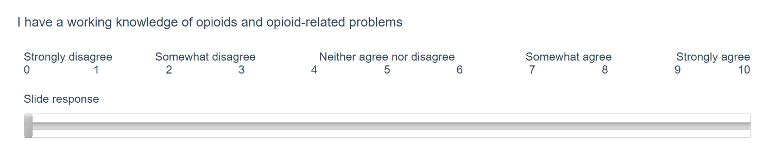

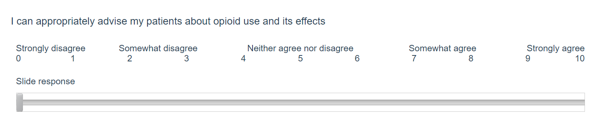

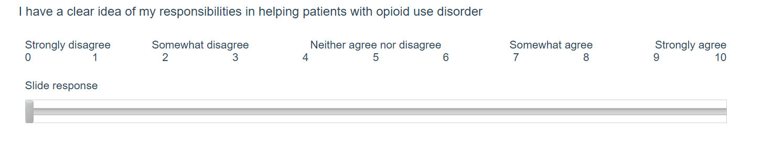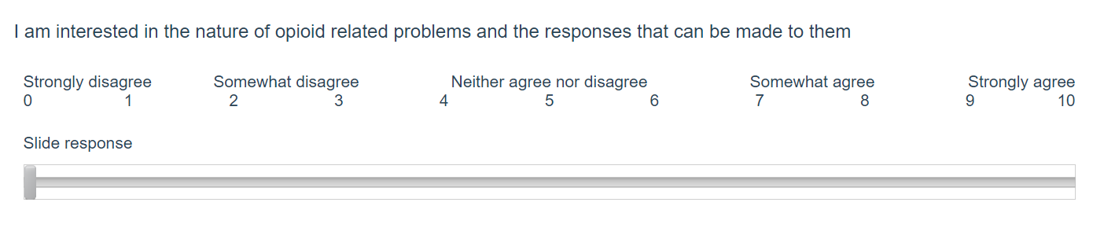

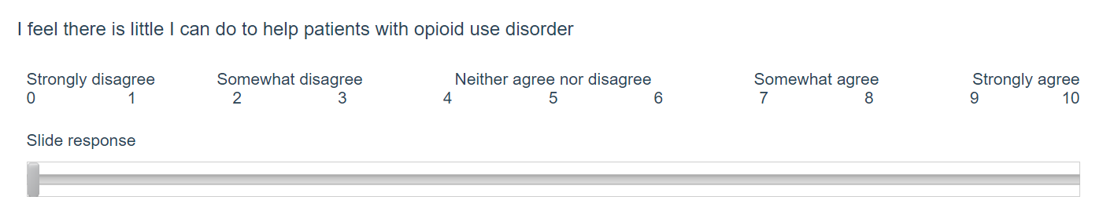

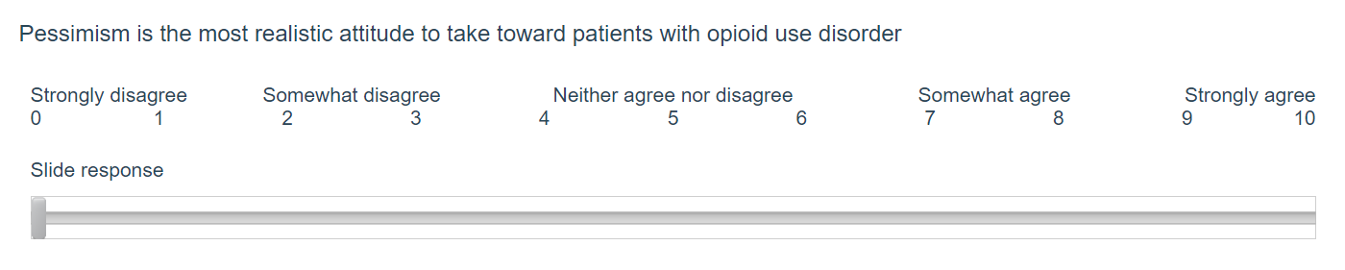

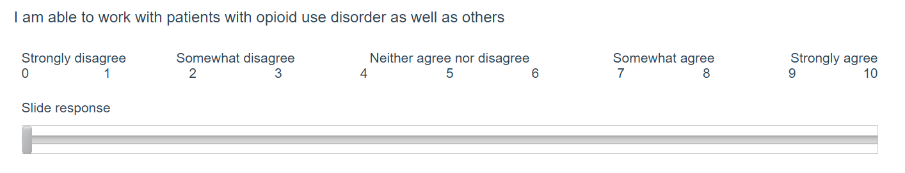

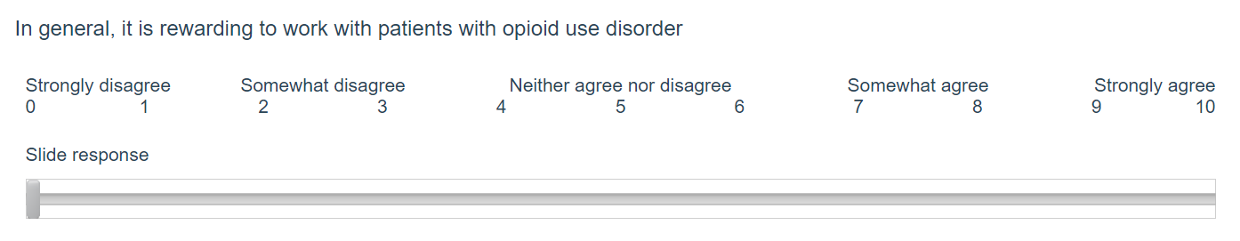

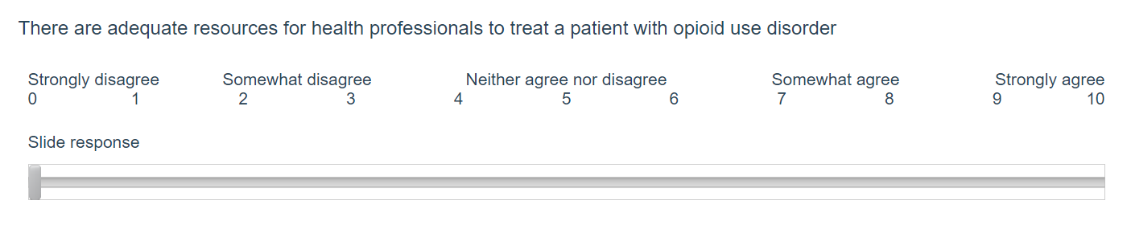

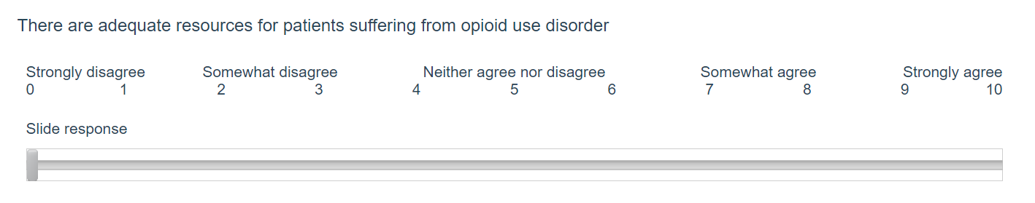

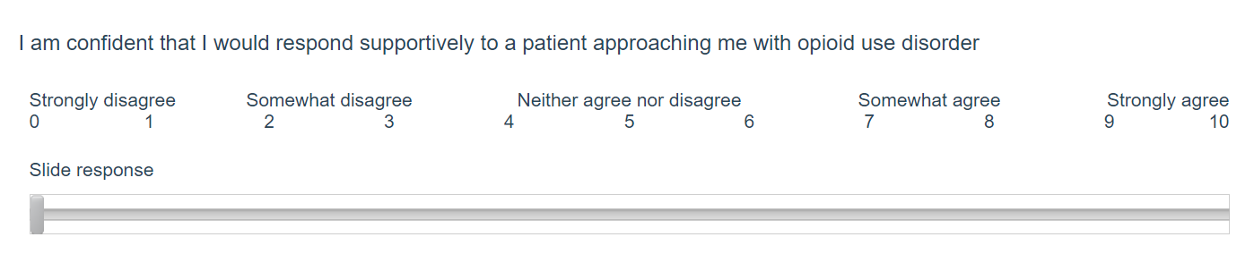

**Appendix 2: Statements Comprising the Original Alcohol and Alcohol Problems Perception Questionnaire (AAPPQ) Attitude Scales**

|  |  |  |  |  |  |
| --- | --- | --- | --- | --- | --- |
| Role Adequacy | | Role Legitimacy | | Role Support | |
| **1** | **I feel I have a working knowledge of alcohol and alcohol related problems** | **8** | **I feel I have a clear idea of my responsibilities in helping drinkers** | 12 | If I felt the need when working with drinkers, I could easily find someone with whom I could discuss any personal difficulties I might encounter |
| 2 | I feel I know enough about the causes of drinking problems to carry out my role when working with drinkers | 9 | I feel I have the right to ask patients questions about their drinking when necessary | 13 | If I feel the need when working with drinkers, I could easily find someone who would help me clarify any professional responsibilities |
| 3 | I feel I know enough about the alcohol dependence syndrome to carry out my role when working with drinkers | 10 | I feel that my patients believe I have the right to ask them questions about drinking when necessary | 14 | If I felt the need, I could easily find someone who would be able to help me formulate the best approach to a drinker |
| 4 | I feel I know enough about the psychological effects of alcohol to carry out my role when working with drinkers | 11 | I feel I have the right to ask a patient for any information that is relevant to their drinking problems. | NV | ***There are adequate resources for health professionals to treat a patient with opioid use disorder*** |
| 5 | I feel I know enough about the factors which put people at risk of developing drinking problems to carry out my role when working with drinkers |  |  | NV | ***There are adequate resources for patients suffering from opioid use disorder*** |
| 6 | I feel I know how to counsel drinkers over the long term |  |  |  |  |
| **7** | **I feel I can appropriately advise my patients about drinking and its effects** |  |  |  |  |
| Motivation | | Task-specific self-esteem | | Work satisfaction | |
| **15** | **I am interested in the nature of alcohol related problems and the responses that can be made to them** | **20** | **I feel I am able to work with drinkers as well as others** | 26 | I often feel uncomfortable when working with drinkers |
| 16 | I want to work with drinkers | 21 | All in all, I am inclined to feel I am a failure with drinkers | 27 | In general, one can get satisfaction from working with drinkers |
| 17 | I feel that the best I can personally offer drinkers is referral to somebody else | 22 | I wish I could have more respect for the way I work with drinkers | **28** | **In general, it is rewarding to work with drinkers** |
| **18** | **I feel that there is little I can do to help drinkers** | 23 | I feel I do not have much to be proud of when working with drinkers | 29 | In general, I feel I can understand drinkers |
| **19** | **Pessimism is the most realistic attitude to take toward drinkers** | 24 | At times, I feel I am no good at all with drinkers | 30 | In general, I like drinkers |
|  |  | 25 | On the whole, I am satisfied with the way I work with drinkers |  |  |
|  |  | NV | ***I am confident I would respond supportively to a patient approaching me with opioid use disorder.*** |  |  |
| Items that were used and adapted for our scale are in bold. Items were selected for their clarity and relevance to a graduate health student. The numbers here represent the original numbers within the Original AAPPQ and not the number of questions in the survey. The total number of questions was 11 and includes original AAPPQ questions 1, 7, 8, 15, 18, 19, 20, and 28, with three additional non-validated questions adapted from the AAPPQ to address perceptions related to healthcare graduate students.  The word alcohol was replaced with opioid.  Three new statements were added (denoted by NV for non-validated) | | | | | |

**Appendix 3**: Sample IPE Curriculum Schedule for April 2020

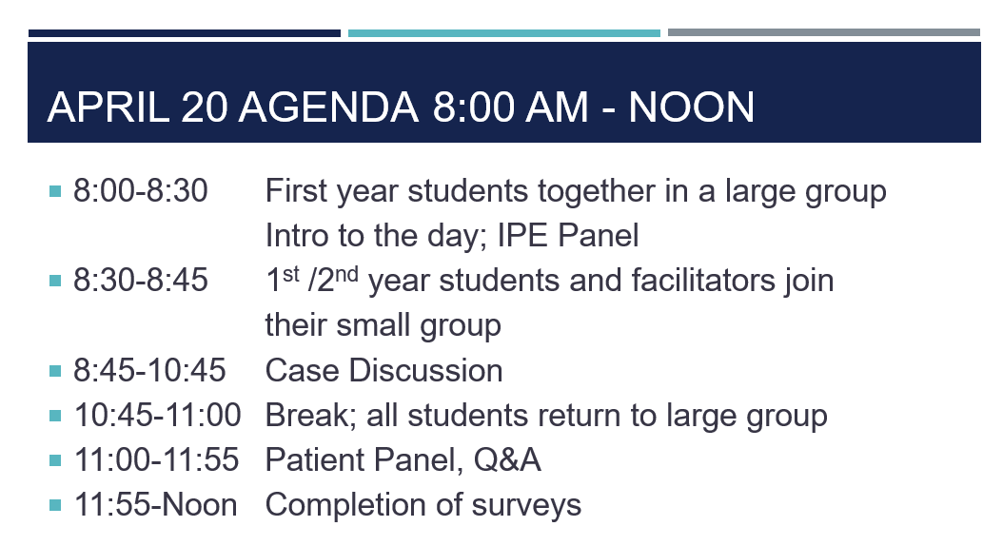

**Appendix 4:** Washington State University - Interprofessional Event Guide

**Facilitator Guide**

**Educating Interprofessional Teams on Opioid Use**

##### Materials developed by faculty at Washington State University:

Barbara Richardson, PhD, MN, BSN *(WSU Elson S. Floyd College of Medicine*) Marian Wilson, PhD, MPH, RN-BC *(WSU College of Nursing)*

Brenda Bray, RPh, MPH *(WSU College of Pharmacy and Pharmaceutical Sciences)*

Connie Remsberg, PhD, PharmD *(WSU College of Pharmacy and Pharmaceutical Sciences)*

These materials were created and tested with support from the Prevention for States (Pfs) Grant

5 NU17CE002734, funded by the Centers for Disease Control and Prevention. Its contents are solely the responsibility of the authors and do not necessarily represent the official views of the Centers for Disease Control and Prevention or the Department of Health and Human Services.

### 1

Introduction

This Interprofessional Opioid Education Curriculum was developed by faculty from Washington State University Health Sciences in collaboration with the Washington State Department of Health. While the curriculum is specific to Washington, it may be adapted to other states (has been adapted to California.)

The purpose of this curriculum is to provide an interprofessional learning opportunity for students from different health professions to collaborate with each other and practice using a team approach when caring for a patient who is taking opioid medications. The curriculum is intended for use with students who are nearing the end of their profession-specific training.

Through participation in this curriculum, interprofessional team learners will apply skills in the following areas: assessment of a patient with chronic pain who is taking opioids; interpretation of results from screening and diagnostic tools for pain and/or opioid use disorder; identification of treatment options for management of chronic pain and/or opioid use disorder including pharmacologic and non-pharmacologic approaches; development of a patient specific plan; and opioid overdose prevention. Throughout the learning experience, interprofessional team-based practice will be encouraged and emphasized.

The curriculum is designed with two patient case vignettes designed to guide the student teams through evaluation and care decisions for patients taking opioids. For the purposes of our session today, we will use just Patient case 1 (Sam Jones), a male patient who is taking prescription opioids for chronic back pain.

# Learning objectives

Upon completion of this curriculum, learners should be able to do the following:

1. Describe the roles and responsibilities of the healthcare team and how they work together to provide team-based care to patients using opioids.
2. Utilize appropriate non-stigmatizing language when caring for patients taking or potentially misusing opioids.
3. Express one’s knowledge and opinions to healthcare team members with confidence, clarity, and respect, working to ensure common understanding of information, treatment, and care decisions.
4. As a member of the healthcare team, evaluate a patient for potential opioid misuse or opioid use disorder.
5. Differentiate between treatment options for a patient with an opioid use disorder and/or pain management.
6. Work collaboratively with the healthcare team and the patient to develop a patient care plan.

# Curriculum overview

For our event today, the curriculum will have facilitator pairs, with one facilitator taking the lead with IPE facilitation/timing and the other being a “content expert” with addiction. The session will take approximately 2 hours and 15 minutes including a 5 minute break.

###### List of course materials:

* 1. *Facilitator Guide*

1. *In-class PowerPoint Presentation:* Contains in-class PowerPoint slides with facilitator notes. Embedded with the presentation are a video-taped patient case vignette for Patient case 1 (Sam Jones).
2. *In-class student team materials for 2 hour session*: Handouts used throughout the interprofessional session that include Patient case 1 (Sam Jones).

This curriculum is designed for the following healthcare students nearing the end of their professional training. It may also be adapted for interdisciplinary team members in a primary care clinic who assess patients on chronic opioids.

* Physicians (MD, DO)
* Physician assistants (PA)
* Nurse practitioners (ARNP)
* Nurses (RN, BSN, ADN, MN, CNA)
* Pharmacists (PharmD)
* Social Workers (MSW)
* Medical assistants (MA)
* Substance Use Disorder counselors (SUDC)**

**Curriculum may be more appropriate for students early in their training.

# Student pre-class preparation

* IPE module completion in Canvas including attitude and knowledge surveys.

# Student post-class work

# Post course knowledge and attitude surveys as well as a survey related to SAMHSA grant immediately post course and a separate one 30 days later- completed in Canvas IPE course.

KK

# In-class session

### In-class session overview:

The in-class session has been created with a detailed PowerPoint presentation designed for the facilitator to guide the students through the content by using a combination of large and small group activities, debriefs, and video vignettes. This will be held via Zoom.

The interprofessional in-class session is designed to be flexible according to the needs of the learners. The in-class session lasts approximately two hours and 15 minutes when including only Patient case 1 (Sam Jones).

### Logistics:

* **Interprofessional teams:** To help students understand roles and responsibilities of different disciplines when providing care to patients taking opioids, teams will consist of 4-5 students from different professions per team. Teams will be pre-assigned to ensure a diverse mix of healthcare professions in each group – we anticipate having approx. 25 students per large group thus have 5 or 6 breakout rooms per large group.

###### Materials and instructions for interprofessional session:

|  |  |
| --- | --- |
| **Materials:** | **Instructions:** |
| *In-class PowerPoint* | Prior the session, the facilitator should familiarize themselves with the PowerPoint and check that video/audio is working appropriately for all video links. |
| In-class student team materials for 2 hour session. All needed materials are contained in one document. They include the following:   1. Healthcare Team Roles and Responsibilities handout, 2. Patient Case 1 – Sam Jones, 3. Treatment plan for Sam Jones 4. Breakout Group exercises | Suggest that you print one copy of the “*In-class student team materials for 2 hour session”* documents. |
| *Student pre-session and post session work* | Surveys and assessments in Canvas. |
| *Program evaluation tool* | Online session to be completed at the end of the session. |
| Resources for the facilitator(s):   1. Facilitator guide 2. PowerPoint slides with notes 3. In-class student team materials | Recommend that each facilitator bring printed copies of documents to have on-hand during the Zoom session. Be sure to print the PPT slides WITH notes. |

**Estimated timeline for in-class session:** An overview of the session is provided in the table below.

|  |  |  |  |  |
| --- | --- | --- | --- | --- |
| **TIME** | **LEARNING GROUP** | **Slide numbers** | **ACTIVITY** | **LEARNING OBJECTIVE(S)** |
| 25 minutes | All learners and facilitators | 1-11 | Provide overview of session  Highlight learning objectives.  Overview of opioid epidemic  Intro to Health Disparities  IPE panel discussion | Overview of today’s session  Highlight epidemiology of opioid use disorder epidemic nationally and locally  Understand how social determinants of health increase risk for substance use disorder  Discussion the impact of OUD epidemic from interprofessional perspective |
| 10 min | Leave large group zoom session and login to assigned group zoom session | 12-14 | Introductions of facilitators  Introduction to the process to evaluate and provide care to a patient who is taking opioid;  Put students into breakout room |  |
| 10  Minutes  Time Check: 8:45 | Small group | 15 | ***Exercise One***  ***Activity 1- Roles and responsibilities*** Icebreaker activity to introduce student teams and discuss roles and responsibilities  ***Activity 2 – Using appropriate language*** This interactive discussion activity will have students consider stigmatizing language around opioid use. Students will evaluate specific phrases and suggest more appropriate language to use that minimizes patient stigmatization.  Come back to large group | Describe the roles and responsibilities of the healthcare team and the key information that each member/discipline needs to provide in order to work together to provide team-based care for patients taking opioids.  Utilize appropriate vocabulary when caring for patients taking or potentially misusing opioids. |
| 5 minutes | Large group | 16-19 | Discuss/debrief Exercise One as a large group |  |
| 20 minutes | Large group | 20-24 | Review Step 2 and 3  Introduction to ***Patient Case 1 (Sam Jones).***  Video: intake interview between nurse and Sam Jones with short debrief  Put students into breakout rooms |  |
| 15  Minutes  Time check:  9:25 | Small group | 25 | ***Exercise Two: Review Hx, Screening Tools and PMP Report***  Come back to large group |  |
| 5 min | Break | 26 |  |  |
| 10 minutes | Large group | 27-30 | Large group debrief findings on Hx, Screening tools and PMP report |  |
| 15 minutes | Large group | 31-33 | Review Step 4 and 5  Video: hand-off between nurse and prescriber  Video: Sam Jones and prescriber interaction  Short debrief  Students to breakouts |  |

|  |  |  |  |  |
| --- | --- | --- | --- | --- |
| 15 minutes  Time check:  10:10 | Small group | 34 | ***Exercise Three: Morphine Equivalent Dose (MME) calculation***  ***Aberrant behaviors and possible opioid use disorder***  Come back to large group |  |
| 10 minutes | Large group | 35-38 | ***Large group debrief and summary of what we know about Sam Jones so far;* brief summary of Sam’s problem list** |  |
| 10 minutes | Large group | 39-40 | Conclusion/Drug Safe Solano/Evaluations |  |
| **Total: 2 hours 30 minutes/end at 10:30 (then 15 min break and patient panel discussion starts at 10:45)** | | | | |

### Facilitator preparation:

Facilitators should review all content/materials prior to the in-class session including the following documents: *Facilitator guide, In-class Powerpoint slides and facilitator notes and In-class student team materials*.

### Directions for facilitating the in-class session:

Using the *In-class Powerpoint presentation* as a guide, the format for the interprofessional session is organized as a combination of large group facilitated discussions and small group team discussions followed by large group debriefs.

Each large group session will be run by two facilitator as noted above.

All learners should be encouraged to actively participate in both the large group discussions and during the small group team discussions. The learners will facilitate themselves during the small group discussions.

The facilitator(s) will debrief each content section to ensure learners leave with accurate information. Additionally, the facilitator will encourage learners to reflect on the learning that occurred. As noted, facilitators will need to monitor the timing in order to get through all of the material and debriefs.

### KEYs to student in-class materials

Keys to each of the in-class student materials are available below.

**Healthcare Team Roles and Responsibilities: (KEY) Team #:**

**Directions**: Discuss as a team who can do the following tasks within the scope of their licenses in Washington State. Different clinics use team members in different ways. As a team, fill in the table below with the license type(s) that generally complete the majority of items in each box. License types to include are ***registered nurse (RN), prescribers (MD, DO, ARNP, PA-C), medical assistant (MA- C), pharmacist (PharmD, RPh), social worker (MSW), and chemical dependency professional (CDP)***.

|  |  |
| --- | --- |
| **Description of roles and responsibilities related to providing care to a patient who is taking opioids for pain or who may be misusing opioids** | **Profession** |
| * Has initial contact with the patient prior to the prescriber * Administers and interprets oral, paper, or electronic screens (i.e. PHQ-9, GAD- 7, Suicide, etc.) * Updates patient’s medical records * Communicates concerns about aberrant behaviors, excessive somnolence to prescriber. * Can be delegated to assess opioid uses through the Prescription Monitoring Program (PMP) * Communicates information to the health care team (e.g. requests for prescription renewal, lack of adherence to pain care agreement, patient/family reports of symptoms/concerns) * Collects and prepares laboratory specimens such as a urine sample | Medical assistant (MA-C) |
| * For patients with acute, subacute, or chronic pain, assess patient and their medical record for diagnosis or underlying cause of pain * Diagnoses opioid use disorder or opioid dependence * Establishes functional goals with patients * Makes tapering or risk decisions based on opioid morphine equivalent dose * Uses information from Prescription Monitoring Program (PMP), screening tools, and urine drug screens to guide opioid prescribing * Prescribes pain treatment including starting, tapering, and discontinuing of opioid, non-opioid, and non-pharmacologic therapies * Identifies need for specialized referrals (e.g. pain management specialists, pain psychologist) * Counsels the patient on safe and appropriate use of opioid and non-opioid medications * Monitors for safety and efficacy of therapy | Prescriber  (MD, DO, ARNP, PA-C) |
| * Formulates a behavioral health treatment plan which consists of goals designed to promote recovery and utilize a holistic model for treatment * Serve as the substance use disorder specialists on the healthcare team * Provides counseling to the patient and family (as allowed by licensing boards) related to a substance use disorder * Makes referrals to community resources such as addiction and pain support groups * Provides emotional support | Substance Use Disorder Counselor (SUDC) |

|  |  |
| --- | --- |
| * Administers and interprets oral, paper, or electronic screens (i.e. PHQ-9, GAD- 7, Suicide, etc.) * Interviews patient for opioid use and conducts pill counts as needed. * Communicates concerns about aberrant behaviors, excessive somnolence to prescriber. * Updates patient’s medical records * Administers opioids and non-opioids * Advocates for patients * Can calculate morphine equivalent dose * Can be delegated to assess opioid uses through the Prescription Monitoring Program (PMP) * Counsels the patient on safe and appropriate use of opioid and non-opioid medications * Monitors for safety and efficacy of therapy | Registered nurse (RN) |
| * Reviews patient profile for appropriateness of prescribed medication * Makes recommendations to the patient for self-care * Calculates morphine equivalent dose * As part of the healthcare team, makes recommendations on appropriate treatments * Assesses opioid use through the Prescription Monitoring Program (PMP) * Counsels the patient on safe and appropriate use of opioid and non-opioid medications * Monitors for safety and efficacy of medication therapy | Pharmacist (PharmD, RPh) |
| * Advocates for patients * Provides behavioral therapy to the patient and family * Provides emotional support * Identifies resources and facilitates referrals * Facilitates coordination of care | Social worker (MSW) |

**Collection and Assessment of Patient Information: Team #: Instructions: The following questions are designed to guide your team through evaluation of Sam Jones. Please work through each question recording your team’s answer(s).** Read through the first page of the patient case available on the next page (**page 14**).

* + What components of the patient’s history stand out?

It has been ~3 months since his accident. This means the patient is now transitioning to chronic opioid use (>3 months).

1. Interpret the results of the screening tools provided on **pages 15-17** of this packet.
   * What do the results of the PEG suggest?

PEG score consistently 7 out of 10 which suggests inadequately controlled pain. The PEG also indicates the patient has no clinically meaningful improvement in function.

* + What do the results of the PHQ-9 suggest? PHQ-9 scoring is suggestive of moderate depression.

Question 1 total score of 11 indicates the prescriber should use clinical judgement about treatment – counseling +/- medication.

Question 2 indicates the patient's function is not impaired.

* + What do the results of the DAST suggest?

DAST score of 4 suggests moderate level of problems related to drug use

1. Interpret the PMP profile listed on **page 19** of this packet.
   * Do the prescriptions noted within PMP match the prescriptions listed within the patient chart?

See key provided on PMP report below.

* + Are there any red flags? Explain.

Yes, patient has received prescriptions from other providers including a dentist, urgent care, and ER. He is also using multiple pharmacies.

**Patient case**

|  |  |
| --- | --- |
| **Case:** | |
| Sam Jones, 63 year old male, retired lawyer | |
| **Case Setting:** | |
| Rural, primary care clinic with access to pharmacy, social work, and chemical dependency professionals. The patient has previously seen this prescriber but not since his car accident. | |
| **CC:** | |
| Here today for wellness check. Patient reports continued pain and is requesting additional hydrocodone prescriptions. | |
| **History of present illness:** | |
| Car accident three months ago causing an acute back injury resulting in a lumbar strain.  Emergency department initiated at the time of the accident hydrocodone/acetaminophen 5 mg/325 mg 1 tab PO q 4-6 hours prn pain for 14 days following visit to emergency department.  Ten days following the accident, the patient has a follow up appointment with a prescriber at the clinic. Reported continued pain (6 out of 10) despite reporting use of maximum dose of hydrocodone/acetaminophen. Average PEG score was 7 out of 10. Prescribed hydrocodone/acetaminophen 5 mg/325 mg 1 tab PO q 4-6 hours prn pain for 15 days.  One month following the accident patient returned to clinic. Patient reported taking the prescription every 4 hours. Patient’s pain 7 out of 10. Average PEG score 7 out of 10. Prescriber increased dose of hydrocodone/acetaminophen to 10 mg/325 mg 1 tab PO q 4-6 hours prn pain and initiated patient on carisoprodol 250 mg 1 tab PO TID and at bedtime prn back muscle spasm for 14 days.  For the past two months, the patient has continued on hydrocodone/acetaminophen to 10 mg/325 mg 1 tab PO q 4-6 hours prn pain. Reports taking carisoprodol most nights of the week.  Patient indicates he avoids most activity/exercise to prevent any additional injury to his back.  Prior to the accident, he cycled three times a week and hiked often on the weekends. | |
| **Past medical history:** | |
| Allergies: penicillin (rash) Problem list: 1. Hypertension   1. Hyperlipidemia 2. History of depression 10 years ago. Improvement following counseling and exercise. 3. Lumbar strain from vehicular accident | |
| **Social History:** | |
| Reports drinking occasionally 3-4 drinks per week either beer or wine. Drinks 1-2 cups of coffee per day Does not smoke or use tobacco products. Retired lawyer that lives with his wife and two dogs. No children. | |
| **Family History:** | |
| Reports father died of alcoholic cirrhosis | |
| **Medication list:** | |
| * Hydrocodone/acetaminophen 10 mg/325 mg 1 tab PO q 4-6 hours prn pain for back pain * Carisoprodol 250 mg 1 tab PO TID and at bedtime prn back muscle spasm * Lisinopril 10 mg 1 tab PO daily for hypertension * Rosuvastatin 20 mg 1 tab PO daily for hyperlipidemia | |
| **Vital signs:** | |
| * Height: 5’6” * Weight: 145 lbs   • BMI: 23.4 | • HR: 73 RR: 16  • BP: 125/84   * Temp: 37°C |
| **Today’s Lab results:** | |
| * Complete metabolic panel: Within normal limits * Lipid panel: Within normal limits | |
| **Past surgeries:** | |
| * No surgeries | |

**Results of screening tools administered today:**



**PEG Scale Assessing Pain Intensity and Interference (Pain, Enjoyment, General Activity)**

#### What number best describes your pain on average in the past week?

0 1 2 3 4 5 6 7 8 9 10

No Pain Pain as bad as

you can imagine

#### What number best describes how, during the past week, pain has interfered with your enjoyment of life?

0 1 2 3 4 5 6 7 8 9 10

Does not Completely

interfere interferes

#### What number best describes how, during the past week, pain has interfered with your general activity?

0 1 2 3 4 5 6 7 8 9 10

Does not Completely

interfere interferes

### PEG score: 7

**Calculating the PEG Score:** Add the responses to the three questions, then divide by three to get a mean score out of 10 points.

#### **Using the PEG Score:** The score is best used to track an individual’s changes over time. The initiation of therapy should result in the individual’s score decreasing over time.

Krebs, E. E., Lorenz, K. A., Bair, M. J., Damush, T. M., Wu, J., Sutherland, J. M., Asch S, Kroenke, K. (2009). Development and Initial Validation of the PEG, a Three-item Scale Assessing Pain Intensity and Interference. Journal of General Internal Medicine, 24(6), 733–738.

**Drug Screening Questionnaire (DAST)**

Using drugs can affect your health and some medications you may take. Please help us provide you with the best medical care by answering the questions below.

Which recreational drugs have you used in the past year? (Check all that apply)

* methamphetamines (speed, crystal)
* cannabis (marijuana, pot)
* inhalants (paint thinner, aerosol, glue)
* tranquilizers (valium)
* cocaine
* narcotics (heroin, oxycodone, methadone, etc.)
* hallucinogens (LSD, mushrooms)
* other

How often have you used these drugs? Monthly or less Weekly Daily or almost daily

|  |  |  |  |
| --- | --- | --- | --- |
| 1. | Have you used drugs other than those required for medical reasons? | No | Yes |
| 2. | Do you abuse (use) more than one drug at a time? | No | Yes |
| 3. | Are you unable to stop using drugs when you want to? | No | Yes |
| 4. | Have you ever had blackouts or flashbacks as a result of drug use? | No | Yes |
| 5. | Do you ever feel bad or guilty about your drug use? | No | Yes |
| 6. | Does your spouse (or parents) ever complain about your involvement with drugs? | No | Yes |
| 7. | Have you neglected your family because of your use of drugs? | No | Yes |
| 8. | Have you engaged in illegal activities in order to obtain drugs? | No | Yes |
| 9. | Have you ever experienced withdrawal symptoms (felt sick) when you stopped taking drugs? | No | Yes |
| 10. | Have you had medical problems as a result of your drug use (e.g. memory loss, hepatitis, convulsions, bleeding)? | No | Yes |
| **Score:** | | | |

**Scoring and interpreting the DAST:**

1. “Yes” responses are one point, “No” responses are zero points. All response scores are added for a total score.
2. The total score correlates with a zone of use.

|  |  |  |  |
| --- | --- | --- | --- |
| **Score\*** | **Zone** | **Explanation** | **Action** |
| 0 | I – Low Risk | “Someone at this level is not currently using drugs and is at low risk for health or social complications.” | Reinforce positive choices and educate about risks of drug use |
| 1 - 2 | II – Risky | “Someone using drugs at this level may develop health problems or existing problems may worsen.” | Brief Intervention to reduce or abstain from use |
| 3 - 5 | III – Harmful | “Someone using drugs at this level has experienced negative effects from drug use.” | Brief Intervention to reduce use and specific follow-up appointment (Brief Treatment if available) |
| 6-10 | IV – Severe | “Someone using drugs at this level could benefit from more assessment and assistance.” | Brief Intervention to accept referral to specialty treatment for a full assessment |

Sam’s score of 4 indicates a Zone III – Harmful. “Someone using drugs at this level has experienced negative effects from drug use.” The recommended action is to “Brief Intervention to reduce use and specific follow-up appointment (Brief Treatment if available)”

**Patient Health Questionnaire (PHQ-9)**

1. Over the last 2 weeks, how often have you been bothered by any of the following problems? Read each item carefully, and circle your response.

|  |  |  |  |  |
| --- | --- | --- | --- | --- |
|  | Not at all (0 points) | Several days  (1 point) | More than half the days (2 points) | Nearly every day (3 points) |
| a. Little interest or pleasure in doing things |  |  | x |  |
| b. Feeling down, depressed, or hopeless |  |  | x |  |
| c. Trouble falling asleep, staying asleep, or sleeping too much |  |  |  | x |
| d. Feeling tired or having little energy |  |  | x |  |
| e. Poor appetite or overeating | x |  |  |  |
| f. Feeling bad about yourself, feeling that you are a failure, or feeling that you have let yourself or your family down |  | x |  |  |
| g. Trouble concentrating on things such as reading the newspaper or watching television |  | x |  |  |
| h. Moving or speaking so slowly that other people could have noticed. Or being so fidgety or restless that you have been moving around a lot more than usual | x |  |  |  |
| i. Thinking that you would be better off dead or that you want to hurt yourself in some way | x |  |  |  |
| Totals |  | 2 | 6 | 3 |

**Score total: 11**

A score of 11 indicates “Prescriber uses clinical judgment about treatment (counseling =/- medications), based on patient’s duration of symptoms and functional impairment.”

#### If you checked off any problem on this questionnaire so far, how difficult have these problems made it for you to do your work, take care of things at home, or get along with other people?

|  |  |  |  |  |  |
| --- | --- | --- | --- | --- | --- |
|  | Not Difficult At All | Somewhat Difficult | Very Difficult | Extremely Difficult |  |
|  |  | **x** |  |  |  |

Since Sam did not answer “very difficult” or “extremely difficult”, his functionality is not likely impaired by these problems. You would want to monitor to ensure that things do not worsen.

**Scoring method for planning and monitoring treatment:**

* + Question one
    - To score the first question, tally each response by the number value of each response: Not at all = 0,

Several days = 1, More than half the days = 2, Nearly every day = 3

* + - Add the numbers together to total the score.
    - Interpret the score by using the guide listed below:
      * <4: The score suggests the patient may not need depression treatment.
      * 5-14: Prescriber uses clinical judgment about treatment, based on patient’s duration of symptoms and functional impairment.
      * >15: Warrants treatment for depression, using antidepressant, psychotherapy and/or a combination of treatment
  + Question Two
    - In question two the patient responses can be one of four: not difficult at all, somewhat difficult, very difficult, extremely difficult. The last two responses suggest that the patient's functionality is impaired. After treatment begins, the functional status is again measured to see if the patient is improving.

*(From the Primary Care Evaluation of Mental Disorders Patient Health Questionnaire (PRIME-MD PHQ).Copyright 1999 by Pfizer, Inc.)*

**Prescription Monitoring Program (PMP)**

KEY to interpreting the PMP report:

* The prescriptions in black match the prescribing history noted within the patient case.
  + As hydrocodone is a CII prescription, a new prescription is needed each time (ie no refills are allowed). Patient is filling the hydrocodone/acetaminophen from clinic prescriber at the earliest possible times (ie the date prescribed and the date dispensed are the same). Indicates that the patient is likely using the max prn dose.
  + Patient is filling the carisoprodol prescriptions from clinic prescriber every two weeks. Indicates that the patient is likely using the max prn dose. Carisoprodol is a Schedule IV (CIV) prescription which can be prescribed with up to 5 refills. It is not an opioid.
* The prescriptions highlighted in red indicate controlled substances being obtained from different providers including:
  + Hydrocodone/Acetaminophen from a dentist 7 weeks ago
  + Tramadol from an urgent care 5 weeks ago (tramadol is a Schedule IV medication)
  + Tramadol from an urgent care 18 days ago
  + Oxycodone/acetaminophen from an ER 5 days ago (oxycodone is a Schedule II medication)
* The patient fills many of these prescriptions at a different pharmacy.

Recipient Provider

Last Name: Jones

First Name: Sam

Date of Birth: 1/5/1958

|  |  |  |  |  |  |  |
| --- | --- | --- | --- | --- | --- | --- |
| **Date Dispensed/ Date Prescribed** | **Drug name/ NDC** | **Quantity dispensed/ Days Supply** | **RX #** | **Prescriber** | **Dispenser** | **Recipient** |
| 3 months ago  3 months ago | Hydrocodone/acetaminophen 5 mg/325 mg  53746-0109-01 | 84  14 | 76248 | Wilson, K AW6125341  (ER MD) | General Hospital  Vallejo, CA | Jones, Sam 1/5/19XX  123 E. 5th Ave. Vallejo, CA |
| 2.5 months ago  2.5 months ago | Hydrocodone/acetaminophen 5 mg/325 mg  00406-0365-23 | 90  15 | 58762 | Larson, J AL7604247  (Clinic MD) | Main Ave. Pharmacy Vallejo, CA | Jones, Sam 1/5/19XX  123 E. 5th Ave. Vallejo, CA |
| 2 months ago  2 months ago | Hydrocodone/acetaminophen 10 mg/325 mg  00406-0367-23 | 90  15 | 59846 | Larson, J AL7604247  (Clinic MD) | Main Ave. Pharmacy Vallejo, CA | Jones, Sam 1/5/19XX  123 E. 5th Ave. Vallejo, CA |
| 2 months ago  2 months ago | Carisoprodol 250 mg  51525-5901-01 | 56  14 | 59850 | Larson, J AL7604247  (Clinic MD) | Main Ave. Pharmacy Vallejo, CA | Jones, Sam 1/5/19XX  123 E. 5th Ave. Vallejo, CA |
| 7 weeks ago  7 weeks ago | Hydrocodone/acetaminophen 5 mg/325 mg | 20  5 | 840921 | Johnson, M AJ6125341  (Dentist) | Walmart Pharmacy Vallejo, CA | Jones, Sam 1/5/19XX  123 E. 5th Ave. Vallejo, CA |
| 6 weeks ago  6 weeks ago | Hydrocodone/acetaminophen 10 mg/325 mg  00406-0367-23 | 90  15 | 61534 | Larson, J AL7604247  (Clinic MD) | Main Ave. Pharmacy Vallejo, CA | Jones, Sam 1/5/19XX  123 E. 5th Ave. Vallejo,CA |
| 6 weeks ago  2 months ago | Carisoprodol 250 mg  51525-5901-01 | 56  14 | 59850 | Larson, J AL7604247  (Clinic MD) | Main Ave. Pharmacy Vallejo, CA | Jones, Sam 1/5/19XX  123 E. 5th Ave. Vallejo, CA |
| 5 weeks ago  5 weeks ago | Tramadol 50 mg  00185-0311-10 | 60  10 | 89427 | Thomson, A AT7604247  (Urgent care PA) | Walmart Pharmacy Vallejo, CA | Jones, Sam 1/5/19XX  123 E. 5th Ave. Vallejo, CA |
| 30 days ago  30 days ago | Hydrocodone/acetaminophen 10 mg/325 mg  00406-0367-23 | 90  15 | 62895 | Larson, J AL7604247  (Clinic MD) | Main Ave. Pharmacy Vallejo,CA | Jones, Sam 1/5/19XX  123 E. 5th Ave. Vallejo, CA |
| 30 days ago  2 months ago | Carisoprodol 250 mg  51525-5901-01 | 56  14 | 59850 | Larson, J AL7604247  (Clinic MD) | Main Ave. Pharmacy Vallejo, CA | Jones, Sam 1/5/19XX  123 E. 5th Ave. Vallejo, CA |
| 18 days ago  18 days ago | Tramadol 50 mg  57664-0377-13 | 60  10 | 124895 | Smith, T AS6125341  (Urgent care DO) | Walmart Pharmacy Vallejo, CA | Jones, Sam 1/5/19XX  123 E. 5th Ave. Vallejo, CA |
| 14 days ago  14 days ago | Hydrocodone/acetaminophen 10 mg/325 mg  00406-0367-23 | 90  15 | 62387 | Larson, J AL7604247  (Clinic MD) | Main Ave. Pharmacy Vallejo, CA | Jones, Sam 1/5/19XX  123 E. 5th Ave. Vallejo, CA |
| 14 days ago  2 months ago | Carisoprodol 250 mg  51525-5901-01 | 56  14 | 59850 | Larson, J AL7604247  (Clinic MD) | Main Ave. Pharmacy Vallejo, CA | Jones, Sam 1/5/19XX  123 E. 5th Ave. Vallejo, CA |
| 5 days ago  5 days ago | Oxycodone/acetaminophen  7.5 mg/325 mg 00406-0522-01 | 28  7 | 62001 | Truman, P AT6125341  (ER MD) | Main Ave. Pharmacy Vallejo, CA | Jones, Sam 1/5/19XX  123 E. 5th Ave. Vallejo, CA |

County: Solano

Zip code: 94590

Dispensed Start Date: One year prior

Dispensed End Date: Today

## Assessment continued:

###### Instructions: The following questions are designed to guide your team through further evaluation of Sam Jones. Please work through each question recording your team’s answer(s). Completed worksheets will be collected at the end of the session today.

1. After discussing the findings of the PMP with the patient, the patient notes that within the last 24-hour period he has taken:
   * 8 tablets - Hydrocodone/ acetaminophen 10 mg/325 mg
   * 3 tablets - Carisoprodol 250 mg
   * 4 tablets - Oxycodone/ acetaminophen 7.5 mg/325 mg

Using these amounts reported by the patient, calculate his MME. Use the MDCalc available at

<https://www.mdcalc.com/morphine-milligram-equivalents-mme-calculator>

* + - MME:

125 morphine equivalents per day

* How would you interpret this MME?

This is a high MED that puts Sam at greater risk of overdose and development of an opioid use disorder.

1. Does this patient show any potential aberrant behaviors? Refer to the table provided in the pre-class materials for assistance.

* If so, what are they?

The below table is from the pre-class materials. Items highlighted in red/bolded are the behaviors most teams will agree that Sam is displaying.

|  |  |
| --- | --- |
| Behaviors more likely to be associated with medication abuse/addiction: | Behaviors that look aberrant that could be associated with addiction but may be more a part of stabilizing a patient’s pain condition, and less predictive of medication abuse/addiction: |
| * Selling medications or obtaining them from non-medical sources * Falsification of prescription—forgery or alteration * Injecting medications meant for oral use; oral or IV use of transdermal patches * Resistance to changing medications despite deterioration in function or significant negative effects * Loss of control over alcohol use * Use of illegal drugs or controlled substances that are not prescribed for the patient * Recurrent episodes of:   + Prescription loss or theft   + Obtaining opioids from other providers in violation of treatment agreement   + **Increases in dosing without provider’s instruction**   + Running short with medication supply, and requests for early refills | * **Asking for, or even demanding, more medication** * **Asking for specific medications** * Stockpiling medications during times when pain is less severe * Use of the pain medications during times when pain is less severe * **Use of the pain medication to treat other symptoms (Sam notes using the hydrocodone to help him sleep)** * **Reluctance to decrease opioid dosing once stable** * And, in the earlier stages of treatment:   + **Increasing medication dosing without instruction to do so from the provider**   + **Obtaining prescriptions from sources other than the primary pain provider**   + Sharing or borrowing similar medications from friends/family |

* Are some behaviors more or less concerning?

Yes, many of the behaviors are associated with the column on the right side of the table indicating that these behaviors may be more related to the patient trying to treat his pain rather than a substance use disorder.

* Are the behaviors potentially related to his unresolved pain or to a mental health issue? Absolutely. Sam is likely experiencing unresolved pain and potentially depression.

1. How would potential opioid use disorder be diagnosed for this patient? DSM5 diagnostic criteria

The DSM5 contains 11 criteria - showing at least two criteria is indicative of opioid use disorder.

(page intentionally blank)