Appendix (A)

Polycystic ovarian Syndrome Questionnaire (PCOSQ)
(Adapted from ‎ Cronin et al., 1998)
Polycystic Ovarian Syndrome Questionnaire:
Interviewer- Format

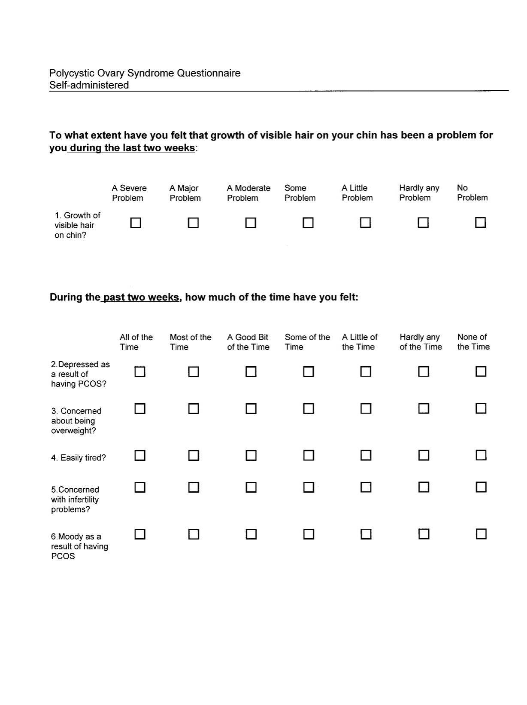

Polycystic Ovarian Syndrome Questionnaire:
Interviewer- Format

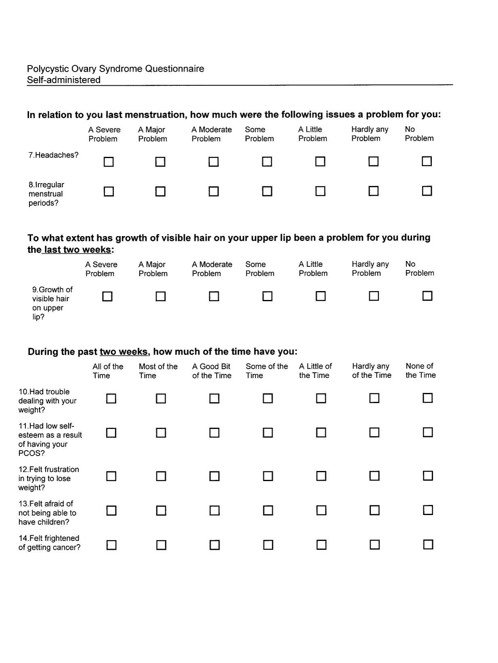

Polycystic Ovarian Syndrome Questionnaire:
Interviewer- Format

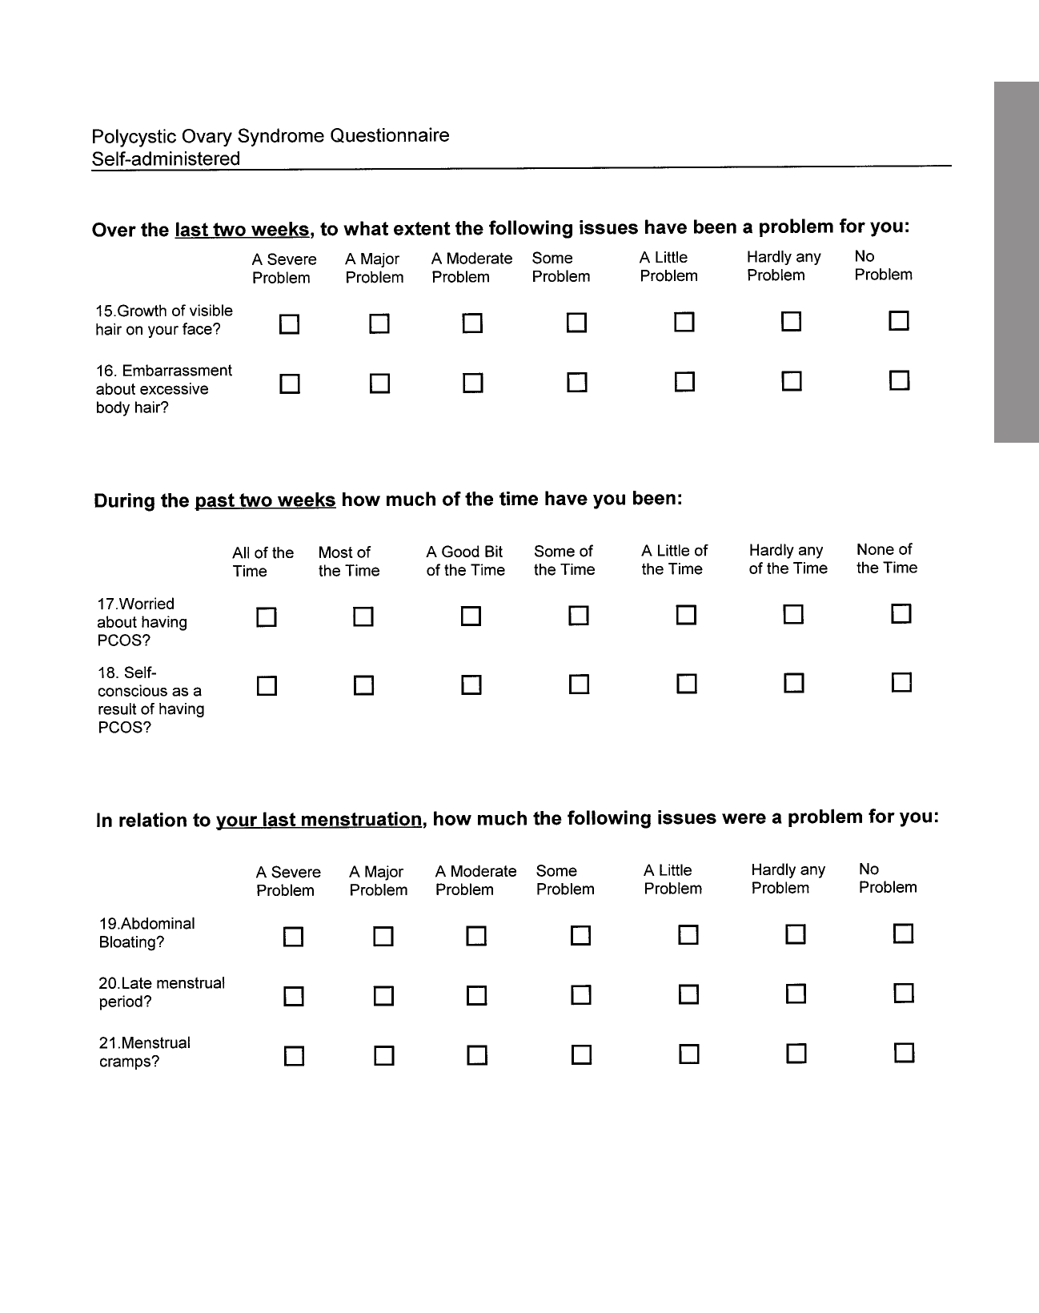

Polycystic Ovarian Syndrome Questionnaire:
Interviewer- Format

