Gaps and Fiscal Adjustment for Debt Stability in Climate-Vulnerable Developing Countries:
How large and by how much?

Supplementary Material

Supplement A: Variable definitions and Data sources

All data are based on information compiled as of 2 February 2022.

- Short-Term Gap
$$t_{0}^{*}-t=d+(r- θ)b_{0}$$

Source: Blanchard et al. (1990), p. 17

$t_{0}^{*}-t$

$$t_{0}^{*}=Sustainable tax revenue ratio$$

$$t=Tax revenue ratio$$
Primary deficit, d

$$d=100 × \frac{Total Expense-Interest Payment-Tax Revenues}{Nominal GDP }$$

Growth adjusted interest rate, r- θ
$$r= i- π$$

$$i=100 × \frac{Interest Payment}{Previous Year^{'}s Debt}$$

$$π=100 × \left(\frac{GDP Deflator}{Previous Year^{'}s GDP Deflator}-1\right)$$

$$θ=100 ×\left(\frac{Real GDP}{Previous Year^{'}s Real GDP}-1\right)$$

b₀, lagged debt (i.e., debt at the end of year 0 or beginning of year 1)

$$b_{0}=100 × \frac{Previous Year^{'}s Debt}{Previous Year^{'}s Nominal GDP}$$

Variable | Source | Units
Total Expense ª | IMF Government Finance Statistics Database ^{c} | National Currency
Interest Payment ^{a, b} | IMF Government Finance Statistics Database ^{c} | National Currency
Tax Revenues ª | IMF Government Finance Statistics Database ^{c} | National Currency
Nominal GDP | IMF World Economic Outlook Database | National Currency, Billions
Debt ^{d} | IMF World Economic Outlook Database | National Currency, Billions
GDP Deflator | IMF World Economic Outlook Database | Index
Real GDP | IMF World Economic Outlook Database | National Currency, Billions

Notes: ª Budgetary Central Government; ^{b} “Interest expense” in the database. Treasury-bill rates were also considered for i. However, they were only available for 28 countries and 8 years on average. ^{c} When not available from this source, we refer to IMF Staff Reports containing Debt Sustainability Analysis, including Article IV, Review Under the Extended Credit Facility Arrangement, Review Under the Stand-by Arrangement, Review Under the Staff-Monitored Program, Request for Disbursement Under the Rapid Credit Facility, Request for Purchase Under the Rapid Financing Instrument, Request for Arrangement Under the Extended Credit Facility. ^{d} General government gross debt

Example: When computing for a country’s 2019 short-term gap, we use fiscal data, interest rate, and GDP growth rate for 2019 together with debt data for beginning 2019 (i.e., end-2018).

- Medium-Term Gap (s = 1, 2, …5)

$$t_{5}^{*}-t_{1}=\left(\frac{r- θ}{1+r- θ}\right)\left[{\left[1-{\left(\frac{1}{1+r- θ}\right)}^{5}\right]}^{-1}\left[\sum_{s=1}^{5}{{\left(\frac{1}{1+r- θ}\right)}^{s-1}\left(g_{s}+ h_{s}\right)}\right]+ b_{0}\right]- t_{1}$$

Source: Note 7, Blanchard et al. (1990), pp. 17 and 35

r - θ, Average Forecast Growth-Adjusted Interest Rate (as of year 0)

$$r- θ= \frac{\sum_{s = 1}^{5}{r_{s}- θ_{s}}}{5}$$

r_{s}. Forecast Real Effective Interest Rate

$$r_{s}=Forecast Effective Interest Rate-Forecast Inflation$$

θ_{s,} Forecast Real GDP Growth

For 2021, r – θ “stressed”:
$$r- θ "stressed"= \left(\overline{r}+σ_{r}\right)-\left(\overline{θ}-σ_{θ}\right)$$

$\overline{r}$ is the country-specific mean interest rate for 2021 to 2025
$σ_{r}$ is the country-specific standard deviation of interest rate for 2021 to 2025
$\overline{θ}$ is the country-specific mean GDP growth rate for 2021 to 2025
$σ_{θ}$ is the country-specific standard deviation of GDP growth rate for 2021 to 2025

g_{s} + h_{s}, Forecast Non-Interest Spending Ratio in year s (as of year 0)

$$g_{s}+ h_{s}=100 × \frac{Forecast Total Expense-Forecast Interest Expense}{Forecast Nominal GDP}$$

b₀, lagged debt (i.e., debt at the end of year 0 or beginning of year 1)

$$b_{0}=100 × \frac{Previous Year^{'}s Debt}{Previous Year^{'}s Nominal GDP}$$

t₁, Forecast Tax Revenue Ratio in year 1 (as of year 0)

$$t_{1}=100 × \frac{Forecast Tax Revenues}{Forecast Nominal GDP }$$

Variable | Source | Units
Forecast Effective Interest Rate | IMF Staff Reports containing Debt Sustainability Analysis ª | Percent
Forecast Inflation (GDP Deflator) | IMF Staff Reports containing Debt Sustainability Analysis ª | Percent
Forecast Real GDP Growth | IMF Staff Reports containing Debt Sustainability Analysis ª | Percent
Forecast Total Expense | IMF Staff Reports containing Debt Sustainability Analysis ª | National Currency, Billions
Forecast Interest Expense | IMF Staff Reports containing Debt Sustainability Analysis ª | National Currency, Billions
Forecast Nominal GDP | IMF Staff Reports containing Debt Sustainability Analysis ª | National Currency, Billions
Forecast Tax Revenues | IMF Staff Reports containing Debt Sustainability Analysis ª | National Currency, Billions
Debt ^{b} | IMF World Economic Outlook Database | National Currency, Billions
Nominal GDP | IMF World Economic Outlook Database | National Currency, Billions

Notes: ª Includes Article IV, Review Under the Extended Credit Facility Arrangement, Review Under the Stand-by Arrangement, Review Under the Staff-Monitored Program, Request for Disbursement Under the Rapid Credit Facility, Request for Purchase Under the Rapid Financing Instrument, Request for Arrangement Under the Extended Credit Facility; ^{b} General government gross debt

Example: When computing for a country’s 2020 medium-term gap, we use fiscal data, interest rates, and GDP growth rates for 2020 to 2024, together with debt data for beginning 2020 (i.e., end-2019).

Four countries have no 5-year forecasts for any year and therefore have no estimated MTGs. Seven countries do not have a complete 5-year forecast for years 2021-2025 as of 2020, and therefore have no MTG for 2021.

- Climate Change Gaps (s = 1, 2, … 10)

$$t_{10}^{*}-t_{1}=\left(\frac{r- θ}{1+r- θ}\right)\left[{\left[1-{\left(\frac{1}{1+r- θ}\right)}^{10}\right]}^{-1}\left[\sum_{s=1}^{10}{{\left(\frac{1}{1+r- θ}\right)}^{s-1}\left(g_{s}+ h_{s}\right)}\right]+ b_{0}\right]- t_{1}$$

r - θ, Average Forecast Growth-Adjusted Interest Rate (as of year 0)

$$r- θ= \frac{\sum_{s = 1}^{n}{r_{s}- θ_{s}}}{n}$$

Where n is the length of the available forecast

r_{s}, Forecast Real Effective Interest Rate

$$r_{s}=Forecast Effective Interest Rate-Forecast Inflation$$

θ_{s}, Forecast Real GDP Growth

r – θ “stressed”:
$$r- θ "stressed"= \left(\overline{r}+σ_{r}\right)-\left(\overline{θ}-σ_{θ}\right)$$

$\overline{r}$ is the country-specific mean interest rate for 2021 to 2025
$σ_{r}$ is the country-specific standard deviation of interest rate for 2021 to 2025
$\overline{θ}$ is the country-specific mean GDP growth rate for 2021 to 2025
$σ_{θ}$ is the country-specific standard deviation of GDP growth rate for 2021 to 2025

g_{s} + h_{s}, Forecast Non-Interest Spending Ratio (as of year 0)

For 2021 - 2026:

$$g_{s}+ h_{s}=100 × \frac{Forecast Total Expense-Forecast Interest Expense}{Forecast Nominal GDP}$$

Note: When the forecast is not available, the value is replaced by the average of the available years.

For 2025, reported climate change costed needs is added

$$g_{5}+h_{5}=\left(100 × \frac{{Forecast Total Expense}_{5}-{Forecast Interest Expense}_{5}}{{Forecast Nominal GDP}_{5}}\right)+ \left(100 × \frac{Stated Needs for Climate Change}{{Forecast Nominal GDP in USD}_{5}}\right)$$

For 2027 – 2030:

$$g_{s}+ h_{s}= \sum_{s=1}^{n}{\frac{{Forecast Total Expense}_{s}-{Forecast Interest Expense}_{s}}{{Forecast Nominal GDP}_{s}}} ÷n$$

Where n is the length of the available forecast

b₀, lagged debt (i.e., debt at end of year 0 or beginning of year 1)

$$b_{0}=100 × \frac{Previous Year^{'}s Debt}{Previous Year^{'}s Nominal GDP}$$

t₁, Forecast Tax Revenue Ratio in year 1 (as of year 0)

$$t_{1}=100 × \frac{Forecast Tax Revenues}{Forecast Nominal GDP }$$

Variable | Source | Units
Forecast Effective Interest Rate | IMF Staff Reports containing Debt Sustainability Analysis ^{a, b} | Percent
Forecast Inflation (GDP Deflator) |  | Percent
Forecast Real GDP Growth |  | Percent
Forecast Total Expense |  | National Currency, Billions
Forecast Interest Expense |  | National Currency, Billions
Forecast Nominal GDP |  | National Currency, Billions
Forecast Tax Revenues |  | National Currency, Billions
Stated Needs for Climate Change | UNFCCC (2021) | USD, Billions
Forecast Nominal GDP in USD (GDP, current prices) | IMF World Economic Outlook Database | USD, Billions
Debt ^{c} | IMF World Economic Outlook Database | National Currency, Billions
Nominal GDP | IMF World Economic Outlook Database | National Currency, Billions
Notes: ª Includes Article IV, Review Under the Extended Credit Facility Arrangement, Review Under the Stand-by Arrangement, Review Under the Staff-Monitored Program, Request for Disbursement Under the Rapid Credit Facility, Request for Purchase Under the Rapid Financing Instrument, Request for Arrangement Under the Extended Credit Facility. ^{b} Five countries did not have complete data on interest rate, inflation and GDP for 2021 to 2025 and so a shorter series was used to compute r – θ: 2021 to 2023 for Bhutan and Kiribati, and 2021 to 2024 data for Haiti, Lebanon, and Sri Lanka.
^{C} General government gross debt

Although not all countries in the sample have an estimated MTG for 2021, all countries will have a Climate Change gap because a 5-year forecast for 2021-2025 is not required.

Supplement B.1 National Reports, Costed Needs and Estimated Costs

Country | Region | Selected National Report ª | Number of expressed needs | Number of costed needs | Costed Need (high range), USD Billions | Ave Annual Costed Needs (% of GDP) ^{b} | Note: Ave. Annual Losses from extreme weather events, US$ M (PPP) ^{c} | Note: Ave. Annual Losses from extreme weather per unit of GDP in % ^{c}
Afghanistan | AP | NC | 16 | 16 | 11.4 | 4.8 | 100.8 | 0.218
Bangladesh | AP | NC | 30 | 25 | 79.7 | 1.5 | 2,403.8 | 0.640
Barbados | LAC | NC | 56 | -- | -- | -- | 4.0 | 0.092
Bhutan | AP | NC | 69 | 14 | 0.9 | 2.5 | 5.0 | 0.133
Burkina Faso | AME | NDC | 60 | 60 | 7.8 | 2.7 | 40.2 | 0.193
Cambodia | AP | NDC | 96 | 79 | 4.2 | 1.2 | 242.5 | 0.723
Colombia | LAC | NDC | 32 | 1 | 0.1 | 0.0 | 628.9 | 0.128
Comoros | AME | NDC | 26 | 1 | 0.7 | 4.0 | 0.7 | 0.066
Costa Rica | LAC | BUR | 34 | 2 | 3.4 | 0.4 | 66.3 | 0.117
DR of the Congo | AME | NDC | 5 | 4 | 12.5 | 1.6 | 5.9 | 0.015
Dominican Republic | LAC | NDC | 41 | 41 | 17.6 | 1.4 | 268.8 | 0.269
Ethiopia | AME | NDC | 5 | 5 | 294.7 | 22.0 | 240.2 | 0.242
Fiji | AP | LEDS | 152 | 86 | 57.3 | 89.0 | 120.0 | 1.896
Gambia | AME | NAPA | 10 | 10 | 0.2 | 0.5 | 7.2 | 0.198
Ghana | AME | NDC | 27 | 27 | 22.6 | 2.2 | 32.4 | 0.044
Grenada | LAC | NDC | 9 | 9 | 1.1 | 7.5 | 78.6 | 7.104
Guatemala | LAC | NC | 39 | -- | -- | -- | 394.5 | 0.408
Haiti | LAC | NDC | 17 | 17 | 25.4 | 11.8 | 418.2 | 2.642
Honduras | LAC | TAPs | 58 | 58 | 0.1 | 0.0 | 556.6 | 1.846
Kenya | AME | NDC | 19 | 11 | 61.7 | 4.2 | 346.6 | 0.329
Kiribati | AP | NDC | 12 | 12 | 0.1 | 2.6 | 10.5 | 6.183
Lebanon | AME | TAP | 64 | 27 | 0.0 | 0.0 | 27.0 | 0.046
Madagascar | AME | NDC | 20 | 4 | 42.1 | 21.1 | 221.3 | 0.794
Malawi | AME | NC | 124 | 3 | 0.0 | 0.0 | 64.9 | 0.494
Maldives | AP | NAPA | 12 | 12 | 0.1 | 0.2 | 0.5 | 0.013
Marshall Islands | AP | NDC | 26 | -- | -- | -- | 0.0 | 0.027
Mongolia | AP | NDC | 14 | 14 | 11.5 | 5.6 | 82.3 | 0.307
Morocco | AME | NDC | 99 | 68 | 90.5 | 5.7 | 174.0 | 0.093
Nepal | AP | NDC | 81 | 53 | 25.0 | 5.4 | 230.8 | 0.438
Niger | AME | NDC | 23 | 23 | 8.7 | 3.5 | 48.4 | 0.369
Palau | AP | NC | 17 | 8 | 0.3 | 8.2 | - | -
Papua New Guinea | AP | NDC | 142 | 41 | 1.6 | 0.5 | 15.1 | 0.076
Philippines | AP | NC | 45 | 2 | 3.0 | 0.1 | 2,932.2 | 0.576
Rwanda | AME | NDC | 54 | 54 | 10.6 | 7.5 | 3.7 | 0.029
Saint Lucia | LAC | NC | 119 | 39 | 0.9 | 3.8 | 17.7 | 0.940
Samoa | AP | NAPA | 33 | 33 | 1.5 | 15.9 | 8.5 | 0.952
Senegal | AME | NDC | 32 | 32 | 13.1 | 3.2 | 15.3 | 0.046
South Sudan | AME | NDC | 46 | 46 | 50.0 | 77.0 | 20.5 | 0.059
Sri Lanka | AP | TNA | 9 | 6 | 9.6 | 0.9 | 491.0 | 0.294
State of Palestine | AME | NDC | 108 | 82 | 14.1 | 6.5 | - | -
Sudan | AME | NDC | 15 | 12 | 14.4 | 3.0 | 95.5 | 0.057
Timor-Leste | AP | NC | 30 | 3 | 0.2 | 1.1 | 0.3 | 0.004
Tunisia | AME | NDC | 13 | 13 | 19.9 | 3.7 | 66.0 | 0.071
Tuvalu | AP | NAPA | 9 | 10 | 0.0 | 0.9 | 2.6 | 8.294
U.R. of Tanzania | AME | NDC | 54 | 54 | 65.0 | 6.9 | 52.7 | 0.060
Vanuatu | AP | NC | 33 | 33 | 1.3 | 10.2 | 15.7 | 2.807
Viet Nam | AP | NC | 14 | 8 | 47.4 | 0.8 | 2,064.7 | 0.516
Yemen | AME | NDC | 34 | 8 | 1.2 | 0.5 | 110.1 | 0.112

Source: UNFCCC [2021], Annex C. Notes: ª Country report that indicates the largest amount of associated costs, which may be either a Biennial Update Report (BUR), Low-Emission Development Strategies (LEDS), National Adaptation Programme of Action (NAPA), National Communication (NC), Nationally Determined Contribution (NDC), Technology Action Plan (TAP), or Technology Needs Assessment (TNA).; ^{b} Authors’ estimates; ^{c} From Global Climate Risk Index 2019, covering the period 1998-2017 [Germanwatch 2018]

Supplement B.2 Cost Reporting of Countries with Positive CCGs and Negative CCGs

Sub-sample | Number of Needs |  | Number of quantified needs |  | % of needs costed | Costed Need (high range), USD Billions |  | Ave Annual Costed Needs (% of GDP)
 | mean | sd | mean | sd |  | mean | Sd | mean | Sd
Positive CCGs (30 countries) | 44.6 | 39.8 | 25.6 | 23.1 | 57 | 66.5 | 38.7 | 28.7 | 47.5
Largest 15 (positive) | 35.6 | 36.5 | 22.8 | 22.5 | 64 | 70.8 | 39.2 | 14.2 | 20.7
Negative CCGs (15 countries) | 39.8 | 36.3 | 24.8 | 23.8 | 62 | 77.6 | 32.7 | 14.2 | 18.8
Base data: Supplement B.1

Supplement B.3 Correlation Matrix of Needs and Costed Needs [UNFCCC 2021] and Average Annual Losses from Extreme Weather Events [Germanwatch 2018]

 | Ave annual absolute losses from extreme weather events, in US M PPP | Ave annual losses from extreme weather events per unit of GDP in %
Number of needs | -0.09 | -0.16
Number of quantified needs | -0.16 | -0.08
Costed Need (high range), USD Billions | 0.13 | -0.13
Ave Annual Costed Needs (% of GDP) | -0.12 | 0.03

Base data: Supplement B.1

Supplement C. Components of Indices of Sustainability

Country | Non-Interest Spending to GDP Ratio |  |  |  |  | Tax Revenue to GDP Ratio |  |  | Growth-Adjusted Interest Rate |  |  |  |  |  | General Government Gross Debt to GDP Ratio
 | g+h | g+h | g+h | mean g+h | mean g+h | t | T | t | r-θ | r-θ | r-θ | mean r-θ | mean r-θ | mean, stressed r-θ | b0 | b0 | b0
 | 2010 | 2019 | 2020 | 2021-25 | 2021-26 | 2010 | 2019 | 2020 | 2010 | 2019 | 2020 | 2021-25 | 2021-26 | 2021-2025 | 2010 | 2019 | 2020
Afghanistan | 17.7 | 19.6 | 18.4 | 17.9 | 17.7 | 9.3 | 8.3 | 7.4 | -16.5 | -9.6 | -4.8 | -7.8 | -7.8 | -6.7 | 7.7 | 6.1 | 7.4
Bangladesh | 7.4 | 7.6 | 7.3 | 12.3 | 12.3 | 7.8 | 10.3 | 10.1 | -7.4 | -6.2 | -1.2 | -10.5 | -10.5 | -9.1 | 35.5 | 35.7 | 38.9
Barbados | 29.0 | 24.2 | 31.6 | 25.6 | 25.3 | 24.7 | 28.3 | 28.6 | 3.9 | -2.2 | 19.0 | -3.8 | -3.1 | 1.2 | 108.9 | 119.6 | 150.4
Bhutan | 21.4 | 17.6 | 24.1 | 14.4 | 14.4 | 14.6 | 16.2 | 12.5 | -10.1 | -4.7 | -2.8 | -7.2 | -7.2 | -5.3 | 61.0 | 106.6 | 120.7
Burkina Faso | 10.2 | 17.0 | 16.1 | 15.3 | 15.3 | 11.3 | 15.7 | 13.7 | -10.4 | -1.7 | -3.0 | -6.1 | -6.1 | -5.3 | 27.8 | 42.0 | 46.5
Cambodia | 10.4 | 15.4 | 18.4 | 18.6 | 18.5 | 10.0 | 19.7 | 18.3 | -8.2 | -9.0 | 7.2 | -7.5 | -7.8 | -5.8 | 28.7 | 28.6 | 34.2
Colombia | 15.1 | 18.4 | 20.2 | 17.3 | 17.0 | 11.3 | 14.9 | 13.0 | 0.3 | -0.8 | 10.4 | -1.4 | -1.4 | -0.6 | 36.5 | 52.3 | 65.4
Comoros | 13.9 | 18.2 | 20.5 | 18.6 | 18.6 | 6.7 | 7.0 | 8.2 | -4.0 | -5.3 | 0.7 | -4.4 | -4.4 | -4.2 | 30.5 | 19.5 | 22.3
Costa Rica | 16.5 | 17.2 | 18.1 | 15.1 | 14.7 | 12.6 | 13.0 | 12.1 | -3.2 | 3.7 | 11.9 | 2.8 | 2.5 | 4.1 | 28.1 | 56.7 | 67.5
DR of the Congo | 8.1 | 9.8 | 9.8 | 14.5 | 14.7 | 8.4 | 7.0 | 6.2 | -27.5 | -8.0 | -6.7 | -12.5 | -12.2 | -6.9 | 30.6 | 15.0 | 15.2
Dominican Republic | 11.2 | 12.6 | 18.9 | 13.9 | 13.9 | 12.2 | 13.3 | 12.4 | -8.2 | -1.7 | 7.9 | -1.5 | -1.5 | -1.0 | 37.3 | 53.5 | 71.5
Ethiopia | 12.1 | 9.2 | 9.4 | 8.6 | 8.6 | 8.2 | 6.7 | 9.2 | -12.6 | -20.2 | -23.2 | -16.9 | -16.9 | -10.2 | 39.6 | 57.9 | 55.4
Fiji | 18.7 | 24.0 | 29.5 | 27.4 | 26.9 | 20.1 | 22.7 | 16.7 | -0.2 | 4.3 | 24.5 | -1.7 | -1.6 | 4.0 | 51.8 | 48.9 | 70.8
Gambia | 7.1 |  | 14.5 | 11.2 | 11.0 | 8.4 |  | 10.8 | -6.1 |  | -1.9 | -9.9 | -9.8 | -8.9 | 42.9 | 83.0 | 83.5
Ghana | 12.6 | 12.0 | 19.1 | 13.8 | 13.8 | 9.9 | 12.0 | 12.0 | -13.2 | -4.7 | 3.5 | -6.9 | -6.9 | -4.4 | 34.5 | 62.6 | 78.9
Grenada | 17.6 | 17.3 | 24.2 | 17.6 | 17.6 | 18.7 | 22.5 | 21.9 | 2.3 | 1.6 | 17.0 | -4.7 | -4.7 | -2.9 | 96.9 | 60.5 | 71.3
Guatemala | 11.2 | 11.4 | 13.2 | 10.9 | 10.9 | 10.4 | 10.5 | 10.0 | -0.9 | -1.0 | 5.4 | -0.5 | -0.5 | 0.4 | 24.0 | 26.5 | 31.5
Haiti | 14.7 | 9.2 | 9.1 | 16.7 | 16.7 | 5.3 | 5.9 | 5.7 | 0.2 | -14.1 | -16.3 | -12.7 | -12.7 | -10.0 | 23.2 | 25.8 | 21.3
Honduras | 19.2 | 15.4 | 18.4 | 17.3 | 17.2 | 14.4 | 17.5 | 14.8 | -4.5 | 0.8 | 11.4 | -4.0 | -3.9 | -3.1 | 22.6 | 43.3 | 51.3
Kenya | 14.3 | 18.0 | 19.1 | 13.7 | 13.7 | 13.9 | 15.1 | 14.2 | -5.0 | -2.6 | 2.4 | -8.8 | -8.8 | -8.4 | 39.1 | 59.0 | 67.6
Kiribati |  | 85.2 | 72.7 | 64.2 | 64.2 |  | 22.7 | 22.3 |  | -1.8 | -1.1 | -1.9 | -1.9 | -1.4 | 8.2 | 18.0 | 17.4
Lebanon | 15.7 | 19.0 | 15.2 | 22.3 | 22.3 | 16.8 | 15.3 | 10.9 | -0.9 | 9.1 | -31.1 | 3.3 | 3.3 | 3.9 | 136.8 | 171.1 | 150.4
Madagascar | 7.9 | 9.4 | 11.0 | 9.0 | 9.0 | 8.5 | 10.5 | 9.4 | -8.6 | -9.0 | 3.8 | -9.6 | -9.6 | -8.4 | 32.3 | 38.5 | 46.0
Malawi | 11.7 | 12.0 | 13.5 | 12.6 | 12.6 | 10.9 | 12.0 | 12.1 | -11.6 | -6.1 | -0.2 | -7.2 | -6.9 | -5.0 | 19.3 | 45.3 | 54.7
Maldives | 23.4 | 24.0 | 31.6 | 21.2 | 21.2 | 8.8 | 20.2 | 18.1 | -5.5 | -3.8 | 36.4 | -7.1 | -7.1 | -3.6 | 52.7 | 78.3 | 146.0
Marshall Islands | 54.2 | 64.2 | 58.6 | 72.9 | 72.1 | 17.8 | 18.4 | 17.0 | -5.3 | -5.5 | -2.5 | -1.7 | -1.7 | 0.5 | 39.4 | 25.0 | 18.9
Mongolia | 16.1 | 19.7 | 26.8 | 26.0 | 26.0 | 19.6 | 22.5 | 21.5 | -44.0 | -10.8 | 4.3 | -10.5 | -10.5 | -9.2 | 31.0 | 68.4 | 77.0
Morocco | 24.8 | 22.6 | 26.1 | 24.0 | 24.0 | 22.8 | 21.4 | 21.2 | 0.3 | 0.1 | 9.3 | -1.4 | -1.4 | -0.7 | 49.0 | 65.1 | 75.4
Nepal | 12.9 | 21.2 | 19.4 | 22.0 | 22.0 | 11.7 | 19.8 | 15.7 | -17.7 | -9.4 | 0.5 | -10.3 | -10.3 | -9.9 | 35.3 | 33.1 | 42.2
Niger |  | 20.3 | 21.8 | 21.9 | 21.9 |  | 11.0 | 9.6 |  | -3.2 | -1.8 | -8.4 | -8.0 | -5.9 | 15.1 | 39.8 | 45.0
Palau | 51.0 | 43.3 | 59.1 | 46.6 | 44.9 | 17.1 | 18.8 | 18.2 |  | 4.6 | 7.2 | -3.6 | -3.4 | 10.6 |  | 38.6 | 62.1
Papua New Guinea | 17.7 | 16.6 | 18.1 | 17.5 | 17.5 | 15.6 | 13.0 | 12.5 | -14.0 | 1.4 | 9.6 | -3.8 | -3.8 | -1.2 | 17.3 | 40.0 | 48.9
Philippines | 10.6 | 13.0 | 17.5 | 18.5 | 18.5 | 11.6 | 14.5 | 14.0 | -4.5 | -1.5 | 13.2 | -4.0 | -4.0 | -3.3 | 47.6 | 37.0 | 51.7
Rwanda | 14.0 | 16.1 | 17.4 | 17.0 | 16.7 | 11.6 | 14.6 | 14.8 | -8.0 | -9.2 | -1.9 | -10.0 | -9.6 | -7.0 | 18.8 | 50.2 | 60.1
Saint Lucia | 15.7 | 17.4 | 24.3 | 18.0 | 18.0 | 18.2 | 19.7 | 21.3 | -1.2 | 2.6 | 29.3 | 0.1 | 0.1 | 2.1 | 52.8 | 61.4 | 93.5
Samoa | 24.9 | 25.1 | 28.6 | 31.5 | 31.0 | 21.0 | 25.7 | 25.9 | 3.9 | -4.3 | 3.9 | -0.8 | -1.2 | 5.8 | 41.3 | 47.5 | 46.5
Senegal | 11.7 | 18.2 | 19.1 | 12.8 | 12.7 | 15.0 | 18.5 | 17.4 | -2.4 | -2.8 | -0.5 | -6.0 | -5.7 | -3.0 | 28.5 | 63.8 | 68.7
South Sudan |  | 29.9 | 36.0 | 23.1 | 23.1 |  | 4.0 | 4.3 |  | -8.7 | 4.8 | -33.4 | -28.8 | 21.3 |  | 31.3 | 35.8
Sri Lanka | 11.4 | 10.9 | 13.4 | 13.4 | 13.4 | 11.3 | 11.6 | 8.1 | -6.8 | 2.5 | 7.7 | -1.3 | -1.3 | -1.0 | 71.6 | 86.8 | 101.2
State of Palestine | 31.3 |  |  |  |  | 18.8 |  |  | -11.1 |  |  |  |  |  | 22.7 | 34.5 | 47.2
Sudan | 13.2 | 18.4 | 11.5 | 14.9 | 14.9 | 5.9 | 5.4 | 3.1 | -24.8 | -50.0 | -160.8 | -52.8 | -52.8 | -3.4 | 74.6 | 200.3 | 272.9
Timor-Leste |  | 58.6 | 73.9 | 71.6 | 70.5 |  | 7.6 | 7.6 |  | -6.4 | 7.4 | -4.2 | -4.3 | -2.4 | 0.0 | 11.5 | 13.9
Tunisia | 19.1 |  | 27.9 | 24.4 | 24.1 | 20.1 |  | 23.8 | -3.1 |  | 8.0 | -4.0 | -4.0 | -3.1 | 45.5 | 74.2 | 89.7
Tuvalu |  |  | 75.0 | 88.7 | 88.7 |  |  | 14.6 |  |  | -2.7 | -5.2 | -5.2 | -3.9 | 20.0 | 11.5 | 7.5
United Republic of Tanzania | 12.6 |  | 14.3 | 15.5 | 15.4 | 10.0 |  | 11.8 | -12.2 |  | -1.9 | -6.9 | -7.2 | -5.6 | 27.6 | 39.0 | 39.1
Vanuatu | 22.7 | 27.0 | 36.9 | 30.8 | 30.8 | 16.2 | 17.6 | 14.6 | -0.2 | -4.4 | 6.8 | -4.3 | -4.2 | -2.4 | 20.2 | 45.3 | 48.7
Viet Nam | 14.2 |  | 13.9 | 13.6 | 13.6 | 17.6 |  | 12.4 | -15.5 |  | -1.2 | -7.0 | -7.0 | -5.9 | 36.8 | 43.6 | 46.3
Yemen |  |  |  |  |  |  |  |  |  |  |  |  |  |  | 42.4 | 76.5 | 84.2

Supplement D. Short-term and Medium-term Gaps

Country | Short-Term Gap (STG) |  |  | STG/(1-t_{year}) |  |  | Medium-Term Gap (MTG) |  |  |  |  |  | MTG/(1-t_{yea}r)
 | 2010 | 2019 | 2020 | 2010 | 2019 | 2020 | 2011 | 2011-2020 (mean) | 2020 | 2020 (perfect foresight) | 2021 | 2021 Stressed | 2021 | 2021 stressed
Afghanistan | 5.7 | 10.7 | 10.7 | 0.06 | 0.12 | 0.12 |  | 12.25 | 11.8 | 10.3 | 8.6 | 8.7 | 0.093 | 0.095
Bangladesh | -3.4 | -4.8 | -3.2 | -0.04 | -0.05 | -0.04 |  | . |  | -1.9 | -0.1 | 0.5 | -0.001 | 0.006
Barbados | 8.2 | -6.9 | 25.7 | 0.11 | -0.10 | 0.36 |  | 2.92 | -3.7 | -1.3 | -7.2 | 0.6 | -0.101 | 0.008
Bhutan | 0.2 | -3.8 | 8.6 | 0.00 | -0.05 | 0.10 |  | -9.51
Burkina Faso | -3.8 | 0.7 | 1.2 | -0.04 | 0.01 | 0.01 |  | -4.65 |  | -0.6 | -3.9 | -3.5 | -0.046 | -0.042
Cambodia | -1.9 | -6.8 | 2.2 | -0.02 | -0.09 | 0.03 |  | -3.82 | -6.0 | -1.0 | -3.8 | -3.1 | -0.046 | -0.038
Colombia | 3.9 | 3.0 | 12.7 | 0.04 | 0.04 | 0.15 | 1.6 | 1.21 | 0.2 | 5.6 | 2.6 | 3.2 | 0.030 | 0.037
Comoros | 6.0 | 10.3 | 12.5 | 0.06 | 0.11 | 0.14 |  | 13.22 | 10.1 | 10.2 | 9.7 | 9.8 | 0.106 | 0.106
Costa Rica | 3.1 | 6.1 | 12.7 | 0.04 | 0.07 | 0.14 |  | 2.86 | 1.5 | 6.5 | 4.2 | 5.1 | 0.048 | 0.058
DR of Congo | -25.4 | 1.6 | 2.6 | -0.28 | 0.02 | 0.03 |  | 4.64 | 3.3 | 5.4 | 4.7 | 5.7 | 0.050 | 0.061
Dominican Rep | -4.0 | -1.5 | 10.7 | -0.05 | -0.02 | 0.12 |  | 0.80 | 0.8 | 2.8 | 0.0 | 0.4 | 0.000 | 0.005
Ethiopia | -0.5 | -9.8 | -13.2 | -0.01 | -0.10 | -0.15 |  | -13.83 | -14.2 | -13.8 | -13.4 | -8.4 | -0.148 | -0.094
Fiji | -1.6 | 3.3 | 24.8 | -0.02 | 0.04 | 0.30 |  | 3.06 | 4.9 | 13.5 | 10.8 | 14.9 | 0.129 | 0.176
Gambia | -3.7 |  | 2.2 | -0.04 |  | 0.02 |  | -6.54 |  | -6.3 | -8.9 | -7.9 | -0.100 | -0.089
Ghana | -0.8 | -3.0 | 9.3 | -0.01 | -0.03 | 0.11 |  | -4.06 | -3.7 | -0.4 | -5.6 | -3.3 | -0.064 | -0.038
Grenada | 0.9 | -4.2 | 12.6 | 0.01 | -0.05 | 0.16 |  | -6.87 | -7.1 | -3.3 | -6.9 | -5.4 | -0.088 | -0.069
Guatemala | 0.6 | 0.7 | 4.7 | 0.01 | 0.01 | 0.05 |  | 0.57 | 0.3 | 1.6 | 0.9 | 1.2 | 0.010 | 0.013
Haiti | 9.4 | 0.2 | -0.8 | 0.10 | 0.00 | -0.01 |  | 2.93 | 2.9 | 6.0
Honduras | 3.7 | -1.8 | 8.6 | 0.04 | -0.02 | 0.10 |  | -2.58 | -2.9 | 2.4 | -1.0 | -0.5 | -0.012 | -0.006
Kenya | -1.3 | 1.5 | 6.3 | -0.02 | 0.02 | 0.07 |  | -7.95 |  | -3.6 | -5.5 | -5.2 | -0.064 | -0.059
Kiribati |  | 62.2 | 50.2 |  | 0.80 | 0.65 |  | 44.06
Lebanon | -2.5 | 17.7 | -48.9 | -0.03 | 0.21 | -0.55 |  | 8.98 | 11.4 | 3.8
Madagascar | -3.7 | -4.7 | 3.0 | -0.04 | -0.05 | 0.03 |  | -6.02 | -6.9 | -3.0 | -5.9 | -5.3 | -0.066 | -0.059
Malawi | -2.0 | -2.6 | 1.3 | -0.02 | -0.03 | 0.02 |  | -0.42 |  | -2.3 | -3.4 | -2.0 | -0.038 | -0.022
Maldives | 11.9 | 1.0 | 41.9 | 0.13 | 0.01 | 0.51 |  | 2.91 |  | 6.1 | -6.6 | -0.8 | -0.080 | -0.009
Marshall Islands | 34.2 | 44.5 | 41.0 | 0.42 | 0.54 | 0.49 |  | 45.03 |  | 54.0 | 58.3 | 58.8 | 0.702 | 0.686
Mongolia | -24.8 | -10.9 | 8.2 | -0.31 | -0.14 | 0.10 |  | -6.93 | -9.2 | -1.1
Morocco | 2.2 | 1.3 | 11.0 | 0.03 | 0.02 | 0.14 |  | -0.80 | -2.6 | 4.0 | 2.1 | 2.6 | 0.026 | 0.033
Nepal | -5.8 | -1.5 | 3.9 | -0.07 | -0.02 | 0.05 |  | -3.03 |  | 3.0 | -4.7 | -4.5 | -0.056 | -0.057
Niger |  | 8.1 | 11.5 |  | 0.09 | 0.13 |  | 8.81 | 7.3 | 9.4 | 7.6 | 8.9 | 0.084 | 0.099
Palau |  | 26.1 | 43.7 |  | 0.32 | 0.53 |  | 16.83 |  | 31.9 | 29.2 | 39.3 | 0.357 | 0.461
Papua NG | -1.0 | 4.1 | 9.5 | -0.01 | 0.05 | 0.11 | -0.9 | -1.37 | 0.8 | 4.8 | 2.9 | 4.3 | 0.033 | 0.049
Philippines | -3.3 | -2.1 | 8.4 | -0.04 | -0.02 | 0.10 |  | .
Rwanda | 0.9 | -2.6 | 1.6 | 0.01 | -0.03 | 0.02 |  | -2.16 |  | -2.2 | -5.6 | -3.4 | -0.066 | -0.040
Saint Lucia | -3.1 | -0.7 | 21.0 | -0.04 | -0.01 | 0.27 | -5.5 | -2.08 | -2.4 | 1.5 | -1.6 | 0.2 | -0.020 | 0.003
Samoa | 5.2 | -2.8 | 4.6 | 0.07 | -0.04 | 0.06 |  | -1.32 | -3.2 | 5.8 | 9.1 | 12.2 | 0.122 | 0.156
Senegal | -4.0 | -2.1 | 1.4 | -0.05 | -0.03 | 0.02 | -5.9 | -8.03 |  | -6.9 | -9.3 | -7.0 | -0.112 | -0.084
South Sudan |  | 21.9 | 33.1 |  | 0.23 | 0.35 |  | . |  | 5.7 | -1.1 | 25.1 | -0.011 | 0.264
Sri Lanka | -5.1 | 1.4 | 11.9 | -0.06 | 0.02 | 0.13 |  | -1.71 |  | 5.7
State of Palestine | 9.9 |  |  | 0.12 |  |  |  | .
Sudan | -10.3 | -80.5 | -313.6 | -0.11 | -0.85 | -3.24 |  | -152.31 | -686.6 | -825.9 | -298.9 | -3.6 | -3.084 | -0.039
Timor-Leste |  | 50.4 | 67.2 |  | 0.55 | 0.73 |  | 40.10 | 37.4 | 65.1 | 63.6 | 63.9 | 0.688 | 0.689
Tunisia | -2.4 |  | 10.0 | -0.03 |  | 0.13 | 1.5 | -1.18 |  | 0.3 | -3.7 | -2.8 | -0.048 | -0.037
Tuvalu |  |  | 60.1 |  |  | 0.70 |  | 97.84 |  | 71.1 | 72.1 | 72.2 | 0.845 | 0.862
UR of Tanzania | -0.3 |  | 1.8 | 0.00 |  | 0.02 |  | . |  | 1.1 | 1.5 | 2.1 | 0.017 | 0.023
Vanuatu | 6.5 | 7.3 | 25.3 | 0.08 | 0.09 | 0.30 |  | 5.31 | 5.4
Viet Nam | -9.0 |  | 1.0 | -0.11 |  | 0.01 |  | .
Yemen |  |  |  |  |  |  |  | .

Supplement E. Indices of Fiscal Policy Sustainability, 2010 to 2021

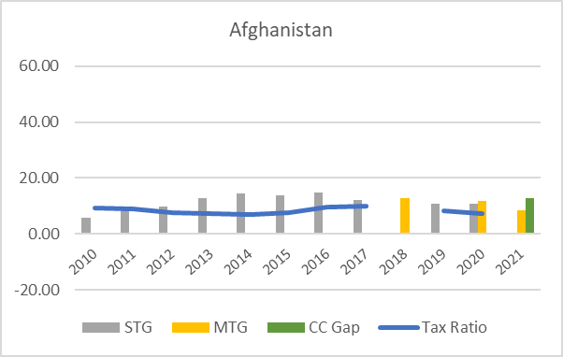 | 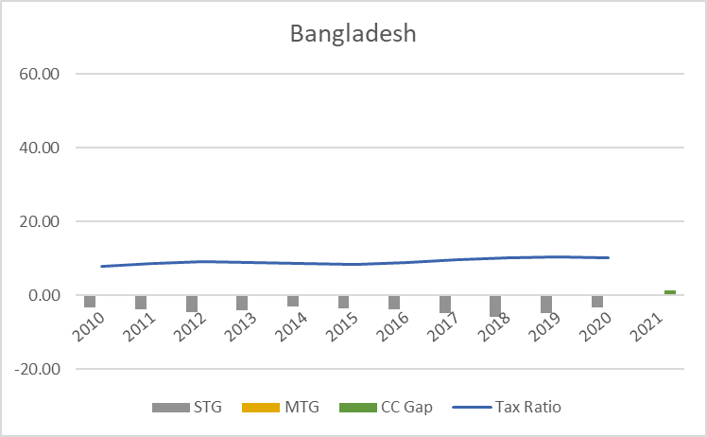
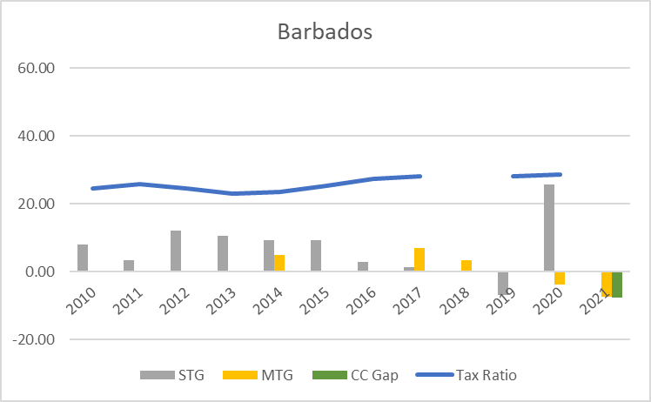 | 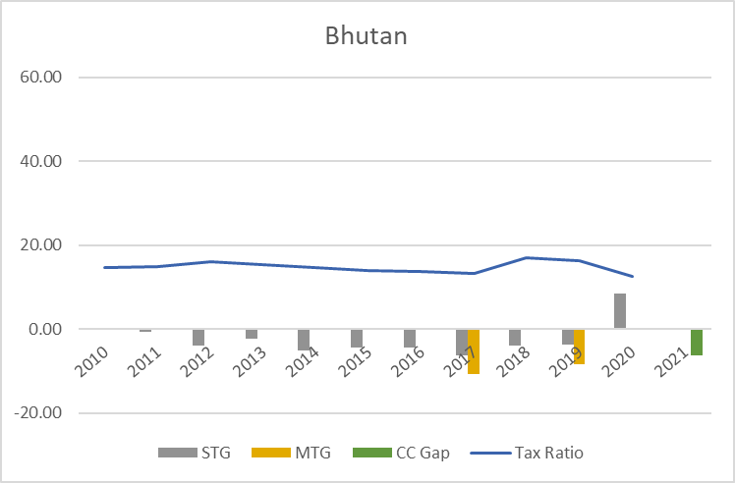
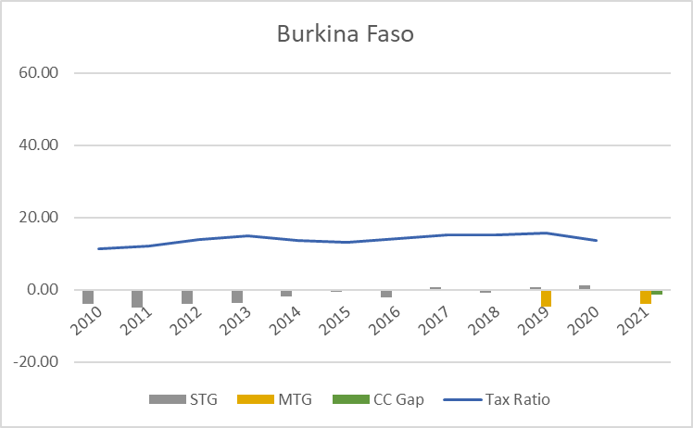 | 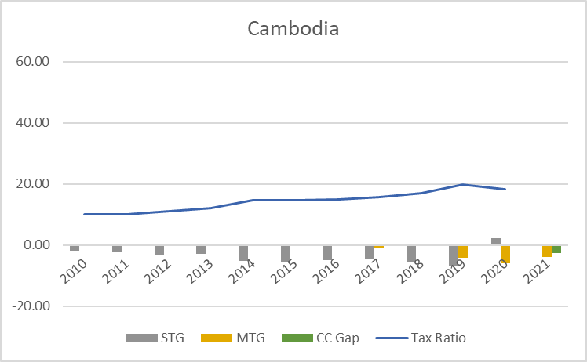
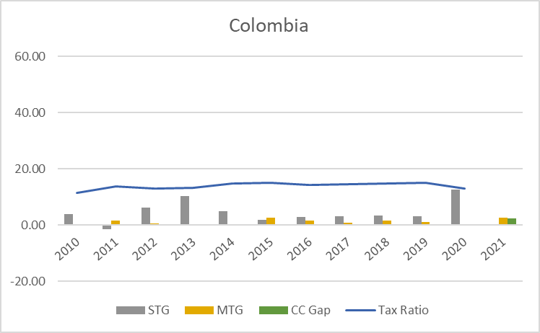 | 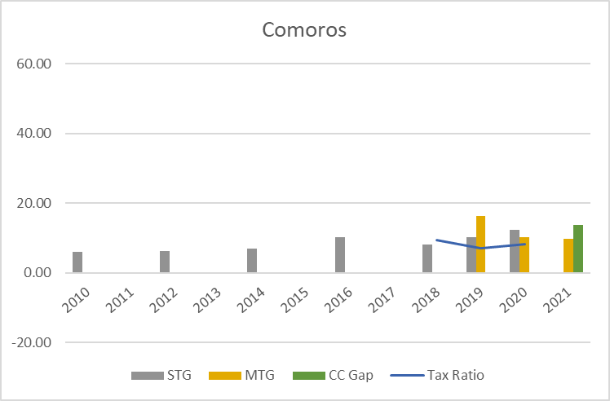
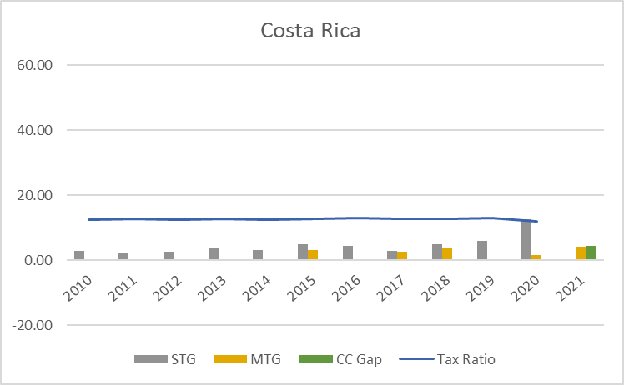 | 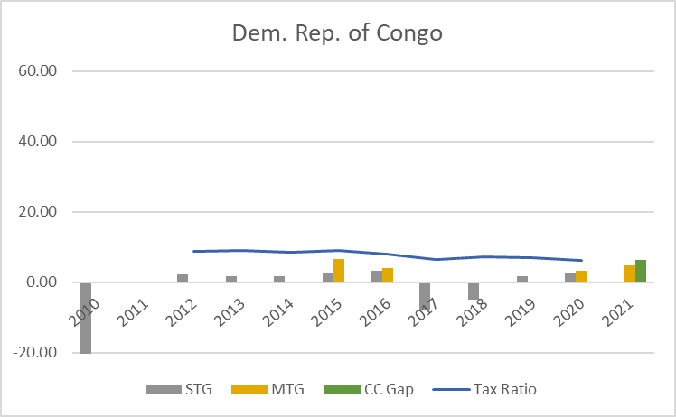
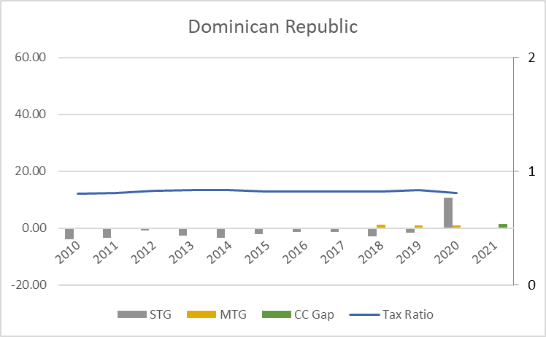 | 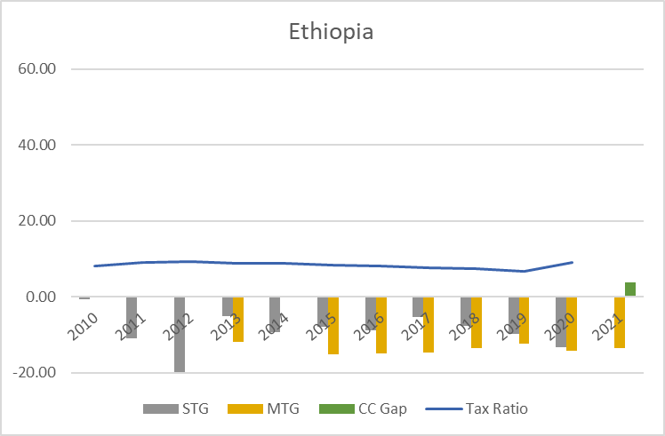
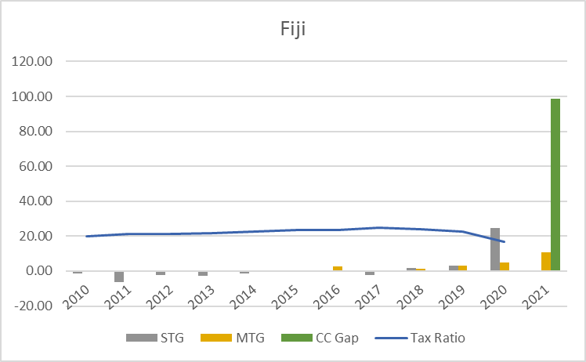 | 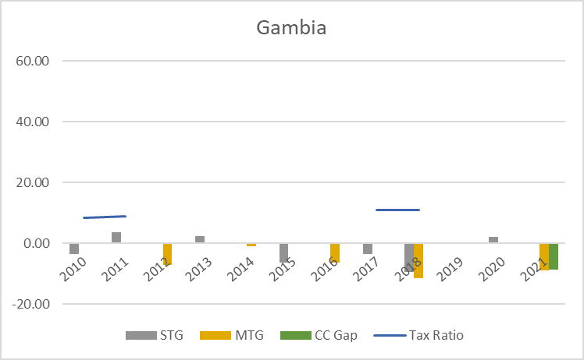
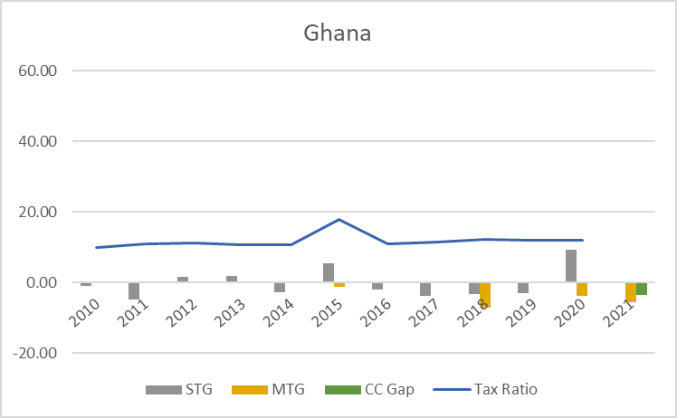 | 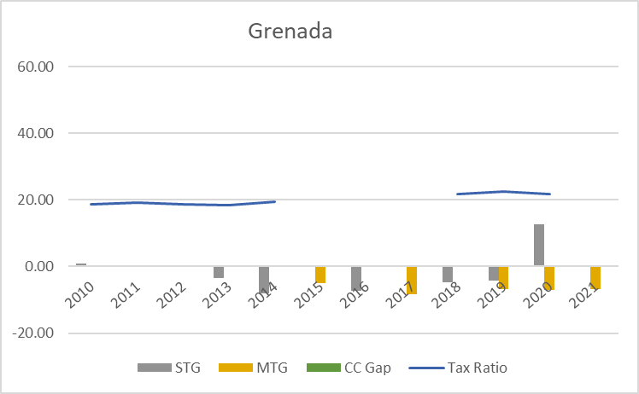
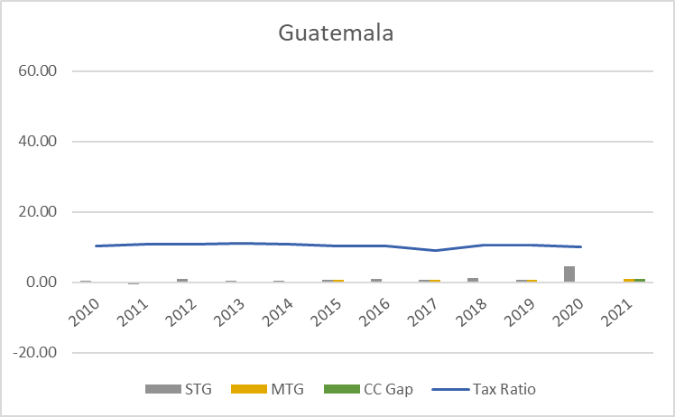 | 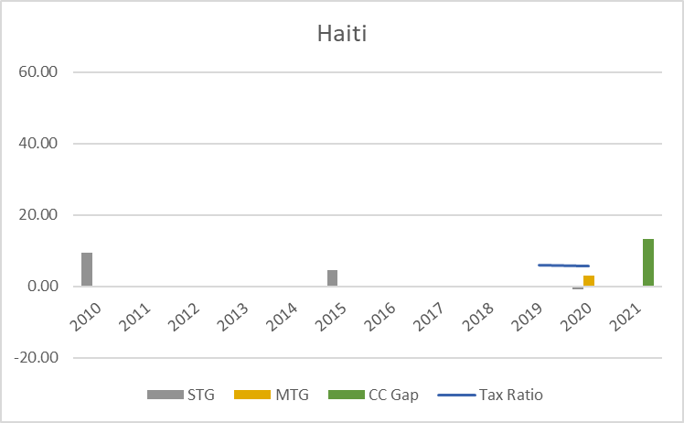
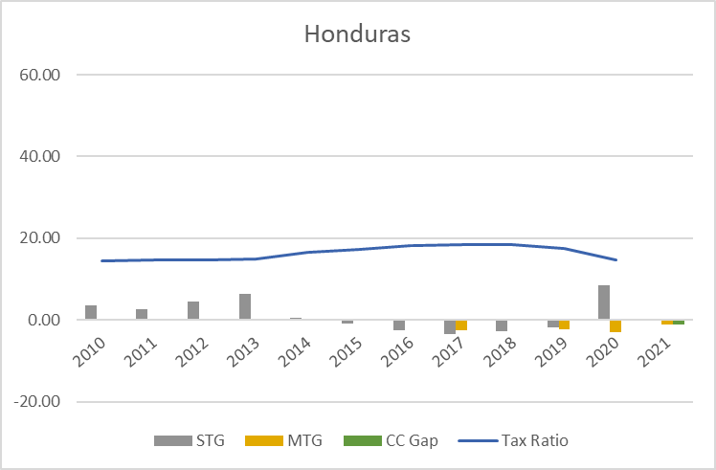 | 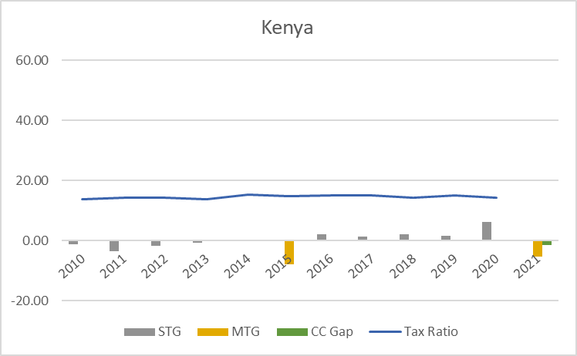
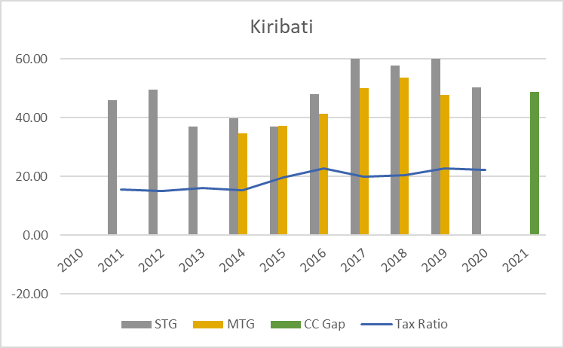 | 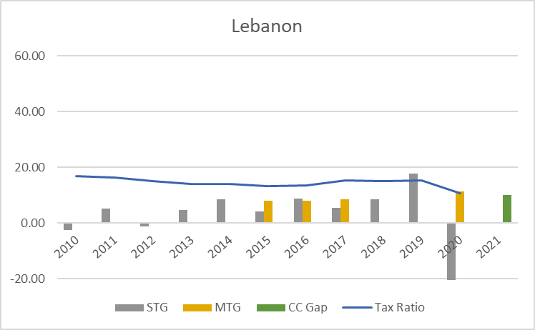
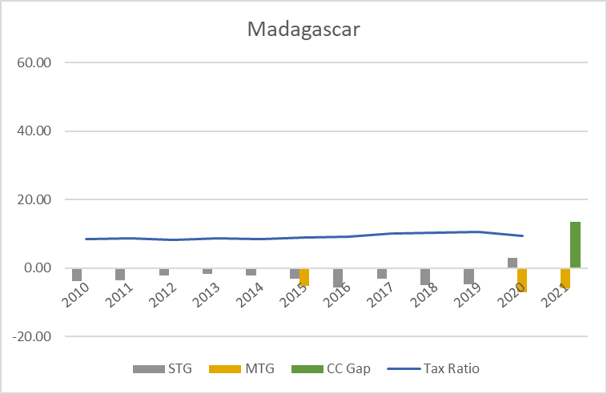 | 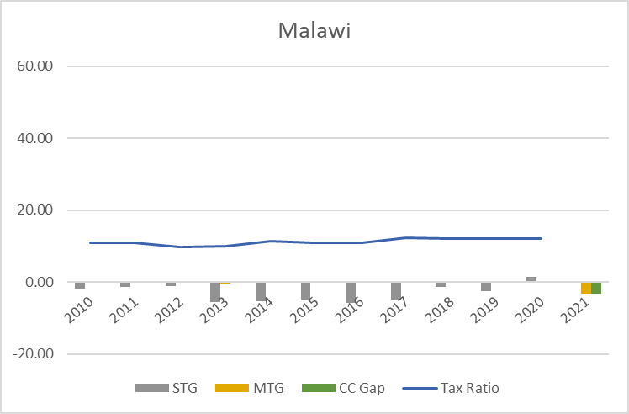
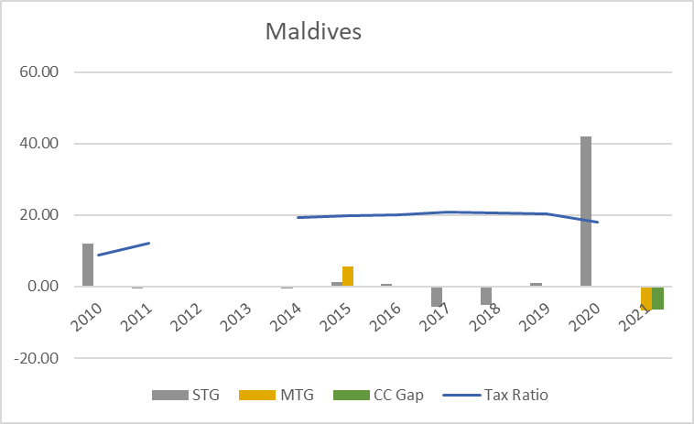 | 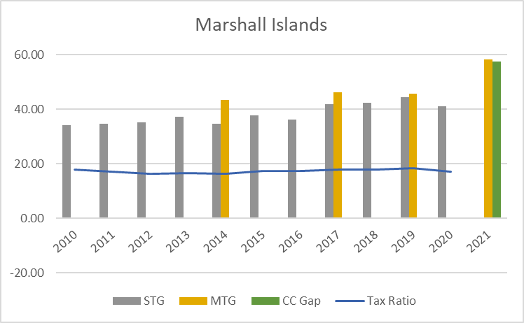
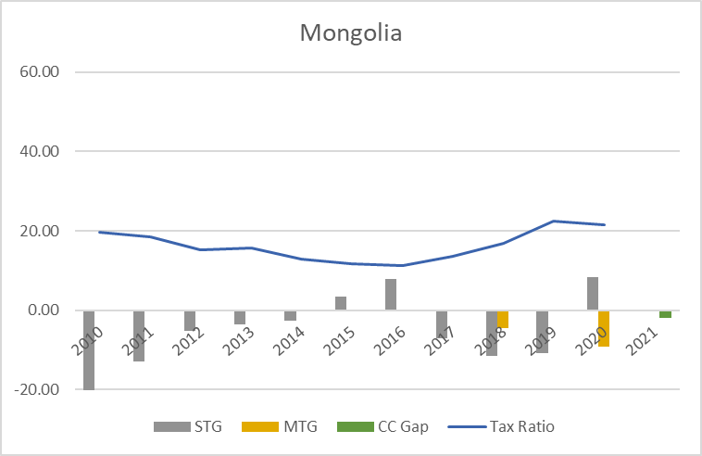 | 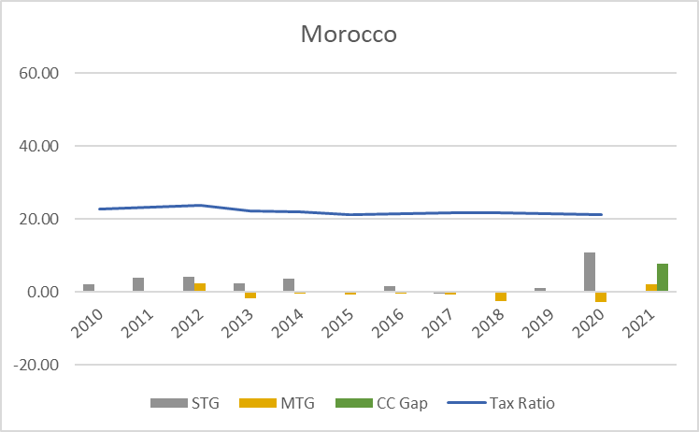
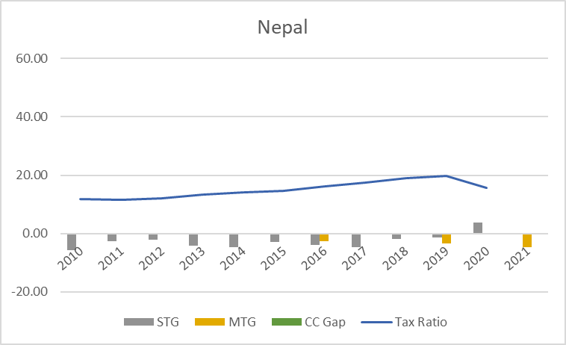 | 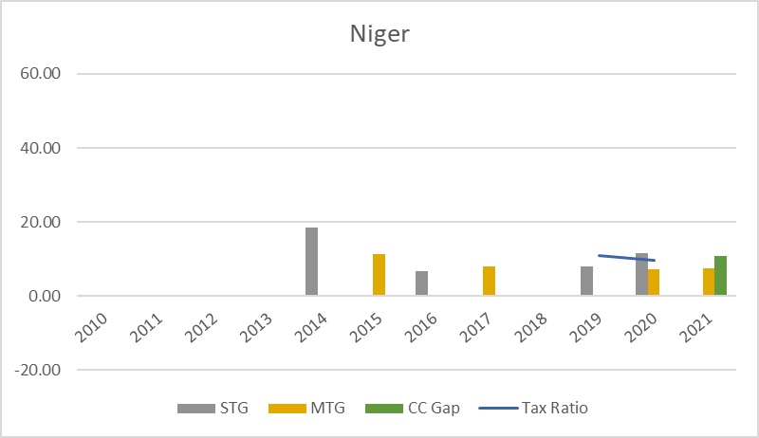
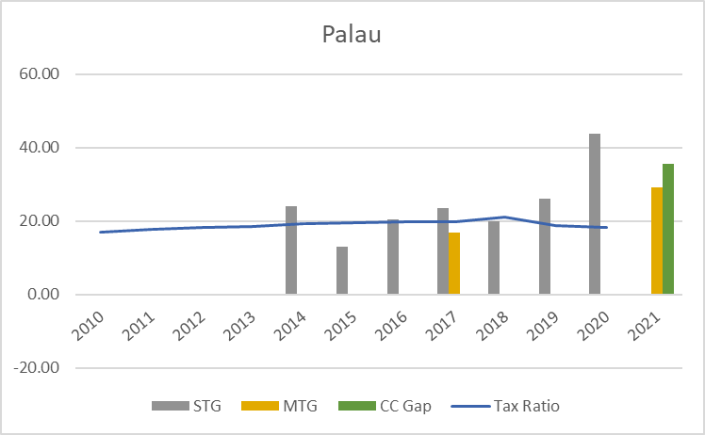 | 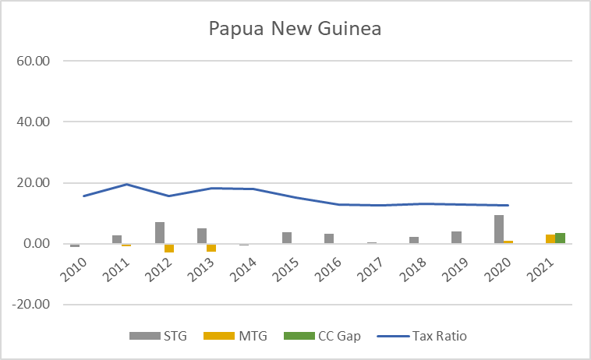
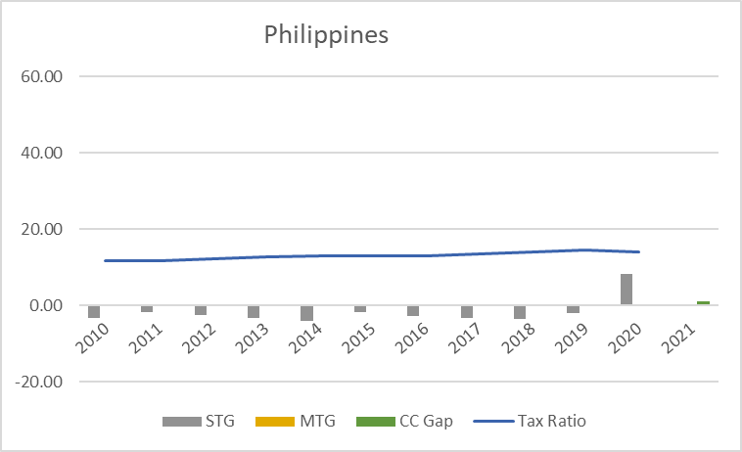 | 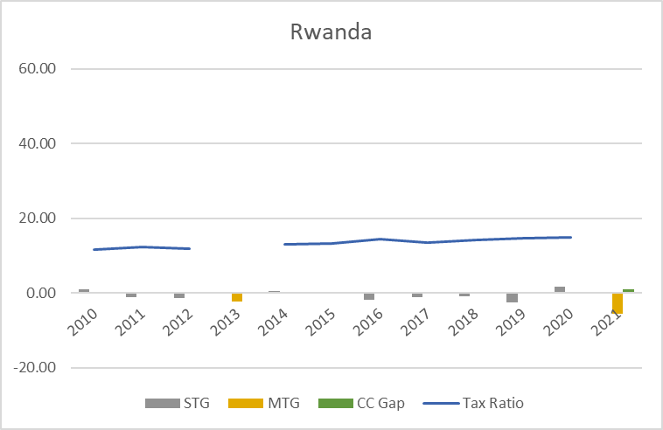
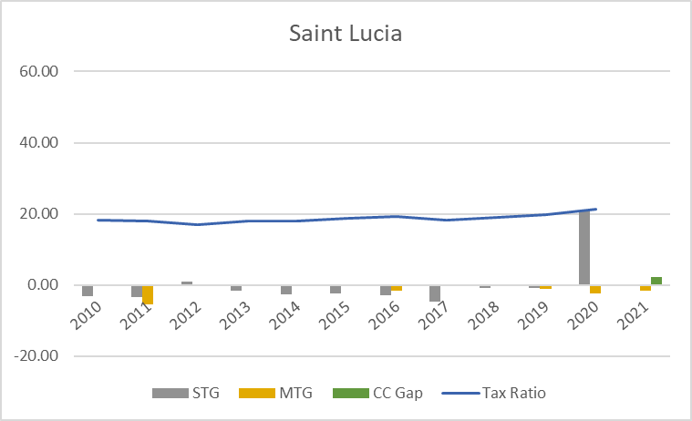 | 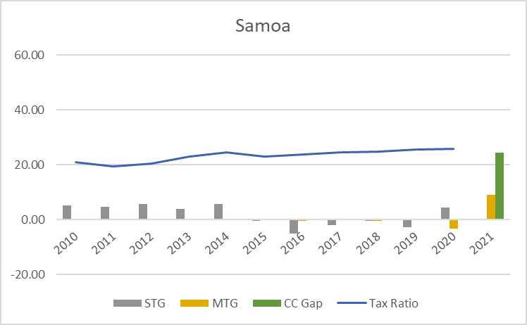
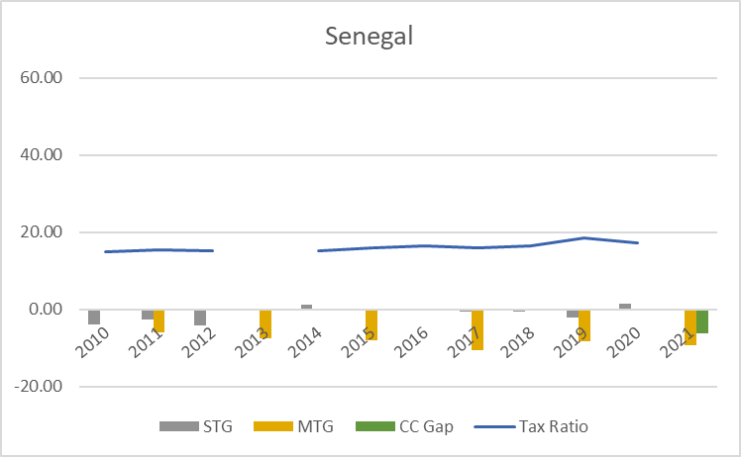 | 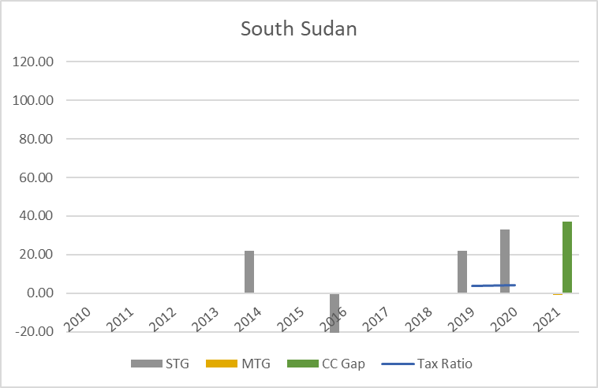
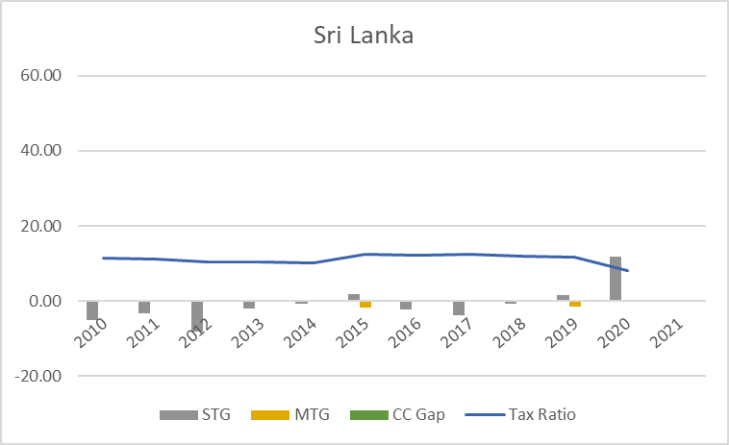 | 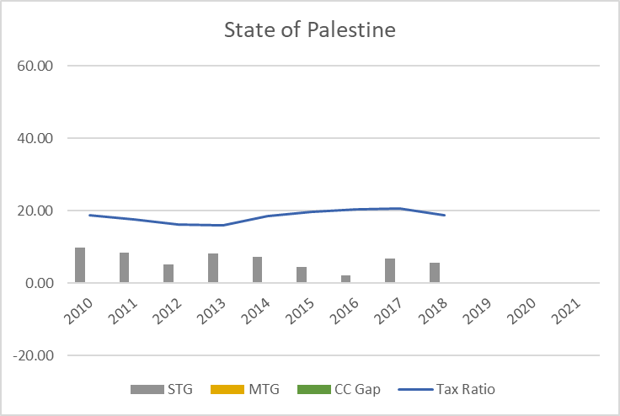
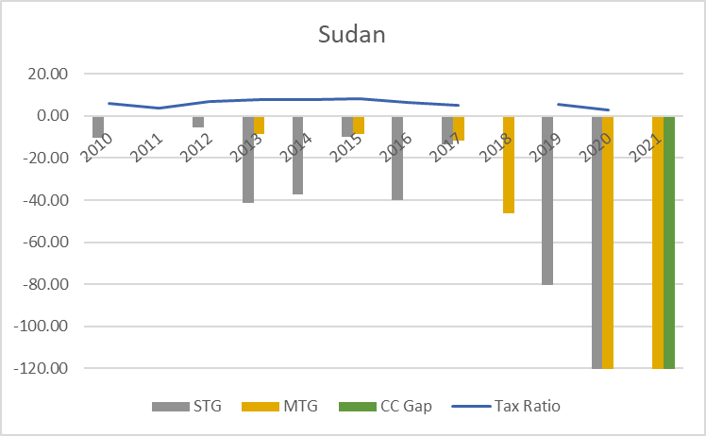 | 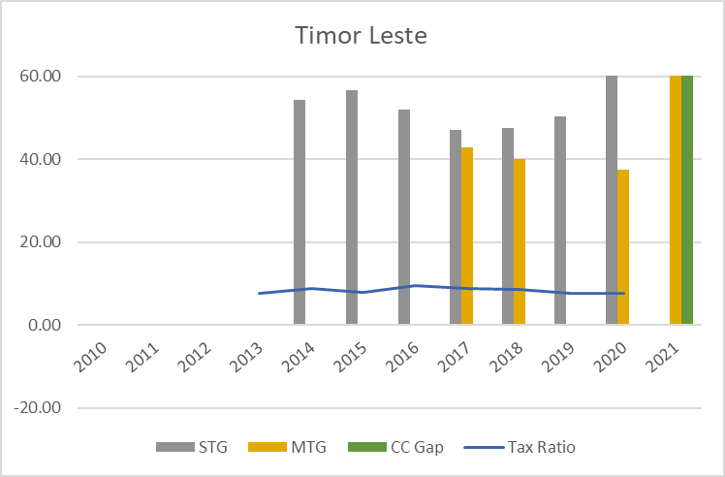
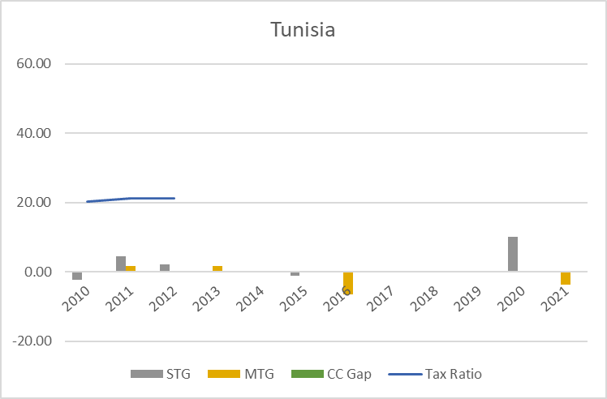 | 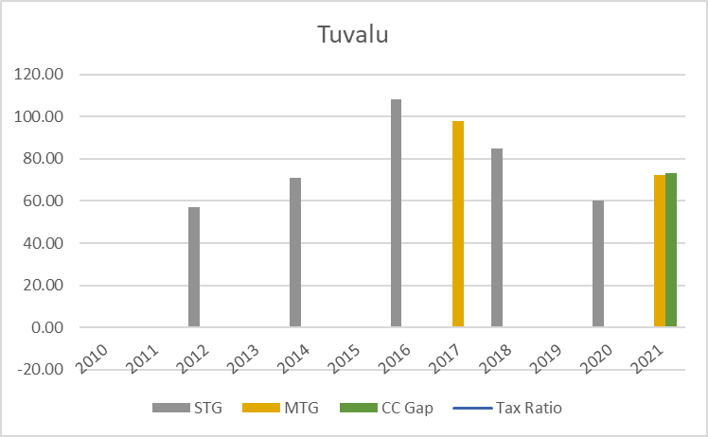
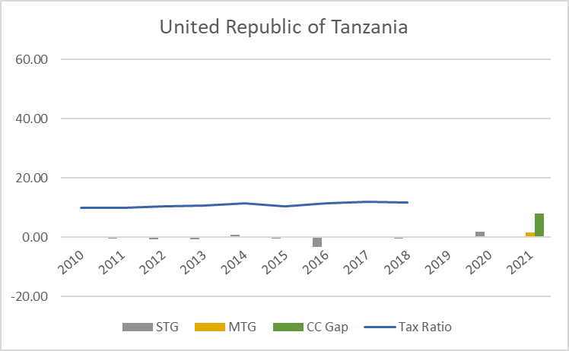 | 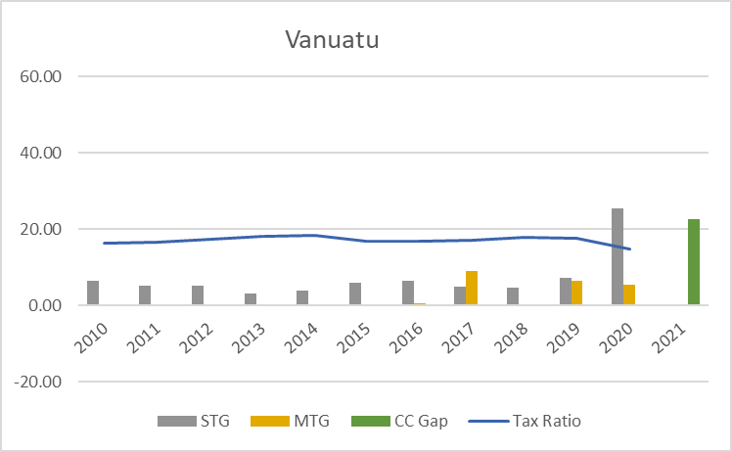
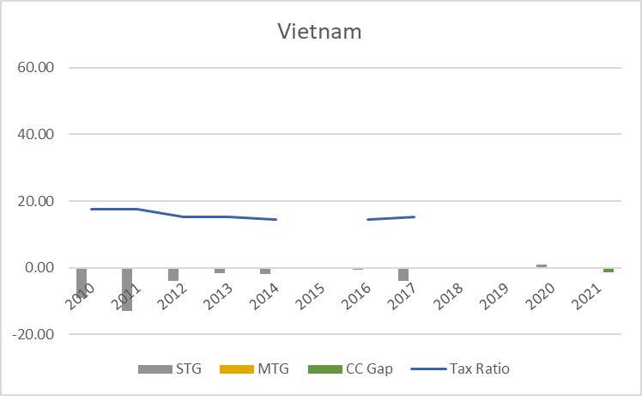 | 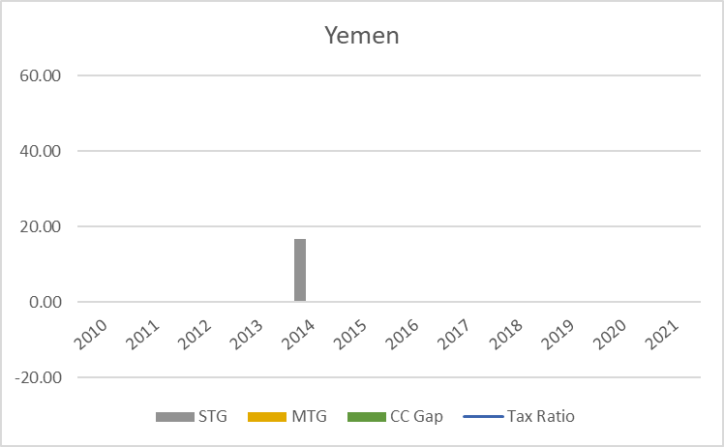

Refer to Annex 1 for definitions.

