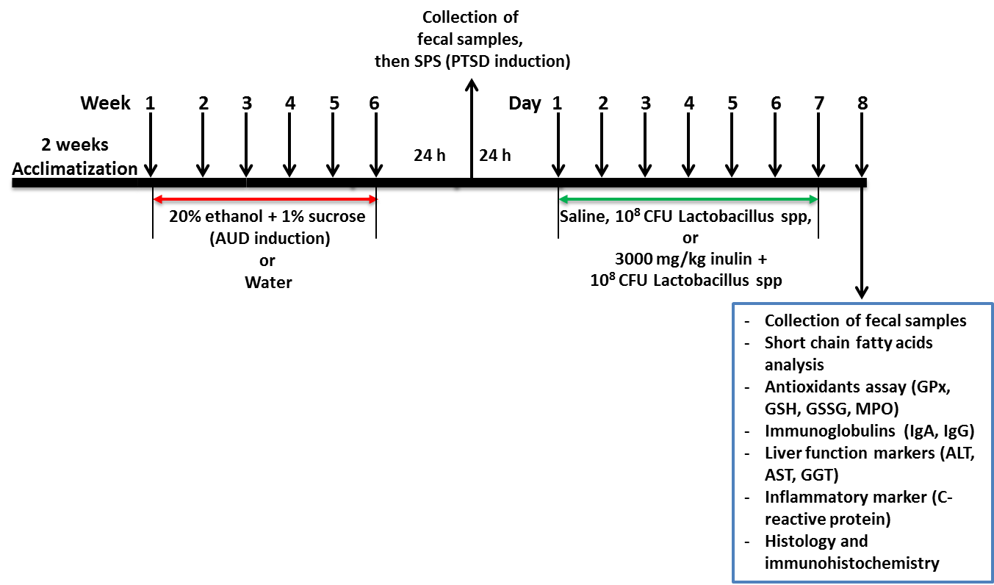

Supplemental Figure 1: scheme showing experimental design

Probiotics and synbiotic do not affect ileal antigen-antibody response
Probiotic and synbiotic effects on immunoglobulins A and G (IgA and IgG) expressions in the ileum of alcohol-drinking rats with PTSD are shown below. Post-hoc analysis revealed no significant (p > 0.05) difference in the Dis group compared to the control. Additionally, probiotics and synbiotic treatments showed no significant difference compared to the AUD/PTSD-induced rats.

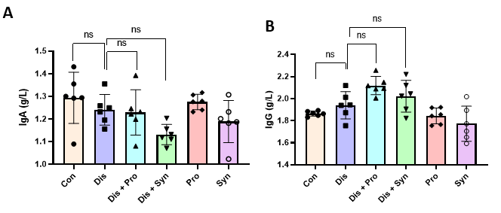
Supplemental Figure 2: Effect of probiotics and synbiotic on (A) IgA and (B) IgG levels in the ileum of AUD/PTSD rats.
ns: not significant. (One-way ANOVA followed by Tukey’s multiple comparisons test). Con: Control (normal saline), Dis: AUD/PTSD (normal saline), Dis + Pro: AUD/PTSD (probiotics), Dis + Syn: AUD/PTSD (synbiotics), Pro: Probiotics, Syn: Synbiotics.

