**Appendix 2:** Forest plots of secondary outcomes

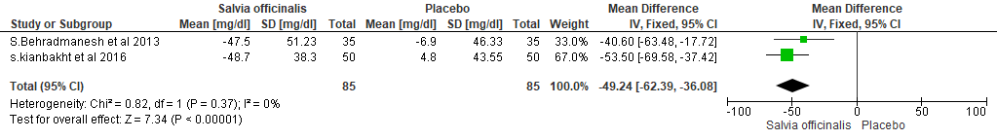

**Figure 1.** Effect of *Salvia Officinalis* compared to placebo on **2HPPG**

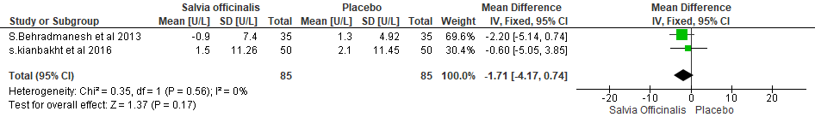

**Figure 2**. Effect of *Salvia Officinalis* compared to placebo on **AST**

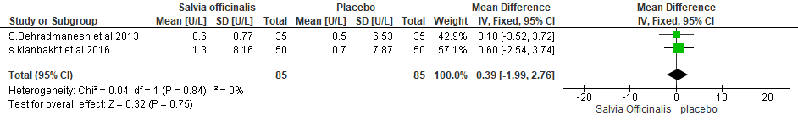

**Figure 3**. Effect of *Salvia Officinalis* compared to placebo on **ALT**