Chemical compositions, antibacterial, antifungal and cytotoxic effects of Alhagi mannifera five extracts
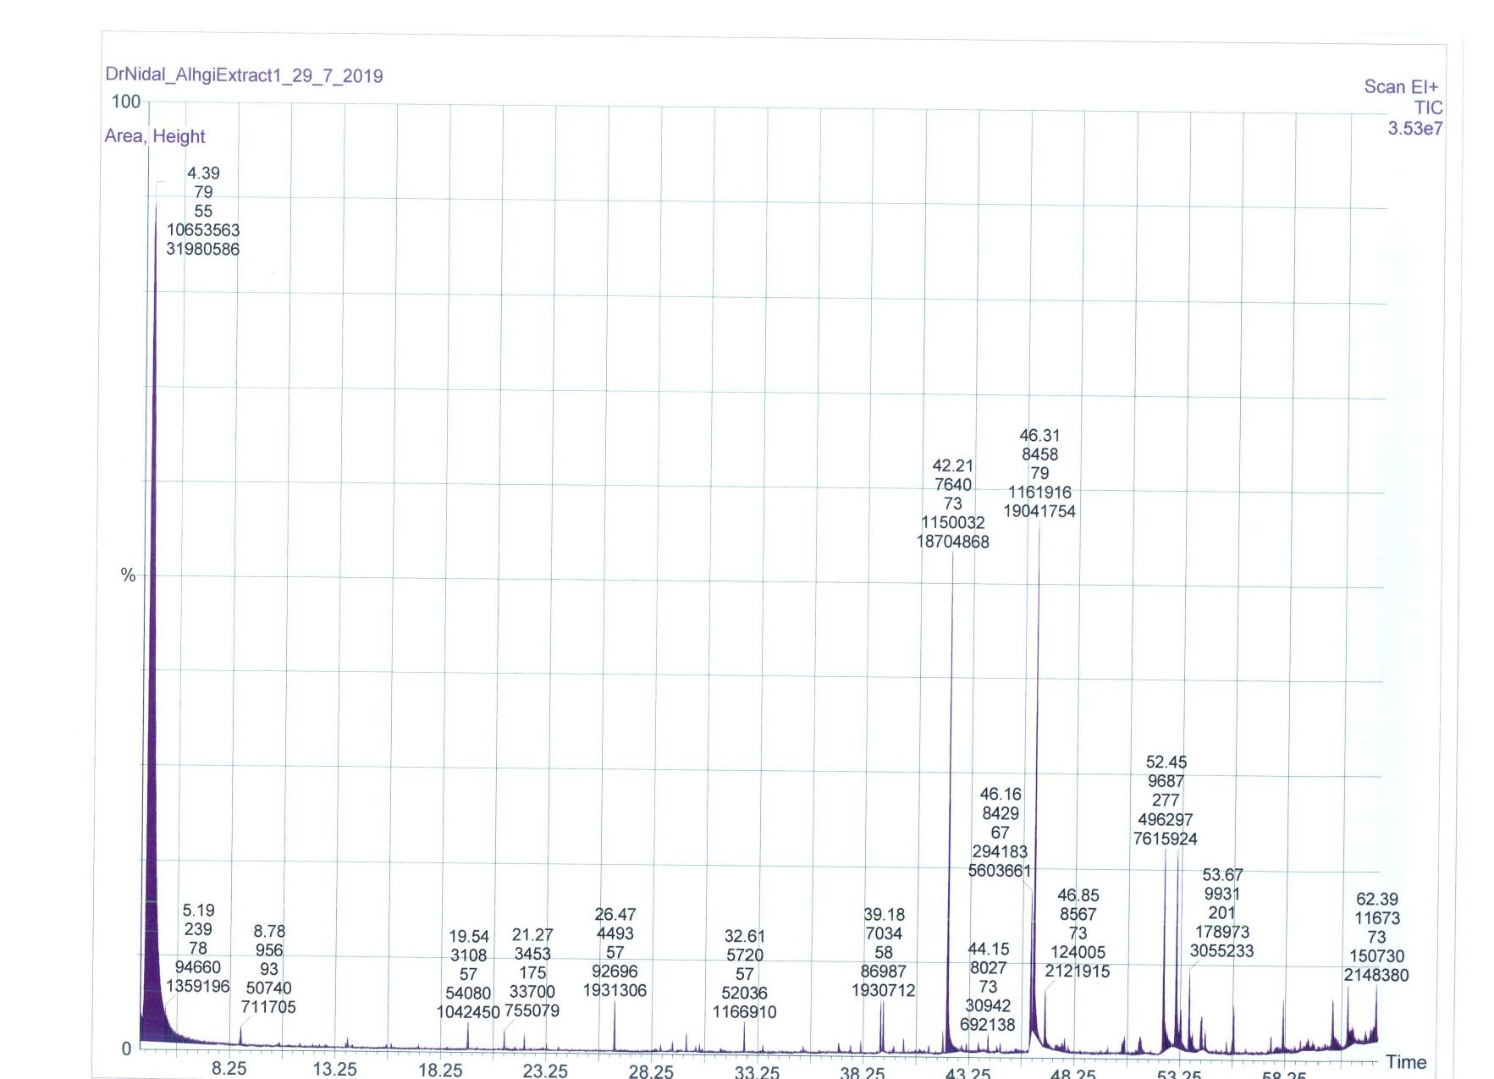
Figure S1. The GC-MS chromatogram of A. mannifera petroleum ether extract
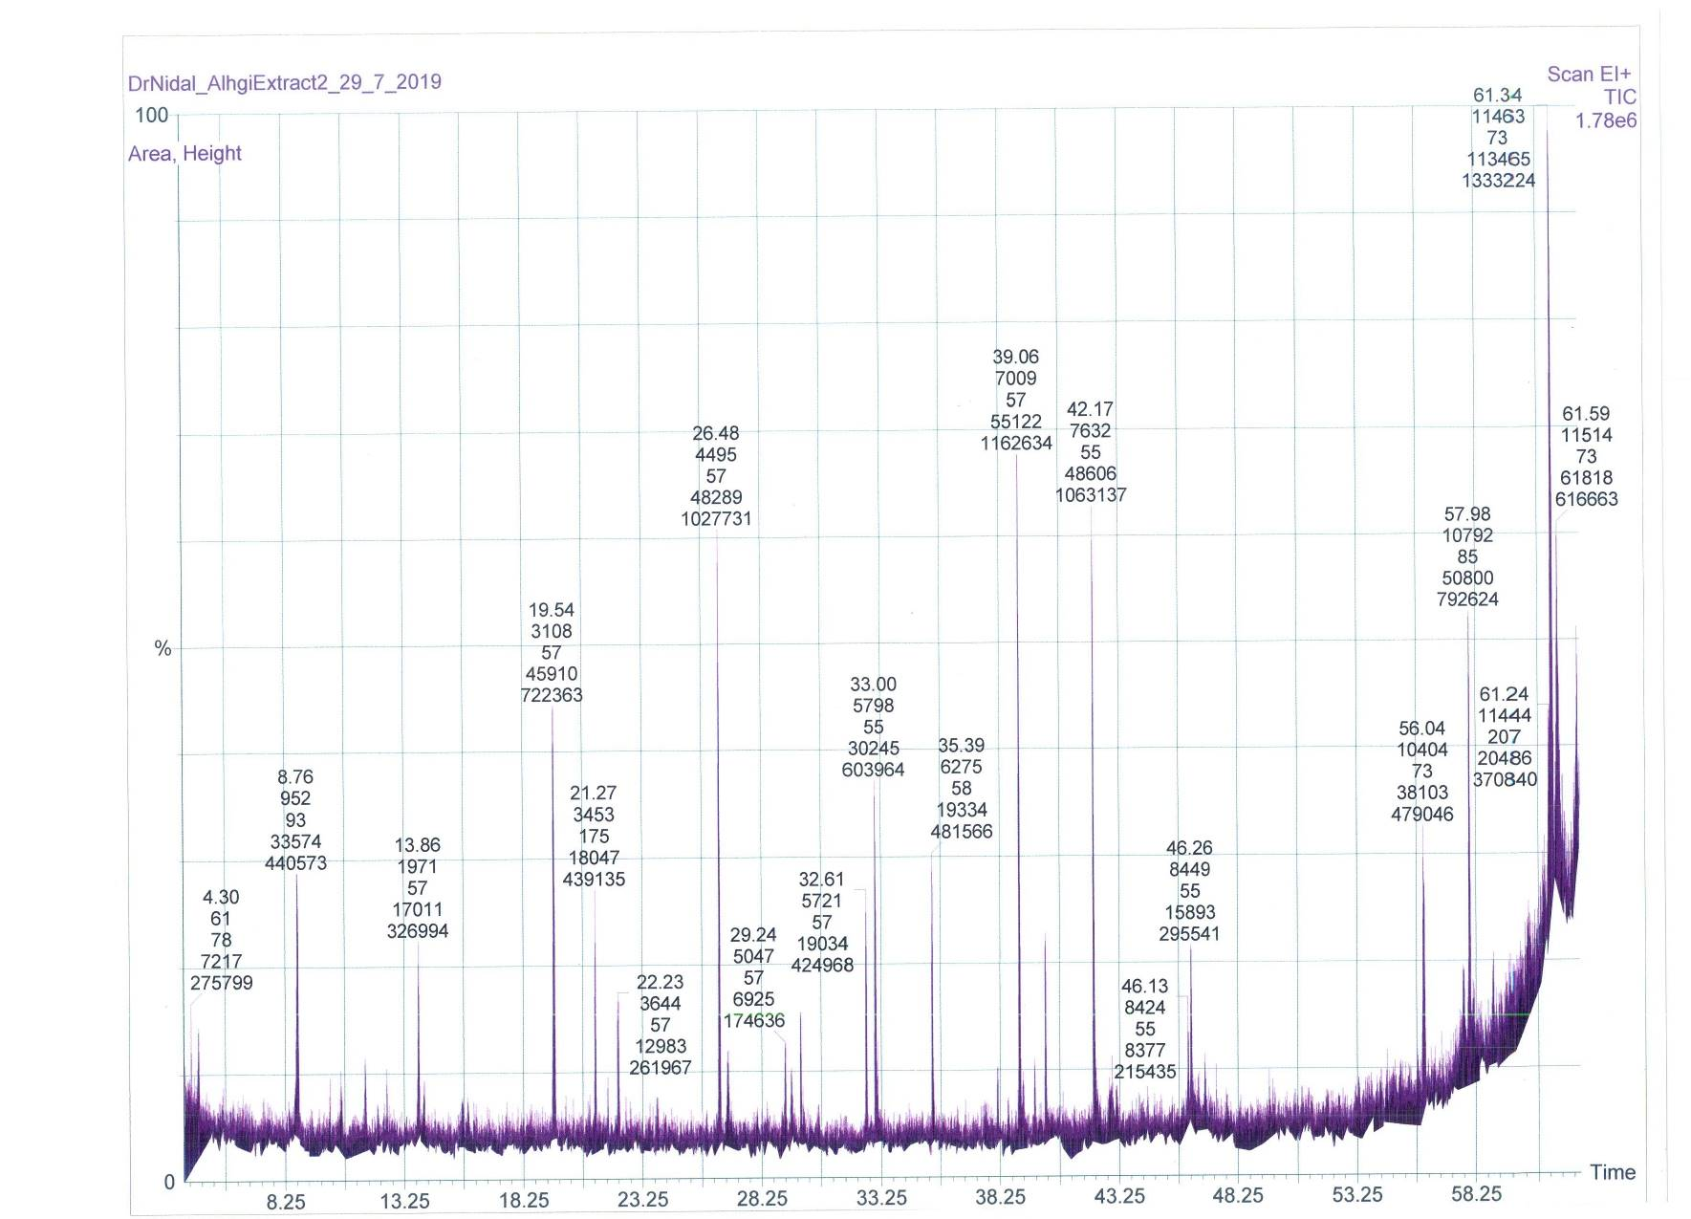Figure S2. The GC-MS chromatogram of A. mannifera methylene chloride extract

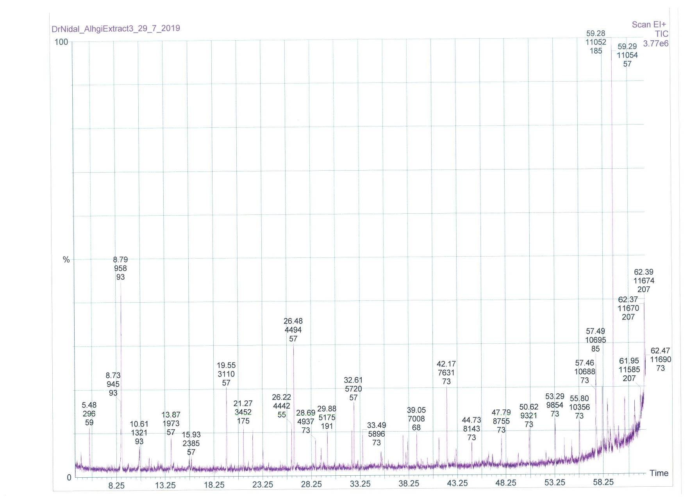
Figure S3. The GC-MS chromatogram of A. mannifera chloroform extract

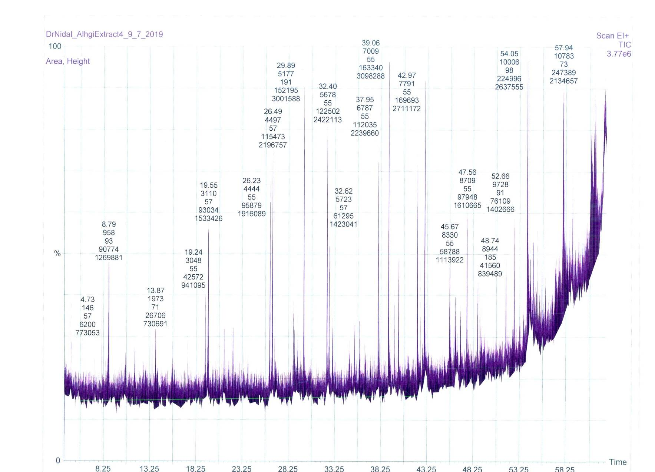
Figure S4. The GC-MS chromatogram of A. mannifera acetone extract
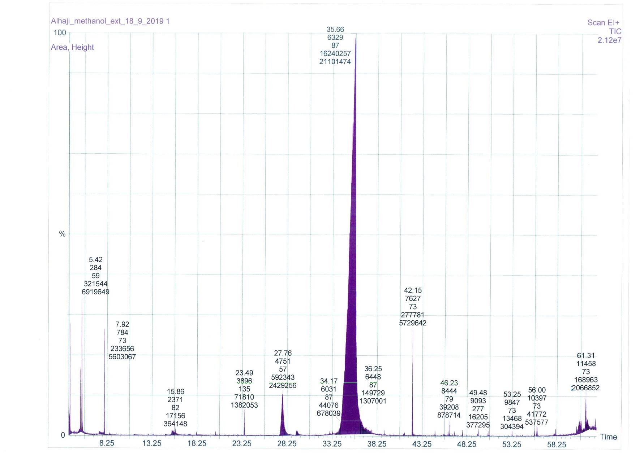
Figure S5. The GC-MS chromatogram of A. mannifera methanol extract

