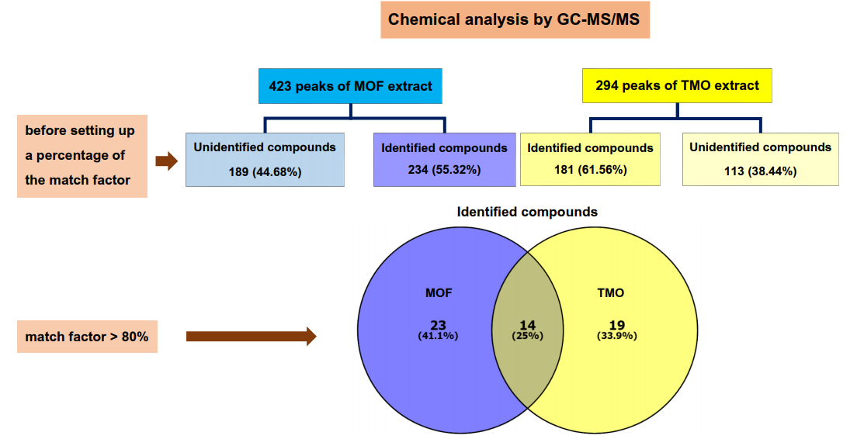Supplement: The comparative constituents (numbers of compounds) between MOF and TMO extract.

