A prospective study to assess the prognosis of patients with necrotizing fasciitis using laboratory risk indicator for necrotizing fasciitis (LRINEC) scoring system in a tertiary care hospital.
Extra tables and figures
Table 1: LRINEC distribution of the study population (n=124)
LRINEC Score | No. of Cases
<6 | 62(50%)
≥6 | 62(50%)

Table 2: Demographic distribution with respect to LRINEC score
Parameter | LRINEC (<6) | LRINEC (≥6) | p value
Age in years  (Mean ±SD) | 52.85±15.43 | 58.73±14.65 | 0.0318
Male, n (%) | 49(79.03%) | 51(82.26%) | 0.8206
Female, n (%) | 13(20.97%) | 11(17.74%) | 0.8206

Table 3: Site Distribution of Necrotizing Fasciitis (n=124)
Site | LRINEC (<6) | LRINEC (≥6)
Lower Limb | 48(77.4%) | 49(79%)
Upper Limb | 9(14.5%) | 11(17.7%)
Anterior Abdominal Wall | 1(1.6%) | 1(1.6%)
Gluteal | 0 | 1(1.6%)
Genital | 4(6.5%) | 1(1.6%)
Breast | 1(1.6%) | 0

Graph 1: Site Distribution of Necrotizing Fasciitis (n=124)
Table 4: Precipitating factors of the study population (n=124)
Risk Factors | LRINEC (<6) | LRINEC (≥6)
TRAUMA | 18(29%) | 25(40.3%)
DIABETES | 13(21%) | 27(43.5%)
HYPERTENSION | 7(11.3%) | 16(25.8%)
CARDIAC DISEASES | 2(3.2%) | 6(9.7%)
CHRONIC LIVER DISEASE | 1(1.6%) | 4(6.5%)
IMMUNOCOMPROMISED STATE | 2(3.2%) | 1(1.6%)
INSECT/SNAKE BITE | 5(8.1%) | 0
CHRONIC AIRWAY DISEASES | 1(1.6%) | 2(3.2%)
CVA | 1(1.6%) | 1(1.6%)
IDIOPATHIC | 17(27.4%) | 10(16.1%)
Table 5: LRINEC score and Amputations
LRINEC Score |  | Amputation Status |  | Total
 |  | No Amputation | Amputation
1 | Count | 11 | 0 | 11
 | % of Total | 8.90% | 0.00% | 8.90%
2 | Count | 13 | 2 | 15
 | % of Total | 10.50% | 1.60% | 12.10%
3 | Count | 16 | 2 | 18
 | % of Total | 12.90% | 1.60% | 14.50%
4 | Count | 8 | 2 | 10
 | % of Total | 6.50% | 1.60% | 8.10%
5 | Count | 7 | 1 | 8
 | % of Total | 5.60% | 0.80% | 6.50%
6 | Count | 2 | 2 | 4
 | % of Total | 1.60% | 1.60% | 3.20%
7 | Count | 7 | 3 | 10
 | % of Total | 5.60% | 2.40% | 8.10%
8 | Count | 6 | 4 | 10
 | % of Total | 4.80% | 3.20% | 8.10%
9 | Count | 14 | 3 | 17
 | % of Total | 11.30% | 2.40% | 13.70%
10 | Count | 8 | 2 | 10
 | % of Total | 6.50% | 1.60% | 8.10%
11 | Count | 4 | 3 | 7
 | % of Total | 3.20% | 2.40% | 5.60%
12 | Count | 3 | 1 | 4
 | % of Total | 2.40% | 0.80% | 3.20%
Count |  | 99 | 25 | 124
% of Total |  | 79.80% | 20.20% | 100.00%
Chi Square statistic is 12.044 and the p-value is 0.360, The p value is not significant at p<0.05.

Table 6: LRINEC score and No. of Debridement’s
LRINEC Score |  | No. of Debridement’s
 |  | 0 | 1 | 2 | 3
1 | Count | 0 | 11 | 0 | 0
 | Percentage | 0.00% | 13.40% | 0.00% | 0.00%
2 | Count | 1 | 13 | 1 | 0
 | Percentage | 5.90% | 15.90% | 5.30% | 0.00%
3 | Count | 0 | 13 | 5 | 0
 | Percentage | 0.00% | 15.90% | 26.30% | 0.00%
4 | Count | 1 | 6 | 2 | 1
 | Percentage | 5.90% | 7.30% | 10.50% | 16.70%
5 | Count | 0 | 8 | 0 | 0
 | Percentage | 0.00% | 9.80% | 0.00% | 0.00%
6 | Count | 0 | 2 | 1 | 1
 | Percentage | 0.00% | 2.40% | 5.30% | 16.70%
7 | Count | 2 | 3 | 5 | 0
 | Percentage | 11.80% | 3.70% | 26.30% | 0.00%
8 | Count | 3 | 3 | 1 | 3
 | Percentage | 17.60% | 3.70% | 5.30% | 50.00%
9 | Count | 5 | 9 | 2 | 1
 | Percentage | 29.40% | 11.00% | 10.50% | 16.70%
10 | Count | 3 | 6 | 1 | 0
 | Percentage | 17.60% | 7.30% | 5.30% | 0.00%
11 | Count | 1 | 5 | 1 | 0
 | Percentage | 5.90% | 6.10% | 5.30% | 0.00%
12 | Count | 1 | 3 | 0 | 0
 | Percentage | 5.90% | 3.70% | 0.00% | 0.00%
Total Count |  | 17 | 82 | 19 | 6
Percentage |  | 100.00% | 100.00% | 100.00% | 100.00%
Chi Square statistic is 58.832 and the p-value is 0.004, The p value is significant at p<0.05.
Table 7: Laboratory Parameters of the study population (n=124)
Parameter | LRINEC (<6) | LRINEC (≥6) | p value
Parameter | Value | Value | p value
CRP | 80.3±28.55 | 187.435±55.05 | <0.0001
TC | 12446.7±4905.2 | 18474.19±7779.87 | <0.0001
HB | 11.68±2.22 | 10.23±2.55 | <0.001
SODIUM | 134.43±4.47 | 131.85±5.38 | <0.001
CREATININE | 1.019±0.34 | 1.94±1.15 | <0.0001
RBS | 112.74±39.92 | 147.59±87.93 | <0.001

Table 8: Predictors of Hospital Outcomes in NF with LRINEC score
Mortality | LRINEC (≥6) | LRINEC (<6) | Total
Present | 32(51.6%) | 2(3.23%) | 34
Absent | 30(48.4%) | 60(96.8%) | 90
Total | 62 | 62 | 124
p value - <0.0001
Odds Ratio(95%CI) - 28.13(6.753-122.8)
Table 9: Comparison of patients in septic shock with LRINEC score (n=124)
Septic Shock | LRINEC (≥6) | LRINEC (<6) | Total
Present | 31(50%) | 2(3.23%) | 33
Absent | 31(50%) | 60(96.77%) | 91
Total | 62 | 62 | 124
p value - <0.0001
Odds Ratio(95%CI) - 30(7.208-130.8)

ANNEXURE- I
KARNATAKA INSTITUTE OF MEDICAL SCIENCES, HUBLI
PROFORMA
A prospective study to assess the prognosis of patients with necrotizing fasciitis using laboratory risk indicator for necrotizing fasciitis (LRINEC) scoring system in a tertiary care hospital.

NAME: DATE OF ADMISSION:
DATE OF PROCEDURE:

AGE: DATE OF DISCHARGE/DEATH:
SEX:
IP NO:
SURGERY UNIT:
ADDRESS:

CONTACT NUMBER:

CHIEF COMPLAINTS:

HISTORY OF PRESENTING ILLNESS:

PAST HISTORY:
DRUG HISTORY:
FAMILY HISTORY:
PERSONAL HISTORY:

GENERAL PHYSICAL EXAMINATION:
CONSCIOUS ORIENTATION

PALLOR ICTERUS CYANOSIS CLUBBING LYMPHADENOPATHY EDEMA

VITAL SIGNS:
PULSE: RR:
BP: TEMP:

LOCAL EXAMINATION:
SITE
EXTENT
NECROSIS
INFLAMMATION
DISCHARGE
CREPITATIONS
SKIN CHANGES

SYSTEMIC EXAMINATION:
CVS:
RS:
P/A:

CLINICAL DIAGNOSIS:

INVESTIGATIONS:
 | VALUES | LRINEC SCORE
1.CRP

2.TOTAL WHITE CELL COUNT

3.HB

4.SODIUM

5.CREATININE

6.RBS

 |  | TOTAL-

HIV & HBSAG
CULTURE & SENSITIVITY
OUTCOMES:
DEBRIDEMENT
1
2
3
4
5
SKIN GRAFTING:

AMPUTATIONS:
DURATION OF HOSPITAL STAY:
SEPTICK SHOCK:
MORTALITY:
FOLLOW UP: 7 TH DAY

30 TH DAY

SUMMARY:

DISCCUSSION:

ANNEXURE-II
INFORMED CONSENT

I, Mr/Ms/Mrs son/ daughter/ wife of Mr/Mrs
aged years have been explained in detail in my own understandable language regarding the study being conducted namely " A prospective study to assess the prognosis of patients with necrotizing fasciitis using laboratory risk indicator for necrotizing fasciitis (LRINEC) scoring system in a tertiary care hospital ” at Department of General Surgery, KIMS Hubballi. The details of study have been explained to me clearly. I have no issues about sharing my details in case records and would co-operate for the study. I have been informed that I will not be getting any incentives. My personal identity will not be revealed but data can be used for publication purposes. During the discussion with the doctor, at any time, there has been no compulsion to undergo the procedure or participate in the study and hence I wilfully give consent for the same. I shall not hold the doctor or the hospital authorities responsible for any untoward incident occurring as a consequence of the procedure or during the study.

Signature of the patient Signature of the doctor

Signature of the attendant/witness Date:

ANNEXURE – III
PRE-OP & POST OP PICTURES OF NECROTIZING FASCIITIS
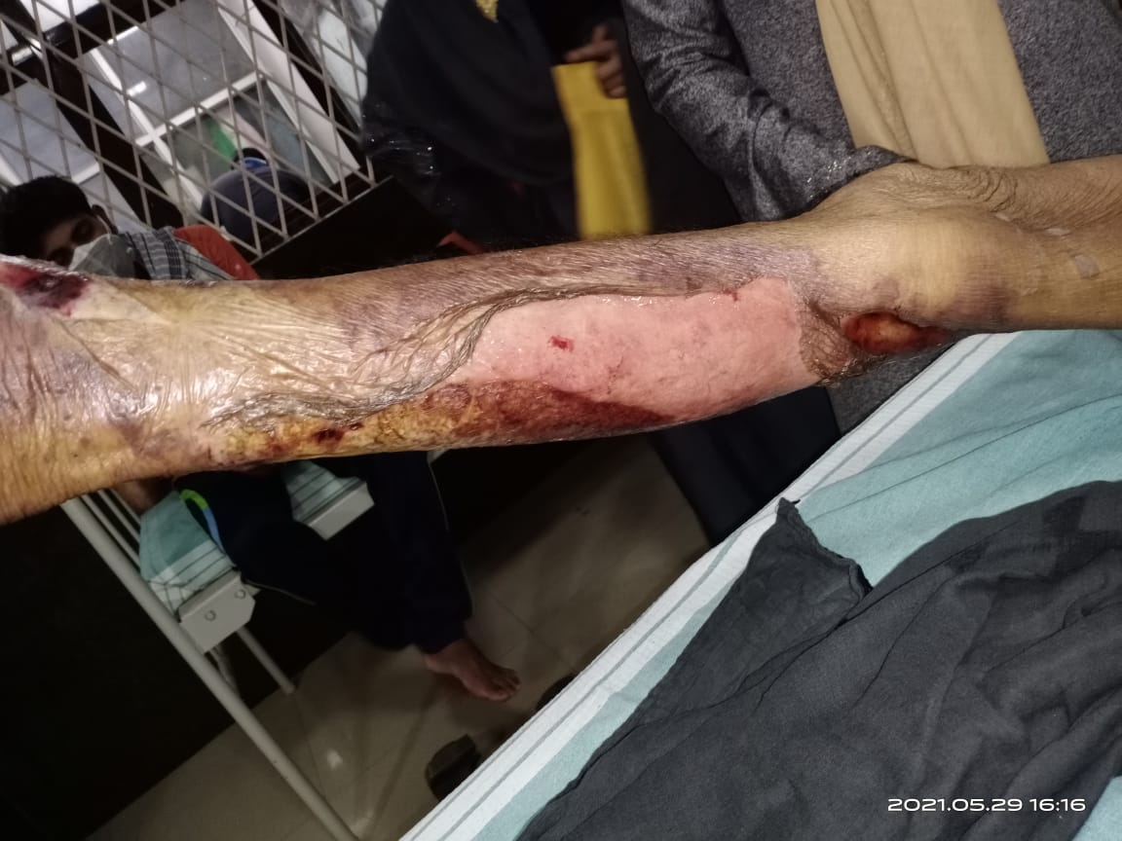

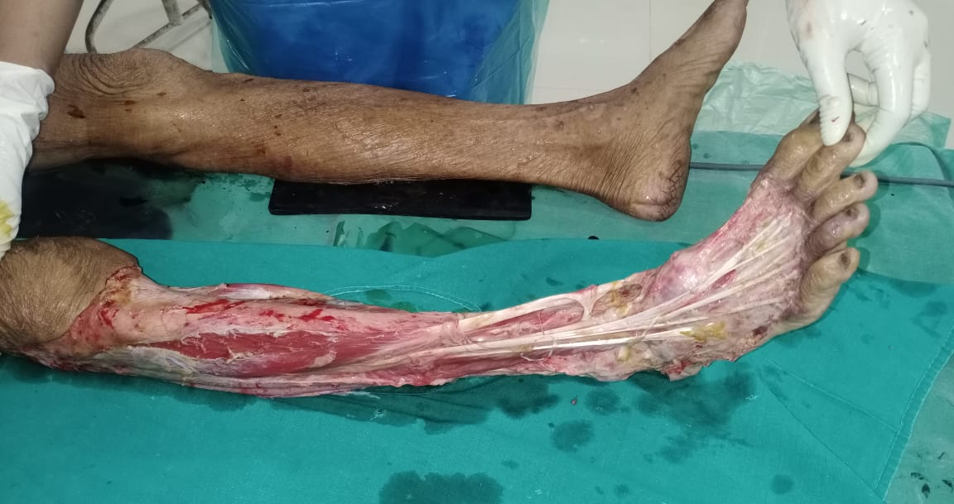
ANNEXURE-IV
Abbreviations
- CRP-C REACTIVE PROTEIN
- D.O.A- DATE OF ADMISSION
- D.O.D- DATE OF DISCHARGE/DEATH
- IP NO- IN PATIENT NUMBER
- HB-HEMOLGLOBIN
- LS-LRINEC SCORE
- TC-TOTAL LEUCOCYTE COUNT
- RBS- RANDOM BLOOD SUGAR
- RT-RIGHT
- LT-LEFT
- UL-UPPER LIMB
- LL-LOWER LIMB

ETHICS COMMITTEE LETTER
