**Image-1. Test for the assessment of the PL tendon**

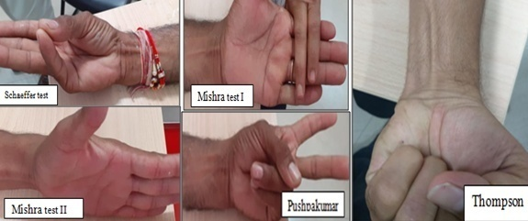

**Image –2. Placement of ring electrode (a) and surface electrode(b) for orthodromic and antidromic recording of median nerve sensory conduction**

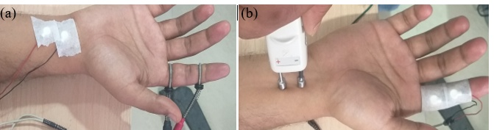

**Image-3. Sensory nerve action potentials recording of antidromic (a)(b) and orthodromic (c)(d) records for sensory median nerve fibers.**

