Supporting Information
A. Sample picture strips for A boy, a dog and a frog
(Mayer 1967)
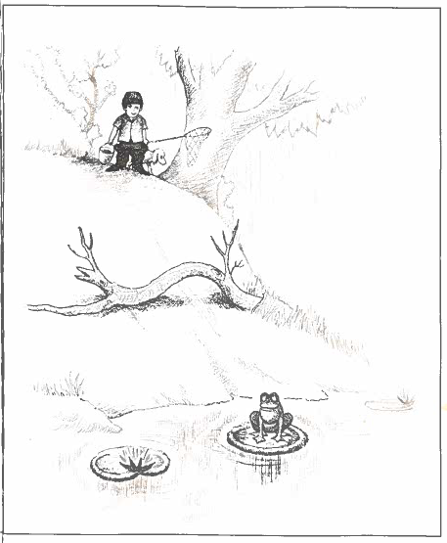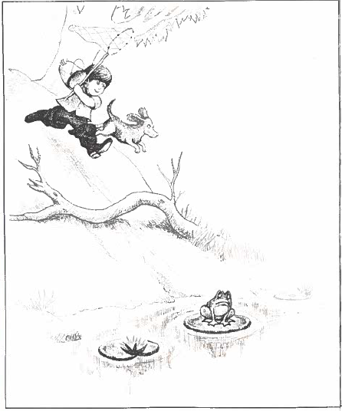
2
11

B. Sample picture strips for Frog, where are you?
(Mayer 1969)
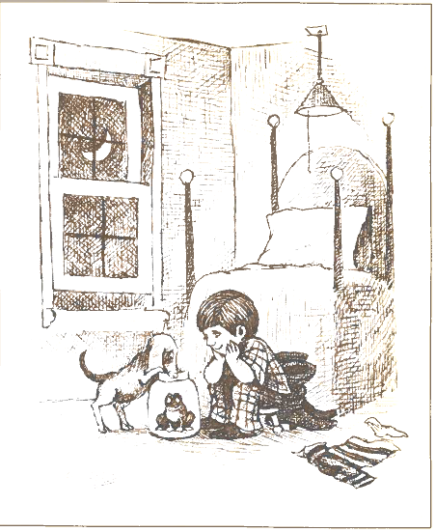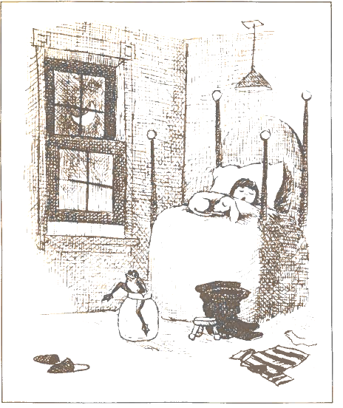
2
11

C. Inter-rater reliability for the creativity variables

Table 1 Cronbach’s alpha coefficients (α) for the 10 creativity measures
Verbal fluency | Verbal originality | Verbal flexibility | Verbal elaboration | Verbal subscore | Figural fluency | Figural originality | Figural flexibility | Figural elaboration | Figural subscore
.999 | .827 | .967 | .972 | .970 | .938 | .819 | .847 | .821 | .798

D. Correlations analyses for the creativity variables

Table 2 Correlational coefficients (r) for the 10 creativity variables
 | Verbal originality | Verbal flexibility | Verbal elaboration | Verbal subscore | Figural fluency | Figural originality | Figural flexibility | Figural elaboration | Figural subscore
Verbal fluency | -.120 | .975** | -.309 | .803** | .164 | -.219 | .017 | -.171 | -.037
Verbal originality |  | -.050 | .009 | .230 | -.170 | .230 | .060 | .044 | .012
Verbal flexibility |  |  | -.319 | .820** | .160 | -.153 | .028 | -.128 | -.001
Verbal elaboration |  |  |  | .202 | -.114 | .236 | -.126 | .356** | .099
Verbal subscore |  |  |  |  | .054 | .009 | -.021 | .047 | .038
Figural fluency |  |  |  |  |  | -.423** | .690** | -.451** | .568**
Figural originality |  |  |  |  |  |  | .125 | .776** | .441**
Figural flexibility |  |  |  |  |  |  |  | -.116 | .848**
Figural elaboration |  |  |  |  |  |  |  |  | .340**
Note: Considering the large number of correlational analyses, a more conservative alpha level of .01 was adopted in order to reduce the chance of Type I error. **p < 0.0
References
Mayer, Mercer. 1967. A boy, a dog and a frog. New York: Dial Press.
Mayer, Mercer. 1969. Frog, where are you? New York: Dial Press.

