Appendixes

APPENDIX A
Scree Plot from the Initial Exploratory Factor Analysis on Items Related to Reasons for Performance Approach Goals
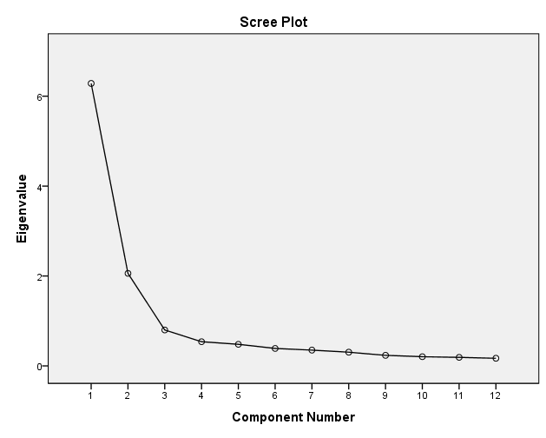

APPENDIX B
Exploratory Factor Analysis on Underlying Reasons of Performance Approach Goals
 |  |  |  |  |  | Pattern matrix
I want to do better than other in English because… | SDT labels |  |  | M | SD | Contr  R | Auto  R | h
Q8-1 its fun and enjoyable. | intrinsic |  |  | 3.70 | 1.348 |  | .760 | .591
Q8-8 it provides a personal challenge. | intrinsic |  |  | 3.88 | 1.289 |  | .815 | .642
Q8-3 it will make me feel proud. | pride |  |  | 3.78 | 1.300 |  | .764 | .620
Q8-4 it is important to my personal or career development. | identified |  |  | 3.44 | 1.383 |  | .597 | .542
Q8-10 it is good for me. | identified |  |  | 3.76 | 1.349 |  | .919 | .771
Q8-12 it makes me feel good. | pride |  |  | 3.82 | 1.271 |  | .865 | .728
Q8-5 it makes me feel ashamed if I don’t. | shame |  |  | 2.63 | 1.362 | .915 |  | .813
Q8-6 my parents demand that I do so. | extrinsic |  |  | 2.47 | 1.354 | .616 |  | .381
Q8-11it brings rewards from teachers or parents. | extrinsic |  |  | 2.42 | 1.336 | .604 |  | .406
Q8-2 I will feel guilty or anxious if I don’t. | introjected |  |  | 2.35 | 1.359 | .781 |  | .626
Q8-7 it’s my duty to do better than others. | introjected |  |  | 2.93 | 1.384 | .774 |  | .682
Q8-9 I will feel ashamed if I don’t do better than others. | shame |  |  | 2.44 | 1.271 | .965 |  | .837
69.6% of Variance |  |  |  |  |  | 52.4% | 17.2%
M(SD) |  |  |  |  | 3.73(1.32) |  | 2.54(1.34)
Cronbach’s alpha |  |  |  |  |  | .90 | .92

APPENDIX C
Scales used in the present study
Scales (English) | Scales (Chinese)
[English] Performance-approach Goal  - It is important for me to do better [in English] than other students are.  - It is important for me to do well [in English] compared to others in this class.  - My goal in this class is to get a better grade [in English] than most of the other students. | [英语]成绩目标定向  - 对我而言，英语超过其他同学很重要。  - 对我而言，比班里其他同学的英语好很重要。  - 我的目标是英语成绩要超过班里的大部分同学。
Reasons for adopting performance approach goals [in English class]  “I am striving to do well compared to others in this class”. Assume you agreed, even if only a little with this statement. What reason(s) motivate you to pursue this goal in your class?  - Doing better than others is fun and enjoyable.  - Doing better than others provides a personal challenge.  - If I don’t do better than others, I will feel guilty or anxious  - It is my duty to do better than others  - Doing better than others is important to my personal or career development.  - Doing better than others is good for me.  - I want to do better than others because my parents demand that I do so.  - Doing better than others will bring rewards from teachers or parents.  - I will feel shame if I don’t do better than others.  - If I don’t do better than others I will feel ashamed.  - Doing better than others will make me feel proud.  - I’ll feel good if I do better than others. | [英语课堂中]努力超越别人的原因  假设你同意“我努力超越班里的其他同学”的这个陈述，即便只有些许认同。请问是哪些原因促使你在班级里实现该目标？  - 超越别人是一种乐趣和享受。  - 超越别人对于我个人来说也是一种挑战。  - 如果没有超过别人，我会产生负罪感和焦虑心理。  - 超越别人是我的任务。  - 超越别人对于我个人或者以后事业发展很重要。  - 超越别人对我个人来说是一件好事。  - 我想超越别人，因为我父母要求我这样做。  - 超越别人，父母或老师会给我奖励。  - 如果没有超越别人，我感到羞愧。  - 如果没有超过别人，我会感到很丢人。  - 超越别人让我感到很自豪。  - 如果超越别人，我的自我感觉会很好。
[English] Learning anxiety  - Before writing in the English language, I feel nervous and uneasy.  - I get so nervous when required to write in the English language I wish the class was over.  - I worry that writing in the English language is too difficult.  - I worry whether I have practiced enough when required to read in the English language.  - I am very nervous when required to read in the English language.  - I feel sick to my stomach when required to read in the English language.  - I feel panicky when listening in the English language.  - I worry if I will be able to listen in the English language effectively.  - I worry if I will be able to speak in the foreign language effectively.  - When I am required to speak in the English language, my heart begins to pound.  - When I am required to speak in the English language, my voice gets shaky.  - I get so nervous when required to speak in the English language I wish I did not have to participate in class discussions. | [英语]学习焦虑度  - 在用英语写作之前，我感到紧张和不自在。  - 当需要用英语写作时，我很紧张并希望赶快下课。  - 我担心英语写作对我来说太困难。  - 当要求阅读英语的时候，我担心自己是否进行过足够的练习。  - 当要求阅读英语时，我感到非常紧张。  - 当要求阅读英语的时候，我会感到胃不舒服。  - 当听英语时，我感到恐慌。  - 我担心自己是否能有效得听懂英语。  - 我担心自己是否能有效的讲英语。  - 当要求说英语时，我会心跳加快。  - 当要求用英语讲话的时候， 我的声音会变得颤抖。  - 当要求用英语讲话的时候，我感到紧张并希望自己不用参与课堂讨论。
[English] Self-efficacy  How certain are you that…  - Write your teacher an e-mail in English.  - Write answers in English in order to complete a homework assignment.  - Write a story in English.  - Write a report on a book that I read in English.  - Complete an essay examination in English.  - Write in a discussion post in English.  - Read a magazine in English.  - Read a course syllabus written in English.  - Read another student’s essay written in English.  - Read a story written in English.  - Comprehend written exam questions on an English examination.  - Read homework instructions in English.  - Understand my classmates’ oral communication in English.  - Understand a native speaker’s oral communication in English.  - Understand class instructions spoken in English.  - Understand class discussions in English.  - Understand my English teacher’s spoken directions for an activity.  - Pass an exam in which I must answer questions relating to a spoken scenario in English.  - Conduct an oral presentation in English.  - Orally communicate with a native speaker of English.  - Present a group presentation in English.  - Participate in class discussions in English.  - Ask the teacher a question in English.  - Speak in English to other students during group work activities. | [英语]学习自信度  标出你在做以下活动时的确信度:  - 给老师用英语写电子邮件。  - 用英语写答案完成作业。  - 用英语写故事。  - 为英语书籍写报告。  - 完成英语作文考试。  - 网上讨论时用英语留言。  - 阅读英语杂志。  - 阅读用英语写成的课程大纲。  - 阅读其他同学的英语作文。  - 阅读英语故事。  - 理解英语考试卷面上的英语问题。  - 阅读作业的英语说明。  - 理解同班同学的英语口语交流。  - 听懂母语是英语的人的口语交际。  - 听懂用英语授课的课堂教学。  - 听懂英语课堂讨论。  - 听懂英语老师对课堂活动的英语说明。  - 通过考英语考试，在考试中我必须用英语回答口语交际情形中一些的问题。  - 用英语做演讲。  - 与母语是英语的人进行口语交际。  - 做英语小组演讲。  - 用英语参加课堂讨论。  - 用英语向老师提问问题。  - 小组活动的时候，和其他同学用英语讲话。

