Supporting Information

Origin of Cloudiness in PET Bottles Modified with Chain Extenders for Mechanical Recycling

Toshihiko Kanda, a,b Miyu Kobayashi, a Asae Ito, a and Koh-hei Nitta, a,*

a Polymer Physics Laboratory, Institute of Science and Engineering, Kanazawa University, Kakuma Campus, Kanazawa , Ishikawa 920-1192 JAPAN

b Material Solutions New Research Engine, Kaneka Corporation, 5-1-1 Torikainishi, Settu, Osaka, 566-0072, JAPAN
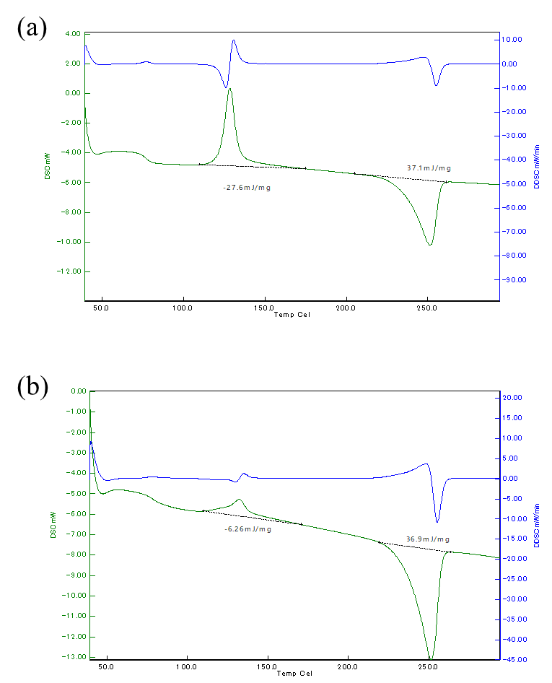

Figure S1 DSC curves for PFs of PET bottles of (a) transparent region before annealing and (b) clouded region after heating at 118ºC.

