**Supplementary Information**

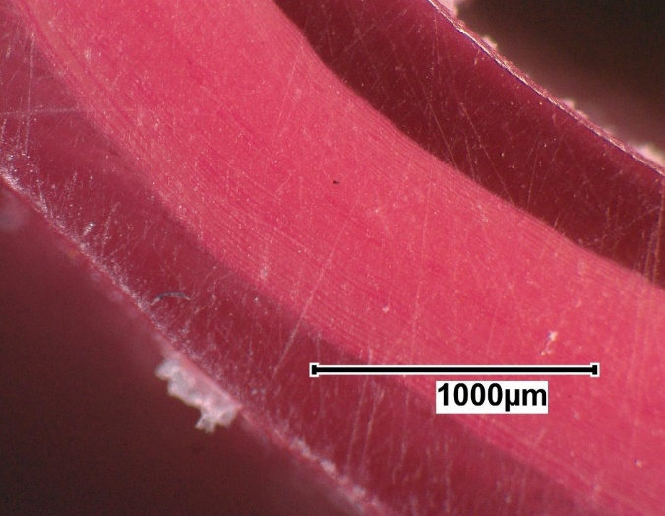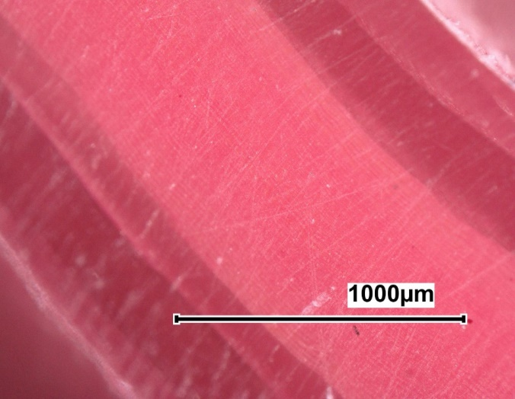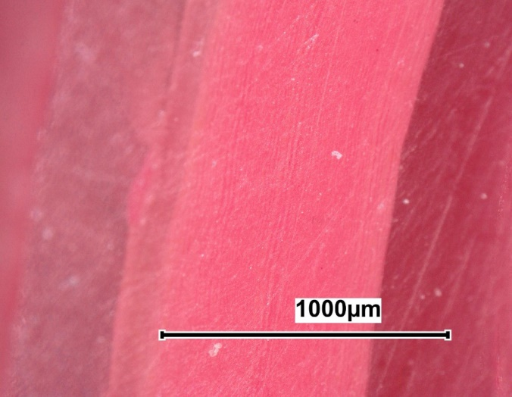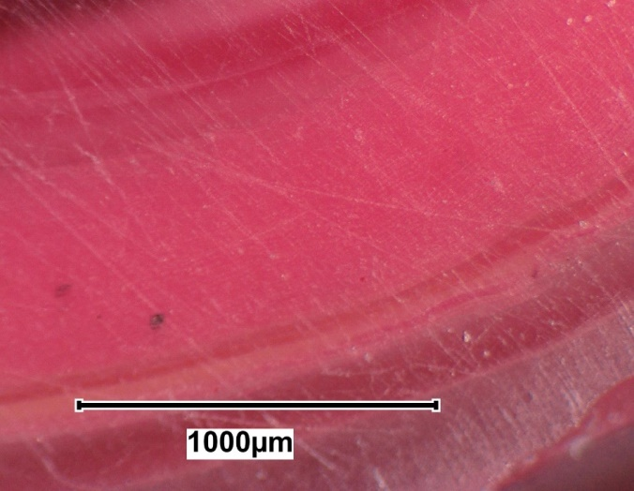

(b)

(c)

(d)

(a)

**Supplementary Figure 1** Pre-heat HVM samples cross sections at different velocity ratios (a) 0.23 (b) 0.57 (c) 0.69 (d) 1.15

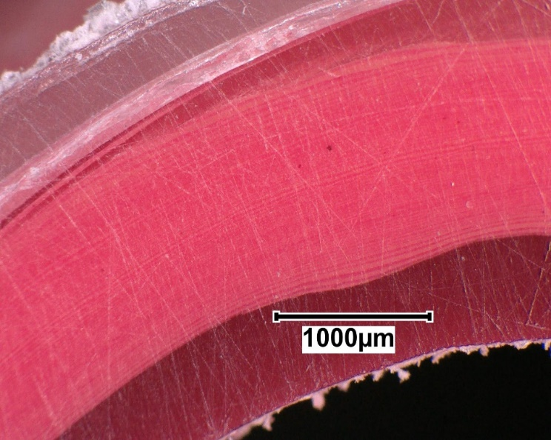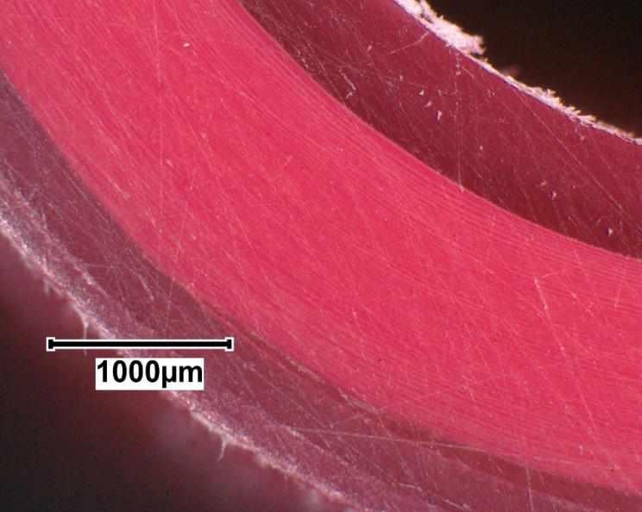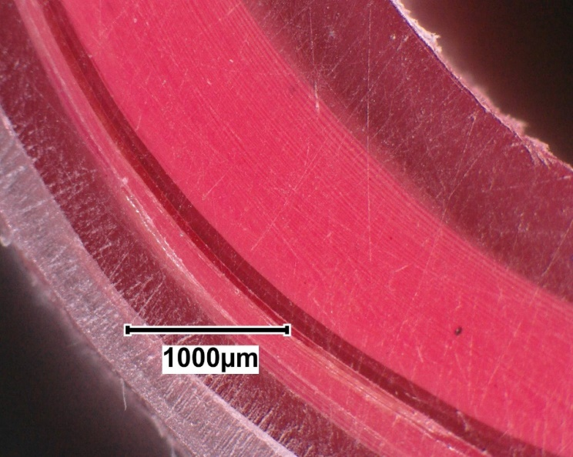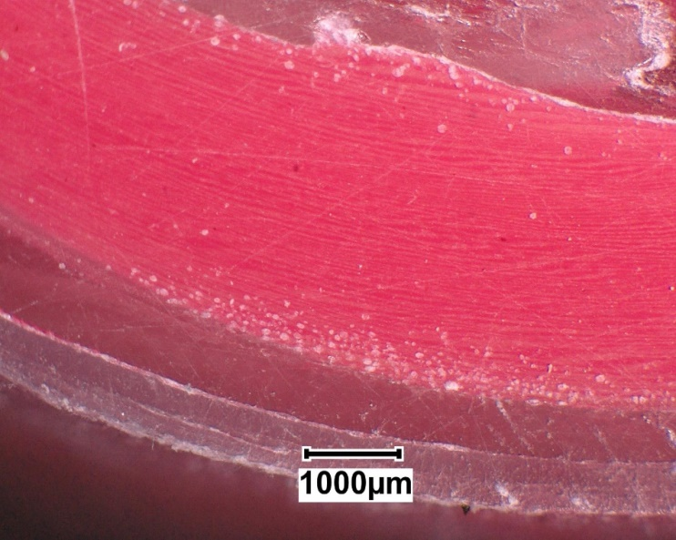

(b)

(c)

(d)

(a)

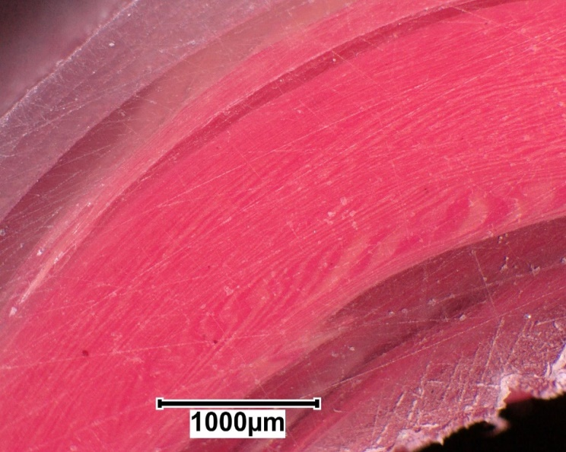

(e)

**Supplementary Figure 2** Pre-heat LVM samples cross sections at different velocity ratios (a) 0.35 (b) 0.46 (c) 0.57 (d) 0.69 (e) 1.15

**Supplementary Figure 3** Post-heat HVM samples cross sections at different velocity ratios (a) 0.23 (b) 0.57 (c) 0.69 (d) 1.15

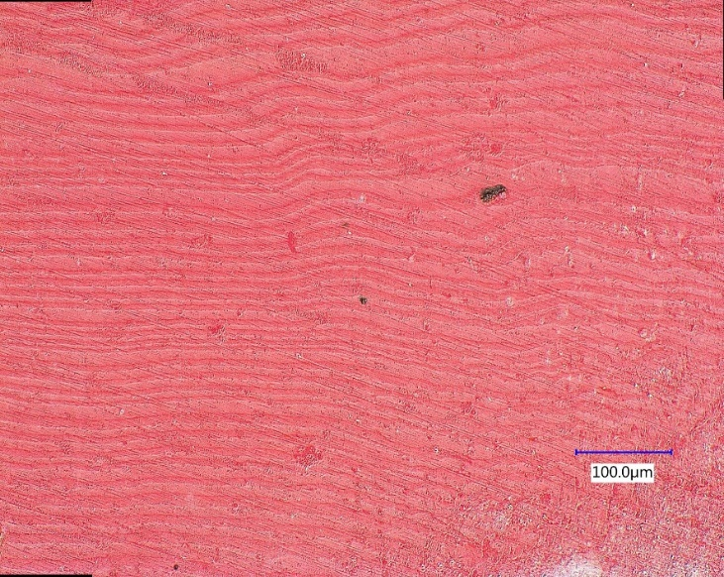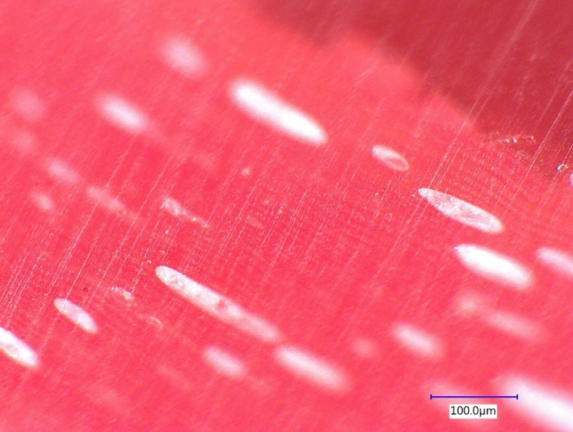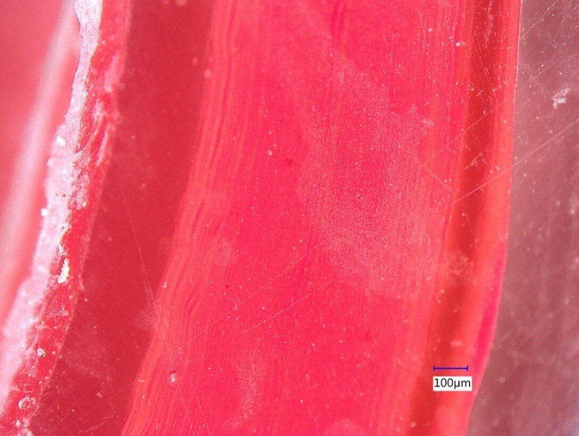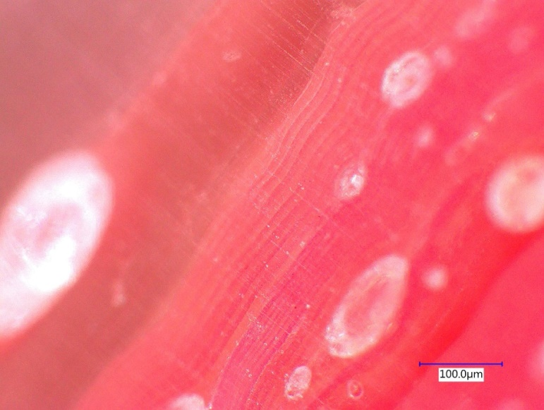

(b)

(c)

(d)

(a)

**Supplementary Figure 4** Post-heat LVM samples cross sections at different velocity ratios (a) 0.35 (b) 0.46 (c) 0.57 (d) 0.69 (e) 1.15

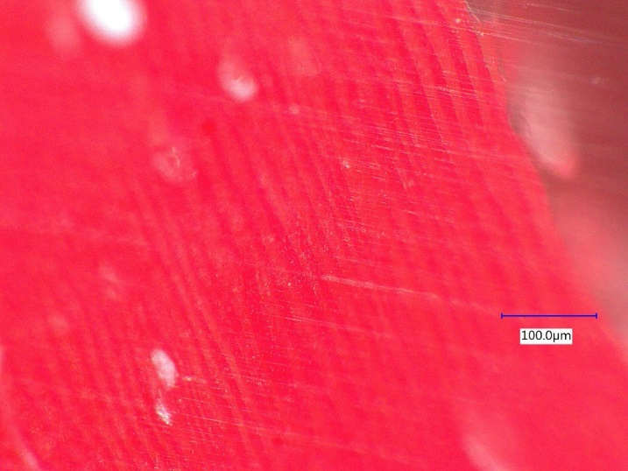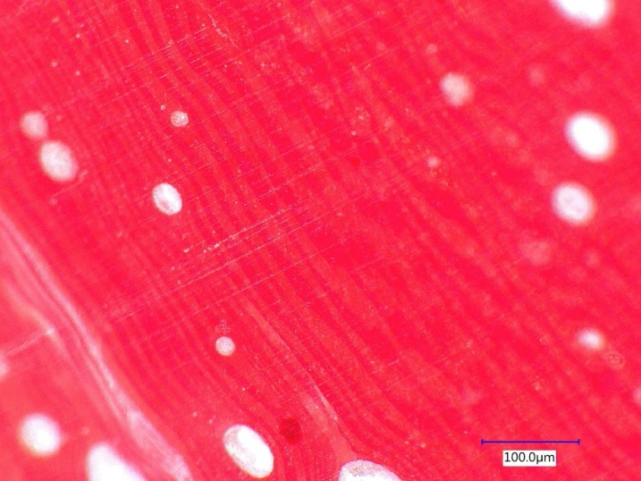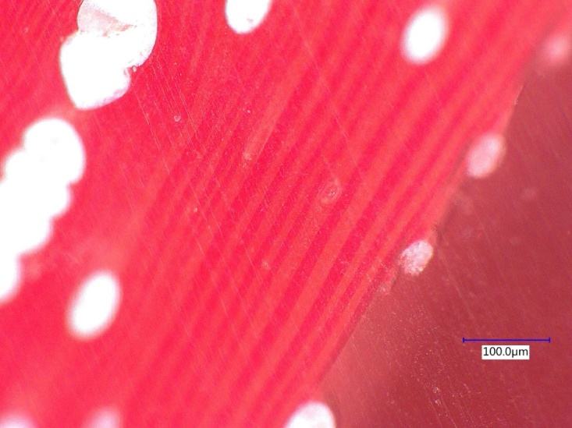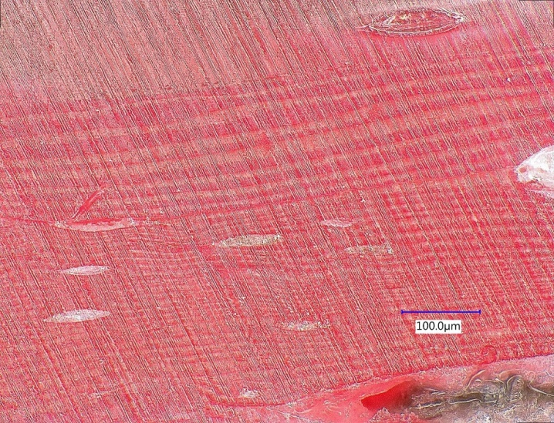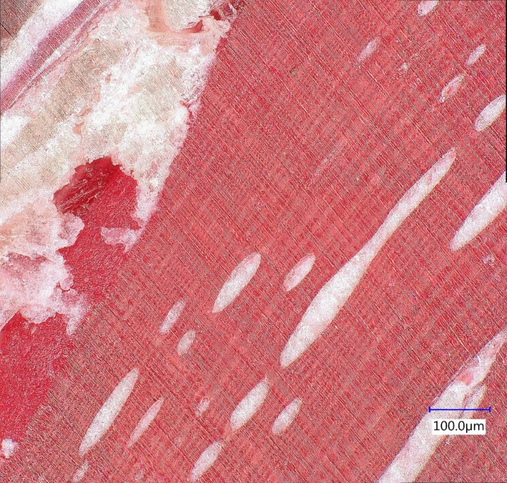

(b)

(c)

(d)

(a)

(e)

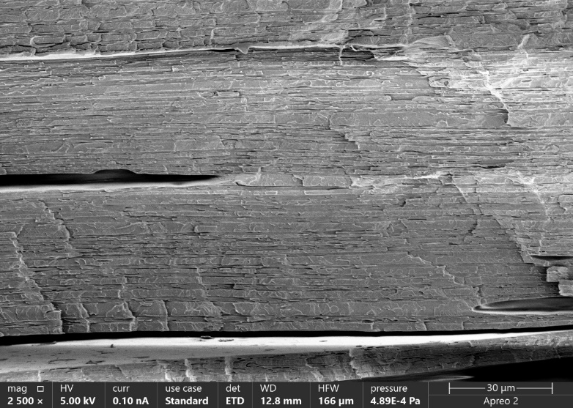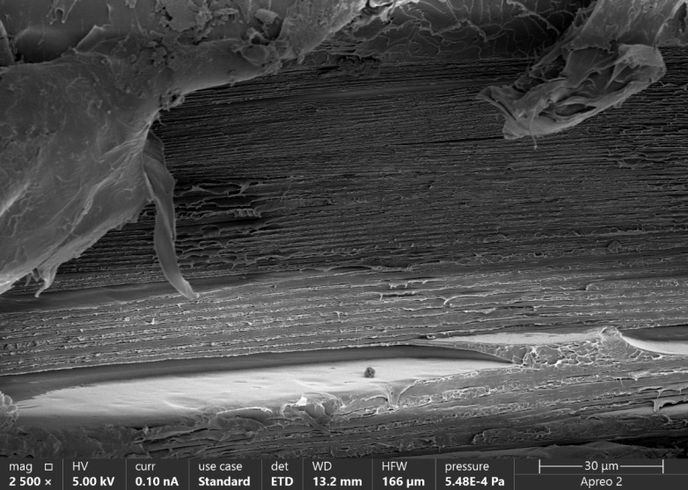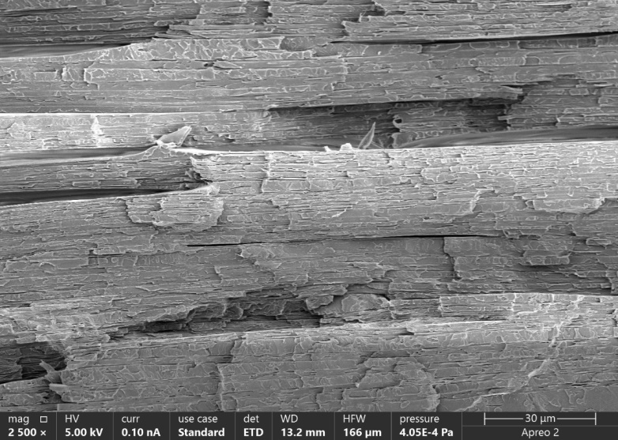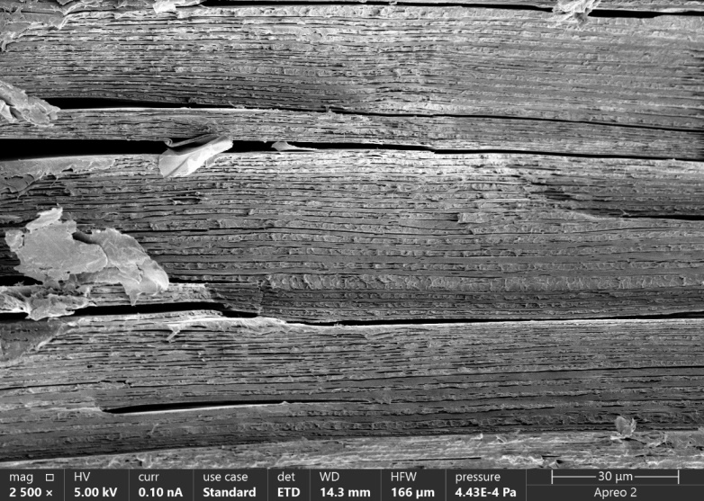

(b)

(c)

(d)

(a)

**Supplementary Figure 5** Blown HVM samples cross sections at different velocity ratios (a) 0.23 (b) 0.57 (c) 0.69 (d) 1.15

**Supplementary Figure 6** Blown LVM samples cross sections at different velocity ratios (a) 0.35 (b) 0.46 (c) 0.57 (d) 0.69 (e) 1.15

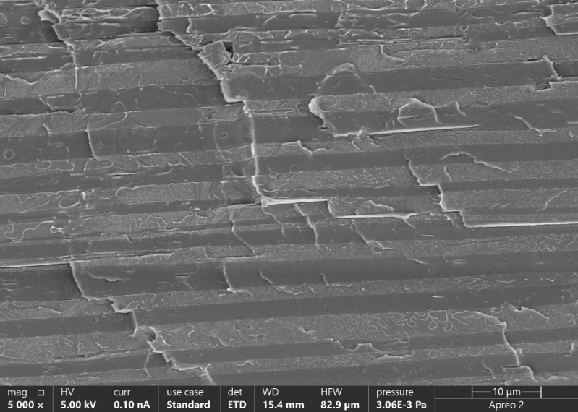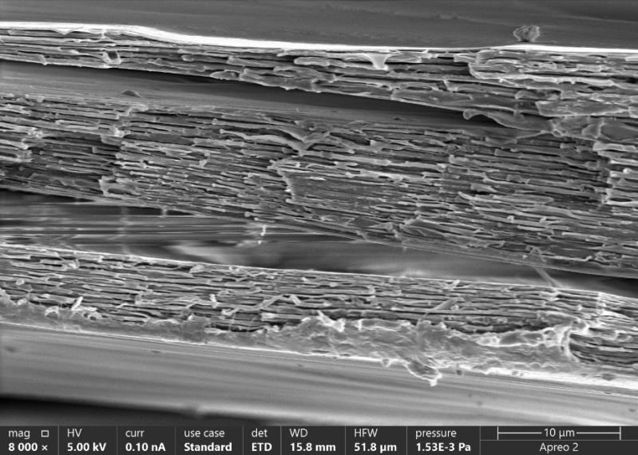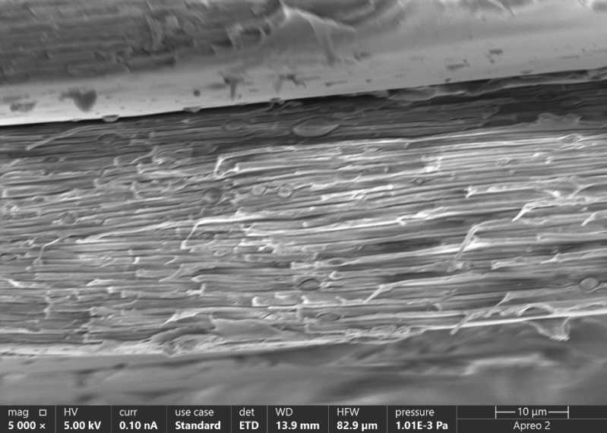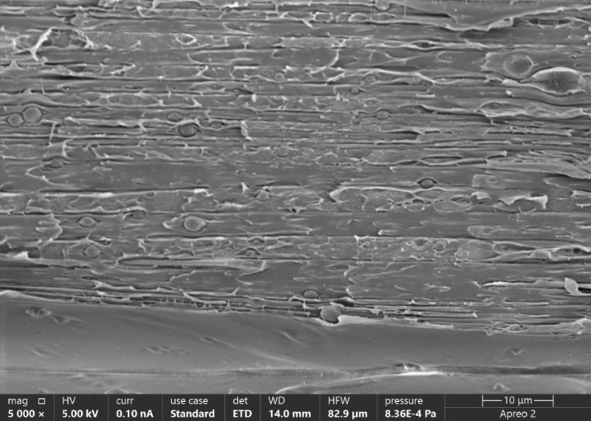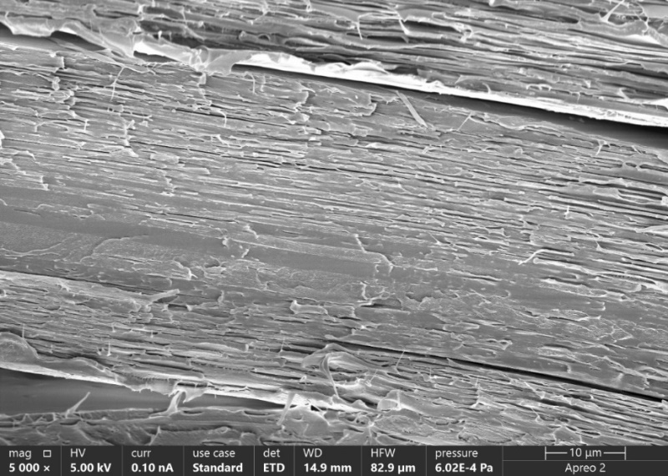

(b)

(c)

(d)

(a)

(e)

|  |  |
| --- | --- |
| HVM Samples | |
| Close-up of a pink object with red arrows  Description automatically generatedA red line with black text  Description automatically generated with medium confidenceA close-up of a white object  Description automatically generatedA close-up of a red and blue object  Description automatically generatedA close-up of a crystal  Description automatically generated  VR 0.23 | A pink capsule with a clothespin  Description automatically generatedA close-up of a microscope  Description automatically generatedA close-up of a microscope  Description automatically generatedA close-up of a microscope  Description automatically generated  VR 0.69 |
| A close-up of a bone  Description automatically generatedA close-up of a ribbon  Description automatically generatedA close-up of a piece of wood  Description automatically generatedA close-up of a long needle  Description automatically generated  VR 0.58 | A close-up of a red and white object  Description automatically generatedA close-up of a red tube  Description automatically generatedA close-up of a tape  Description automatically generatedA close-up of a cell phone screen  Description automatically generatedA close-up of a red object  Description automatically generated  VR 1.15 |

**Supplementary Table 1** Cross-section images of HVM system at different velocity ratios used for wall thickness measurements

|  |  |
| --- | --- |
| LVM Samples | |
| A close-up of a microscope  Description automatically generatedA red ribbon on a white surface  Description automatically generatedA close-up of a long thin red and white object  Description automatically generatedA close-up of a bone  Description automatically generatedA close-up of a red and white object  Description automatically generated  VR 0.35 | A red object with white text  Description automatically generated with medium confidenceA close-up of a red object  Description automatically generatedClose-up of a red object  Description automatically generatedA close-up of a red and black background  Description automatically generatedA pink balloon with a piece of paper  Description automatically generated  VR 0.46 |
| A close-up of some plastic  Description automatically generatedA close-up of a musical instrument  Description automatically generatedA close-up of a cell phone screen  Description automatically generatedA red wall with arrows pointing to the side  Description automatically generatedA close-up of a cell phone screen  Description automatically generated  VR 0.58 | Close-up of a red vein  Description automatically generatedA broken egg shell with writing on it  Description automatically generatedA close-up of a red and black background  Description automatically generatedA close-up of a human body  Description automatically generated  VR 0.69 |
| A red plastic bag with a circle  Description automatically generatedA close-up of a human arm  Description automatically generatedA close-up of a thin red line  Description automatically generatedA close-up of a long thin red stick  Description automatically generatedA close-up of a red and white object  Description automatically generated  VR 1.15 | |

**Supplementary Table 2** Cross-section images of LVM system at different velocity ratios used for wall thickness measurements