Supplementary Material
Table S1. Parameters of DSC curves
Sample | β/(℃*min⁻¹) | T_{i}/(℃) | T_{p}/(℃) | T_{f}/(℃) | ΔH/(J*g⁻¹)
KB | 5 | 112.64 | 149.92 | 185.76 | 26.08
KB | 10 | 117.84 | 158.50 | 195.03 | 45.36
KB | 15 | 120.78 | 164.75 | 203.21 | 58.24
KB | 20 | 124.86 | 169.00 | 210.10 | 91.93
KB | 25 | 127.43 | 174.17 | 213.49 | 99.34
CB/EVM | 5 | 120.50 | 155.75 | 193.42 | 21.13
CB/EVM | 10 | 129.83 | 164.00 | 203.83 | 35.67
CB/EVM | 15 | 134.50 | 168.75 | 207.25 | 51.57
CB/EVM | 20 | 137.67 | 174.67 | 214.00 | 53.49
CB/EVM | 25 | 142.92 | 176.67 | 220.00 | 86.18
SiO₂/EVM | 5 | 109.69 | 148.00 | 197.19 | 20.33
SiO₂/EVM | 10 | 123.20 | 157.17 | 206.59 | 32.75
SiO₂/EVM | 15 | 125.63 | 162.25 | 212.44 | 45.57
SiO₂/EVM | 20 | 127.32 | 166.67 | 216.82 | 78.70
SiO₂/EVM | 25 | 131.04 | 171.25 | 226.85 | 93.02
Mg(OH)₂/EVM | 5 | 109.69 | 148.00 | 197.19 | 19.43
Mg(OH)₂/EVM | 10 | 116.92 | 156.83 | 205.16 | 38.72
Mg(OH)₂/EVM | 15 | 129.79 | 163.25 | 210.45 | 50.02
Mg(OH)₂/EVM | 20 | 131.43 | 167.00 | 215.08 | 83.56
Mg(OH)₂/EVM | 25 | 133.51 | 170.42 | 225.30 | 84.95
Al(OH)₃/EVM | 5 | 109.17 | 150.25 | 186.23 | 22.26
Al(OH)₃/EVM | 10 | 112.64 | 157.83 | 198.71 | 44.99
Al(OH)₃/EVM | 15 | 121.82 | 164.25 | 207.11 | 66.72
Al(OH)₃/EVM | 20 | 128.54 | 168.33 | 211.71 | 81.73
Al(OH)₃/EVM | 25 | 130.07 | 173.33 | 215.86 | 101.81

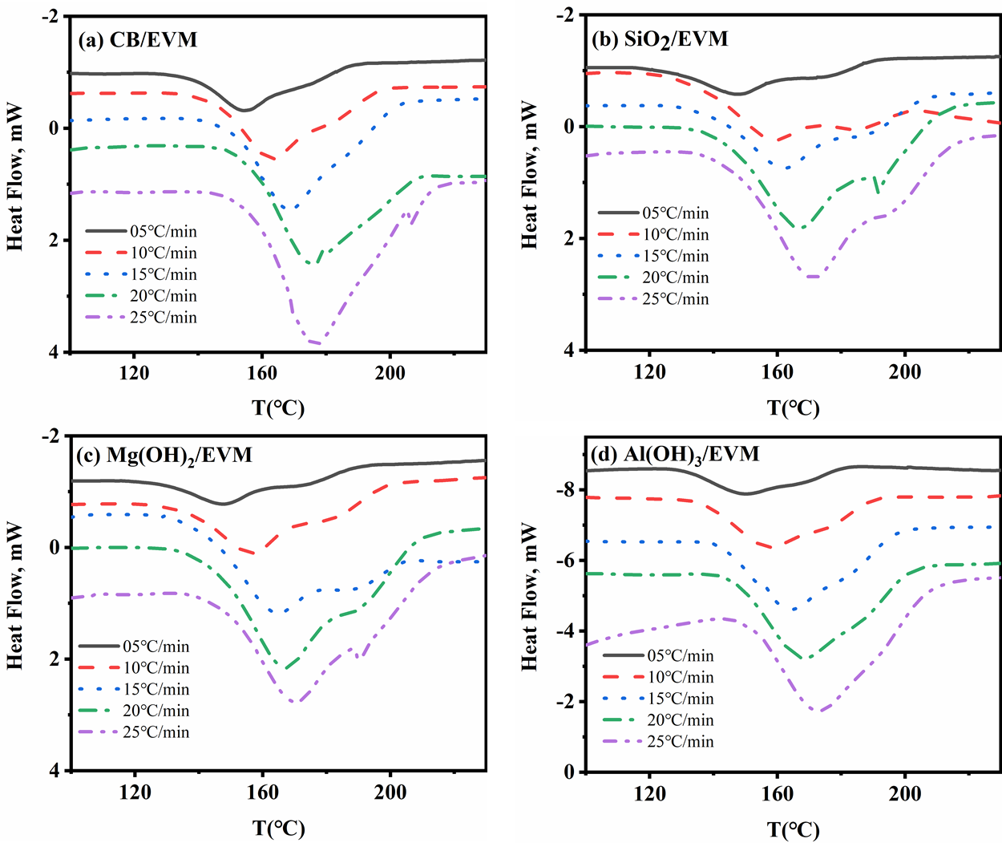
Figure S3. DSC curves of EVM composites with different β.
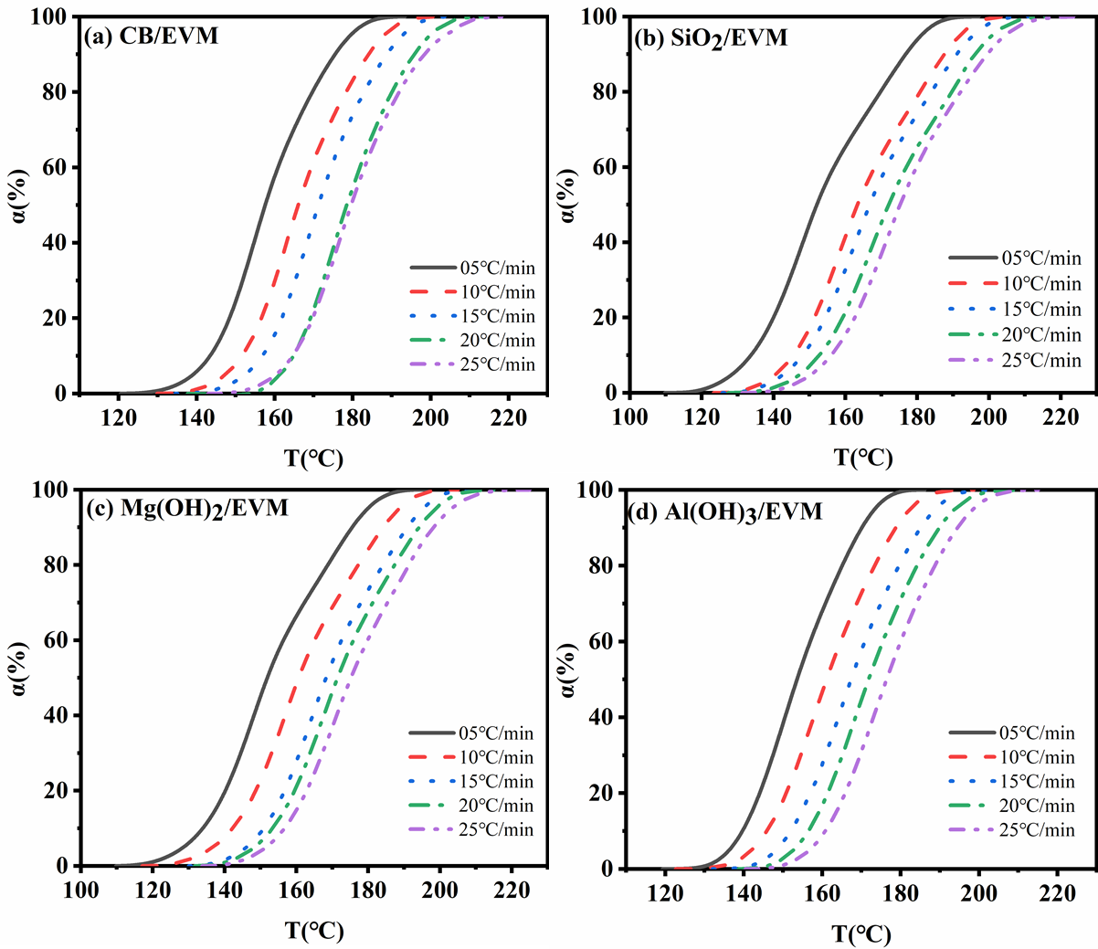
Figure S5. α-T curves of EVM composites with different β.

