**Separate file for figures – Figure 8 (Supplementary Material)**

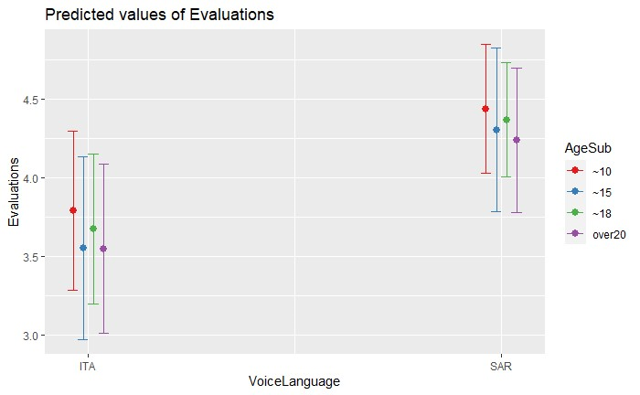

**Figure 8.** Effect of the interaction between subjects’ age (*AgeSub*) and language of the voices (*VoiceLanguage*).