**(LH):** 1.080g, (83%). m.p. 188–190°C: *Anal*. Calc. for C14H10N2OS (254.31 g mol-1): C, 66.12; H, 3.96; N, 11.02; S, 12.61. Found: C, 65.82; H, 3.66; N, 10.60; S, 12.28%.; IR (KBr): 3236 (NH), 1670 (C=O), 1596 (C=CAromatic), 1554 (C=N), 1444, 1296, 1271, 742 cm−1 (Figure S1); 1H NMR (400MHz, DMSO-d6, δ(ppm): 12.87 (1*H*, s, NH); 8.17 (2*H*, d, J=7.49 Hz, *H*-5); 8.05 (1*H*, d, J=7.36 Hz, *H*-1); 7.82 (1*H*, d, J=7.51 Hz, *H*-4); 7.68 (1*H*, t, J=7.45 Hz, *H*-7); 7.59 (2*H*, t, J=7.17 Hz, *H*-6); 7.49 (1*H*, t, J=7.64 Hz, *H*-3); 7.34 (1*H*, t, J=7.50 Hz, *H*-2), (Figure S2); 13C NMR (400 MHz, DMSO-*d*6), δ(ppm): 161.20 (*C*=O); 153.04 (*C*=N); 152.35 (*C*-N); 133.14 (*C*-CO); 131.39 (*C*-S); 130.33 (Ar-*C*H); 129.09 (Ar-*C*H); 128.47 (Ar-*C*H); 128.28 (Ar-*C*H); 126.12 (Ar-*C*H); 123.78 (Ar-*C*H); 119.47 (Ar-*C*H), (Figure S3).



Figure S1: FTIR of LH

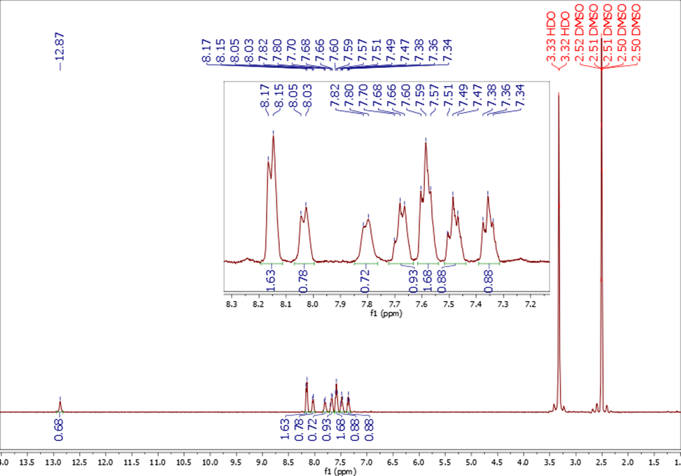

Figure S2: 1HNMR of LH

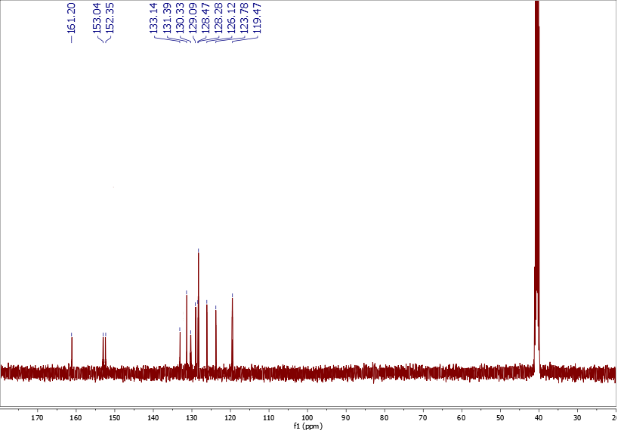

Figure S3: 13CNMR of LH

***[Pd(LH)(2amp)2]Cl2 (1)*** 0.9413g, (71%). m.p. 270–272°C: *Anal*. Calc. for C24H22Cl2PdN6OS (619.86 g mol-1): C, 52.51; H, 4.04; N, 15.31; S, 5.84, Found: C, 52.12; H, 3.53; N, 14.86; S, 5.54%.; IR (KBr): 3286 (NH), 3415 (NH2), 1641 (C=O), 1596 (C=CAromatic), 1554 (C=N), 1498 (C=N amine), 1434, 1280, 1226, 744 cm−1, (Figure S4). 1H NMR (400MHz, DMSO-d6, δ(ppm): 12.83 (1*H*, s, NH); 8.32 (2*H*, d, J=7.57 Hz, *H*-C6 2amp); 8.17 (2*H*, d, J=7.28 Hz, *H*-5); 8.03 (1*H*, d, J=7.60 Hz, *H*-1); 7.81 (1*H*, d, J=7.88 Hz, *H*-4); 7.67 (2*H*, t, J=11.47 Hz, *H*-C4 2amp); 7.64(1*H*, t, J=7.32 Hz, *H*-7); 7.59 (2*H*, t, J=7.32 Hz, *H*-6); 7.49 (1*H*, t, J=7.56 Hz, *H*-3); 7.49 (2*H*, t, J=7.65 Hz, *H*-C5 2amp); 7.36 (1*H*, t, J=7.54 Hz, *H*-2); 7.24 (1*H*, d, J=7.72 Hz, *H*-C3 2amp); 6.01 (4*H*, s, 2NH2), (Figure S5); 13C NMR (400 MHz, DMSO-*d*6): δ 165.30 (*C*=O); 159.33 (*C*=N); 159.27 (*C2*-2amp); 151.37 (*C*-N); 149.47 (*C*-N); 137.29 (*C4*-2amp); 133.41 (*C*-CO); 131.53 (*C*-S); 128.89 (Ar-*C*H); 128.62 (*C6*-2amp); 125.29 (Ar-*C*H); 125.17 (*C3*-2amp); 121.20 (Ar-*C*H); 119.64 (*C5*-2amp); 114.14 (Ar-*C*H) 114.11 (Ar-*C*H); 109.62 (Ar-*C*H), (Figure S6)*. Λ(ohm-1.cm2.mol-1):71.2.*



Figure S4: FTIR of **[Pd(LH)(4amp)2]Cl2**

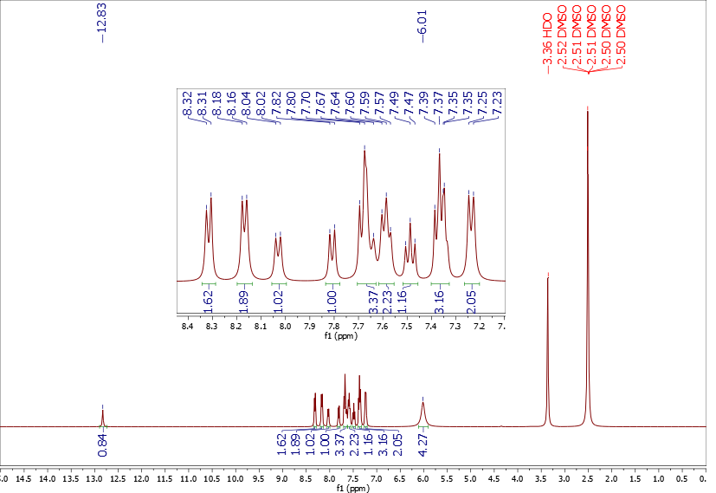

Figure S5: 1HNMR of **[Pd(LH)(4amp)2]Cl2**

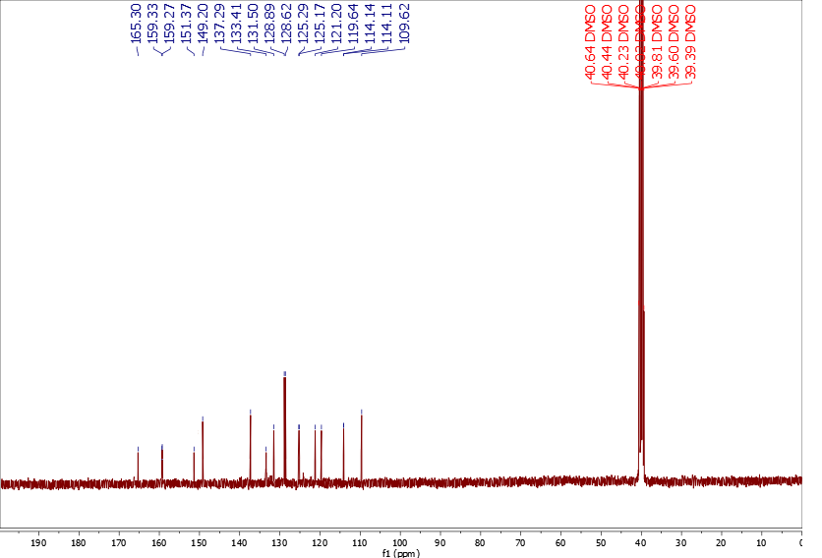

Figure S6: 13CNMR of **[Pd(LH)(4amp)2]Cl2**

***[Pd(LH)(4amp)2]Cl2* *(2)*** 1.198g, (91%). m.p. 285–287°C: Anal. Calc. for C24H22Cl2PdN6OS (619.86 g mol-1): C, 49.96; H, 3.84; N, 14.57; S, 5.56, Found: C, 49.50; H, 3.61; N, 14.37; S, 5.49%.; IR (KBr): 3280 (NH), 3406 (NH2), 1654 (C=O), 1622 (C=CAromatic), 1544 (C=N), 1498 (C=N amine), 1438, 1280, 1230, 742 cm−1, (Figure S7); Λ(ohm-1.cm2.mol-1):72.3. 1H NMR (400MHz, DMSO-d6, δ(ppm): 12.87 (1*H*, s, NH); 8.15 (2*H*, d, J=7.00 Hz, *H*-5); 8.03 (1*H*, d, J=8.14 Hz, *H*-1); 7.80 (1*H*, d, J=97 Hz, *H*-4); 7.68 (2*H*, t, J=7.35 Hz, *H*-7); 7.58 (2*H*, t, J=7.51 Hz, *H*-6); 7.48 (1*H*, t, J=7.66 Hz, *H*-3); 7.35 (1*H*, t, J=6.99 Hz, *H*-2); 6.54 (2*H*, dd, 3J=11.73 Hz, 4J=3.48 Hz, *H*-C1,2 4amp); 6.67 (1*H*, dd, 3J=11.73 Hz, 4J=3.48 Hz, *H*-C1,2 4amp); 5.67 (4*H*, s, 2NH2), (Figure S8); 13C NMR (400 MHz, DMSO-*d*6): δ 165.40 (*C*=O); 159.30 (*C*-N); 155.08 (*C*=N); 151.97 (*C3*-4amp); 149.47 (*C1*-4amp); 149.45 (*C*-N); 133.49 (*C*-CO); 131.28 (*C*-S); 128.87 (Ar-*C*H); 128. 61 (Ar-*C*H); 126.06 (Ar-*C*H); 119.63 (Ar-*C*H) ;114.11 (Ar-*C*H); 110.03 (*C2*-4amp); 109.62 (Ar-*C*H), (Figure S9). Λ(ohm-1.cm2.mol-1):72.3.



Figure S7: FTIR of **[Pd(LH)(2amp)2]Cl2**

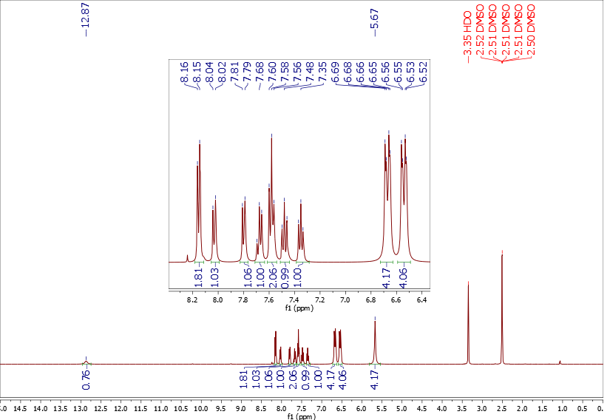

Figure S8: 1HNMR of **[Pd(LH)(2amp)2]Cl2**

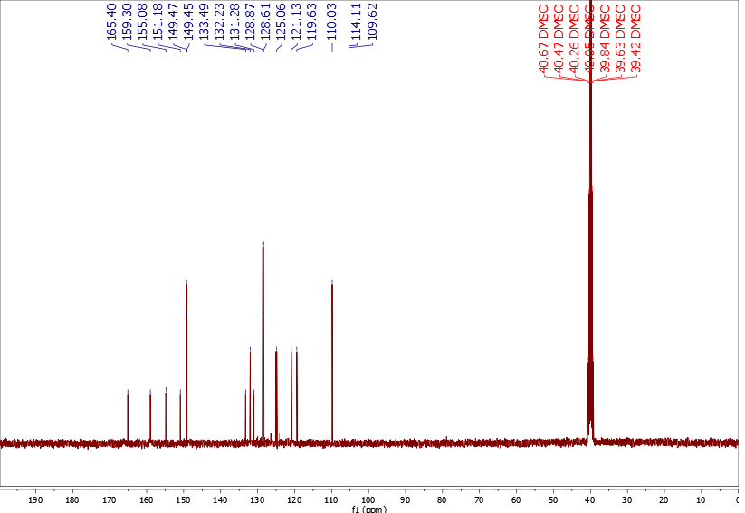

Figure S9: 13CNMR of **[Pd(LH)(2amp)2]Cl2**

***[Pd(LH)(Phen)]Cl2*** *(3)* 1.356g, (93%). m.p. 280–282°C: Anal. Calc. for C26H18Cl2PdN4OS (611.84 g mol-1): C, 56.56; H, 3.80; N, 10.55; S, 6.04, Found: C, 56.14; H, 3.35; N, 10.21; S, 5.66%.; IR (KBr): 3899 (NH), 1649 (C=O), 1575(C=CAromatic), 1421 (C=N), 1512 (C=N amine), 1342, 1215, 838, 709 cm−1 (Figure S10). 1H NMR (400MHz, DMSO-d6, δ(ppm): 12.82(1*H*, s, NH); 9.36 (2*H*, broad s, *H*1-Phen); 9.00 (2*H*, d, J=8.13 Hz, *H*3-Phen); 8.32 (2*H*, s, *H*4-Phen); 8.16 (2*H*, d, J=7.25 Hz, *H*-5); 8.15 (2*H*, m, *H*2-Phen); 8.01 (1*H*, d, J=7.85 Hz, *H*-1); 7.78 (1*H*, d, J=8.04 Hz, *H*-4); 7.68 (1*H*, t, J=7.16 Hz, *H*-7); 7.57 (2*H*, t, J=7.61 Hz, *H*-6); 7.46 (1*H*, t, J=7.61 Hz, *H*-3); 7.35 (1*H*, t, J=7.50 Hz, *H*-2), (Figure S11); 13C NMR (400 MHz, DMSO-*d*6): δ 165.41 (*C*=O); 159.30 (*C*=N); 151.18 (*C*-N); 149.28 (*C*-Phen); 144.97 (*C*-Phen); 135.71 (*C*-Phen); 133.50 (*C*-CO); 132.23 (*C*-S); 131.27 (Ar-*C*H); 128.87 (Ar-*C*H); 128.61 (Ar-*C*H); 126.21 (Ar-*C*H); 125.26 (*C*-Phen); 125.06 (Ar-*C*H); 122.29 (*C*-Phen); 121.13 (Ar-*C*H); 119.63 (*C*-Phen), (Figure S12). Λ(ohm-1.cm2.mol-1):77.2.



Figure S10: FTIR of **[Pd(LH)(Phen)]Cl2**

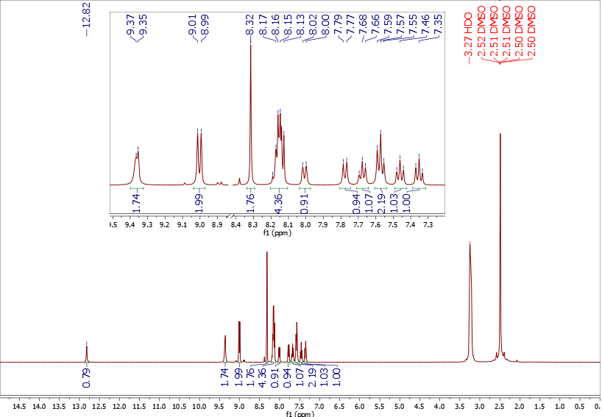

Figure S11: 1HNMR of **[Pd(LH)(Phen)]Cl2**

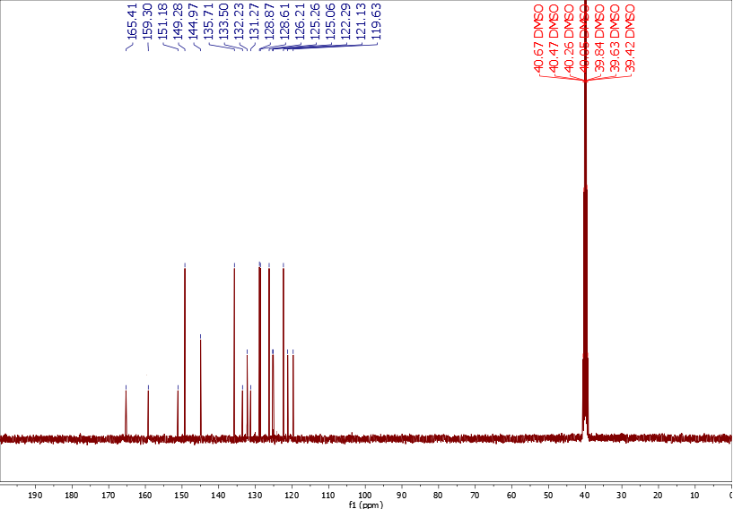Figure S12: 13CNMR of **[Pd(LH)(Phen)]Cl2**

***[Pd(LH)(dppp)]Cl2*** *(4)* 0.957g, (63%). m.p. 298–300°C: Anal. Calc. for C41H36Cl2PdN2OP2S (844.08 g mol-1): C, 63.69; H, 4.69; N, 3.62; S, 4.15, Found: C, 63.25; H, 4.30; N, 3.23; S, 4.05%.; IR (KBr): 3442 (NH), 1660 (C=O), 1600 (C=CAromatic), 1531 (C=N), 1454, 1431, 1251, 1153, 746, 696 cm−1, (Figure S13). 1H NMR (400MHz, DMSO-d6, δ(ppm): 12.89 (1*H*, s, NH); 8.15 (2*H*, d, J=5.29 Hz, *H*-5); 8.04 (1*H*, d, J=7.40 Hz, *H*-1); 7.88 (1*H*, m, J=7.61 Hz, *H*-4); 7.68 (1*H*, m, Hz, *H*-7); 7.59 (2*H*, m, Hz, *H*-6); 7.57 (10*H*, m, *H*-Ar); 7.36 (14*H*, m, *H*-Ar); 2.93 (2*H*, s, 2C*H2*); 1.76 (1*H*, s, C*H2*), (Figure S14). 13P{1H}NMR (400MHz, DMSO-d6, δ(ppm): 25.74, (Figure S15). Λ(ohm-1.cm2.mol-1):77.4.



Figure S13: FTIR of [Pd(LH)(dppp)]Cl2

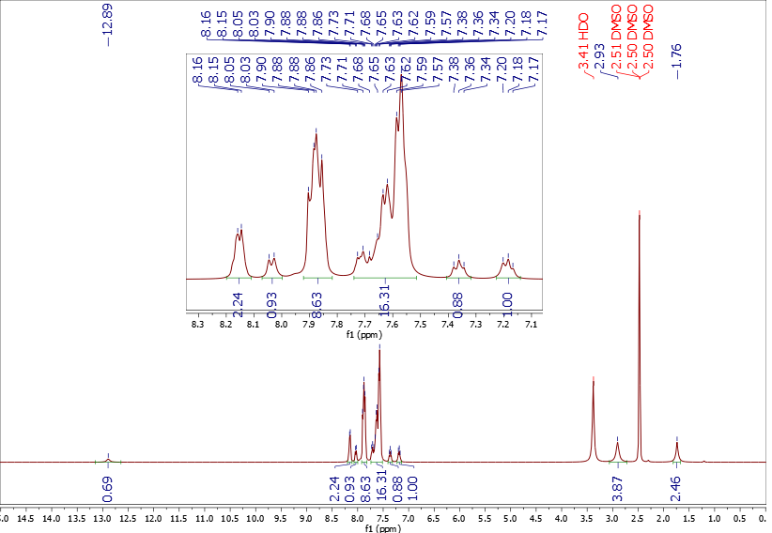

Figure S14: 1HNMR of [Pd(LH)(dppp)]Cl2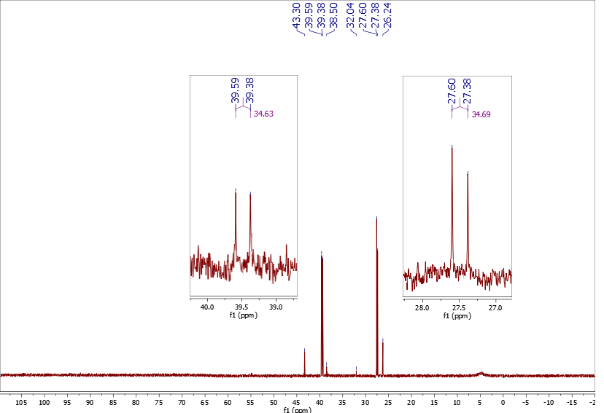

Figure S15: 31PNMR of [Pd(LH)(dppp)]Cl2

***[Pd(LH)(dppb)]Cl2*** *(5)* 1.098g, (72%). m.p. 335–337°C: Anal. Calc. for C42H38Cl2PdN2OP2S (858.11 g mol-1): C, 50.96; H, 3.88; N, 15.59; S, 4.10, Found: C, 49.80; H, 3.24; N, 14.80; S, 4.02%. IR (KBr): 3265 (NH), 1660 (C=O), 1596 (C=CAromatic), 1479 (C=N), 1433 , 1352, 1099, 744, 694 cm−1 (Figure S16). 1H NMR (400MHz, DMSO-d6, δ(ppm): 12.89 (1*H*, s, NH); 8.15 (2*H*, d, J=8.26 Hz, *H*-5); 8.03 (1*H*, d, J=7.86 Hz, *H*-1); 7.81 (10*H*, m, *H*-Ar); 7.76 (14*H*, m, *H*-Ar); 7.65 (1*H*, m, J=7.61 Hz, *H*-4); 7.58 (2*H*, m, Hz, *H*-6); 7.55 (1*H*, m, Hz, *H*-7); 7.48(1*H*, t, J=7.43 Hz, *H*-3); 7.35 (1*H*, t, J=7.57 Hz, *H*-2); 3.05 (2*H*, s, C*H2*); 1.87 (2*H*, s, C*H2*), (Figure S17). 13P{1H}NMR (400MHz, DMSO-d6, δ(ppm): 39.69, (Figure S18).Λ(ohm-1.cm2.mol-1):74.3.



Figure S16: FTIR of [Pd(LH)(dppb)]Cl2

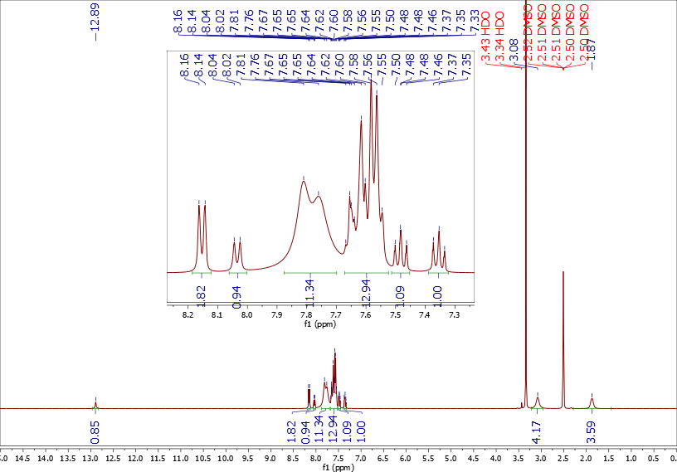

Figure S17: 1HNMR of [Pd(LH)(dppb)]Cl2

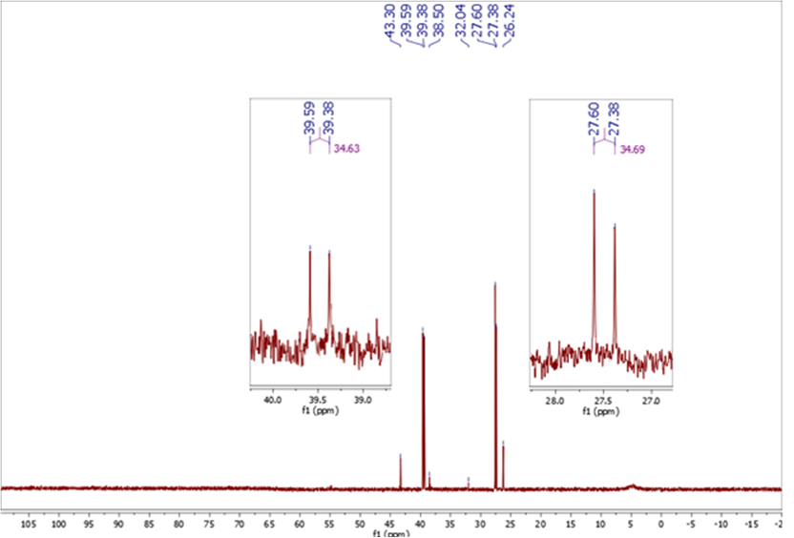

Figure S18: 31PNMR of [Pd(LH)(dppb)]Cl2

***[Pd(LH)(PPh3)Cl]Cl* *(6)*** 1.173g, (83%). m.p. 290–272°C: Anal. Calc. for C32H25Cl2PdN2OP2S (693.92 g mol-1): C, 61.32; H, 4.84; N, 17.28; S, 6.73, Found: C, 59.50; H, 4.12; N, 17.36; S, 6.19%.; IR (KBr): 3255 (NH), 1662 (C=O), 1585 (C=CAromatic), 1521 (C=N), 1438, 1340, 1014, 750, 690 cm−1, (Figure S19). 1H NMR (400MHz, DMSO-d6, δ(ppm): 12.88 (1*H*, s, NH); 8.15 (2*H*, d, J=7.35 Hz, *H*-5); 8.03 (1*H*, d, J=8.17 Hz, *H*-1); 7.62 (18*H*, m, *H*-Ar); 7.80 (1*H*, m, J=7.51 Hz, *H*-4); 7.60 (2*H*, m, Hz, *H*-6); 7.56 (1*H*, m, Hz, *H*-7); 7.48(1*H*, t, J=7.62 Hz, *H*-3); 7.35 (1*H*, t, J=7.49 Hz, *H*-2), (Figure S20). 13P{1H}NMR (400MHz, DMSO-d6, δ(ppm): 23.78, 25.5, (Figure S21). Λ(ohm-1.cm2.mol-1):33.4.



Figure S19: FTIR of [Pd(LH)(PPh3)Cl]Cl

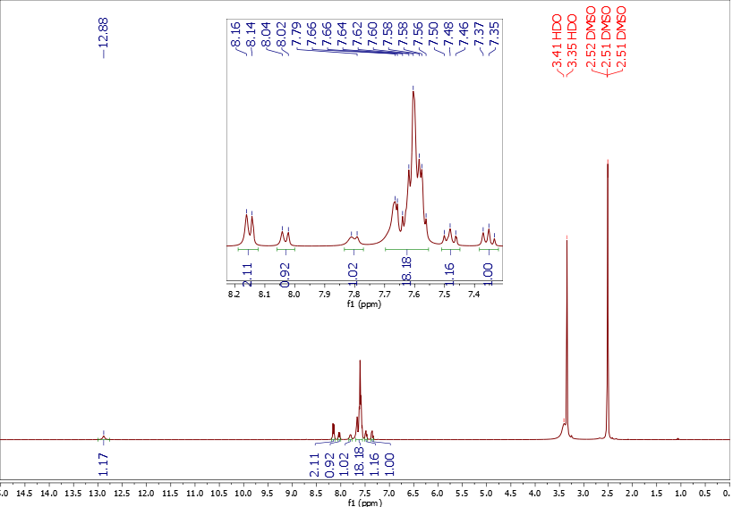

Figure S20: 1HNMR of [Pd(LH)(PPh3)Cl]Cl

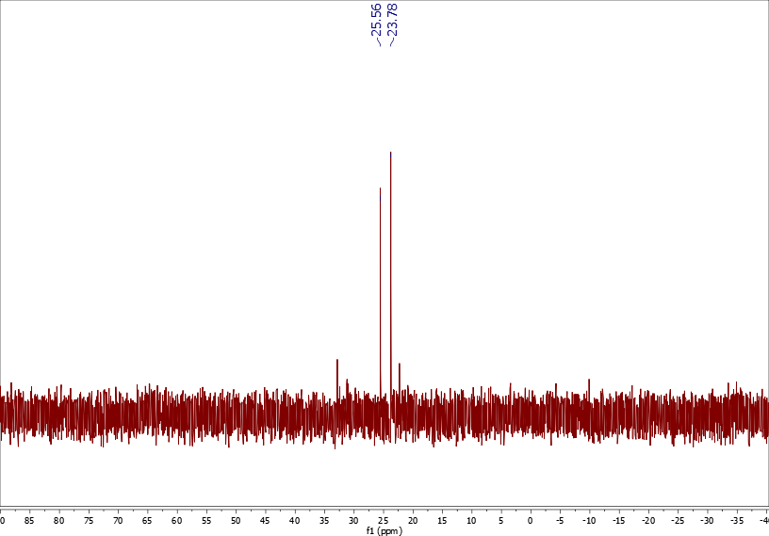

Figure S21: 31PNMR of [Pd(LH)(PPh3)Cl]Cl