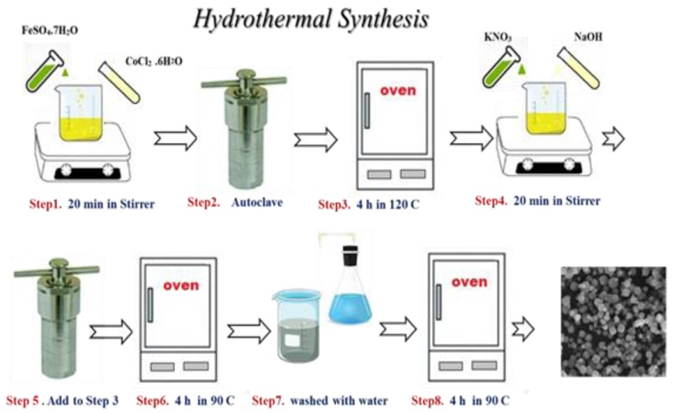
Fig. s1-1. The preparation of the CF flowchart with hydrothermal synthesis method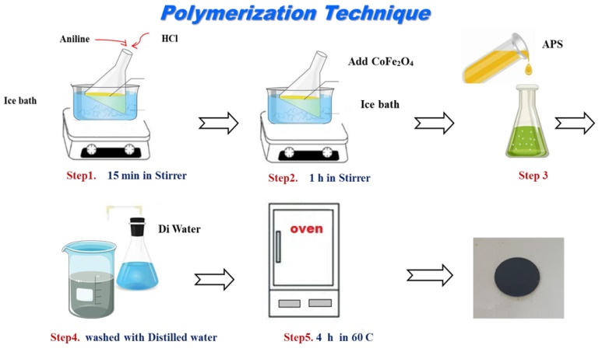
Fig. s1-2. The preparation of the CF/ PANI flowchart with polymerization technique
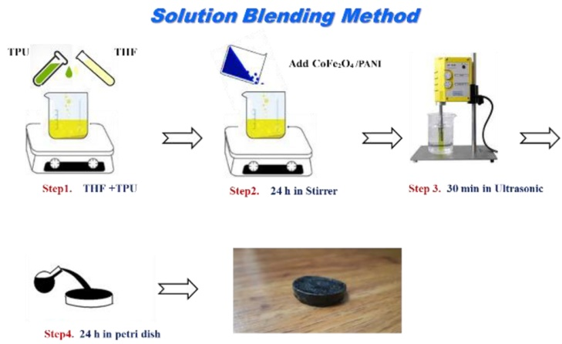
Fig. s1-3. The preparation of the CF/ PANI/ TPU flowchart with solution belending method
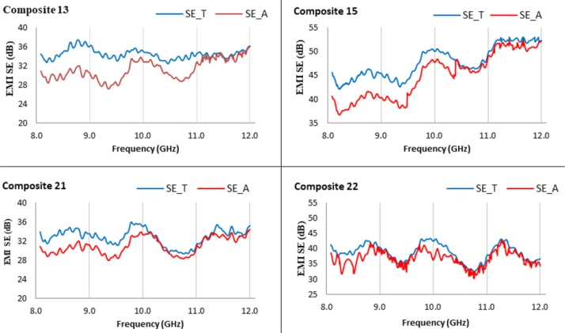
Fig. s2. The relationship between SET and SEA in the X-band
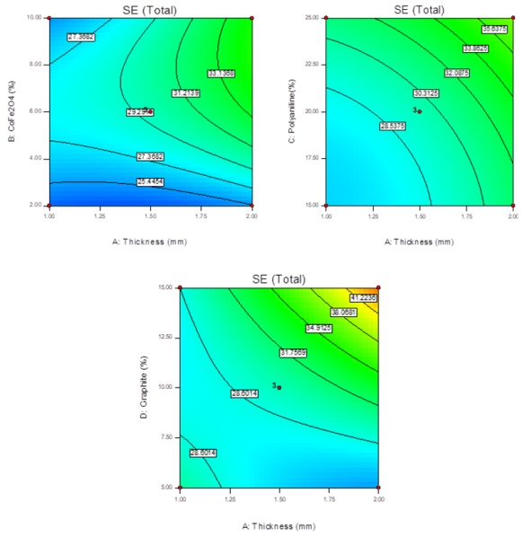
Fig s.3. Response surface plot of interacting effects of CF, PANI, and graphite on SET

