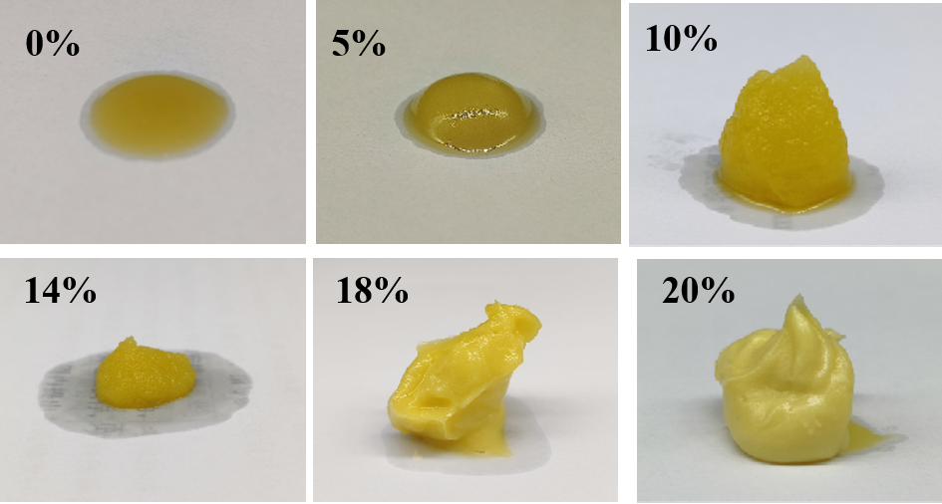
Figure S1: Visual appearance of suspension prepared via OPD using various water phase contents at the particle concentration of 30%.

