Supplementary Data
Identification and quantification of phenolics in karonda using HPLC
Suppl. Fig 1. and Suppl. Table 1 provide information on various phenolic compounds analyzed using high-performance liquid chromatography (HPLC). The compounds include Gallic Acid + 4 Amino Benzoic Acid, (+) Catechin Hydrate, Caffeic Acid, Vanillic Acid, 3 Hydroxy Benzoic Acid, 2-3 Dihydroxybenzoic Acid, Syringic Acid, p-Coumeric Acid, Rutin, Trans Ferulic Acid, Chlorogenic Acid, Quercetin, Kaempferol, and Sinapic Acid. Retention times were determined, representing the time taken for each compound to travel through the chromatography column. Sinapic Acid exhibited the highest retention time (28.397), while Gallic Acid + 4 Amino Benzoic Acid had the lowest retention time (3.900).The study also calculated standard concentrations in parts per million (ppm) for each compound, indicating their concentration in the analyzed sample. The highest standard concentration was found for 3 Hydroxy Benzoic Acid (10040 ppm), while the lowest was for Kaempferol (100 ppm). These concentrations are crucial for quantification, assessing the relative abundance of different compounds in the sample.
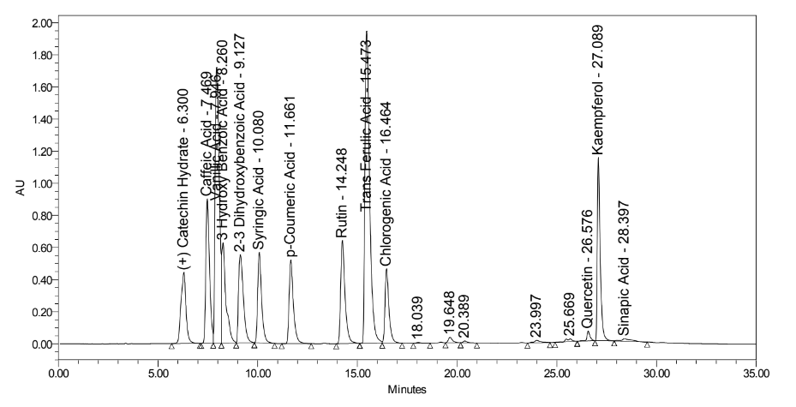
Suppl. Fig 1. HPLC chromatogram of a mixture of polyphenolic standard compounds

Suppl. Table 1. Retention time and content of polyphenolic standards run on HPLC
Phenolic compounds | Molecular weight (g/mol) | Retention Time (RT) | Std concentration (ppm)
Gallic Acid+ 4 Amino Benzoic Acid | 170.12 137.138 g·mol−1 | 3.900 | 852.4
(+) Catechin Hydrate | 308.28 | 6.300 | 2299
Caffeic Acid | 180.16 | 7.469 | 401
Vanillic Acid | 168.15 | 7.946 | 220
3 Hydroxy Benzoic Acid | 138.12 | 8.260 | 10040
2-3 Dihydroxybenzoic Acid | 154.12 | 9.127 | 10022
Syringic Acid | 198.174 | 10.080 | 528
p-Coumeric Acid | 164.16 | 11.661 | 350
Rutin | 610.521 | 14.248 | 2125
Trans Ferulic Acid | 194.18 | 15.473 | 700
Chlorogenic Acid | 354.311 | 16.464 | 1500
Quercetin | 302.236 | 26.576 | 105
Kaempferol | 286.24 | 27.069 | 100
Sinapic acid | 224.21 | 28.397 | 271

Suppl. Table 2 depicts the concentrations of each compound present in karonda powder in parts per million (ppm). The concentration of Gallic Acid+ 4 Amino Benzoic Acid, (+) Catechin Hydrate, Caffeic Acid, Vanillic Acid, 3 Hydroxy Benzoic Acid, 2-3 Dihydroxybenzoic Acid, Syringic Acid, p-Coumeric Acid, Rutin, Trans Ferulic Acid, Chlorogenic Acid, Quercetin, Kaempferol, Sinapic Acid found in karonda powder was 2.35, 2.44, 11.57, 19.95, 0.02, 9.13, 0.39, 0.57, 3.47, 0.27, 13.36, 0.00, 0.01, 23.74 ppm respectively. Thus, it was found that sinapicacid was found in highest concentration followed by vanillic caid, chlorogenic acid and caffeic acid. Quercetin was nondetectable in the sample. Azeez et al (2016) conducted a similar study in which they also found that Vanillic acid was present in the highest amount in karonda fruit.

Suppl. Table 2. Identification and quantification of phenolic compounds in karonda using HPLC
S. No. | Name | Molecular weight (g/mol) | Retention Time (RT) | Karonda powder concentration (ppm)
1 | Gallic Acid+ 4 Amino Benzoic Acid | 170.12 137.138 g·mol−1 | 3.900 | 2.35
2 | (+) Catechin Hydrate | 308.28 | 6.300 | 2.44
3 | Caffeic Acid | 180.16 | 7.469 | 11.57
4 | Vanillic Acid | 168.15 | 7.946 | 19.95
5 | 3 Hydroxy Benzoic Acid | 138.12 | 8.260 | 0.02
6 | 2-3 Dihydroxybenzoic Acid | 154.12 | 9.127 | 9.13
7 | Syringic Acid | 198.174 | 10.080 | 0.39
8 | p-Coumeric Acid | 164.16 | 11.661 | 0.57
9 | Rutin | 610.521 | 14.248 | 3.47
10 | Trans Ferulic Acid | 194.18 | 15.473 | 0.27
11 | Chlorogenic Acid | 354.311 | 16.464 | 13.36
12 | Quercetin | 302.236 | 26.576 | 0.00
13 | Kaempferol | 286.24 | 27.069 | 0.01
14 | Sinapic acid | 224.21 | 28.397 | 23.74
 | Total phenolic compounds in ppm |  |  | 87.27

