Graphic abstract

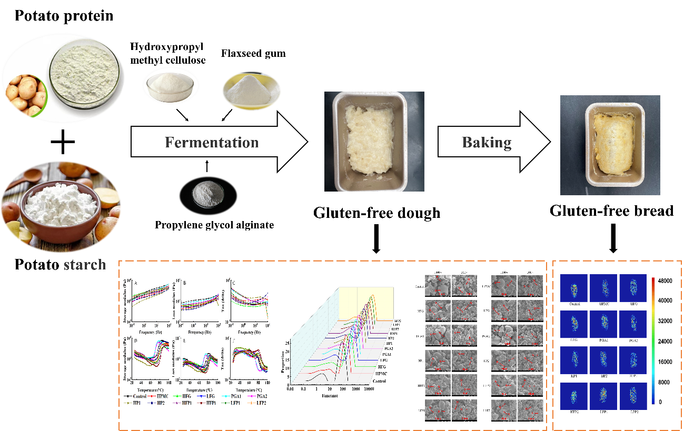

Potato GF dough, which prepared with potato starch and potato protein, adding the binary blends of propylene glycol alginate (PGA), with hydroxypropyl methyl cellulose (HPMC) or flaxseed gum (FG) are investigated from dough characteristic and bread quality.

