Supplementary Materials

Mass transfer intensification and kinetics of o-xylene nitration in the microreactor
Dong Liu, Na Fan, Shulong Li, Lu Ji, Shihao Liu, Tiehan Xing, Xiaodong Liu, Shuai Guo*
Research Institute of Chemical Advanced Materials Shenyang Research Institute of Chemical Industry 8 East Shen Liao Road, Shenyang, 110021, P. R. of China
- Nitro products ¹H NMR S1.
¹H NMR (500 MHz, Chloroform-d) δ 8.05 (s, 1H), 8.00 (d, J = 5.8 Hz, 1H), 7.64 (d, J = 8.1 Hz, 2H), 7.41 (d, J = 7.4 Hz, 1H), 7.31 (d, J = 8.3 Hz, 1H), 7.25 (t, J = 7.8 Hz, 1H), 2.42 (d, J = 3.6 Hz, 6H), 2.41 (s, 6H).
- Experimental setup diagram S2.
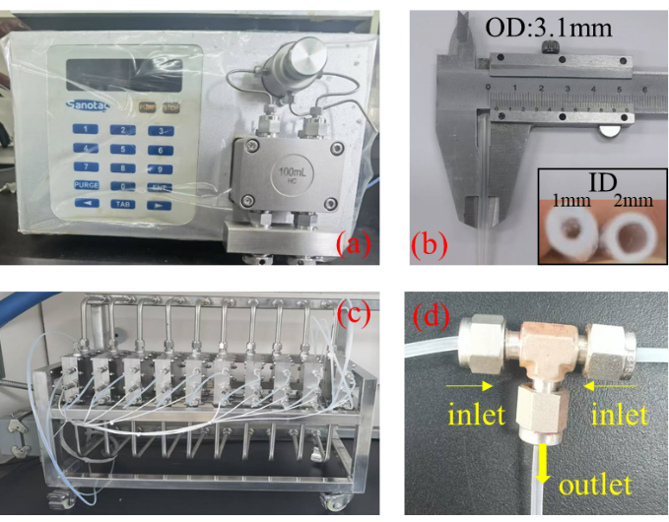
Figure 1 Experimental setup diagram. (a) metering pump (b) capillary tubes (c) microreactor (d) T-mixer
- Table with the lengths of droplets and slugs of Figure 3 S3
Table1. The lengths of droplets and slugs of Figure 3
Flow rate | Q_{H2SO4} (mm) | Qo-xylene (mm)
Q_{H2SO4}=3 mL; Qo-xylene=3 mL | 12 | 13
Q_{H2SO4}=4 mL; Qo-xylene=4 mL | 9 | 11
Q_{H2SO4}=5 mL; Qo-xylene=5 mL | 7 | 8
Q_{H2SO4}=6 mL; Qo-xylene=6 mL | 5 | 6
Q_{H2SO4}=7 mL; Qo-xylene=7 mL | 3 | 4
Q_{H2SO4}=8 mL; Qo-xylene=8 mL | 13 | 2

* Corresponding author at College of Chemical Engineering, Nanjing University of Science and Technology, Nanjing 210094, China. E-mail addresses: guoshuai8@sinochem.com.

