Naphthalene-pyridine Based NNO Schiff Base Ligand for Colorimetric Detection of Fe²⁺, Fe³⁺, and Cu²⁺
Poonam Kaswan*^{1,2}
^{poonamcym@gmail.com}
¹Department of Chemistry, Biochemistry, and Forensic Science, Amity School of Applied Sciences, Amity University Haryana, India, 122413
²Department of Industrial Chemistry, AISSMS’s Institute of Information Technology, Pune, Pin Code 411001, Maharashtra, India

Figure S1. FTIR of2-(1-(pyridin-2-ylmethylimino)ethyl) naphthalen-1-ol (PMNOL)

Figure S2. ¹H NMR of 2-(1-(pyridin-2-ylmethylimino)ethyl)naphthalen-1-ol
Figure S3. ¹³C{¹H}-NMR of 2-(1-(pyridin-2-ylmethylimino)ethyl)naphthalen-1-ol ligand
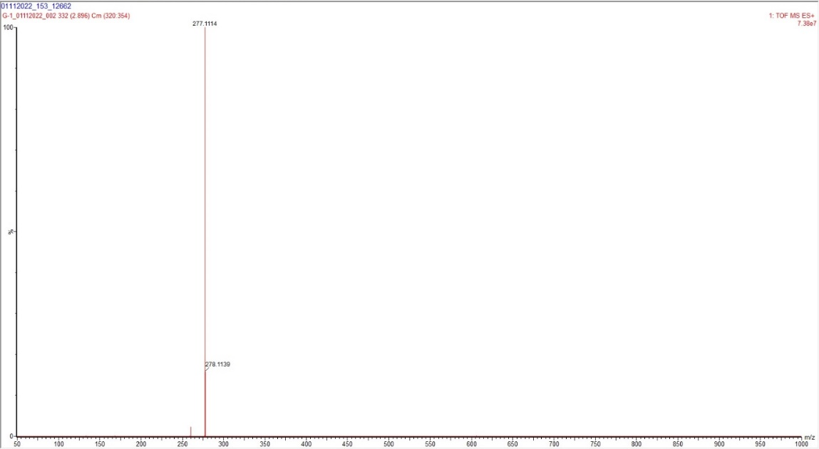
Figure S4. Mass spectra of 2-(1-(pyridin-2-ylmethylimino)ethyl) naphthalene-1-ol (PMNOL)

