Supplementary data
Ferrous and manganese oxalate composite catalyst for efficient heterogenous-Fenton degradation of organic pollutants
Liumi Deng¹, Hao Ren¹, Lu Fu¹, Meng Liao¹, Xiang Zhou¹, Shaohua Chen^{1,*}, Hua Wang^{1**}, Luoxin Wang¹

¹ Key Laboratory for New Textile, Materials and Applications of Hubei Province, College of Materials Science and Engineering, Wuhan Textile University, Wuhan, 430200, China.
E-mail addresses: shaohuachen@foxmail.com, huawangabc@163.com.
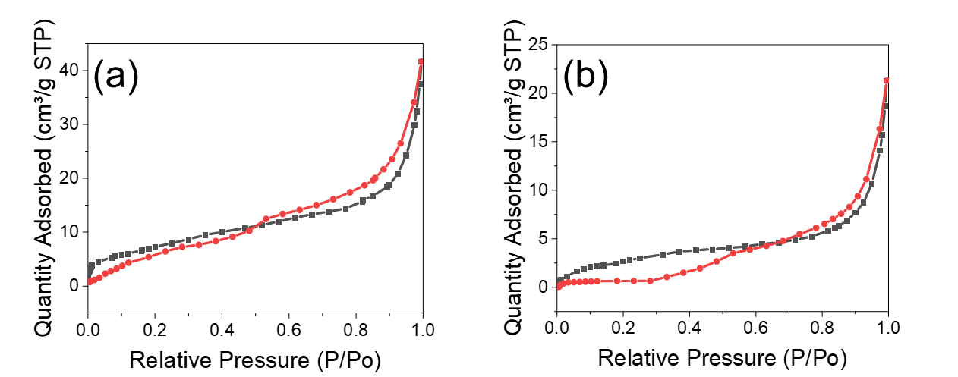
Fig. S1. BET analysis of MnC₂O₄ (a) and 6-1FeMn after 1 cycle (b).
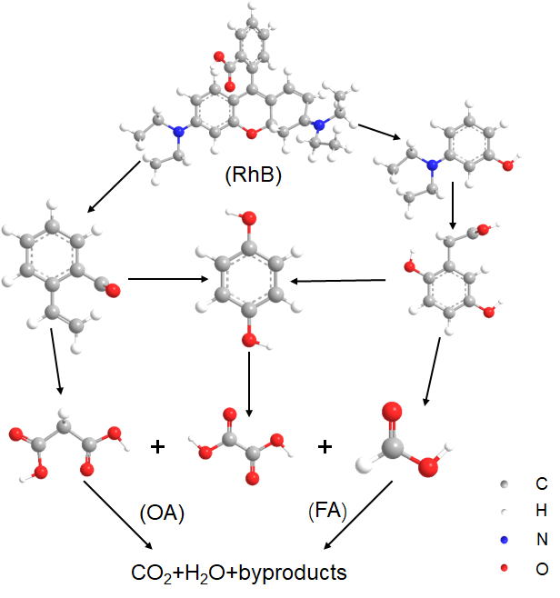
Fig. S2. Schematic diagram of the degradation mechanism of RhB(Diao et al. 2017).

Table S1. Structural parameters of MnC₂O₄, 6-1FeMn, FeC₂O₄.
Samples | S_{BET} (m²/g) | Average Pore Size (nm)
MnC₂O₄ | 50.03 | 9.06
6-1FeMn | 27.47 | 9.38
FeC₂O₄ | 23.63 | 6.86

Table S2. Structural parameters of fresh 6-1FeMn and 6-1FeMn after 1 cycle
Samples | S_{BET} (m²/g) | Average Pore Size (nm)
Fresh 6-1FeMn | 27.47 | 9.38
6-1FeMn after 1 cycle | 10.71 | 12.29

References
Diao, Z.-H., Liu, J.-J., Hu, Y.-X., Kong, L.-J., Jiang, D. & Xu, X.-R. (2017) Comparative study of Rhodamine B degradation by the systems pyrite/H 2 O 2 and pyrite/persulfate: Reactivity, stability, products and mechanism. Separation and Purification Technology, 184, 374-383.

