SUPPLEMENTARY MATERIALS
Table S1: Packed bed parameters for adsorption of MCPA on BFA
C₀  (mg/L) | Q  (mL/min) | Z  (cm) | t_{b}  (min) | t_{s}  (min) | V_{e}  (mL) | q_{b}  (mg/g) | q_{s}  (mg/g) | MTZ  (cm) | FBU | Removal %
50 | 1 | 8.5 | 139.93 | 1050.41 | 1050.41 | 1.34 | 2.86 | 4.52 | 0.47 | 39.56
100 | 1 | 8.5 | 107.15 | 945.46 | 945.46 | 1.84 | 4.10 | 4.69 | 0.45 | 32.56
150 | 1 | 8.5 | 66.88 | 696.27 | 696.27 | 2.13 | 4.92 | 4.82 | 0.43 | 24.07
100 | 1 | 8.5 | 107.15 | 945.46 | 945.46 | 1.84 | 4.10 | 4.69 | 0.45 | 32.56
100 | 2 | 8.5 | 48.96 | 540.36 | 1080.72 | 1.64 | 3.79 | 4.83 | 0.43 | 30.87
100 | 3 | 8.5 | 27.5 | 284.733 | 854.20 | 1.38 | 3.53 | 5.17 | 0.39 | 26.31
100 | 1 | 6.0 | 58.03 | 831.50 | 831.50 | 1.42 | 3.95 | 3.84 | 0.36 | 28.46
100 | 1 | 8.5 | 107.15 | 945.46 | 945.46 | 1.84 | 4.10 | 4.69 | 0.45 | 32.56
100 | 1 | 11.5 | 142.15 | 1212.63 | 1212.63 | 2.00 | 4.86 | 6.77 | 0.41 | 40.74

Table S2 Parameters of packed bed models for adsorption of MCPA on BFA
Experimental condition |  |  | Bohart–Adams model |  |  |  |  | Wolborska model |  |  |  |  | Thomas model
C₀  mg/L | Q  mL/min | Z  cm | K_{AB}  L/(mg min) | N₀  mg/L | t_{b}pred  min | Є | MPSD | β  min⁻¹ | Q_{W}  mg/g | t_{b}pred  min | Є | MPSD | K_{T}  L/(mg min) | q₀  mg/g | t_{b}pred  min | Є | MPSD
50 | 1 | 8.5 | 2.60 × 10⁻⁴ | 1656.59 | 141.11 | -0.84 | 14.47 | 0.454 | 7.80 | 141.11 | -0.84 | 14.47 | 2.64 × 10⁻⁴ | 3.09 | 139.52 | 0.29 | 18.88
100 | 1 | 8.5 | 2.10 ×10⁻⁴ | 2161.57 | 97.97 | 8.57 | 22.21 | 0.431 | 10.18 | 97.97 | 8.57 | 22.21 | 1.81 × 10⁻⁴ | 4.24 | 89.71 | 16.28 | 24.17
150 | 1 | 8.5 | 1.93 × 10⁻⁴ | 2260.14 | 65.32 | 2.33 | 24.79 | 0.437 | 10.64 | 65.32 | 2.33 | 24.79 | 1.60 × 10⁻⁴ | 4.48 | 57.66 | 13.79 | 22.82
100 | 1 | 8.5 | 2.10 × 10⁻⁴ | 2161.57 | 97.97 | 8.57 | 22.21 | 0.431 | 10.18 | 97.97 | 8.57 | 22.21 | 1.81 × 10⁻⁴ | 4.24 | 89.71 | 16.28 | 24.17
100 | 2 | 8.5 | 5.10 × 10⁻⁴ | 1899.34 | 46.07 | 5.91 | 36.37 | 0.969 | 8.94 | 46.07 | 5.91 | 36.37 | 3.73 × 10⁻⁴ | 3.98 | 40.18 | 17.93 | 43.67
100 | 3 | 8.5 | 7.30 × 10⁻⁴ | 1786.31 | 25.65 | 6.73 | 37.08 | 1.304 | 8.41 | 25.65 | 6.73 | 37.08 | 6.01 × 10⁻⁴ | 3.45 | 20.81 | 24.32 | 38.21
100 | 1 | 6.0 | 4.80 × 10⁻⁴ | 1640.86 | 63.28 | -9.05 | 35.13 | 0.788 | 7.73 | 63.28 | -9.05 | 35.13 | 2.93 × 10⁻⁴ | 3.91 | 41.41 | 28.65 | 59.86
100 | 1 | 8.5 | 2.10 × 10⁻⁴ | 2161.57 | 97.97 | 8.57 | 22.21 | 0.454 | 10.18 | 97.97 | 8.57 | 22.21 | 1.81 × 10⁻⁴ | 4.24 | 89.71 | 16.28 | 24.17
100 | 1 | 11.5 | 1.60 × 10⁻⁴ | 2247.50 | 148.15 | -4.22 | 24.02 | 0.360 | 10.58 | 148.15 | -4.22 | 24.02 | 1.30 × 10⁻⁴ | 4.76 | 163.91 | -15.31 | 32.97
Experimental condition |  |  | Clark model |  |  |  |  | Yoon–Nelson model |  |  |  |  | Deactivation Kinetic model
C₀  mg/L | Q  mL/min | Z  cm | A | r  min⁻¹ | t_{b} pred  min | Є | MPSD | K_{YN}  min⁻¹ | t_{0.5} expt  min | t_{0.5} pred  min | Є | MPSD | k₀  mL/(g min) | k_{d}  min⁻¹ | t_{b} pred  min | Є | MPSD
50 | 1 | 8.5 | 124.34 | 0.015 | 141.67 | -1.24 | 18.52 | 0.013 | 277.5 | 297.20 | -7.10 | 21.52 | 0.563 | 0.011 | 135.24 | 3.35 | 16.48
100 | 1 | 8.5 | 107.88 | 0.021 | 94.43 | 11.87 | 29.81 | 0.023 | 170.3 | 176.52 | -3.65 | 39.25 | 0.606 | 0.019 | 101.14 | 5.61 | 16.69
150 | 1 | 8.5 | 83.10 | 0.029 | 59.38 | 11.21 | 26.46 | 0.029 | 114.23 | 129.72 | -13.56 | 28.99 | 0.552 | 0.024 | 61.92 | 7.42 | 20.94
100 | 1 | 8.5 | 107.88 | 0.021 | 94.43 | 11.87 | 29.81 | 0.023 | 170.3 | 176.52 | -3.65 | 39.25 | 0.606 | 0.019 | 101.14 | 5.61 | 16.69
100 | 2 | 8.5 | 66.69 | 0.039 | 38.51 | 21.33 | 50.84 | 0.046 | 74.78 | 89.50 | -19.68 | 33.69 | 1.534 | 0.043 | 47.67 | 2.64 | 20.69
100 | 3 | 8.5 | 22.58 | 0.045 | 9.31 | 66.14 | 33.83 | 0.071 | 46.5 | 53.38 | -14.80 | 27.03 | 1.762 | 0.068 | 26.37 | 4.11 | 18.95
100 | 1 | 6.0 | 32.01 | 0.026 | 29.54 | 49.09 | 19.24 | 0.043 | 99.52 | 114.65 | -15.20 | 39.17 | 0.871 | 0.026 | 52.83 | 8.96 | 17.73
100 | 1 | 8.5 | 107.88 | 0.021 | 94.43 | 11.87 | 29.81 | 0.023 | 170.3 | 176.52 | -3.65 | 39.25 | 0.606 | 0.019 | 101.14 | 5.61 | 16.69
100 | 1 | 11.5 | 117.10 | 0.015 | 137.67 | 3.15 | 44.33 | 0.016 | 254.43 | 280.69 | -10.32 | 22.57 | 0.403 | 0.012 | 136.40 | 4.04 | 21.32

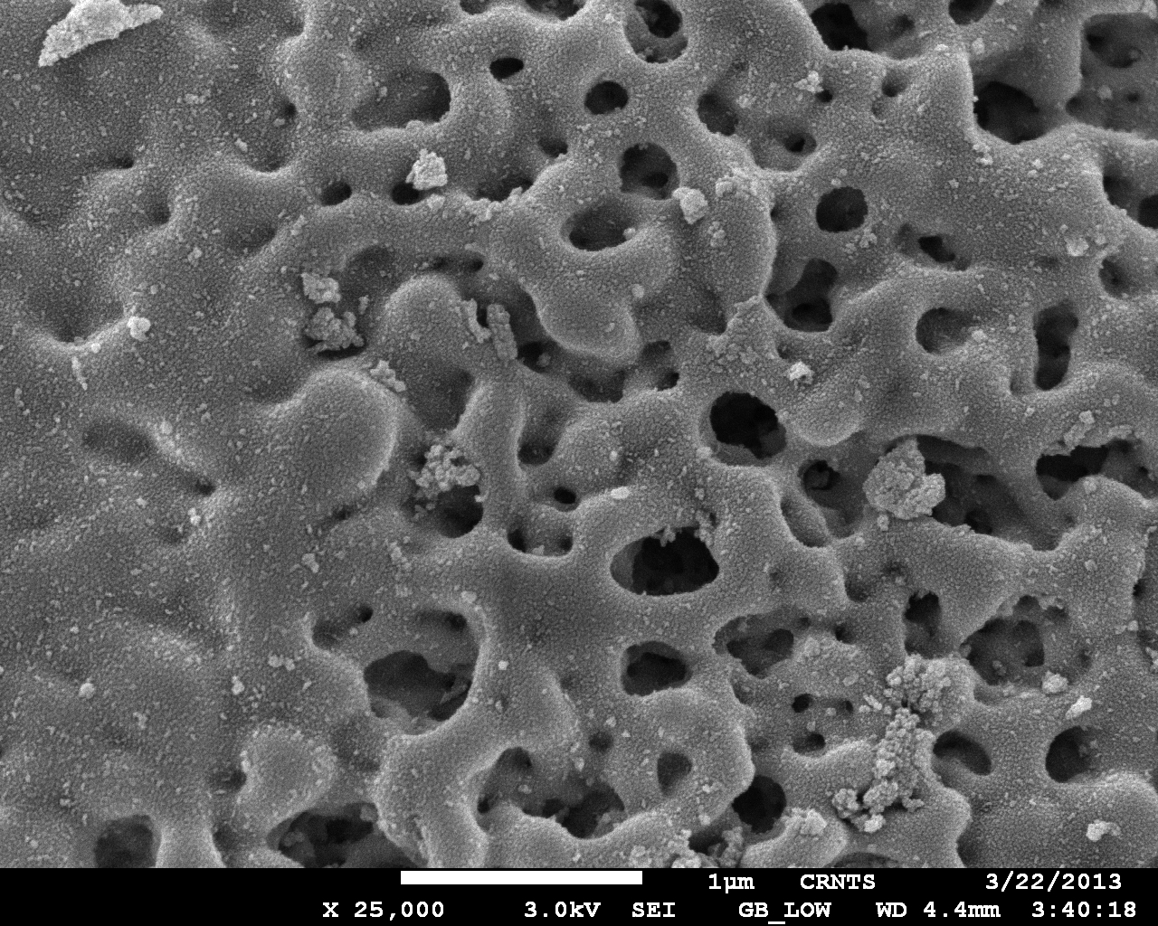
Figure S1. Scanning electron micrograph (SEM) of BFA
Figure S2. Effect of BFA dosage on removal of MCPA at 303 K
Figure S3. Effect of solution pH on the removal of MCPA (100 mg/L, 720 min, 303 K)

Figure S4. Effect of influent concentration on packed bed adsorption of MCPA on BFA

Figure S5. Effect of flow rate on packed bed adsorption of MCPA on BFA
Figure S6. Effect of bed height on packed bed adsorption of MCPA on BFA

