Supplementary Material

S.1. Heuristic justification
We first present some heuristic analysis to better understand some of the concepts described in section 2. In this subsection we assume that the polygenic scores are centered and each SNP column in the X matrix is standardized (i.e. mean zero and standard deviation equal to one) so that without loss of generality we may assume that the PGS vector is obtained by adding the β-weighted (i.e. not t-value weighted) SNP columns. Although Lasso does not have a closed form solution for the β’s in the general case, it does have a closed form solution when the design matrix is orthonormal: X^{T}X = I. This special case would correspond to pairwise uncorrelated SNP columns. The orthonormal case will help us in understanding roughly why the correlation plots presented in this paper have their particular shape. With orthonormal assumption, we get the closed form solution for the Lasso estimate of the effect of the k^{th} SNP as
<display>\begin{equation*} \hat{\beta}^{{\lambda}}_{k} = \sgn\left(\hat{\beta}^{O}_{k}\right)\left(\abs{\hat{\beta}^{O}_{k}} - \frac{{\lambda}}{2} \right)^{+}, \end{equation*}</display>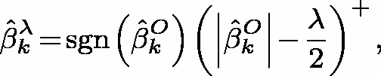
where <inline>\hat{\beta}^{O}_{k}</inline>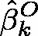 denotes the ordinary least squares estimate (i.e. the case λ = 0) and sgn(x) is + 1 or − 1 depending on x > 0 or x < 0. For our analysis, assume that all <inline>\hat{\beta}^{O}_{k}</inline>’s are positive; this assumption is made for simplicity only, although our conclusions will hold in general. With this assumption,
<display>\begin{equation*} \hat{\beta}^{{\lambda}}_{k} = \left(\hat{\beta}^{O}_{k} - \frac{{\lambda}}{2} \right)^{+} = \left\{\begin{array}{cr} \hat{\beta}^{O}_{k} - \frac{{\lambda}}{2} & \quad\mbox{if } \hat{\beta}^{O}_{k} - \frac{{\lambda}}{2} \geq 0 \\ 0 & \quad\mbox{if } \hat{\beta}^{O}_{k} - \frac{{\lambda}}{2} \leq 0 \end{array} \right. \end{equation*}</display>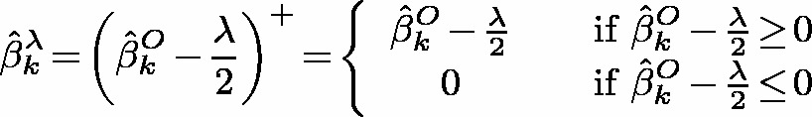
For any given λ, let n_{λ} = Cardinality(S_{λ}) where S_{λ} is the set of all non-zero <inline>\hat{\beta}^{{\lambda}}_{k}</inline>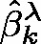’s. Then the PGS vector based on the full set of SNPs and that based on the subset of SNPs selected by Lasso for a given λ are
<display>\begin{equation*}\displaystyle \mathrm{PGS}_{\spmathrm{full}} = \sum\limits_{k=1}^{M} \hat{\beta}^{O}_{k} \mathbf{x}_{k} \;\;\;\mathrm{and}\;\;\;\mathrm{PGS}_{\spmathrm{Lasso}}^{{\lambda}} = \sum\limits_{\left[k^{\prime}:\hat{\beta}^{{\lambda}}_{k^{\prime}} \in {S}_{{\lambda}} \right]} \hat{\beta}^{O}_{k^{\prime}} \mathbf{x}_{k^{\prime}}, \;\;\mathrm{so}\;\;\mathrm{that} \end{equation*}</display>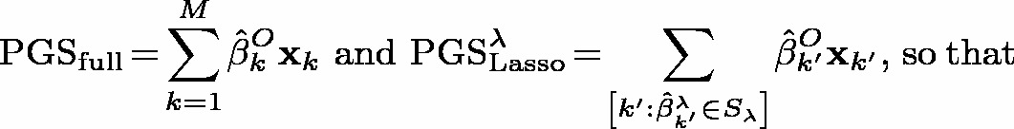
<display>\begin{equation} \begin{aligned} \mathrm{Cor}\left(\mathrm{PGS}_{\spmathrm{full}}, \mathrm{PGS}_{\spmathrm{Lasso}}^{{\lambda}}\right) &= \frac{\sum\limits_{k=1}^{M}\sum\limits_{ \left[k^{\prime}:\hat{\beta}^{{\lambda}}_{k^{\prime}} \in {S}_{{\lambda}} \right] } \hat{\beta}^{O}_{k} \hat{\beta}^{O}_{k^{\prime}} \mathrm{\Cov}\left(\mathbf{x}_{k}, \mathbf{x}_{k^{\prime}}\right) }{\left\{Var(\mathrm{PGS}_{\spmathrm{full}})\Var\left(\mathrm{PGS}_{\spmathrm{Lasso}}^{{\lambda}}\right) \right\}^{1/2} } \\ &= \frac{\sum\limits_{k=1}^{M}\sum\limits_{\left[k^{\prime}:\hat{\beta}^{{\lambda}}_{k^{\prime}} \in {S}_{{\lambda}} \right] } \hat{\beta}^{O}_{k} \hat{\beta}^{O}_{k^{\prime}} \delta_{kk^{\prime}} }{\sqrt{\left[\sum\limits_{k=1}^{M}\left(\hat{\beta}^{O}_{k}\right)^{2} \right] \left[\sum\limits_{\left[k^{\prime}:\hat{\beta}^{{\lambda}}_{k^{\prime}} \in {S}_{{\lambda}} \right]} \left(\hat{\beta}^{O}_{k^{\prime}}\right)^{2} \right] }} \\ &= \sqrt{\frac{\sum\limits_{\left[k:\hat{\beta}^{{\lambda}}_{k} \in {S}_{{\lambda}} \right] } \left(\hat{\beta}^{O}_{k}\right)^{2} }{\sum\limits_{k=1}^{M} \left(\hat{\beta}^{O}_{k}\right)^{2} } } \;\;\; \longrightarrow \;\;\; \left\{\begin{array}{cl} 1 & \quad\mbox{as } {\lambda} \rightarrow 0 \\ 0 & \quad\mbox{as } {\lambda} \rightarrow \infty \;(\mathrm{or}\;{\lambda}_{\spmathit{{max}}}) \end{array} \right. \end{aligned} \end{equation}</display>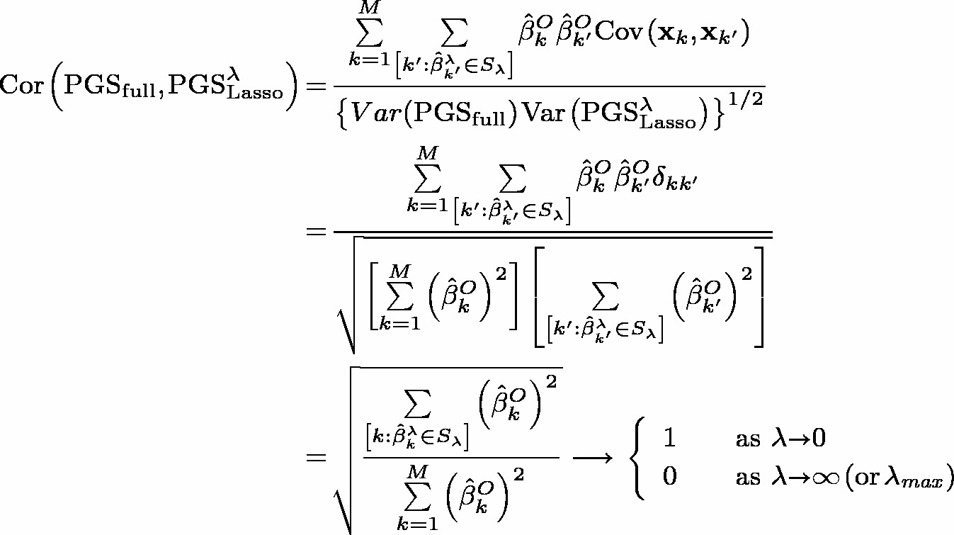 (S.1)
where we have used the fact that the covariance between the k^{th} and the m^{th} SNP column is the Kronecker delta δ_{km}, based on the orthonormality asumption for the design matrix. If we assume <inline>\hat{\beta}^{O}_{k} = \Theta(b)</inline>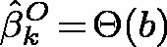 (i.e. bounded below and above by C₁b and C₂b for some b and constants C₁ and C₂), then from Eq. (S.1), we also get
<display>\begin{equation*}\mathrm{Cor}\left(\mathrm{PGS}_{\spmathrm{full}}, \mathrm{PGS}_{\spmathrm{Lasso}}^{{\lambda}}\right) = \frac{n_{{\lambda}}\Theta(b^{2})}{\sqrt{\left(M\Theta(b^{2})\right) \left(n_{{\lambda}}\Theta(b^{2}) \right) }} = \Theta\left(n_{{\lambda}}^{1/2}\right). \end{equation*}</display>
In the simplest (and non-realistic) case where all the univariate OLS β’s are the same, we have <inline>\mathrm{Cor}\left(\mathrm{PGS}_{\spmathrm{full}}, \mathrm{PGS}_{\spmathrm{Lasso}}^{{\lambda}}\right) = \sqrt{n_{{\lambda}}/M}</inline>. We may summarize the above discussion as a lemma.
Lemma 1. If the pairwise correlations between the standardized SNP columns are zero (i.e. the design matrix X is orthonormal) and the OLS estimators of the SNP effects are bounded, then
<display>\begin{equation*}\mathrm{Cor}\left(\mathrm{PGS}_{\spmathrm{full}}, \mathrm{PGS}_{\spmathrm{Lasso}}^{{\lambda}}\right) = \Theta\left(n_{{\lambda}}^{1/2}\right). \end{equation*}</display>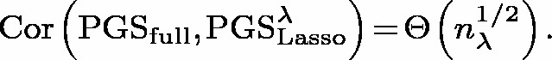
In other words, the lemma implies that the shape of <inline>\mathrm{Cor}\left(\mathrm{PGS}_{\spmathrm{full}}, \mathrm{PGS}_{\spmathrm{Lasso}}^{{\lambda}}\right) (\equiv \rho_{\spmathrm{PGS}}({\lambda}))</inline> plotted against the number of SNPs selected will be roughly similar to that of the square-root function. Although the plots in the right-panel of Figure 1 and left-most panel in Figure 2 are not exactly shaped like a square-root function, we do see some rough similarity with square-root function’s shape.

S.2. Comparison between Lasso and Elastic Nets (with α ∈ (0, 1))
The difference between Lasso and elastic nets (with α ∈ (0, 1)) is in the grouped variables context. We review here material from Zou and Hastie’s article¹ to understand better this difference. A regression method is said to have grouping effect if highly correlated predictor variables have very similar estimates for their effects on the dependent variable. Elastic nets (with α ∈ (0, 1)) is a grouping effect method while Lasso is not. In the extreme case when two explanatory variables are exactly the same, the corresponding effect-estimates based on method with grouping effect will also be exactly same. This property is due to the strict convexity of the penalty function P_{λ}(⋅) as seen from Lemma 2 in (Zou and Hastie¹, p. 306). The penalty function for elastic nets (with α ∈ (0, 1)) are strictly convex, and hence the above-mentioned lemma guarantees identical effects in the extreme situation of identical SNP variables, while as Lasso does not even have a unique solution. The grouping effect in a more realistic setting can be explained using the theoretical result (Theorem 1 in Zou and Hastie)¹ based on naive elastic nets (i.e. with penalty function <inline>{\lambda}_{2} \Vert \boldsymbol \gamma\Vert_{2}^{2} + {\lambda}_{1} \Vert \boldsymbol \gamma\Vert_{1}</inline>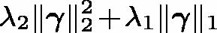), which states that the elastic net estimates are just a scaled version of the estimates from a naive elastic net, with (1 + λ₂) as the scaling factor. Theorem 1 in Zou and Hastie¹ guarantees that if two SNP vectors are highly correlated, then the difference between their naive elastic net estimates are nearly zero, and hence the difference between their elastic net estimates are also nearly zero. In other words, Theorem 1 in Zou and Hastie¹ theoretically justifies the grouping effect for elastic nets. See subsection B.1 (in Appendix B) for a further illustration of the concepts mentioned here.

S.3. Comparison with p-value thresholding method
A simple alternate approach for selecting SNPs, based on thresholding p-values related to SNP-effects on polygenic scores, may be adapted to detecting SSEs. For each phenotype, the idea is to rank the SNPs based on their univariate p-values and select the SNPs below a particular p-value or rank threshold (e.g. below the 50th percentile). We then intersect the list of selected SNPs for both phenotypes to obtain the SSEs. In this paper we label this as the rank ordering (RO) approach. The major drawback for this approach is that it does not take into account any potential collinearity between the SNP columns.
Since the p-value and t-value for each SNP are monotonically inversely related in the univariate case, we may equivalently conduct the thresholding based on the t-values. If the dependent variable z (vector of polygenic scores in our case) and the SNP matrix are standardized, t-value is same as the corresponding effect β. Thus, in the standardized case, p-value thresholding approach is equivalent to thresholding based on the β_{k}’s, which is known in the literature by the name ‘univariate soft-thresholding’. There is an interesting theoretical connection of this thresholding approach to elastic nets. The above approach may be equivalently based on the estimates of the form
<display>\begin{equation} \left(\abs{\mathbf{z}^{T}\mathbf{x}_{k}} - \frac{{\lambda}_{1}}{2} \right)_{+}\sgn\left(\abs{\mathbf{z}^{T}\mathbf{x}_{k}}\right) \end{equation}</display>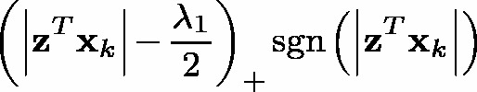 (S.2)
where z^{T}x_{k} is the univariate regression coefficient estimate (i.e. <inline>\hat{\beta}_{k}</inline>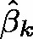) for x_{k} in the standardized case. Based on Theorem 2 in Zou and Hastie¹, it may be deduced that estimates in Eq. (S.2) are same as the estimates obtained from a naive elastic net method (i.e. the case when λ₂ → ∞). Thus p-value thresholding approach is a special case of naive elastic net. Lasso corresponds to the case λ₂ = 0. Thus elastic net naturally bridges Lasso and univariate soft-thresholding. Although univariate soft-thresholding may be considered not ideal in the presence of collinearity, it has been utilized extensively in applied statistical literature (e.g. significance analysis of microarrays and nearest centroid classifier) and have surprisingly shown good empirical performance as mentioned in Zou and Hastie’s article¹.

S.4. Stability Issues for Lasso in the presence of correlated data
Stability issues for Lasso in other applied statistical settings have been pointed out in prior literature². In this subsection, we theoretically study potential stability issues for Lasso for our shared polygenicity detection scheme. In order to understand the stability-issues of Lasso in the presence of correlated SNPs, we need to focus on only one of the GWASs. For k = 1, …, M, let <inline>\mathbf{x}_{k} = [x_{1,k}, \ldots, x_{N,k}]^{T}</inline>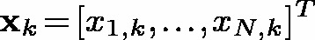 be the k^{th} column in the SNP matrix X. In this subsection, we assume x_{k} is mean-centered to avoid writing the intercept in the regression equation. The univariate estimate of the corresponding β_{k} coefficient (omitting the superscript O) is
<display>\begin{equation*} \hat{\beta}_{k} = \left(\sum\limits_{l = 1}^{N} x_{l,k}y_{l}\right)/\left(\sum\limits_{l = 1}^{N} x_{l,k}^{2}\right) = \left(\mathbf{x}_{k}^{T}\mathbf{y}\right)/\left(\mathbf{x}_{k}^{T}\mathbf{x}_{k}\right), \; k = 1, \ldots, M.\end{equation*}</display>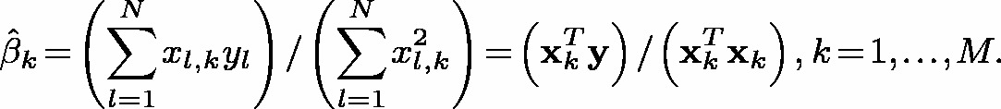
The polygenic score for the i^{th} subject is <inline>z_{i} = \mathrm{PGS}_{i} = \sum_{k=1}^{M}\hat{\beta}_{k}x_{i,k}, \; i = 1, \ldots, N</inline>; for ease of exposition, the <inline>\hat{\beta}</inline>’s were used as the weights instead of t-scores. To simplify the presentation, we also assume that all β’s are non-negative and restrict ourselves momentarily to the case M = 2. However the presentation below will hold for the general case without these restrictive assumptions as well. Thus, with these assumptions, the loss function that needs to be minimized to obtain the Lasso weights is
<display>\begin{align*} \mathbb{L} \equiv \mathbb{L}(\gamma_{1}, \gamma_{2}; {\lambda}) &= \sum\limits_{i=1}^{N}[z_{i} - \gamma_{1}x_{i,1} - \gamma_{2}x_{i,2}]^{2} + {\lambda}(\vert \gamma_{1}\vert + \vert \gamma_{2}\vert )\nonumber\\ &= \sum\limits_{i=1}^{N}[(\hat{\beta}_{1} - \gamma_{1})x_{i,1} + (\hat{\beta}_{2} - \gamma_{2})x_{i,2} ]^{2} + {\lambda}(\gamma_{1} + \gamma_{2}), \nonumber \end{align*}</display>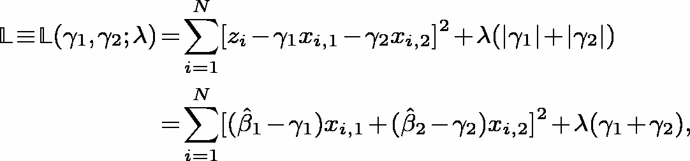
where in the second equation we substituted for the polygenic scores, and also used the fact that γ_{k}’s have to be non-negative since we assume β_{k}’s to be non-negative. Let γ and <inline>\hat{\boldsymbol \beta}</inline> denote the column vector with elements γ_{k}’s and <inline>\hat{\beta}_{k}</inline>’s. Setting the gradient of <inline>\mathbb{L}</inline> (with respect to γ) equal to zero we obtain
<display>\begin{equation} \Gamma\boldsymbol \gamma = \Gamma\hat{\boldsymbol \beta} - ({\lambda}/2)\mathbf{J},\;\;\; \mathbf{J} = [1,1]^{T}, \end{equation}</display> (S.3)
where
<display>\begin{equation} \Gamma = \begin{bmatrix} \sum\limits_{i=1}^{N}x_{i,1}^{2} & \sum\limits_{i=1}^{N}[x_{i,1}x_{i,2}] \\ \sum\limits_{i=1}^{N}[x_{i,2}x_{i,1}] & \sum\limits_{i=1}^{N}x_{i,2}^{2} \end{bmatrix}. \end{equation}</display>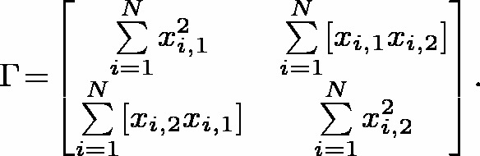 (S.4)
Equations (S.3) and (S.4) in the general M case will have J as an M-vector of 1’s and Γ an M × M matrix with <inline>\sum_{i=1}^{N}[x_{i,k}x_{i,m}]</inline>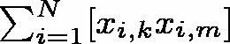 as the km^{th} entry. It is easy to see that the determinant of Γ in Eq. (S.4) is exactly zero (or near zero) when the absolute value of the correlation between x₁ and x₂ is perfectly equal to 1 (or near 1) implying non-invertibility (or near non-invertibility) of Γ. This observation about Γ points to the instability of the Lasso estimates when x₁ and x₂ are highly correlated. Instability is not just an issue in the PGS case, because in the general case where z_{i}’s are not polygenic scores, instead of <inline>\Gamma\hat{\boldsymbol \beta}</inline>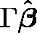 in the right side of Eq. (S.3), we will have a vector whose k^{th} element will be <inline>\sum_{i=1}^{N}z_{i}x_{i,k}</inline>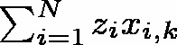, and in order to get the Lasso estimates (i.e. <inline>\hat{\gamma}</inline>’s) we still will have to invert Γ.
This phenomenon (i.e. the instability of Lasso in the presence of correlated covariates) can be explained in the general M case as well. Suppose in the general M case two of the x vectors are highly correlated. Without loss of generality, we may assume them to be the first two vectors x₁ and x₂, so that Γ may be be written as a block matrix
<display>\begin{equation*} \Gamma = \begin{bmatrix} A & B \\ C & D \end{bmatrix}, \end{equation*}</display>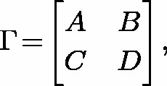
where A is the 2 × 2 matrix given in Eq. (S.4). Using Schur’s determinant identity for block matrices (Horn and Johnson³, Chapter 1), we get det(Γ) = det(A) det(D − CA⁻¹B). Thus, if x₁ and x₂ are perfectly (or highly) correlated, det(A) will be exactly (or near) zero, which in turn will make det(Γ) exactly (or near) zero.
In the results from a simulations study presented in section 5.1, we see that the performance of the Lasso based strategy gets closer to that based on univariate thresholding, especially for smaller values of λ, as the pairwise correlations of columns within the X matrix increases. This phenomenon can be explained using Eq. (S.3). Again, we revert back to M = 2 case first for ease of exposition. When Γ is invertible (i.e. when x₁ and x₂ are not perfectly correlated or anti-correlated), then Eq. (S.3) may be re-written as
<display>\begin{equation} \boldsymbol \gamma = \left(\hat{\boldsymbol \beta} -({\lambda}/2)\Gamma^{-1}\mathbf{J}\right)_{+}, \;\mathrm{where}\; a_{+} = \max\{a,0\}. \end{equation}</display> (S.5)
We used the ‘+’ sign to ensure that γ is non-negative based on our assumption. As a heuristic approach, if we assume for simplicity that the variance of x₁ and x₂ both equal to s² and the correlation between them equal r, then Eq. (S.5) simplifies to
<display>\begin{equation*} \boldsymbol \gamma = \left(\hat{\boldsymbol \beta} - \frac{{\lambda}}{2s^{4}(1 - r^{2})}\begin{bmatrix} s^{2} & -r s^{2} \\ -r s^{2} & s^{2} \end{bmatrix}\begin{bmatrix} 1 \\ 1 \end{bmatrix} \right)_{+} = \left(\hat{\boldsymbol \beta} - \frac{{\lambda}}{2s^{2}(1 + r)}\mathbf{J} \right)_{+}, \end{equation*}</display>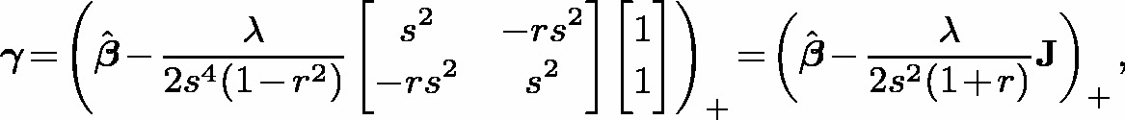
from which it is easy to see that γ gets closer to <inline>\hat{\boldsymbol \beta}</inline> as r gets closer to 1, explaining the phenomenon observed in the results from simulations in section 5.1. Note that this particular phenomenon need not hold for Lasso in general, but only for our adaptation for polygenic scores. Extending our heuristic (that is, with the assumption of equal variance s² and same value r for all pairwise correlations) to the general M case, we will then have Γ as an M × M compound symmetry matrix with s² as diagonal and rs² as off-diagonal elements. That is,
<display>\begin{equation*} \Gamma = s^{2}(1-r)\mathbf{I}_{M \times M} + rs^{2}\mathbf{J}_{M\times M}, \end{equation*}</display>
where I_{M×M} is the identity matrix and J_{M×M} is the matrix of ones. Hence,
<display>\begin{equation*} \Gamma^{-1} = \frac{1}{s^{2}(1-r)}\mathbf{I}_{M \times M} - \frac{rs^{2}}{s^{2}(1-r)[s^{2}(1-r) + Mrs^{2}]}\mathbf{J}_{M \times M}, \end{equation*}</display>
<display>\begin{equation*} \Gamma^{-1}\mathbf{J} = \frac{1}{s^{2}(1-r)}\left(1 - \frac{Mrs^{2}}{s^{2}(1-r) + Mrs^{2}} \right)\mathbf{J} = \frac{1}{s^{2}[1 + (M-1)r]}\mathbf{J}. \end{equation*}</display>
Based on this, and Eq. (S.5), it is again easy to see that γ gets closer to <inline>\hat{\boldsymbol \beta}</inline> as r gets closer to 1. A general Γ without the above heuristic assumption, may be written as a compound symmetry matrix plus a random perturbation matrix with small ‘error’ terms. The leading term on inverting such a matrix will again inversely depend on r, so that the conclusions will be similar to those obtained via our heuristic analysis above. A recent paper² proposed a modified penalty called ‘Precision Lasso’ to account for correlations among the covariates; this new penalty may be more suitable than Lasso for shared polygenicity detection in the presence of correlated variables. Precision Lasso penalty and other penalties related to elastic nets are discussed in the section 3.2.

S.5. Proof of the model selection consistency theorem
Remark 4. It is easy to check that for nonzero real numbers a, b and any given 0 < δ < 1, sgn(a) ≠ sgn(b) implies
<display>\begin{equation} \vert a-b\vert \gt \delta \vert b\vert . \end{equation}</display>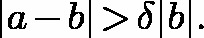 (S.6)
Here sgn denotes the sign function: sgn(c) = −1, 0, and 1, respectively, when c < 0, = 0 and <inline>\gtrbin 0</inline>. To show (S.6) to be true, first assume a > 0 > b. Then |a − b| = a + |b|≥|b| > δ|b|. A similar argument applies for b > 0 > a, concluding the remark.
Proof of Theorem 1: Let <inline>E_{\delta} = \left\{\boldsymbol\gamma: \Vert \boldsymbol \gamma_{(1)} - \boldsymbol \beta_{(1)}^{0}\Vert_{\infty} \leq \delta \boldsymbol \beta_{\ast }, \boldsymbol \gamma_{(2)} = 0 \right\}</inline>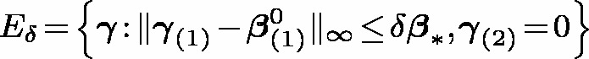. Based on Remark 4, in order to prove the theorem, it suffices to show that <inline>P({\mathcal{S}} \cap E_{\delta}) \rightarrow 1</inline>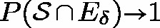 as N → ∞. In turn it suffices to show that <inline>P({\mathcal{S}}_{1} \cap E_{\delta}) \rightarrow 1</inline>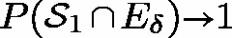 (Claim-1) and the conditional probability <inline>P(\{{\mathcal{S}}_{2}\cap E_{\delta}\}/\{{\mathcal{S}}_{1} \cap E_{\delta}\}) \rightarrow 1</inline> (Claim-2). We now prove the two claims.
Proof of Claim-1: Using Eqs. (5) and (6), and the fact that <inline>\sgn(\hat{\boldsymbol \gamma}_{(1)}) = \sgn(\boldsymbol \beta_{(1)}^{0})</inline>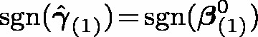 for <inline>\hat{\boldsymbol \gamma} \in E_{\delta}</inline>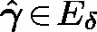,
<display>\begin{align} {\mathcal{S}}_{1} \cap E_{\delta} &= \left\{\hat{\boldsymbol \gamma}:\; 2\mathbf{X}_{(1)}^{T}\mathbf{X}_{(1)}\hat{\boldsymbol \gamma}_{(1)} - 2\mathbf{X}_{(1)}^{T}(\mathbf{X}\mathbf{D}\mathbf{E}\mathbf{X}^{T})\mathbf{X}_{(1)}\boldsymbol \beta_{(1)}^{0} - 2\mathbf{X}_{(1)}^{T}(\mathbf{X}\mathbf{D}\mathbf{V})\boldsymbol{{\varepsilon}} \nonumber \right.\\ &\quad +\left. {\lambda}_{1}\sgn(\boldsymbol \beta_{(1)}^{0}) + 2{\lambda}_{2}\hat{\boldsymbol \gamma}_{(1)} = 0 \right\} \cap \left\{\hat{\boldsymbol \gamma}: \lVert \hat{\boldsymbol \gamma}_{(1)} - \boldsymbol \beta_{(1)}^{0}\rVert_{\infty} \leq \delta \boldsymbol \beta_{\ast } \right\} \nonumber \\ &= \left\{\hat{\boldsymbol \gamma}:\; \tilde{\Sigma}_{11}(\hat{\boldsymbol \gamma}_{(1)} - \boldsymbol \beta_{(1)}^{0}) = (1/N)\mathbf{X}_{(1)}^{T}(\mathbf{X}\mathbf{D}\mathbf{V})\boldsymbol{{\varepsilon}} + (1/N)\vardbtilde{\Sigma}_{11}\boldsymbol \beta_{(1)}^{0} \right.\\ & \quad -\left. ({\lambda}_{1}/2N)\sgn(\boldsymbol \beta_{(1)}^{0}) \right\} \cap \left\{\hat{\boldsymbol \gamma}: \Vert \hat{\boldsymbol \gamma}_{(1)} - \boldsymbol \beta_{(1)}^{0}\Vert_{\infty} \leq \delta \boldsymbol \beta_{\ast } \right\}, \nonumber \\ &= \left\{\hat{\boldsymbol \gamma}:\; \Vert (1/N)\tilde{\Sigma}_{11}^{-1}\mathbf{X}_{(1)}^{T}(\mathbf{X}\mathbf{D}\mathbf{V})\boldsymbol{{\varepsilon}} + \tilde{\Sigma}_{11}^{-1}\{(1/N)\vardbtilde{\Sigma}_{11}\boldsymbol \beta_{(1)}^{0} - ({\lambda}_{1}/2N)\sgn(\boldsymbol \beta_{(1)}^{0}) \}\Vert_{\infty} \nonumber \right.\\ &\leq\left. \delta \boldsymbol \beta_{\ast } \right\} \nonumber \end{align}</display>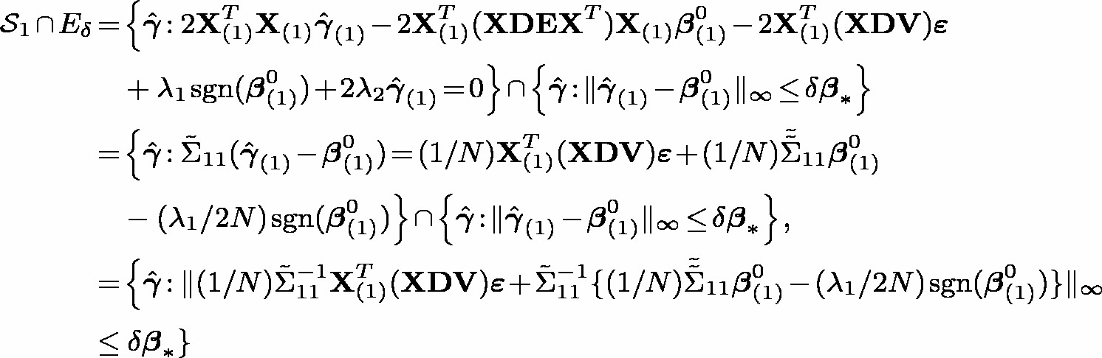 (S.7)
Thus in order to prove the claim it suffices to show that, as N → ∞,
<display>\begin{equation*}P\left\{\hat{\boldsymbol \gamma}:\; \Vert (1/N)\tilde{\Sigma}_{11}^{-1}\mathbf{X}_{(1)}^{T}(\mathbf{X}\mathbf{D}\mathbf{V})\boldsymbol{{\varepsilon}} + \tilde{\Sigma}_{11}^{-1}\{(1/N)\vardbtilde{\Sigma}_{11}\boldsymbol \beta_{(1)}^{0} - ({\lambda}_{1}/2N)\sgn(\boldsymbol \beta_{(1)}^{0}) \}\Vert_{\infty} \gt \delta \boldsymbol \beta_{\ast } \right\} \rightarrow 0. \end{equation*}</display>
By Markov inequality and then triangle inequality, the probability on the left-hand side above is upper bounded by
<display>\begin{equation} \frac{1}{\delta \boldsymbol \beta_{\ast }} \left\{\mathbb{E}(\Vert (1/N)\tilde{\Sigma}_{11}^{-1}\mathbf{X}_{(1)}^{T}(\mathbf{X}\mathbf{D}\mathbf{V})\boldsymbol{{\varepsilon}}\Vert_{\infty}) + \Vert \tilde{\Sigma}_{11}^{-1}\left\{(1/N)\vardbtilde{\Sigma}_{11}\boldsymbol \beta_{(1)}^{0} - ({\lambda}_{1}/2N)\sgn(\boldsymbol \beta_{(1)}^{0}) \right\}\Vert_{\infty} \right\}. \end{equation}</display> (S.8)
<inline>(1/N)\tilde{\Sigma}_{11}^{-1}\mathbf{X}_{(1)}^{T}(\mathbf{X}\mathbf{D}\mathbf{V})\boldsymbol{{\varepsilon}}</inline>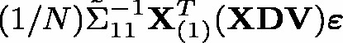 is a q × 1 vector of mean-zero Gaussian random variables, say <inline>U = [U_{1}, \ldots, U_{q}]^{T}</inline>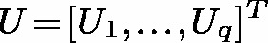. Then by the standard Gaussian maximum inequality (obtained using a straightforward application of Jensen’s inequality),
<display>\begin{equation*}\mathbb{E}[\max_{i} U_{i}] \leq \sqrt{2v^{\ast }\log(q)},\; \mathrm{where}\; v^{\ast } = \max_{i}\{\Var(U_{i})\}.\end{equation*}</display>
Now, if e_{i} denotes the q × 1 vector with 1 in the i^{th} position and zeroes elsewhere, then <inline>U_{i} = e_{i}^{T}\tilde{\Sigma}_{11}^{-1}\mathbf{X}_{(1)}^{T}(\mathbf{X}\mathbf{D}\mathbf{V})\boldsymbol{{\varepsilon}}/N</inline>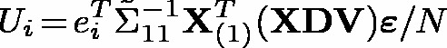 so that
<display>\begin{equation*}\Var(U_{i}) = \frac{\sigma^{2}}{N^{2}}e_{i}^{T}\tilde{\Sigma}_{11}^{-1}(\mathbf{X}_{(1)}^{T}\mathbf{X})\mathbf{D}^{2}\mathbf{V}^{2}\left(\mathbf{X}^{T}\mathbf{X}_{1}\right)\tilde{\Sigma}_{11}^{-1}e_{i} \leq \frac{\sigma^{2}}{N^{2}C_{\min} }. \end{equation*}</display>
Putting all these together, the term in Eq. (S.8) converges to zero if
<display>\begin{equation*}\frac{1}{\delta \boldsymbol \beta_{\ast }} \left\{\frac{\sigma}{N}\sqrt{\frac{2\log (q)}{C_{\min} }} + \Vert \tilde{\Sigma}_{11}^{-1}\left\{(1/N)\vardbtilde{\Sigma}_{11}\boldsymbol \beta_{(1)}^{0} - ({\lambda}_{1}/2N)\sgn(\boldsymbol \beta_{(1)}^{0}) \right\}\Vert_{\infty} \right\} \rightarrow 0 \end{equation*}</display>
which holds true based on the condition (a) assumed in the statement of theorem, completing the proof of Claim-1.
Proof of Claim-2: Using the fact that <inline>\hat{\boldsymbol \gamma}_{(2)} = 0</inline>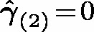 for <inline>\hat{\boldsymbol \gamma}</inline> in E_{δ},
<display>\begin{align*} {\mathcal{S}}_{2}\cap E_{\delta} &= \left\{\hat{\boldsymbol \gamma}:\; 2\mathbf{X}_{(2)}^{T}\mathbf{X}_{(1)}\hat{\boldsymbol \gamma}_{(1)} - 2\mathbf{X}_{(2)}^{T}(\mathbf{X}\mathbf{D}\mathbf{E}\mathbf{X}^{T})(\mathbf{X}_{(1)}\boldsymbol \beta_{(1)}^{0} + \boldsymbol{{\varepsilon}}) + {\lambda}_{1}\mathbf{u} = 0,\right.\\ & \qquad\qquad\qquad\qquad\qquad\qquad\qquad\qquad\qquad \mathbf{u}\left. = (u_{k})_{k = q+1, \ldots, M}, \vert u_{k}\vert \leq 1\right\} \\ &= \left\{\hat{\boldsymbol \gamma}:\; 2\Vert \mathbf{X}_{(2)}^{T}\mathbf{X}_{(1)}(\hat{\boldsymbol \gamma}_{(1)} - \boldsymbol \beta_{(1)}^{0})\right. \\ &\quad+\left. \mathbf{X}_{(2)}^{T}\left[\mathbf{I}_{N\times N} - (\mathbf{X}\mathbf{D}\mathbf{E}\mathbf{X}^{T}) \right]\mathbf{X}_{(1)}\boldsymbol \beta_{(1)}^{0} - \mathbf{X}_{(2)}^{T}(\mathbf{X}\mathbf{D}\mathbf{V})\boldsymbol{{\varepsilon}} \Vert_{\infty} \leq {\lambda}_{1} \right\}. \end{align*}</display>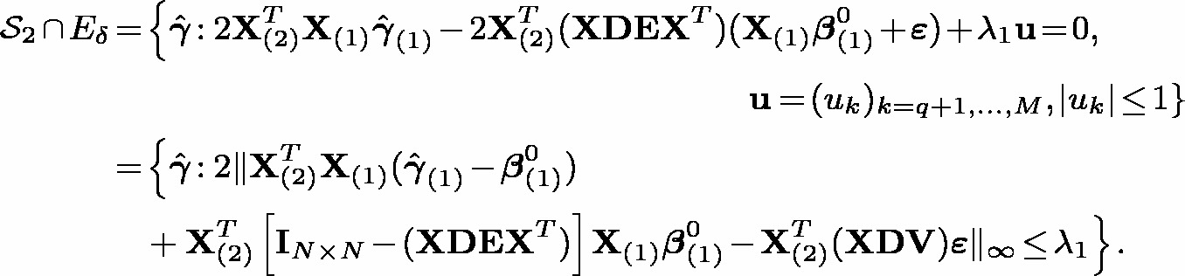
Substituting for <inline>(\hat{\boldsymbol \gamma}_{(1)} - \boldsymbol \beta_{(1)}^{0})</inline>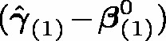 using (S.7), <inline>\{{\mathcal{S}}_{2} \cap E_{\delta}\}</inline>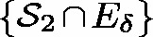 conditioned on <inline>\{{\mathcal{S}}_{1} \cap E_{\delta} \}</inline>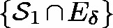 equals
<display>\begin{align*} &\left\{\hat{\boldsymbol \gamma}:\; \Vert 2(\Sigma_{21}\tilde{\Sigma}_{11}^{-1}\mathbf{X}_{(1)}^{T} - \mathbf{X}_{(2)})(\mathbf{XDV})\boldsymbol{{\varepsilon}} \right.\\ &\quad+\left. \left\{2\left(\Sigma_{21}\tilde{\Sigma}_{11}^{-1}\vardbtilde{\Sigma}_{11} + \mathbf{X}_{(2)}^{T}\left[\mathbf{I}_{N\times N} - (\mathbf{XDEX}^{T}) \right]\mathbf{X}_{(1)}\right)\boldsymbol \beta_{(1)}^{0} - {\lambda}_{1}\Sigma_{21}\tilde{\Sigma}_{11}^{-1}\sgn(\boldsymbol \beta_{(1)}^{0}) \right\}\Vert_{\infty} \leq {\lambda}_{1} \right\}. \end{align*}</display>
PEIC guarantees that
<display>\begin{align*} &\Vert \left\{2\left(\Sigma_{21}\tilde{\Sigma}_{11}^{-1}\vardbtilde{\Sigma}_{11} + \mathbf{X}_{(2)}^{T}\left[\mathbf{I}_{N\times N} - (\mathbf{XDEX}^{T}) \right]\mathbf{X}_{(1)}\right)\boldsymbol \beta_{(1)}^{0} - {\lambda}_{1}\Sigma_{21}\tilde{\Sigma}_{11}^{-1}\sgn(\boldsymbol \beta_{(1)}^{0}) \right\}\Vert_{\infty} \\ &\quad\leq (1-\eta){\lambda}_{1}. \end{align*}</display>
Thus, in order to prove the claim it suffices to show that
<display>\begin{equation} P\left\{\Vert (\Sigma_{21}\tilde{\Sigma}_{11}^{-1}\mathbf{X}_{(1)}^{T} - \mathbf{X}_{(2)})(\mathbf{XDV})\boldsymbol{{\varepsilon}}\Vert_{\infty}/\sqrt{N} \gt (\eta/2\sqrt{N}){\lambda}_{1} \right\} \rightarrow 0. \end{equation}</display> (S.9)
Using classical standard Gaussian tail bound and Bonferroni’s inequality, the probability in (S.9) can be upper-bounded by <inline>(M-q)\exp \left\{-C {\lambda}_{1}^{2}/N \right\}</inline>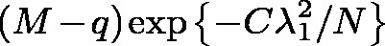 for a positive constant C. This upper bound converges to zero based on assumption (b), proving Claim-2 and completing the proof for the theorem. ■
Note that the necessary conditions ((a) and (b) in the statement of Theorem 1) on λ₁ and λ₂ depend on the SNP matrix X and sample size N, and hence they can vary between the two GWASs. Note also that, provided λ₁ and λ₂ are chosen appropriately, Theorem 1 only guarantees consistent selection of SNPs with true nonzero effects within each GWAS. Since the set of SNPs with nonzero effects could vary across the GWASs, Theorem 1 does not directly imply consistency for our overall scheme of shared SNPs selection. In this regard, the theorem is primarily a justification for our choice of PGS vector rather than the phenotype vector as the dependent variable. However, since by definition the true shared SNPs are those SNPs for which the true underlying effects are nonzero in both GWASs, Theorem 1 indirectly provides a consistency justification for our overall approach.

S.6. Second data analysis: GWAS from Singapore Integrative Omics study, Malay individuals
The second dataset used for illustration is a GWAS dataset from Malay individuals in the Singapore Integrative Omics Study⁴. The dataset was publicly available⁵. GWAS data was put together from the PLINK-converted .bed, .fam, and .bim Illumina files using the commands from the R package snpStats⁶ following GWAS tutorials^{7,8}. Preprocessing steps included discarding SNPs with call rate <inline>\lessbin </inline> 1 or MAF <inline>\lessbin </inline> 0.1 and discarding samples with call rate <inline>\lessbin </inline> 100% or inbreeding coefficient <inline>\gtrbin </inline> 0.1. However, we did not conduct LD pruning as part of the preprocessing steps. The final SNP matrix used in our analysis had (N =) 106 individuals and (M =) 18513 SNPs. There were several clinical, lifestyle and dietary variables available in the Singapore Integrative Omics Study dataset. The analysis that we did was primarily to illustrate the differences among the methods and we chose cholesterol and systolic blood pressure as the two phenotypes.
The correlation between the polygenic scores (i.e. estimate of genetic correlation) was low: 0.067. Based on this low genetic correlation estimate and based on correlation plots as in figures 1 and 2, we decided to select a shared subset of size approximately 32, for this illustration analysis. The λ-grid for QRR did not yield a λ-threshold with exactly 32 shared SNPs, but there was a grid point which yielded 34 shared SNPs. For Lasso and RO, corresponding threshold values which yielded exactly 32 shared SNPs were obtained. Plots similar to Figure 5 were created and available as supplementary material on the github page, https://github.com/mjohn5/sharpen/tree/main/second_ data_ analysis. There were 19 SNPs (i.e. <inline>\gtrbin </inline> 50 %) in common in the subsets selected by QRR and RO. Thus, a lot more similarity was seen between QRR and RO for this data analysis compared to data analysis related to either of the sites for the first dataset. Lasso and RO subsets had 7 SNPs in common and Lasso and QRR subsets had only 2 SNPs in common. Qualitatively the differences among the methods were very similar to those for the data analyses for the first dataset. The only new feature worth mentioning is that in this data analysis, QRR also detected a few SNPs with flipped signs. In the analyses presented for the first dataset, only Lasso and RO had detected SNPs with flipped signs.

Appendices
Appendices A, B, C and D mentioned in the text are available in https://github.com/mjohn5/sharpen as one document - Appendices.pdf
References
[1] Zou H, Hastie T. Regularization and variable selection via the elastic net. J Roy Stat Soc B 2005;67: 301–20.
[2] Wang H, Lengerich BJ, Aragam B amd Xing EP. Precision Lasso: accounting for correlations and linear dependencies in high-dimensional genomic data. Bioinformatics 2019;35: 1181–7. https://doi.org/10.1093/bioinformatics/bty750.
[3] Horn RA, Johnson CR. Matrix analysis, 2nd ed. Cambridge, UK: Cambridge University Press; 2012.
[4] Saw WY, Tantoso E, Begum H, et al. Establishing multiple omics baselines for three southeast Asian populations in the Singapore Integrative omics study. Nat Commun 2017;8:653. https://doi.org/10.1038/s41467-017-00413-x.
[5] github. Github [Internet]. 2020. Available from: github.com/monogenea/GWAStutorial [Accessed September 2021].
[6] Clayton D. snpStats: SnpMatrix and XSnpMatrix classes and methods; 2021. R package version 1.44.0.
[7] de Abreau e Lima F. Genomewide association studies in R (GWAS tutorial) [Internet]. Mainz, Germany: Gravatar; 2017. Available from: https://poissonisfish.com/2017/10/09/genome-wise-association-studies-in-r.
[8]. Reed E, Nunez S, Kulp D, Qian J, Reilly MP, Foulkes AS. A guide to genome-wide association analysis and post-analytic interrogation. Stat Med 2015;34:3769–92. https://doi.org/10.1002/sim.6605.
[9] Bao M, Wang K. Genome-wide association studies using a penalized moving-window regression. Bioinformatics 2017;33:3887–94. https://doi.org/10.1093/bioinformatics/btx522.
[10] Schwender H. R package scrime: analysis of high-dimensional categorical data such as SNP Data; 2013. Available from: https://cran.r-project.org/web/packages/scrime/version 1.3.3.
[11] Nunkesser R, Bernholt T, Schwender H, et al. Detecting high-order interactions of single nucleotide polymorphisms using genetic programming. Bioinformatics 2007;23:3280–8. https://doi.org/10.1093/bioinformatics/btm522.
[12] Barbiero A, Ferrari PA. GenOrd: simulation of discrete random variables with given correlation matrix and marginal distributions; 2015. R package version 1.4.0.

