Title: A systematic review and meta-analysis to determine the effect of Pranayama in reducing anxiety and stress in adolescents
Table S1: PRISMA Checklist (2020)

Section and Topic | Item # | Checklist item | Location where item is reported
TITLE
Title | 1 | Identify the report as a systematic review. | Pg 1
ABSTRACT
Abstract | 2 | Made as per the Journal guidelines | Pg 1
INTRODUCTION
Rationale | 3 | Describe the rationale for the review in the context of existing knowledge. | Pg 2,3
Objectives | 4 | Provide an explicit statement of the objective(s) or question(s) the review addresses. | Pg 3
METHODS
Eligibility criteria | 5 | Specify the inclusion and exclusion criteria for the review and how studies were grouped for the syntheses. | Supplementary Table S2
Information sources | 6 | Specify all databases, registers, websites, organisations, reference lists and other sources searched or consulted to identify studies. Specify the date when each source was last searched or consulted. | Pg 4
Search strategy | 7 | Present the full search strategies for all databases, registers and websites, including any filters and limits used. | Supplementary Table S3
Selection process | 8 | Specify the methods used to decide whether a study met the inclusion criteria of the review, including how many reviewers screened each record and each report retrieved, whether they worked independently, and if applicable, details of automation tools used in the process. | Pg 4
Data collection process | 9 | Specify the methods used to collect data from reports, including how many reviewers collected data from each report, whether they worked independently, any processes for obtaining or confirming data from study investigators, and if applicable, details of automation tools used in the process. | Pg 4,5
Data items | 10a | List and define all outcomes for which data were sought. Specify whether all results that were compatible with each outcome domain in each study were sought (e.g. for all measures, time points, analyses), and if not, the methods used to decide which results to collect. | Pg 3,4
Data items | 10b | List and define all other variables for which data were sought (e.g. participant and intervention characteristics, funding sources). Describe any assumptions made about any missing or unclear information. | Pg 4,5
Study risk of bias assessment | 11 | Specify the methods used to assess risk of bias in the included studies, including details of the tool(s) used, how many reviewers assessed each study and whether they worked independently, and if applicable, details of automation tools used in the process. | Pg 5
Effect measures | 12 | Specify for each outcome the effect measure(s) (e.g. risk ratio, mean difference) used in the synthesis or presentation of results. | Pg 7
Synthesis methods | 13a | Describe the processes used to decide which studies were eligible for each synthesis (e.g. tabulating the study intervention characteristics and comparing against the planned groups for each synthesis (item #5)). | Pg 7,8
Synthesis methods | 13b | Describe any methods required to prepare the data for presentation or synthesis, such as handling of missing summary statistics, or data conversions. | NA
Synthesis methods | 13c | Describe any methods used to tabulate or visually display results of individual studies and syntheses. | Pg 7,8
Synthesis methods | 13d | Describe any methods used to synthesize results and provide a rationale for the choice(s). If meta-analysis was performed, describe the model(s), method(s) to identify the presence and extent of statistical heterogeneity, and software package(s) used. | Pg 5
Synthesis methods | 13e | Describe any methods used to explore possible causes of heterogeneity among study results (e.g. subgroup analysis, meta-regression). | NA
Synthesis methods | 13f | Describe any sensitivity analyses conducted to assess robustness of the synthesized results. | NA
Reporting bias assessment | 14 | Describe any methods used to assess risk of bias due to missing results in a synthesis (arising from reporting biases). | Pg 5
Certainty assessment | 15 | Describe any methods used to assess certainty (or confidence) in the body of evidence for an outcome. | Pg 5
RESULTS
Study selection | 16a | Describe the results of the search and selection process, from the number of records identified in the search to the number of studies included in the review, ideally using a flow diagram. | Pg 6(Figure 1)
Study selection | 16b | Cite studies that might appear to meet the inclusion criteria, but which were excluded, and explain why they were excluded. | Pg 8
Study characteristics | 17 | Cite each included study and present its characteristics. | Pg 7,8, Table 1
Risk of bias in studies | 18 | Present assessments of risk of bias for each included study. | Pg 12, Table S4, S5, S6, S7
Results of individual studies | 19 | For all outcomes, present, for each study: (a) summary statistics for each group (where appropriate) and (b) an effect estimate and its precision (e.g. confidence/credible interval), ideally using structured tables or plots. | Pg 8-12  Figure 2
Results of syntheses | 20a | For each synthesis, briefly summarise the characteristics and risk of bias among contributing studies. | Pg 12 Table S4,S5,S6,S7
Results of syntheses | 20b | Present results of all statistical syntheses conducted. If meta-analysis was done, present for each the summary estimate and its precision (e.g. confidence/credible interval) and measures of statistical heterogeneity. If comparing groups, describe the direction of the effect. | Figure 2, Supplementary figures
Results of syntheses | 20c | Present results of all investigations of possible causes of heterogeneity among study results. | NA
Results of syntheses | 20d | Present results of all sensitivity analyses conducted to assess the robustness of the synthesized results. | Pg 8,9, Figure S 3,5,8,11
Reporting biases | 21 | Present assessments of risk of bias due to missing results (arising from reporting biases) for each synthesis assessed. | NA
Certainty of evidence | 22 | Present assessments of certainty (or confidence) in the body of evidence for each outcome assessed. | Pg 11,12  Figure 12 Suppl.
DISCUSSION
Discussion | 23a | Provide a general interpretation of the results in the context of other evidence. | Pg 13,14,15
Discussion | 23b | Discuss any limitations of the evidence included in the review. | Pg 15
Discussion | 23c | Discuss any limitations of the review processes used. | Pg 15
Discussion | 23d | Discuss implications of the results for practice, policy, and future research. | Pg 14,15
OTHER INFORMATION
Registration and protocol | 24a | Provide registration information for the review, including register name and registration number, or state that the review was not registered. | Pg 3
Registration and protocol | 24b | Indicate where the review protocol can be accessed, or state that a protocol was not prepared. | Pg 3
Registration and protocol | 24c | Describe and explain any amendments to information provided at registration or in the protocol. | NA
Support | 25 | Describe sources of financial or non-financial support for the review, and the role of the funders or sponsors in the review. | Pg 16
Competing interests | 26 | Declare any competing interests of review authors. | Pg 16
Availability of data, code and other materials | 27 | Report which of the following are publicly available and where they can be found: template data collection forms; data extracted from included studies; data used for all analyses; analytic code; any other materials used in the review. | Pg 16

Table S2. Inclusion and exclusion criteria for the systematic review and meta-analysis

Research Question: Is pranayama effective in reducing anxiety and stress in adolescents?

Inclusion
Participants | Adolescents  10 to 19 years (both inclusive)  Gender: all
Exposure/ Interventions | Pranayama  (Yogic breathing/controlled breathing exercises/diaphragmatic breathing exercises/structured breathing exercises/any type of pranayama)
Comparator | No pranayama/any other strategy
Outcomes | Reduced anxiety level  Reduced stress level  Subgroup analysis according to adolescents’ age, sex, geographical settings, type of intervention
Study Designs | Randomized-controlled studies  Quasi-experimental studies
Study Designs | Databases: PubMed, Scopus, Web of Science  Other sources: Citation searching of the eligible studies  Geography- Global  Date of Search- 1st January 2015 to 31st December 2024  English Language  Human studies
Study Designs | Published and Unpublished data

Table S3: The adjusted search terms as per searched electronic databases
Database | No | Search Query | Results
PubMed
 | #1 | ("adolescent"[MeSH Terms] OR "adolescen*"[Title/Abstract] OR "teen"[Title/Abstract] OR "teenage*"[Title/Abstract] OR "young adult*"[Title/Abstract] OR "child*"[Title/Abstract] OR "student*"[Title/Abstract]) AND ("deep breathing"[Title/Abstract] OR "yoga breathing"[Title/Abstract] OR "yogic breathing"[Title/Abstract] OR "controlled breathing"[Title/Abstract] OR "bhastrika"[Title/Abstract] OR "vilom*"[Title/Abstract] OR "kapal bhati"[Title/Abstract] OR "kapalbhati"[Title/Abstract] OR "breath holding"[Title/Abstract] OR "diaphragmatic breathing"[Title/Abstract] OR ("breathing exercises"[MeSH Terms] OR "breathing exercise*"[Title/Abstract]) OR "pranayam*"[Title/Abstract] OR "relaxation therapy"[MeSH Terms]) AND ("trauma and stressor related disorders"[MeSH Terms] OR ("anxi*"[Title/Abstract] OR "anxiety"[MeSH Terms] OR "stress*"[Title/Abstract] OR "anxiety disorders"[MeSH Terms])) | 1,209
 | #2 | (("adolescent"[MeSH Terms] OR "adolescen*"[Title/Abstract] OR "teen"[Title/Abstract] OR "teenage*"[Title/Abstract] OR "young adult*"[Title/Abstract] OR "child*"[Title/Abstract] OR "student*"[Title/Abstract]) AND ("deep breathing"[Title/Abstract] OR "yoga breathing"[Title/Abstract] OR "yogic breathing"[Title/Abstract] OR "controlled breathing"[Title/Abstract] OR "bhastrika"[Title/Abstract] OR "vilom*"[Title/Abstract] OR "kapal bhati"[Title/Abstract] OR "kapalbhati"[Title/Abstract] OR "breath holding"[Title/Abstract] OR "diaphragmatic breathing"[Title/Abstract] OR ("breathing exercises"[MeSH Terms] OR "breathing exercise*"[Title/Abstract]) OR "pranayam*"[Title/Abstract] OR "relaxation therapy"[MeSH Terms]) AND ("trauma and stressor related disorders"[MeSH Terms] OR ("anxi*"[Title/Abstract] OR "anxiety"[MeSH Terms] OR "stress*"[Title/Abstract] OR "anxiety disorders"[MeSH Terms]))) AND ((randomizedcontrolledtrial[Filter]) AND (2014:2024[pdat])) | 159
 | #3 | (("adolescent"[MeSH Terms] OR "adolescen*"[Title/Abstract] OR "teen"[Title/Abstract] OR "teenage*"[Title/Abstract] OR "young adult*"[Title/Abstract] OR "child*"[Title/Abstract] OR "student*"[Title/Abstract]) AND ("deep breathing"[Title/Abstract] OR "yoga breathing"[Title/Abstract] OR "yogic breathing"[Title/Abstract] OR "controlled breathing"[Title/Abstract] OR "bhastrika"[Title/Abstract] OR "vilom*"[Title/Abstract] OR "kapal bhati"[Title/Abstract] OR "kapalbhati"[Title/Abstract] OR "breath holding"[Title/Abstract] OR "diaphragmatic breathing"[Title/Abstract] OR ("breathing exercises"[MeSH Terms] OR "breathing exercise*"[Title/Abstract]) OR "pranayam*"[Title/Abstract] OR "relaxation therapy"[MeSH Terms]) AND ("trauma and stressor related disorders"[MeSH Terms] OR ("anxi*"[Title/Abstract] OR "anxiety"[MeSH Terms] OR "stress*"[Title/Abstract] OR "anxiety disorders"[MeSH Terms]))) AND (2014:2024[pdat]) | 575
 | #4 | (("adolescent"[MeSH Terms] OR "adolescen*"[Title/Abstract] OR "teen"[Title/Abstract] OR "teenage*"[Title/Abstract] OR "young adult*"[Title/Abstract] OR "child*"[Title/Abstract] OR "student*"[Title/Abstract]) AND ("deep breathing"[Title/Abstract] OR "yoga breathing"[Title/Abstract] OR "yogic breathing"[Title/Abstract] OR "controlled breathing"[Title/Abstract] OR "bhastrika"[Title/Abstract] OR "vilom*"[Title/Abstract] OR "kapal bhati"[Title/Abstract] OR "kapalbhati"[Title/Abstract] OR "breath holding"[Title/Abstract] OR "diaphragmatic breathing"[Title/Abstract] OR ("breathing exercises"[MeSH Terms] OR "breathing exercise*"[Title/Abstract]) OR "pranayam*"[Title/Abstract] OR "relaxation therapy"[MeSH Terms]) AND ("trauma and stressor related disorders"[MeSH Terms] OR ("anxi*"[Title/Abstract] OR "anxiety"[MeSH Terms] OR "stress*"[Title/Abstract] OR "anxiety disorders"[MeSH Terms]))) AND (2015:2024[pdat]) | 532
 | #5 | ("adolescent"[MeSH Terms] OR "adolescen*"[Title/Abstract] OR "teen"[Title/Abstract] OR "teenage*"[Title/Abstract] OR "young adult*"[Title/Abstract] OR "child*"[Title/Abstract] OR "student*"[Title/Abstract]) AND ("deep breathing"[Title/Abstract] OR "yoga breathing"[Title/Abstract] OR "yogic breathing"[Title/Abstract] OR "controlled breathing"[Title/Abstract] OR "bhastrika"[Title/Abstract] OR "vilom*"[Title/Abstract] OR "kapal bhati"[Title/Abstract] OR "kapalbhati"[Title/Abstract] OR "breath holding"[Title/Abstract] OR "diaphragmatic breathing"[Title/Abstract] OR ("breathing exercises"[MeSH Terms] OR "breathing exercise*"[Title/Abstract]) OR "pranayam*"[Title/Abstract] OR "relaxation therapy"[MeSH Terms]) AND ("trauma and stressor related disorders"[MeSH Terms] OR ("anxi*"[Title/Abstract] OR "anxiety"[MeSH Terms] OR "stress*"[Title/Abstract] OR "anxiety disorders"[MeSH Terms])) AND 2015/01/01:2024/12/31[Date - Publication] | 536
#6 |  | (("adolescent"[MeSH Terms] OR "adolescen*"[Title/Abstract] OR "teen"[Title/Abstract] OR "teenage*"[Title/Abstract] OR "young adult*"[Title/Abstract] OR "child*"[Title/Abstract] OR "student*"[Title/Abstract]) AND ("deep breathing"[Title/Abstract] OR "yoga breathing"[Title/Abstract] OR "yogic breathing"[Title/Abstract] OR "controlled breathing"[Title/Abstract] OR "bhastrika"[Title/Abstract] OR "vilom*"[Title/Abstract] OR "kapal bhati"[Title/Abstract] OR "kapalbhati"[Title/Abstract] OR "breath holding"[Title/Abstract] OR "diaphragmatic breathing"[Title/Abstract] OR ("breathing exercises"[MeSH Terms] OR "breathing exercise*"[Title/Abstract]) OR "pranayam*"[Title/Abstract] OR "relaxation therapy"[MeSH Terms]) AND ("trauma and stressor related disorders"[MeSH Terms] OR ("anxi*"[Title/Abstract] OR "anxiety"[MeSH Terms] OR "stress*"[Title/Abstract] OR "anxiety disorders"[MeSH Terms])) AND 2015/01/01:2024/12/31[Date - Publication]) AND (english[Filter]) | 527
#7 |  | (("adolescent"[MeSH Terms] OR "adolescen*"[Title/Abstract] OR "teen"[Title/Abstract] OR "teenage*"[Title/Abstract] OR "young adult*"[Title/Abstract] OR "child*"[Title/Abstract] OR "student*"[Title/Abstract]) AND ("deep breathing"[Title/Abstract] OR "yoga breathing"[Title/Abstract] OR "yogic breathing"[Title/Abstract] OR "controlled breathing"[Title/Abstract] OR "bhastrika"[Title/Abstract] OR "vilom*"[Title/Abstract] OR "kapal bhati"[Title/Abstract] OR "kapalbhati"[Title/Abstract] OR "breath holding"[Title/Abstract] OR "diaphragmatic breathing"[Title/Abstract] OR ("breathing exercises"[MeSH Terms] OR "breathing exercise*"[Title/Abstract]) OR "pranayam*"[Title/Abstract] OR "relaxation therapy"[MeSH Terms]) AND ("trauma and stressor related disorders"[MeSH Terms] OR ("anxi*"[Title/Abstract] OR "anxiety"[MeSH Terms] OR "stress*"[Title/Abstract] OR "anxiety disorders"[MeSH Terms])) AND 2015/01/01:2024/12/31[Date - Publication]) AND ((humans[Filter]) AND (english[Filter])) | 459
Web of Science
 | #1 | ((((TS=("adolescen*")) OR TS=("teen*")) OR TS=("young adult*")) OR TS=("child*")) OR TS=("student*") | 1089172
 | #2 | ((((TS=("adolescen*")) OR TS=("teen*")) OR TS=("young adult*")) OR TS=("child*")) OR TS=("student*") | 1082533
 | #3 | # (((((((((((((TS=("deep breathing")) OR TS=("yoga breathing")) OR TS=("yogic breathing")) OR TS=("controlled breathing")) OR TS=("bhastrika")) OR TS=("vilom*")) OR TS=("kapal bhati")) OR TS=("kapalbhati")) OR TS=("breath holding")) OR TS=("diaphragmatic breathing")) OR TS=("breathing exercises")) OR TS=("breathing exercise*")) OR TS=("pranayam*")) OR TS=("relaxation therapy") | 7810
 | #4 | (TS=("anxi*")) OR TS=("stress*") | 2602194
 | #5 | #2 AND #3 AND #4 | 148
Embase
 | #1 | 'adolescent'/exp OR 'adolescen*':ab,kw,ti OR teen*:ab,kw,ti OR 'young adult*':ab,kw,ti OR 'child*':ab,kw,ti OR 'student*':ab,kw,ti | 4389544
 | #2 | 'deep breathing':ab,kw,ti OR 'yoga breathing':ab,kw,ti OR 'pranayama':ab,kw,ti OR 'yogic breathing':ab,kw,ti OR 'controlled breathing':ab,kw,ti OR 'bhastrika':ab,kw,ti OR 'vilom*':ab,kw,ti OR 'kapal bhati':ab,kw,ti OR 'kapalbhati':ab,kw,ti OR 'breath holding':ab,kw,ti OR 'diaphragmatic breathing':ab,kw,ti OR 'breathing exercise'/exp OR 'breathing exercise*':ab,kw,ti OR 'pranayama'/exp OR 'pranayam*':ab,kw,ti OR 'relaxation therapy':ab,kw,ti | 23398
 | #3 | 'anxiety'/exp OR 'anxi*':ab,kw,ti OR 'stress*':ab,kw,ti OR 'anxiety disorder'/exp | 2101082
 | #4 | #1 AND #2 AND #3 | 758
 | #5 | #1 AND #2 AND #3 AND [humans]/lim AND [english]/lim | 708
 | #6 | #1 AND #2 AND #3 AND [humans]/lim AND [english]/lim AND [2015-2024]/py | 504

Cochrane
 | #1 | MeSH descriptor: [Adolescent] this term only | 139606
 | #2 | (adolescent):ti,ab,kw | 166084
 | #3 | #1 OR #2 | 166084
 | #4 | MeSH descriptor: [Breathing Exercises] this term only | 1270
 | #5 | (deep breathing):ti,ab,kw OR (yoga breathing):ti,ab,kw OR (yogic breathing):ti,ab,kw OR (controlled breathing):ti,ab,kw OR (bhastrika):ti,ab,kw | 17928
 | #6 | (vilom):ti,ab,kw OR (kapal bhati):ti,ab,kw OR (kapalbhati):ti,ab,kw OR (breath holding):ti,ab,kw OR (diaphragmatic breathing):ti,ab,kw | 1920
 | #7 | MeSH descriptor: [Breathing Exercises] this term only | 1270
 | #8 | #4 OR #5 OR #6 OR #7 OR #8 | 12413
 | #9 | MeSH descriptor: [Anxiety] this term only | 27852
 | #10 | (anxiety):ti,ab,kw OR (stress):ti,ab,kw | 12539
 | #11 | #10 OR #11 | 152545
 | #12 | #3 AND #9 AND #12 with Cochrane Library publication date Between Jan 2015 and Dec 2024 | 152545
 | #13 | #4 OR #5 OR #6 OR #7 OR #8 | 365

Table S4: Details of the various scales used in the included studies
Sr No | Author, year | Study Design | Anxiety scale used | Stress Scale used
Sr No | Author, year | Study design | Anxiety scales used | Stress scales used
1 | Okado et al, 2020 | RCT | Patient Health Questionnaire —Somatization, Anxiety, and Depression (PHQ-SADS), Generalized Anxiety Disorder 7 | Perceived Stress Scale
2 | Kim et al, 2024 | RCT | NA | Psychological Social Well-Being Index (PWI-SF)
3 | Dziembowska et al, 2015 | RCT | State-Trait Anxiety Inventory | NA
4 | Ariga et al, 2015 | Quasi-experimental, non RCT | Modified from Zung self-rating anxiety scale | NA
5 | Schleicher et al, 2024 | RCT | NA | Trier Social Stress Test, subjective stress levels via ratings, salivary cortisol and alpha-amylase levels
6 | Nebhinani et al, 2024 | Quasi-experimental, pre-post | NA | Medical Students Stressor Questionnaire
7 | Ranjani et al, 2023 | Cluster RCT | NA | The ADOlescence Stress Scale (ADOSS), salivary cortisol
8 | Adhikari et al, 2023 | Quasi-experimental, pre-post | NA | Stress questionnaire designed by the International Stress Management Association.
9 | Lagare et al, 2023 | Quasi-experimental, non-RCT | NA | Perceived Stress Scale
10 | Telles et al, 2019 | RCT | Spielberger’s State Trait Anxiety Inventory – State (STAI-S) | NA
11 | Wilson et al, 2015 | Quasi-experimental, pre-post | State-Trait Anxiety Inventory-Form Y (STAI-Y) | Stress management subscale of the Health-promoting Lifestyle Profile II (HPLP-II)
12 | Wang et al, 2024 | Quasi-experimental, pre-post | Zung Self-rating Anxiety Scale | NA
13 | Rodrigues et al, 2024 | RCT | State-Trait Anxiety Inventory (STAI) Y1 and Y2 | NA
14 | Parajuli et al, 2022 | RCT | State-Trait Anxiety Inventory for Children (STAIC) | NA
15 | Khng et al, 2016 | RCT | STAIC-S | NA
16 | Bentley et al, 2022 | Cluster RCT | STAI-Trait  STAI-State | NA
17 | Nithiya Devi et al, 2018 | Quasi-experimental, pre-post | DASS 21 | DASS 21
18 | Dimou et al, 2013 | RCT | NA | Perceived Stress Scale

Table S5: Quality assessment of included Randomized Controlled Trial studies with the use of ROB-2 quality assessment tool
Author (YOP) | D1 | D2 | D3 | D4 | D5 | Overall Quality
Okado et al (2020) | Some concerns | Low | Low | Low | Low | Some concerns
Kim et al (2024) | Low | Low | Some concerns | Low | Low | Some concerns
Dziembowska et al (2015) | Low | Low | Some concerns | Low | Low | Some concerns
Schleicher et al (2024) | Some concerns | Low | High | Low | Low | High
Ranjani et al (2023) | Low | Low | Low | Low | Low | Low risk
Rodrigues et al (2021) | Low | Low | Low | Low | Low | Low risk
Parajuli et al (2022) | Low | Low | Low | Low | Low | Low risk
Khng et al (2016) | Some concerns | Low | Low | Low | Low | Some concerns
Telles et al (2019) | Low | Low | Low | Low | Low | Low
Bentley et al (2022) | Some concerns | Low | Some concerns | Low | Low | Some concerns
Dimou et al ( 2013) | Low | Low | Some concerns | Low | Low | Some concerns
D1: Was bias arising from the randomization process?
D2: Were bias due to deviations from intended interventions?
D3: Was bias due to missing outcome data
D4: Was the bias in measurement of the outcome
D5: Was the bias in selection of the reported result
Table S6: Quality assessment of included Interventional (pre-post) studies with the use of JBI critical appraisal quality assessment tool (we have taken the pre values as controls and post as experimental groups)

Author (YOP) | 1 | 2 | 3 | 4 | 5 | 6 | 7 | 8 | 9 | Overall Quality
Nebhinani et al (2024) | Yes | No | NA | NA | Yes | Yes | Yes | Yes | Yes | Include
Adhikari et al (2023) | Yes | No | NA | NA | Yes | Yes | Yes | Yes | Yes | Include
Lagare et al (2023) | Yes | No | NA | NA | Yes | Yes | Yes | Yes | Yes | Include
Telles et al (2019) | Yes | No | NA | NA | Yes | Yes | Yes | Yes | Yes | Include
Wilson et al (2015) | Yes | No | NA | NA | Yes | Yes | Yes | Yes | Yes | Include
Wang et al (2024) | Yes | No | NA | NA | Yes | Yes | Yes | Yes | Yes | Include
Nithiya Devi et al (2018) | Yes | No | NA | NA | Yes | Yes | Yes | Yes | Yes | Include

1 – Bias related to temporal precedence
2 – Bias related to selection and allocation
3 - Bias related to confounding factors
4 - Bias related to administration of intervention/exposure
5 - Bias related to assessment of the outcome
6 - Bias related to detection of the outcome
7 - Bias related to measurement of the outcome
8 - Bias related to participant retention
9 - Statistical conclusion validity

Supplementary Figure 1: Forest Plot for stress (1-4 months)
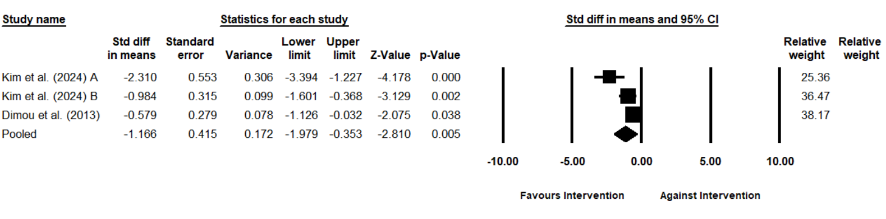
Supplementary figure 2: Sensitivity analysis at correlation coefficients of 0.1 and 0.9 for stress after 1-4 months
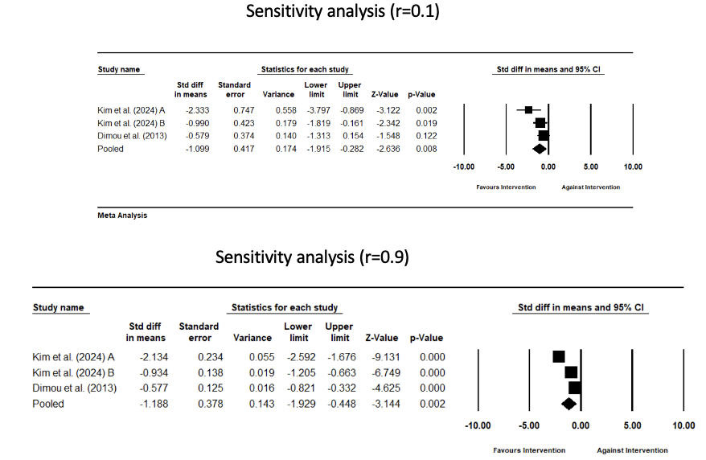

Supplementary Figure 3: Leave one out analysis
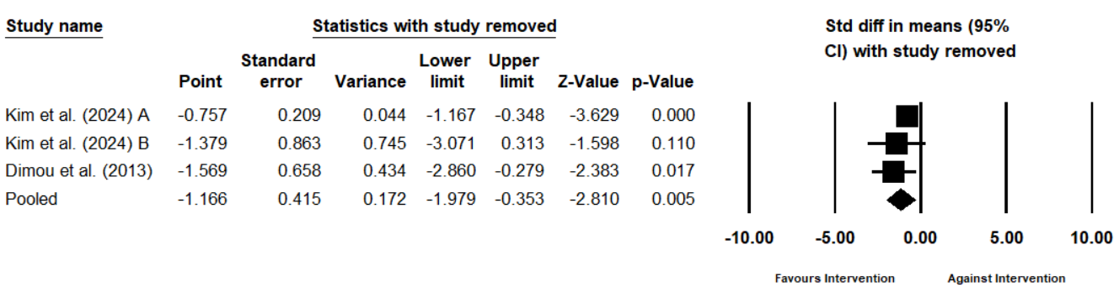

Supplementary Figure 4: Risk of bias of included studies
