Table S1 (Supplementary file): Search strategy and results yield
Database |  | Query | Results
PubMed  [All Fields] | Search 1 | "obeses"[All Fields] OR "obesity"[MeSH Terms] OR "obesity"[All Fields] OR "obese"[All Fields] OR "obesities"[All Fields] OR "obesity s"[All Fields] OR ("overweight"[MeSH Terms] OR "overweight"[All Fields] OR "overweighted"[All Fields] OR "overweightness"[All Fields] OR "overweights"[All Fields]) OR ("weight s"[All Fields] OR "weighted"[All Fields] OR "weighting"[All Fields] OR "weightings"[All Fields] OR "weights and measures"[MeSH Terms] OR ("weights"[All Fields] AND "measures"[All Fields]) OR "weights and measures"[All Fields] OR "weight"[All Fields] OR "body weight"[MeSH Terms] OR ("body"[All Fields] AND "weight"[All Fields]) OR "body weight"[All Fields] OR "weights"[All Fields]) OR "adipos*"[All Fields] OR "obes*"[All Fields] | 2310760
PubMed  [All Fields] | Search 2 | "Anti-Obesity Agents"[All Fields] OR "Anti-Obesity Drugs"[All Fields] OR "Appetite Depressants"[All Fields] OR "Appetite suppressants"[All Fields] OR "Anorexic agents"[All Fields] OR "Anorectic agents"[All Fields] OR "glp 1"[All Fields] OR "ehmt1 protein human"[Supplementary Concept] OR "ehmt1 protein human"[All Fields] OR "glp1"[All Fields] OR "glp 1"[All Fields] OR "glucagon-like peptide"[All Fields] OR "glucagon analogs"[All Fields] OR "phentermine"[Supplementary Concept] OR "phentermine"[All Fields] OR "phentermine"[MeSH Terms] OR "orlistat"[Supplementary Concept] OR "orlistat"[All Fields] OR "orlistat"[MeSH Terms] OR "orlistat s"[All Fields] OR "semaglutide"[Supplementary Concept] OR "semaglutide"[All Fields] OR "liraglutid"[All Fields] OR "liraglutide"[Supplementary Concept] OR "liraglutide"[All Fields] OR "liraglutide"[MeSH Terms] OR "liraglutide s"[All Fields] | 43362
PubMed  [All Fields] | Search 3 | "child*"[All Fields] OR ("paediatrics"[All Fields] OR "pediatrics"[MeSH Terms] OR "pediatrics"[All Fields] OR "paediatric"[All Fields] OR "pediatric"[All Fields]) OR ("minority groups"[MeSH Terms] OR ("minority"[All Fields] AND "groups"[All Fields]) OR "minority groups"[All Fields] OR "minorities"[All Fields] OR "minority"[All Fields] OR "minority s"[All Fields] OR "minors"[MeSH Terms] OR "minors"[All Fields] OR "minor"[All Fields]) OR ("men"[MeSH Terms] OR "men"[All Fields] OR "boy"[All Fields]) OR ("men"[MeSH Terms] OR "men"[All Fields] OR "boys"[All Fields]) OR "boyhood"[All Fields] OR ("women"[MeSH Terms] OR "women"[All Fields] OR "girl"[All Fields]) OR "kid"[All Fields] OR "kids"[All Fields] OR ("child"[MeSH Terms] OR "child"[All Fields] OR "children"[All Fields] OR "child s"[All Fields] OR "children s"[All Fields] OR "childrens"[All Fields] OR "childs"[All Fields]) OR "schoolchild"[All Fields] OR "adolescen*"[All Fields] OR "juvenil*"[All Fields] OR ("adolescent"[MeSH Terms] OR "adolescent"[All Fields] OR "teen"[All Fields]) OR ("preteen"[All Fields] OR "preteens"[All Fields]) OR ("adolescent"[MeSH Terms] OR "adolescent"[All Fields] OR "youth"[All Fields] OR "youths"[All Fields] OR "youth s"[All Fields]) OR "underage*"[All Fields] OR "under age"[All Fields] OR "pubescen*"[All Fields] OR "pediatric*"[All Fields] | 6919597
PubMed  [All Fields] | Search 4 | (("cardiometabolic risk"[All Fields] OR "blood pressure"[All Fields] OR ("systole"[MeSH Terms] OR "systole"[All Fields] OR "systoles"[All Fields] OR "systolic"[All Fields] OR "systolically"[All Fields]) OR ("diastole"[MeSH Terms] OR "diastole"[All Fields] OR "diastoles"[All Fields] OR "diastolic"[All Fields] OR "diastolically"[All Fields]) OR "SBP"[All Fields] OR "DBP"[All Fields] OR ("lipid s"[All Fields] OR "lipidate"[All Fields] OR "lipidated"[All Fields] OR "lipidates"[All Fields] OR "lipidation"[All Fields] OR "lipidations"[All Fields] OR "lipide"[All Fields] OR "lipides"[All Fields] OR "lipidic"[All Fields] OR "lipids"[Supplementary Concept] OR "lipids"[All Fields] OR "lipid"[All Fields] OR "lipids"[MeSH Terms]) OR "HDL"[All Fields] OR "high density lipoprotein"[All Fields] OR ("oxidized low density lipoprotein"[Supplementary Concept] OR "oxidized low density lipoprotein"[All Fields] OR "ldl"[All Fields]) OR "low density lipoprotein"[All Fields]) AND "VLDL"[All Fields]) OR "very low density lipoprotein"[All Fields] OR ("trans gis"[Journal] OR "ieee trans games"[Journal] OR "tg"[All Fields]) OR "triglyceride*"[All Fields] OR ("cholesterol"[Supplementary Concept] OR "cholesterol"[All Fields] OR "cholesterol"[MeSH Terms] OR "cholesterol s"[All Fields] OR "cholesterole"[All Fields] OR "cholesterols"[All Fields]) OR ("dyslipidaemias"[All Fields] OR "dyslipidemias"[MeSH Terms] OR "dyslipidemias"[All Fields] OR "dyslipidaemia"[All Fields] OR "dyslipidemia"[All Fields]) OR ("hyperinsulinaemia"[All Fields] OR "hyperinsulinism"[MeSH Terms] OR "hyperinsulinism"[All Fields] OR "hyperinsulinemia"[All Fields]) OR ("insulin"[Supplementary Concept] OR "insulin"[All Fields] OR "insulin"[MeSH Terms] OR "insulin s"[All Fields] OR "insuline"[All Fields] OR "insulinic"[All Fields] OR "insulinization"[All Fields] OR "insulinized"[All Fields] OR "insulins"[MeSH Terms] OR "insulins"[All Fields]) OR ("glucose"[Supplementary Concept] OR "glucose"[All Fields] OR "glucose"[MeSH Terms] OR "glucoses"[All Fields] OR "glucose s"[All Fields]) OR "Insulin resistance"[All Fields] OR "waist circumference"[All Fields] OR "C-reactive protein"[All Fields] OR ("curr res psychol"[Journal] OR "crp"[All Fields]) | 1569856
PubMed  [All Fields] | Search 5 | "RCT"[All Fields] OR "Randomized controlled trials"[All Fields] OR "Clinical trial"[All Fields] OR "Controlled clinical trial"[All Fields] | 1102147
PubMed  [All Fields] | Search 6 | # 1 AND # 2 AND # 3 AND # 4 AND # 5  Filters: Clinical Trial, Randomized Controlled Trial | 217
Web of Science | Search 1 | ALL=(Obesity OR Overweight OR Weight OR Adiposity OR Obese) | 3137690
Web of Science | Search 2 | ALL=((Anti-Obesity Agents) OR (Anti-Obesity Drugs) OR (Appetite Depressants) OR (Appetite suppressants) OR (Anorexic agents) OR (Anorectic agents) OR (GLP 1) OR GLP1 OR (GLP-1) OR (glucagon-like peptide) OR (glucagon analogs) OR Phentermine OR Orlistat OR Semaglutide OR Liraglutide) | 55121
Web of Science | Search 3 | ALL=(Child OR Children OR Pediatrics OR Minors OR boy or boys or boyhood OR girl OR kid or kids OR child or schoolchild OR adolescent OR juvenile OR teen OR preteen OR youth OR underage OR (under age) OR pubescent OR pediatric) | 5620347
Web of Science | Search 4 | ALL=((cardiometabolic risk) OR (blood pressure) OR systolic OR diastolic OR SBP OR DBP OR lipid OR HDL OR (high density lipoprotein) OR LDL OR (low density lipoprotein) VLDL OR (very low density lipoprotein) OR TG OR triglyceride OR cholesterol OR dyslipidemia OR hyperinsulinemia OR insulin OR glucose OR (Insulin resistance) OR (waist circumference) OR (C-reactive protein) OR CRP) | 3435160
Web of Science | Search 5 | ALL=(RCT OR (Randomized controlled trials) OR (Clinical trial) OR (Controlled clinical trial)) | 1554738
Web of Science | Search 6 | # 1 AND # 2 AND # 3 AND # 4 AND # 5 and English (Languages) and Open Access and Review Article (Exclude – Document Types) and Enriched Cited References (Exclude) | 100
Scopus | Search 1 | TITLE-ABS-KEY (Obesity OR Overweight OR Weight OR Adiposity OR Obese) | 4300221
Scopus | Search 2 | TITLE-ABS-KEY (“Anti-Obesity Agents” OR “Anti-Obesity Drugs” OR “Appetite Depressants” OR “Appetite suppressants” OR “Anorexic agents” OR “Anorectic agents” OR “GLP 1” OR GLP1 OR “GLP-1” OR “glucagon-like peptide” OR “glucagon analogs” OR Phentermine OR Orlistat OR Semaglutide OR Liraglutide) | 166098
Scopus | Search 3 | TITLE-ABS-KEY (Child OR Children OR Pediatrics OR Minors OR boy or boys or boyhood OR girl OR kid or kids OR child or schoolchild OR adolescent OR juvenile OR teen OR preteen OR youth OR underage OR (under age) OR pubescent OR pediatric) | 7555431
Scopus | Search 4 | TITLE-ABS-KEY (“cardiometabolic risk” OR “blood pressure” OR systolic OR diastolic OR SBP OR DBP OR lipid OR HDL OR “high density lipoprotein” OR LDL OR “low density lipoprotein” VLDL OR “very low density lipoprotein” OR TG OR triglyceride* OR cholesterol OR dyslipidemia OR hyperinsulinemia OR insulin OR glucose OR “Insulin resistance” OR "waist circumference" OR “C-reactive protein” OR CRP) | 5543871
Scopus | Search 5 | TITLE-ABS-KEY RCT OR "Randomized controlled trials” OR "Clinical trial" OR "Controlled clinical trial" | 2398743
Scopus | Search 6 | # 1 AND # 2 AND # 3 AND # 4 AND # 5 | 295

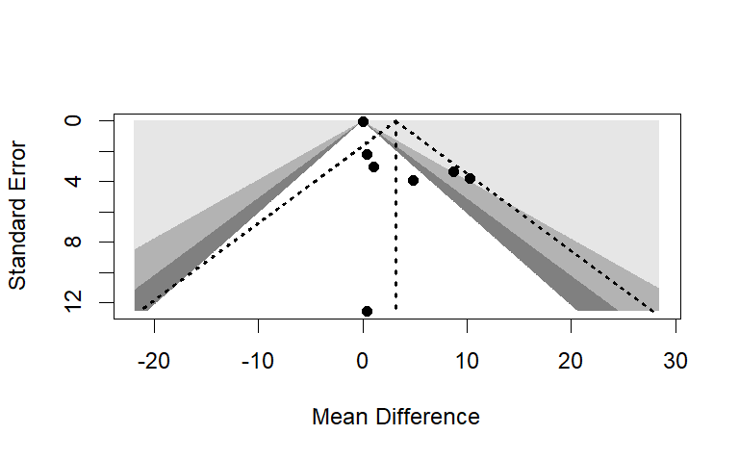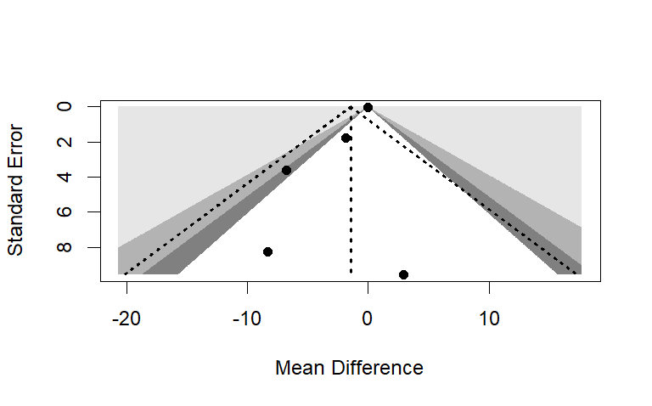
A: High Density Lipoproteins B: Low Density Lipoproteins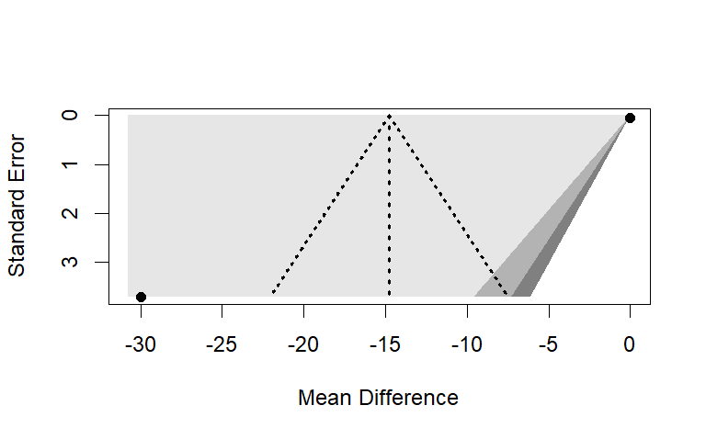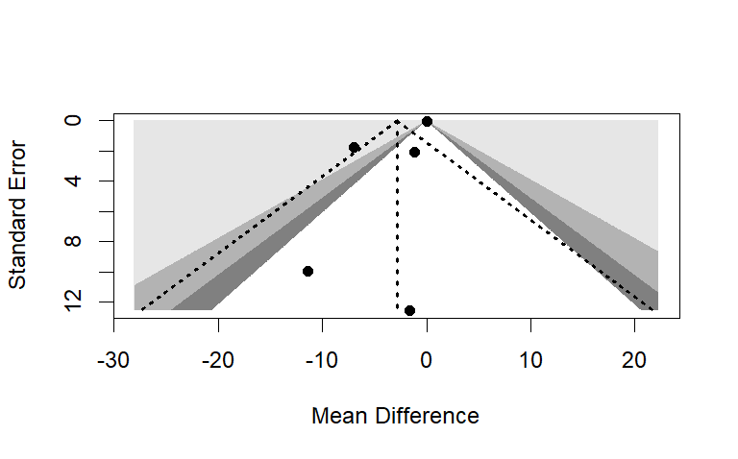
C: Very Low Density Lipoproteins D: Total Cholesterol
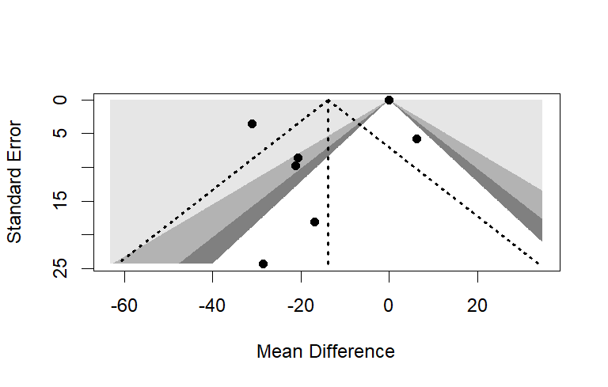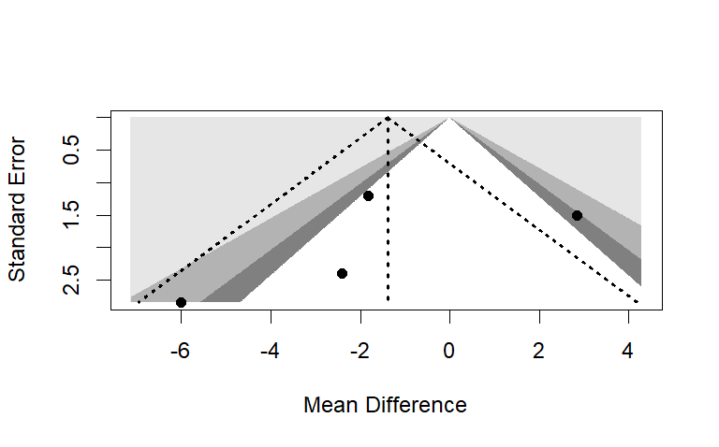
E: Triglycerides F: Fasting Glucose

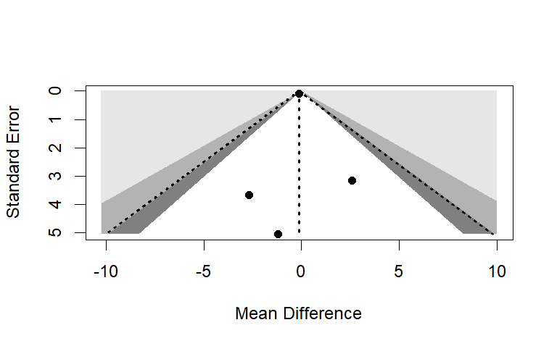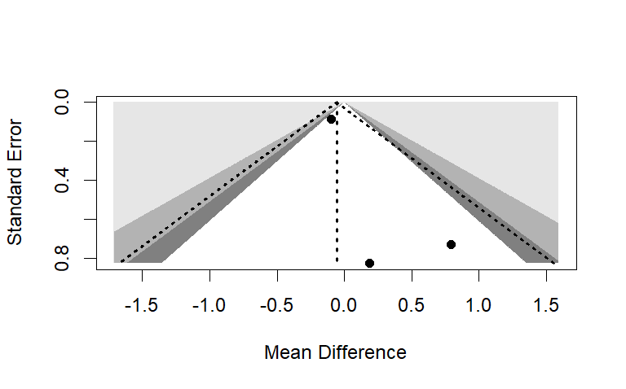
G: Fasting Insulin H: Insulin Resistance
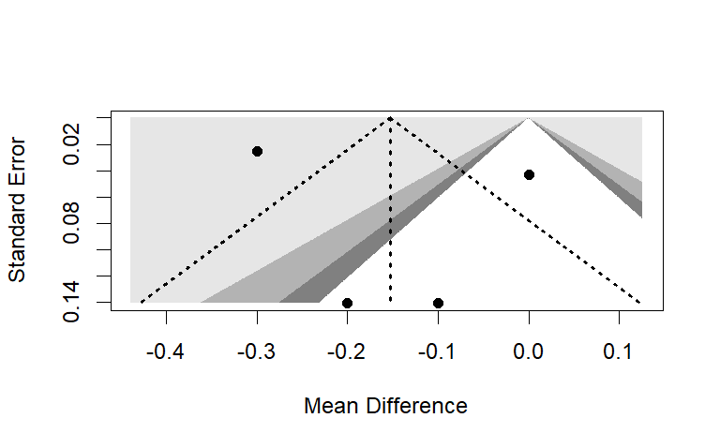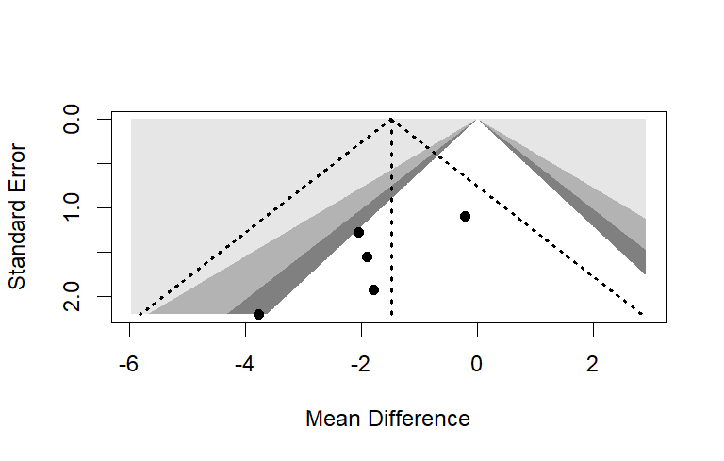
I: Hb A1C % J: Systolic Blood Pressure
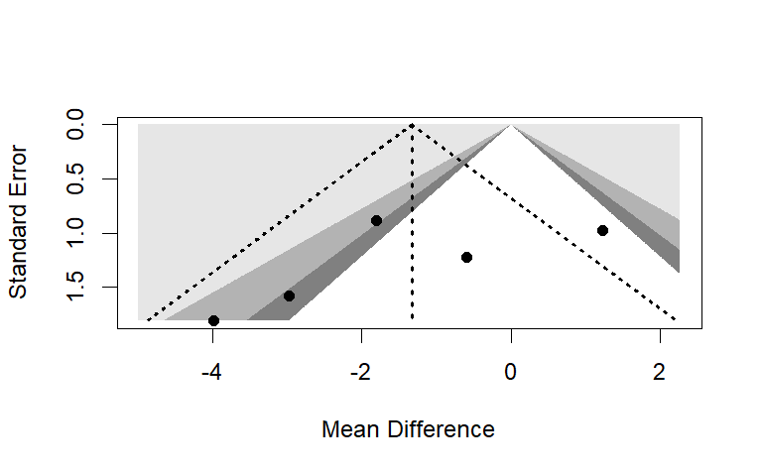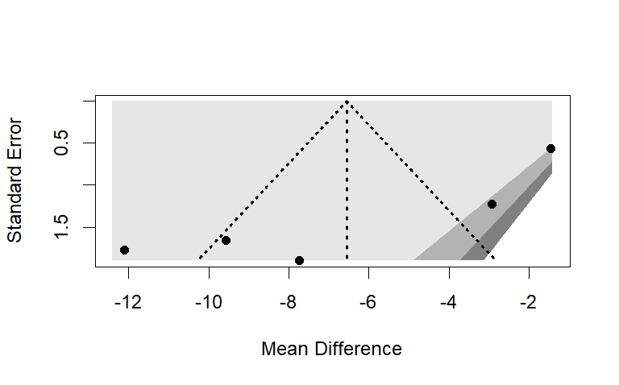
K: Diastolic Blood Pressure L: Waist Circumference
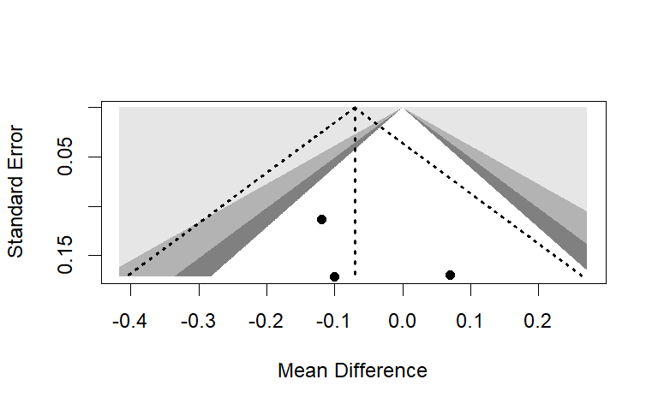
M: C-Reactive Protein

Figure S1: Funnel Plots of studies included in the pooled estimates of effects of anti-obesity drugs on A) High Density Lipoproteins B) Low Density Lipoproteins C) Very Low Density Lipoproteins D) Total Cholesterol E) Triglycerides F) Fasting Glucose G) Fasting Insulin H) Insulin Resistance I) Hb A1C % J) Systolic Blood Pressure K) Diastolic Blood Pressure L) Waist Circumference M) C-Reactive Protein

