Supplemental Materials

Unanalyzed Measures

The measurements below were measured but not included in any analysis.

Perceived sarcasm, offensiveness and funniness. The participants were asked to rate sarcasm (M = 3.67, SD = 1.53), offensiveness (M = 2.99, SD =1.52), and funniness of the jokes (M = 3.61, SD = 1.47) on a scale of 1 (Strongly disagree) to 7 (Strongly agree).

Attitudes towards traditional gender role (Bakioğlu & Türküm, 2018; García-Cueto et al., 2014). A Turkish-adapted version of the 15-item Traditional Gender Role Scale was used to measure participants’ attitudes toward traditional gender roles (e.g., ‘I think it is worse to see a man cry than a woman.’ Response options ranged from 1 = Strongly Disagree to 5 = Strongly Agree). The mean score was 2.45, (SD = 1.11) in the current study.

Mood. Participants’ momentary mood was assessed using two items. They rated the extent to which they felt happy (vs. unhappy) and good (vs. bad) at the time of assessment, using a 7-point scale ranging from 1 (Extremely unhappy/bad) to 7 (Extremely happy/good).

Manipulation check. Participants were asked to rate the extent to which jokes targeting women and men reflect social perceptions of women and men, respectively, on a 7-point Likert scale (1= Not at all, 7 = Very much). All participants assessed about jokes targeting women after seeing 3 traditional or counter-traditional jokes about women, and related jokes targeting men after 3 traditional or counter-traditional jokes about men.

Experimental Stimuli

Image 1. Men-targeted non-traditional joke 1
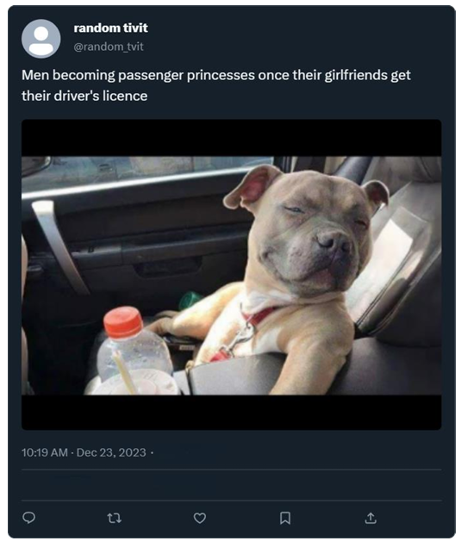

Image 2. Men-targeted non-traditional joke 2 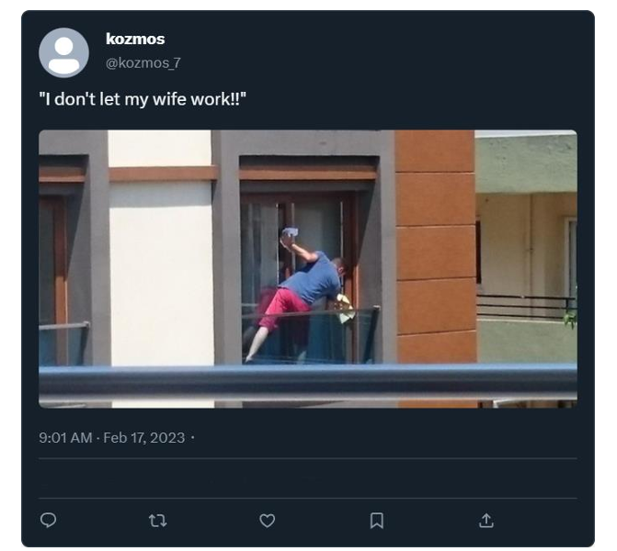

Image 3. Men-targeted non-traditional joke 3 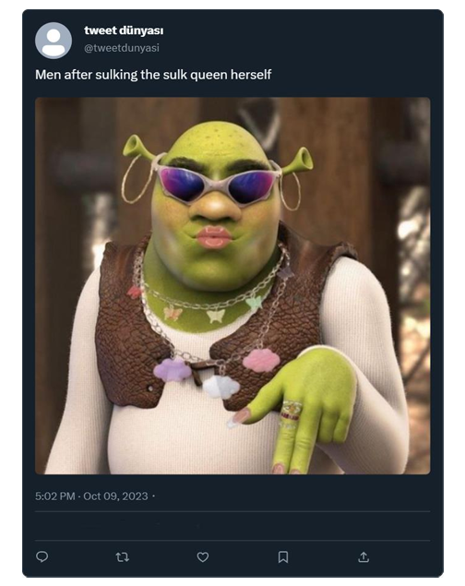

Image 4. Men-targeted traditional joke 1
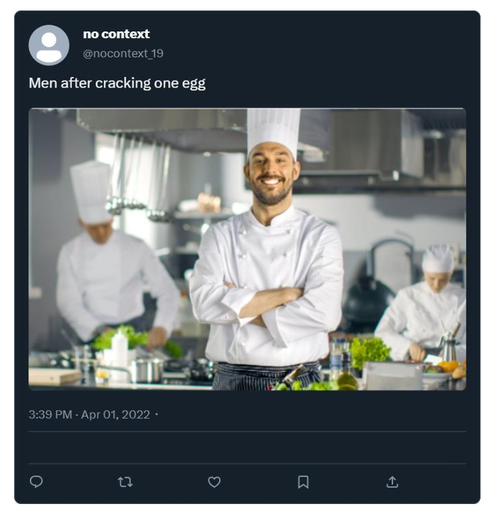

Image 5. Men-targeted traditional joke 2
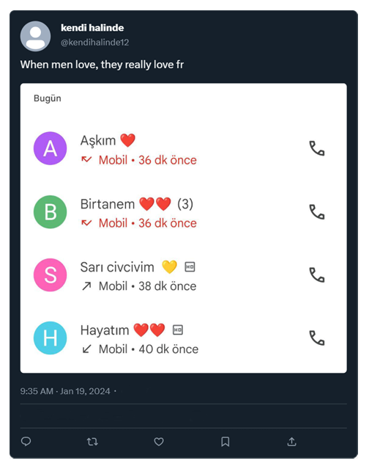

Image 6. Men-targeted traditional joke 3
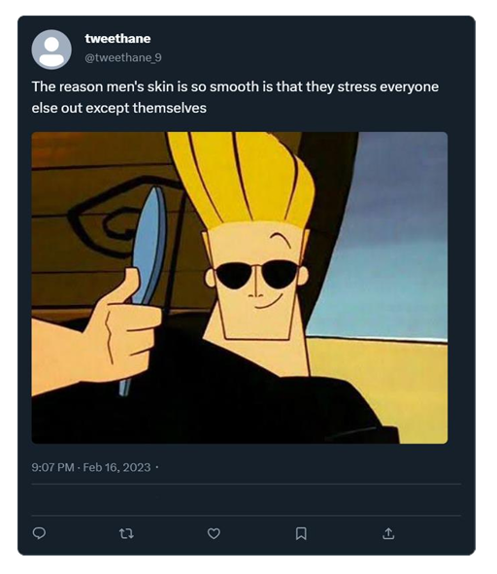

Image 7. Women-targeted traditional joke 1
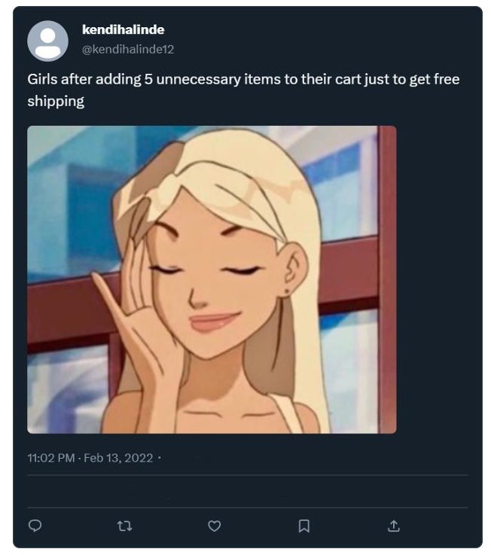

Image 8. Women-targeted traditional joke 2
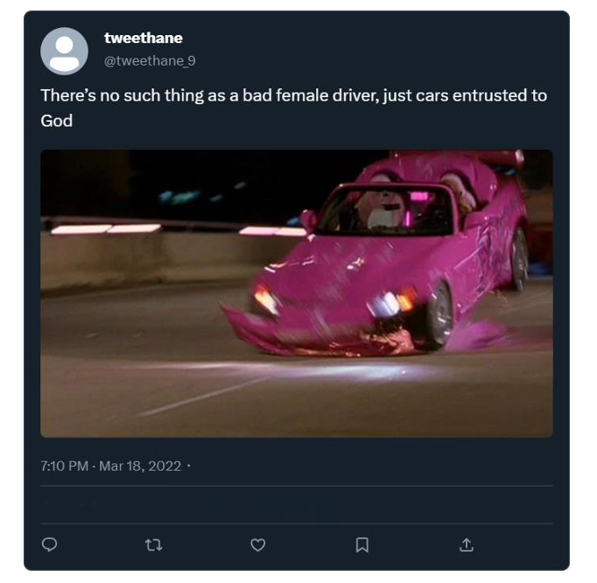

Image 9. Women-targeted traditional joke 3
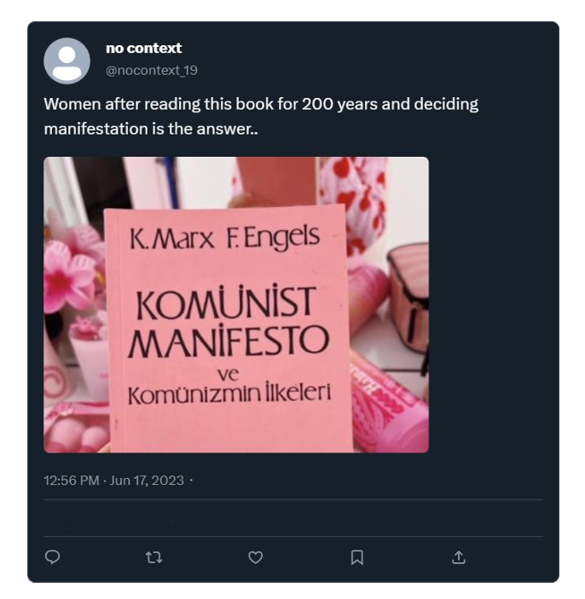

Image 10. Women-targeted non-traditional joke 1
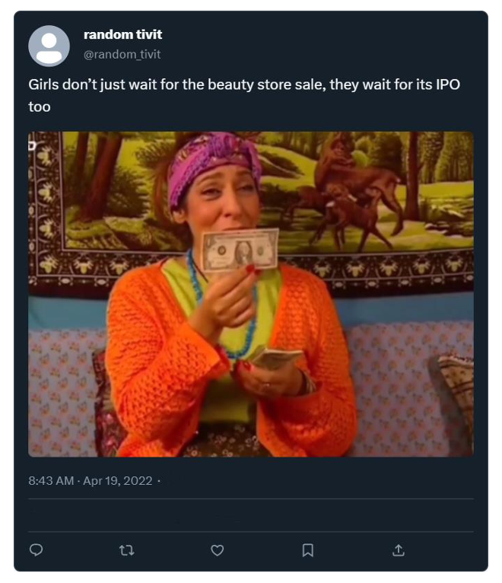

Image 11. Women-targeted non-traditional joke 2
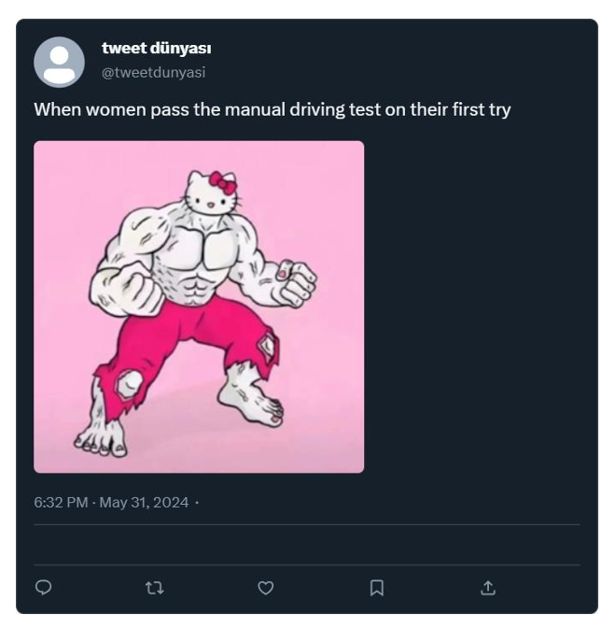

Image 12. Women-targeted non-traditional joke 3