SUPPLEMENTARY MATERIAL
Understanding predictors of trust in science among university students: examining scientific reasoning, cognitive reflection, education, and personal experiences with the scientific community

SECTION A
Examining differences in trust in science between fields of study using ANOVA
To examine potential differences in trust in science across different academic disciplines, a one-way analysis of variance (ANOVA) was conducted. The analysis included participants from six academic fields: Science, Technology, Engineering, and Mathematics; Health Sciences; Economics; Social Sciences and Humanities; Education; and Psychology. The ANOVA revealed no statistically significant differences in trust in science across the six academic disciplines (F(5, 144) = 1.00, p = .419) (descriptive statistics are presented in Table S1 and Figure S1). The analysis found no evidence that trust in science differed between university students studying different academic disciplines.

Table S1 Descriptive Statistics of Trust in Science by Field of Study
Field of study |  | N | M | SD
1 | Science, Technology, Engineering, and Mathematics | 21 | 32.5 | 6.48
2 | Health Sciences | 18 | 31.6 | 8.19
3 | Economics | 35 | 28.5 | 7.59
4 | Social Sciences and Humanities | 26 | 30.2 | 7.27
5 | Education | 17 | 29.3 | 8.01
6 | Psychology | 33 | 29.3 | 7.53
Note. N = number of university students studying a certain field of study, M = mean, SD = standard deviation

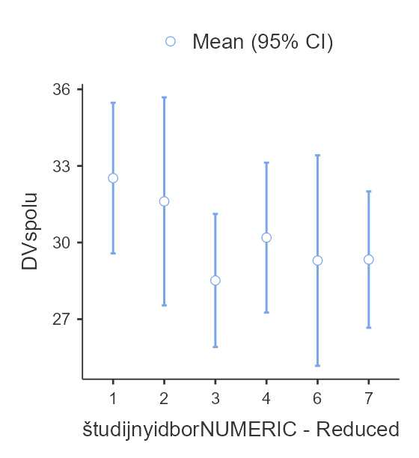
Trust in science
1 2 3 4 5 6
Field of study
Figure S1 Comparing average score with 95% confidence interval of trust in science across different academic fields
Fields of study are coded as 1 = Science, Technology, Engineering, and Mathematics, 2 = Health Sciences, 3 = Economics, 4 = Social Sciences and Humanities, 5 = Education, 6 = Psychology

SECTION B
Results of hierarchical linear regression analysis predicting trust in science from scientific reasoning, cognitive reflection, parents' highest level of education and personal experiences with the scientific community, controlling for demographic variables
In the main paper, a linear regression analysis was conducted to examine whether scientific reasoning, cognitive reflection, length of study, parental education and personal experience with the scientific community predict trust in science. To account for potential confounding effects, demographic variables, including age, gender and field of study, an additional regression analysis was run. The first step of the analysis reflects the analysis presented in the main paper, and the second step includes the variables from the first step and demographic factors to control for their potential effect. Including demographic variables in the analysis reduces the likelihood of confounding factors, thereby ensuring more accurate conclusions (results of the analysis are presented in Table S2).
The hierarchical regression model at the first step was statistically significant (F(5,144) = 9.66, p < .001), indicating that the set of predictors collectively explained a significant portion of variance in trust in science. Among the predictors included – scientific reasoning, cognitive reflection, length of study, parental education, and personal experience with the scientific community – only personal experience with the scientific community emerged as a significant predictor (β = .41, p < .001). None of the remaining variables were statistically significant predictors of trust in science.
In the second step of the analysis, demographic variables were added to the initial model. The model, including scientific reasoning, cognitive reflection, length of study, parental education and personal experience of the scientific community, remained statistically significant when demographic variables were added (F(12, 137) = 4.11, p < .001). However, none of the predictors, neither variables from the initial model nor demographic variables, except for personal experience with the scientific community (β = .44, p < .001), which was also significant in the previous model, were found to be significant. In addition, inclusion of demographic variables did not significantly enhance the predictive ability of the model (ΔF(7,137) = .35, p = .924). Controlling for demographic factors did not result in identifying demographic variables as predictors of trust in science, nor did it modify the predictive contributions of the primary tested independent variables, nor a significant enhancement of the explained variance of the model.
Table S2 The results of hierarchical linear regression analysis predicting trust in science
 | B | β | 95% CI | p
Step 1 | R² = .25, F(5,144) = 9.66, p < .001
Scientific reasoning | .41 | .11 | [-.02, .26] | .115
Cognitive reflection | .21 | .06 | [-08., .20] | .411
Parents' highest level of education | 1.75 | .14 | [-.00, .28] | .054
Length of university study | -.56 | -.12 | [-.26, .02] | .101
Personal experiences with the scientific community | 2.39 | .41 | [.27, .55] | < .001
Step 2 | F(12,137) = 4.11, p < .001,  ΔR² = .01, ΔF(7,137) = 0.35, p = .924
Scientific reasoning | .46 | .13 | [-.02, .29] | .088
Cognitive reflection | .24 | .06 | [-.08, .22] | .367
Parents' highest level of education | 1.67 | .13 | [-.01, .28] | .075
Length of university study | -.22 | -.04 | [-.28, .19] | .689
Personal experiences with the scientific community | 2.55 | .44 | [.28, .60] | < .001
Age | -.36 | -.08 | [-.33, .17] | .516
Gender
Woman | 1.21 | .16 | [-.19, .52] | .376
Academic fields
Health Sciences | -1.30 | -.17 | [-.76, .41] | .559
Economics | -.47 | -.06 | [-.58, .46] | .812
Social Sciences and Humanities | .39 | .05 | [-.51, .62] | .856
Education | -.18 | -.02 | [-.63, .58] | .936
Psychology | -1.84 | -.24 | [-.76, .27] | .353
Note. The table displays the results of hierarchical linear regression predicting trust in science with scientific reasoning, cognitive reflection, parents' highest level of education and personal experiences with the scientific community as main predictors and demographic data as covariates. The table presents unstandardized regression coefficients (B) as well as standardised regression coefficients (β), their 95% confidence intervals and p-values for the regression models predicting trust in science. The reference group for the gender was men. The reference group for academic disciplines was Science, Technology, Engineering and Mathematics.

